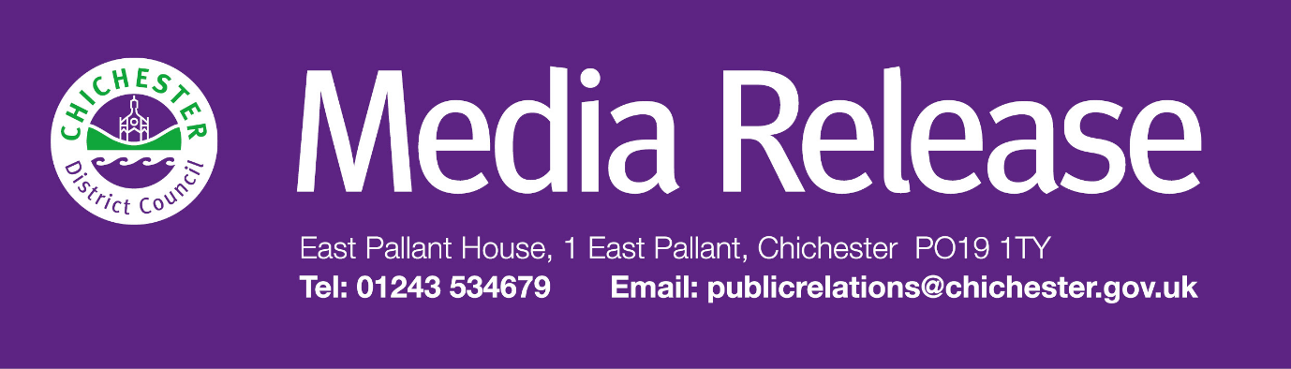
Date of Release: 2 November 2026 Ref: 4656

Fun festive events programme will support city and bring plenty of joy to Chichester!

People of all ages will be able to enjoy a range of events as part of Chichester District Council’s festive events programme which kicks off at the end of this month.
This year’s line-up features a number of events that will take place in and around Chichester’s Priory Park. These include a live performance trail, pantomime, storytelling sessions for pre-schoolers, a silent disco and jazz café.
“Our programme has been carefully designed to be as inclusive and as welcoming as possible for everyone in the district,” says Councillor Harsha Desai, Cabinet Member for Economic Development, Licensing, Communications and Events at Chichester District Council. “At the heart of the celebrations will be the stunning Guildhall building in Priory Park which will again be beautifully set with a decorative Christmas willow sculpture which will welcome visitors and set the festive scene.
“As well as helping to create joyful and memorable experiences for people across our communities, our events programme is also aimed at supporting our local businesses, attracting more visitors to our beautiful city and helping to create a bustling, vibrant atmosphere at this wonderful time of year.”
The fun kicks off on Friday 27 November and Saturday 28 November with the Sounds of Home live performance trail, now in its second year. Running from 4pm until 6pm, the trail starts at The Novium Museum in Tower Street, with various art and craft activities. People can then visit different locations around the city and enjoy a range of live music performances from local talent.
Pre-schoolers will have lots of opportunities to create sound effects and dress up as characters from festive stories during a series of storytelling sessions starting on 8 December.
On 9 December there will be an opportunity for people to relax with a Festive Soundbath, while on 12 December people are encouraged to dig out their festive jumpers for ‘Deck The Guildhall’ – an evening of seasonal songs, poetry and more led the cast of the Priory Park Panto Experience.
The Priory Park Panto Experience returns with more magic and mayhem from Fairy Sparkle, Santa, Mrs Santa and Norman the Elf – plus a visit from Uncle Holly this year. Shows take place on 12, 13, 19, 20, 21 and 22 December at selected times.
Mike Carey’s Big House and Jazz Band will return for their Festive Jazz Café on 16 December, which will feature a mix of seasonal words and music, with actors, poets and special guests.
Sparkles and sequins will be a must for a Silent Disco which takes place on 17 December. Aimed at over-18s, the event is a chance for people to enjoy a range of music in historic surroundings.
The Chichester Festive Market will also be taking place across two weekends in December 4,5,6 and 11, 12, and 13 December. Visitors will be able to wander through a range of different stalls with gifts, crafts and seasonal treats – there will be something for everyone.
Tickets for the council’s festive events can be booked through The Novium Museum at: www.thenovium.org/christmasevents
For more information, seasonal parking offers and even more Christmas information, people can go to: www.chichester.gov.uk/countdowntochristmas
People can also follow the council’s Facebook, X and Instagram pages plus the events and markets Facebook page: www.facebook.com/ChichesterDistrictEventsAndMarkets
For regular updates about council events people can also sign up to Chichester District Council’s monthly email newsletter Initiatives + at: www.chichester.gov.uk/newsalerts
For further information, please contact Clare Hawkin, Senior Communications Officer, Chichester District Council on
01243 534679 or email chawkin@chichester.gov.uk

