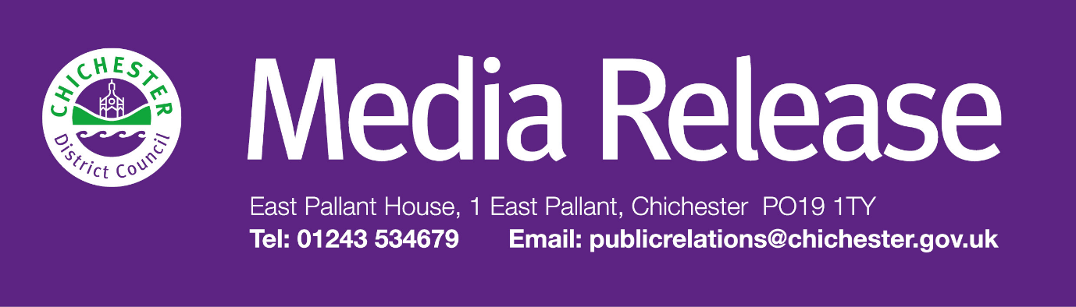
Date of Release: 29 October 2026 Ref: 4655

Government delays decision on local government reorganisation in West Sussex

A decision on local government reorganisation in West Sussex has been further delayed, following an announcement by the Government today (Thursday 29 October).

The Government has confirmed that it intends to move forward with local government reorganisation in five areas, subject to a three-week consultation with council leaders. These include Gloucestershire, Worcestershire, Warwickshire, Oxfordshire, and East Sussex and Brighton & Hove.

West Sussex is one of 15 areas where a final decision has not yet been made and remains under review. A final decision is unlikely to be made until early in the new year. However, the Government has stated that some areas may be informed before Christmas.

The Government has also confirmed that all new authorities are expected to hold shadow elections in 2028, with the new councils coming into effect in April 2029.

"While it is frustrating that a decision on local government reorganisation in West Sussex has been delayed, we welcome the additional time to ensure that any future arrangements are carefully considered and deliver the best possible outcomes for our residents, communities and businesses,” says Councillor Adrian Moss, Leader of Chichester District Council.

"The Government has confirmed that all options for West Sussex remain under consideration. With East Sussex and Brighton & Hove now progressing separately, we have greater clarity that any future proposals affecting our area will be focused within the West Sussex boundary.

"For over a year, councils across West Sussex have worked closely together to explore the opportunities and challenges presented by local government reorganisation. Significant progress has already been made, and we will continue that collaborative work so that we are well prepared when the Government reaches its decision.

"Throughout this process, our priority remains serving our residents and delivering the high-quality local services that our communities rely on every day. It remains very much business as usual, and we are committed to continuing to keep residents closely informed as further updates become available."

District Council elections will now take place in May 2027, with shadow elections for any new unitary authority or authorities expected in May 2028. The new authorities are expected to come into effect in April 2029.

Further information about local government reorganisation in West Sussex can be found at www.shapingwestsussex.org and www.chichester.gov.uk/devolution

For further information, please contact Sarah Parker, Communications Manager on 01243 534537 or email: sjparker@chichester.gov.uk

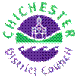 | Terri Foster  Senior Communications Officer  Communications  Chichester District Council

Ext: 21226 | Tel: 01243521226 | tfoster@chichester.gov.uk | https://www.chichester.gov.uk
East Pallant House opening hours: 9am-4pm Monday to Friday


