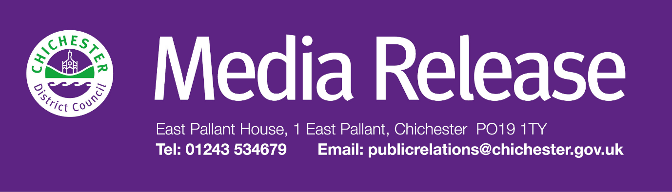
Date of Release: 22 October 2026 Ref: 4652

Free Carbon Literacy training for residents and community groups will support local climate action

Chichester District Council is inviting residents and community groups to take part in a free climate education training day to mark this year’s Carbon Literacy Action Day on Monday 9 November.

Based on the globally recognised Carbon Literacy Project, this event follows a successful training day held last year which also saw the launch of the Chichester District Climate Action Network. The training is designed to help people identify practical changes they can make to reduce their carbon footprint. Delivered by the council’s experienced in-house Carbon Literacy Facilitator, the event is taking place at The Novium Museum in Tower Street, Chichester, from 9.30am to 5.30pm. Places can be booked through Eventbrite: www.eventbrite.co.uk/e/carbon-literacy-action-day-training-tickets-2003344150282?aff=oddtdtcreator.

"Across our district, residents, community groups and organisations are already taking positive steps to respond to climate change at a local level. This free training is a fantastic opportunity to build on that momentum, helping more people turn climate concern into practical action,” says Cllr Jonathan Brown, Deputy Leader and Cabinet Member for the Environment at Chichester District Council.

“Whether you’re just starting to think about your carbon footprint or are already involved in local climate action, this event will equip you with practical knowledge, useful tools and the opportunity for individuals and groups to connect with and learn from others who share the same passion.

“The course will help participants understand the causes and impacts of climate change, explore the positive work already happening across our district, and identify actions they can take in their own lives and communities. By working together, we can all play a part in reducing emissions and creating a more sustainable future for our district.”

This free training day is open to everyone in the Chichester District and a light lunch will be provided by UK Harvest. To book a space and become certified as ‘Carbon Literate’ through the Carbon Literacy Project, please visit: www.eventbrite.co.uk/e/carbon-literacy-action-day-training-tickets-2003344150282?aff=oddtdtcreator. Spaces are limited, so early booking is advised.

This event is an integral part of the council’s Climate Emergency Action Plan, which runs from 2025 to 2030 and includes a range of projects addressing different aspects of the climate emergency — such as home energy efficiency, tree planting, and community action. People can find out more about this work on our new Chichester District Council climate change website: https://cdc4climate.org.

To find out more about Carbon Literacy, visit: https://carbonliteracy.com/what-is-carbon-literacy/. To stay informed about climate initiatives in the Chichester District, sign up to our dedicated newsletter: www.chichester.gov.uk/climatechangenewsletter

For further information, please contact Thomas Carr, Assistant Communications Officer at Chichester District Council on 01243 521297 or by emailing tcarr@chichester.gov.uk

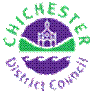 | Thomas Carr  Assistant Communications Officer  Chichester District Council

Tel: 01243521297 | tcarr@chichester.gov.uk | https://www.chichester.gov.uk
East Pallant House opening hours: 9am-4pm Monday to Friday


