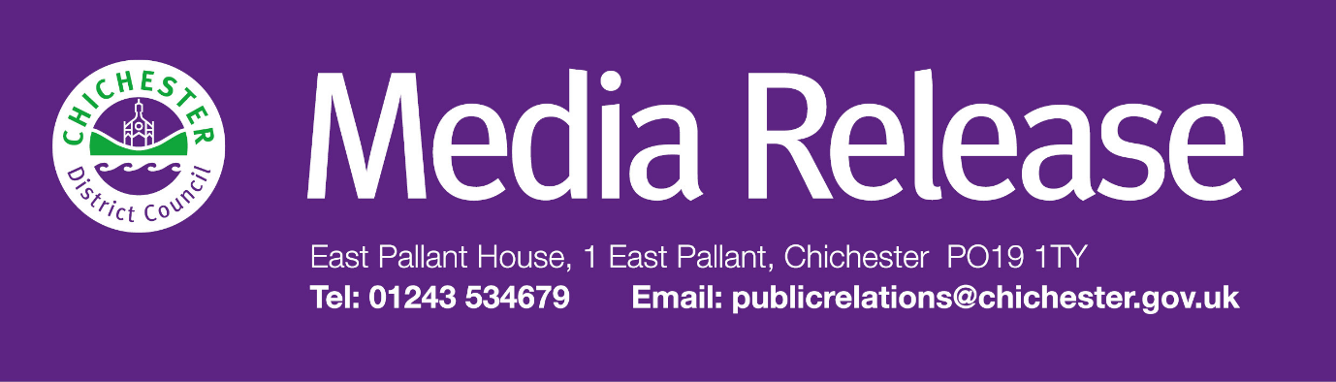
Date of Release: 21 September 2026 Ref: 4632

Free ‘MakeBeth’ performances will bring Shakespeare to life for young audiences in Chichester District

Children across the district will have the opportunity to enjoy one of Shakespeare’s most famous works thanks to an interactive series of free performances arranged through the Culture Spark initiative.
The production will tour schools across the district, as well as staging two performances at 11am and 2pm at the historic Guildhall in Priory Park, Chichester on Sunday 4 October. The tour has been organised by Culture Spark, an arts partnership between Chichester District Council, Chichester Festival Theatre and Pallant House Gallery which has been running since 2021.
Aimed at children aged 5-11 years old, ‘MakeBeth’ is a laugh-out-loud immersive adventure from theatre company Cardboard Adventures and Shakespeare’s Globe, created in partnership with Chichester Festival Theatre and Leeds Playhouse.
Audiences don’t just watch the story, they help create it by making cardboard witches, becoming the moving trees of Birnam Wood and crafting along as the story progresses. Performed with live music, puppetry and hands-on fun, the show invites children to use cut-outs to help bring the story to life.
Caroline Sharman-Mendoza, creative co-ordinator of Culture Spark, says: “Our aim is to offer arts and creative opportunities to all ages within the community that are fun, free and accessible to all. The response to ‘Makebeth’ when Chichester Festival Theatre took it to local schools was overwhelmingly positive, so it is wonderful that we can bring Cardboard Adventures back to Chichester for these free performances in the beautiful Guildhall.”
Councillor Adrian Moss, Leader of Chichester District Council, says: “I am delighted that this really unique piece of theatre is coming to the Chichester district. This is a wonderful opportunity for young children in our communities to learn about a classic story in a fun-filled way, and maybe even encounter their first experience of live theatre.
“Culture Spark have also arranged for ‘Makebeth’ to be performed at schools including Bosham Primary School, Portfield Primary School, Sidlesham Primary School and Chichester Free School, and Petworth Primary School, plus Fishbourne Roman Palace. I hope as many children as possible can come along to enjoy this production and use their imaginations and creativity to interact with this innovative piece of live theatre.”
Places are limited to 60 guests per show, and each performance lasts approximately one hour. People can book a free place at one of two performances of ‘Makebeth’ at The Guildhall, Priory Park on 4 October by visiting: https://shop.thenovium.org/products/makebeth
People can also find out more about what Culture Spark has been working on at: www.culturesparkchi.co.uk
People can visit Chichester District Council’s online What’s On calendar to find more information about events in the district: www.chichester.gov.uk/whatson

Events information and updates can also be found by following the Chichester District Events and Markets Facebook page: www.facebook.com/ChichesterDistrictEventsAndMarkets and Instagram page: https://www.instagram.com/chidisevents/
For regular updates about events and activities across the district, sign up to the council’s monthly email newsletter, Initiatives+, at: www.chichester.gov.uk/newsalerts

ENDS

For further information, please contact Jenny Bathurst-Taylor, Communications Assistant at Chichester District Council on 01243 972813 or by emailing jbathurst-taylor@chichester.gov.uk

About Culture Spark:
Culture Spark is a Chichester District Council initiative.
It was formed in 2022 in partnership with Chichester Festival Theatre and Pallant House Gallery in response to the end of the covid pandemic.
One of the partnership’s aims is to celebrate the whole of the district, from Midhurst to Chichester, Selsey and the Witterings to Petworth and everywhere in between.
Culture Spark aims to use the arts to help rebuild local communities by offering accessible events and creative workshops including to schools and community groups across the district, as well providing opportunities for local artists to lead projects and/or explore their own creativity
www.culturesparkchi.co.uk

________________________________________________________________________
LEGAL DISCLAIMER
This e-mail and any files transmitted with it are confidential and intended solely for the use of the individual or entity to whom they are addressed. However, any views or opinions presented are solely those of the author and do not necessarily represent those of Chichester District Council.
If you are not the intended recipient or the person responsible for delivering the e-mail to the intended recipient, be advised that you have received this e-mail in error and that any use, dissemination, forwarding, printing or copying of this e-mail is strictly prohibited.
Communications on or through Chichester District Council's computer systems may be monitored or recorded to secure effective system operation and for other lawful purposes.
If you have received this e-mail in error please notify the Chichester District Council administrator.
E-mail or phone 44 (0) 1243 785166
contact@chichester.gov.uk

