Introducing…
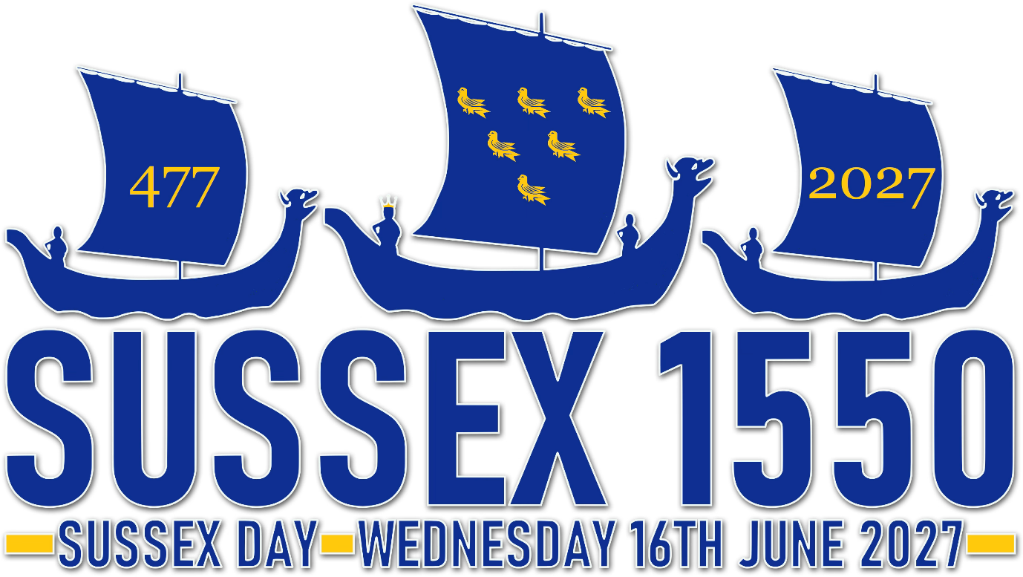

We’d like to invite you to partake and celebrate Sussex 1550 - marking the 1550th anniversary since our beloved Sussex was traditionally founded, in the year 477 - which we believe this is worthy of great rejoicing and festivities - together!
Let's celebrate the wonderful County of Sussex and its cherished customs, traditions, and heritage. We have so much to be proud of, and our unique ways deserve to be observed in a large fashion and as an act of union and togetherness.
The 'Anglo-Saxon Chronicle', a set of annals compiled in the late 9th Century, states Sussex was established, as an independent Kingdom, in the year 477 by King Ælle and his three sons, Cymen, Wlencing and Cissa, who arrived on the coast in three ships at a place called 'Cymenshore'.
These celebrations are to take place on the week of Sussex Day, Wednesday 16th June 2027, inclusive of the weekends either side - Saturday 12th until Sunday 20th June 2027.
🔥 Co-ordinated Beacon / Bonfire Lightings at 9pm on 16th June
🎈 Street Parties
🎪 Village Fetes
🐤 + Any other Sussex related events and activities
Your full information pack to Sussex 1550 can be found here…

SUSSEX 1550 BEACONS & BONFIRES @9PM - 16TH JUNE 2026
As part of the celebrations, we would like to formally invite you to partake in the centrepiece of events - a coordinated county-wide Beacon and Bonfire Lighting at 9pm on Sussex Day, Wednesday 16th June 2027, uniting every corner of Sussex at the same moment.
We are now accepting registrations for commemorative Sussex 1550 beacons and bonfires Register online at www.sussex1550.com , or email beacons@sussex1550.com
A full lighting guide for Sussex 1550 Beacon and Bonfires can be found here…

To keep fully up-to-date on Sussex 1550 activities, progress, and events, please follow our facebook page: www.facebook.com/SussexFlag
Let’s give existing Sussex Day celebrations a real boost in this special anniversary year!
We Wunt be Druv
Many thanks for your time,
Brady Brooks-Ells
Sussex 1550
www.sussex1550.com

