
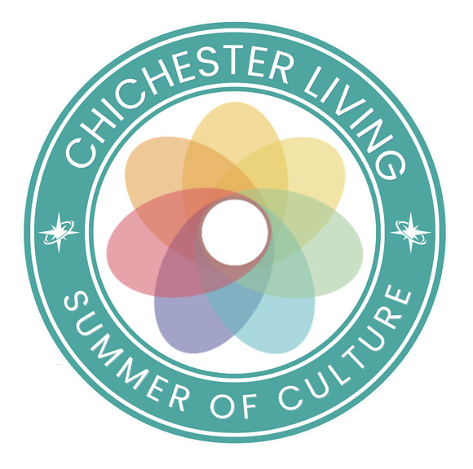
Today, 13th August, is International Left Handers day. There have been some very famous left-handers - Leonardo da Vinci, Michelangelo, Paul McCartney, Jimi Hendrix, Marie Curie, Helen Keller and Barack Obama and then there is ...your editor
Lots of outdoor events this week so you can continue to benefit from the good weather - outdoor performances, jousting, street markets, open gardens and an art trail.
Pallant House Gallery brings the outdoors inside with their hugely popular exhibition British Landscapes: A Sense of Place and the Goodwood Art Foundation is the place for sculpture outdoors with their Art in the Landscape exhibition and Expressions in Blue in the park at Petworth House brings you towering works in ceramics.
Indoors, the Festival Theatre opens next week with a small and quiet life, the extraordinary story of Noor Khan who was a Special Operations Executive in WWII. She was flown to France from Tangmere and below you can read about the talks and tours running at the museum to coincide with the play.
Also at the theatre both Atlantis and My Fair Lady will end soon so this is the last chance to get to see either one. Save the date of the 1st September for the announcement of their winter programme.
Our Summer of Culture page this week focuses on the theatre too, including our 'Discover' article about how the theatre was founded.
Our younger residents can participate in the Summer of Colour at the Cathedral, inspired by the vibrant colours of the John Piper tapestry which celebrates 60 years in its own exhibition. We are delighted to offer you the opportunity to win tickets to the spectacular light show at the cathedral in the Autumn (see below for details)
Events marking the 250th anniversary of the American Declaration of Independence continue with an evening at Goodwood House about the 3rd Duke of Richmond and his involvement (see below). Please note that the tour of the West Sussex Record Office to view the West Sussex exemplar of the Declaration is now sold out.
Chichester District Council are inviting residents, businesses, community groups and organisations to help shape the future of the Chichester area as work begins on a new local plan that will guide development across the Chichester plan area until 2045. The consultation is open until the 25th September
Heads up too for the celebrations of 800 years of Chichester City Council which are taking place in September
The 34th International Film Festival is in full swing until the 23rd August with an impressive range of films and talks
There are many more events, news, experiences and articles on the website. Follow this link to see the calendar of events for the rest of August.
Wishing you all a good week
Vicki
Founder/Editor

Today, 13th August, is International Left Handers day. There have been some very famous left-handers - Leonardo da Vinci, Michelangelo, Paul McCartney, Jimi Hendrix, Marie Curie, Helen Keller and Barack Obama and then there is ...your editor
Lots of outdoor events this week so you can continue to benefit from the good weather - outdoor performances, jousting, street markets, open gardens and an art trail.
Pallant House Gallery brings the outdoors inside with their hugely popular exhibition British Landscapes: A Sense of Place and the Goodwood Art Foundation is the place for sculpture outdoors with their Art in the Landscape exhibition and Expressions in Blue in the park at Petworth House brings you towering works in ceramics.
Indoors, the Festival Theatre opens next week with a small and quiet life, the extraordinary story of Noor Khan who was a Special Operations Executive in WWII. She was flown to France from Tangmere and below you can read about the talks and tours running at the museum to coincide with the play.
Also at the theatre both Atlantis and My Fair Lady will end soon so this is the last chance to get to see either one. Save the date of the 1st September for the announcement of their winter programme.
Our Summer of Culture page this week focuses on the theatre too, including our 'Discover' article about how the theatre was founded.
Our younger residents can participate in the Summer of Colour at the Cathedral, inspired by the vibrant colours of the John Piper tapestry which celebrates 60 years in its own exhibition. We are delighted to offer you the opportunity to win tickets to the spectacular light show at the cathedral in the Autumn (see below for details)
Events marking the 250th anniversary of the American Declaration of Independence continue with an evening at Goodwood House about the 3rd Duke of Richmond and his involvement (see below). Please note that the tour of the West Sussex Record Office to view the West Sussex exemplar of the Declaration is now sold out.
Chichester District Council are inviting residents, businesses, community groups and organisations to help shape the future of the Chichester area as work begins on a new local plan that will guide development across the Chichester plan area until 2045. The consultation is open until the 25th September
Heads up too for the celebrations of 800 years of Chichester City Council which are taking place in September
The 34th International Film Festival is in full swing until the 23rd August with an impressive range of films and talks
There are many more events, news, experiences and articles on the website. Follow this link to see the calendar of events for the rest of August.
Wishing you all a good week
Vicki
Founder/Editor



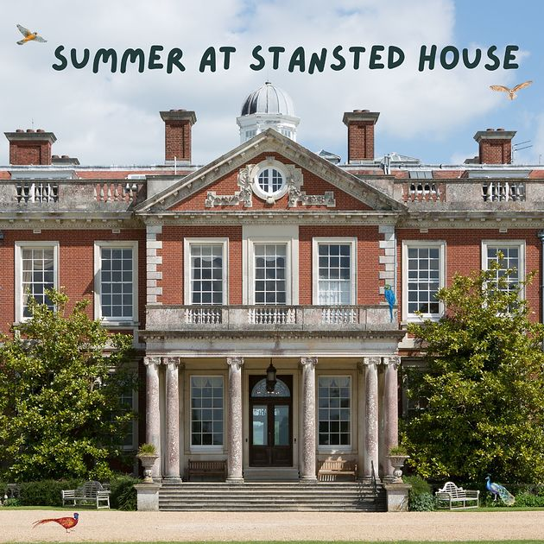
Summer at Stansted House
until 25th August - Stansted House
Enjoy a fun-filled family day out at Stansted House this summer, with kids visiting the House for free over the school holidays!
Step inside the family home of the Earls of Bessborough and discover what life was like on this beautiful country estate. Explore the beautiful State Rooms, where the family entertained guests, before moving downstairs to see the Servants Quarters.
MORE...

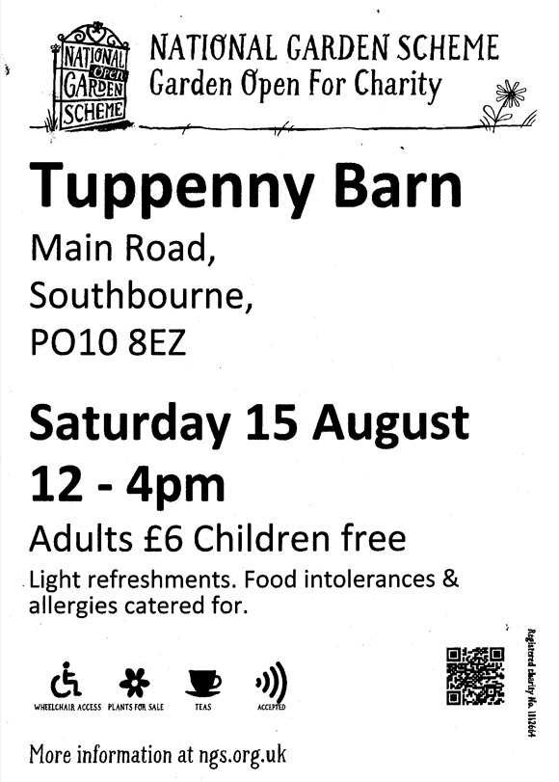
National Garden Scheme
15th August - Tuppenny Barn, Southbourne
As part of the National Garden Scheme Tuppenny Barn will be opening its gates on Saturday 15th August. An iconic, organic smallholding used as an outdoor classroom to teach children about the environment, sustainability and healthy food.
MORE


Emsworth Loves Local
15th August Methodist Church, Emsworth
Join us at Emsworth Methodist Church for a lovely day celebrating small businesses, community and creativity. Our market brings together a carefully curated selection of independent traders, offering unique handmade goods, thoughtful gifts and beautiful treats all made with passion by local makers.
MORE


Noor Khan Talk & SOE Tour
15th August (and other dates) Tangmere Military Aviation Museum
If A Small and Quiet Light inspires you to discover more about the extraordinary world of the Special Operations Executive, a visit to Tangmere Military Aviation Museum is the perfect next step
To accompany A Small and Quiet Life, acknowledged SOE historian Sheryl Green will present an exclusive Noor Khan Talk & SOE Tour at the museum. Combining an engaging, illustrated talk with a guided tour of the museums SOE collection, Sheryl will reveal how Noor was recruited and trained, the controversy surrounding the decision to send her to France and all that she achieved once there.

MORE

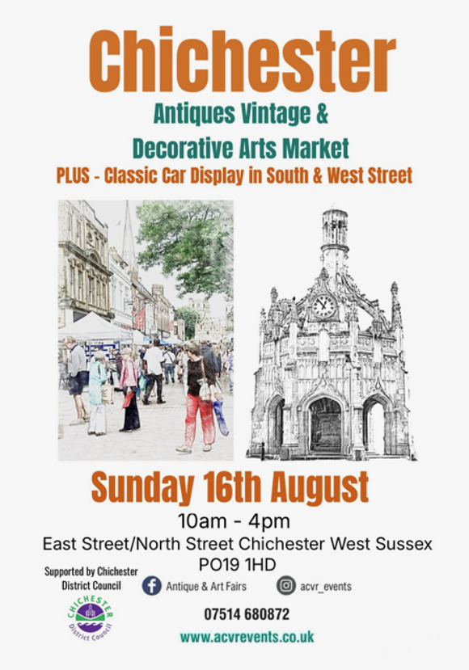
Antiques and Vintage Market
16th August Chichester City Centre
This very popular market makes a welcome return with a huge array of interesting items. Whatever your taste we have something for you, whether for your home, garden, a personal collection or just something you never knew you needed
MORE

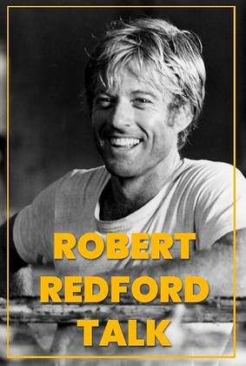 | Robert Redford Talk  17th August - Chichester Cinema  Robert Redford, who died last year, was an extraordinary presence on the big screen for decades, much loved for his acting skills, his choice of films and, lets face it, his looks.  In this talk, Sandy Guthrie, of the Cinema Education Team, will run through Redford's impressive career on screen while also considering the mark he has left on the film industry.  MORE

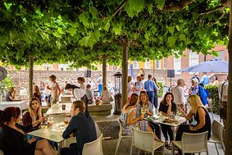
Thursday Late
20th August Pallant House Gallery
We stay open until 8.30pm once a month, inviting you to explore the collection and exhibitions after hours. Pallant Café will be open throughout the evening serving food and drinks, and the Pallant House Gallery Bookshop is stocked with art books, prints and gifts.
In August, alongside a programme of workshops and tours, we'll be joined by art historian and comedian Verity Babbs, back by popular demand for her talk Art Laughs: Art History's Funniest Bits a hilarious and insightful journey through the wildest stories in art history, from feuds and scandals to jaw-dropping masterpieces
MORE


Secrets of a Radical Duke
20th August - Goodwood House
Goodwood House is thrilled to welcome the celebrated classicist and political scientist, Professor Danielle Allen. Danielle will be discussing her new historical biography, The Radical Duke: a thrilling journey, as she seeks to figure out how a large, ceremonial parchment Declaration of Independence ended up in West Sussex.
When Danielle discovered the Declaration of Independence buried in the Chichester archives, little did she know she had stumbled onto a larger story that fundamentally changes our understanding of eighteenth-century British and American history.

MORE

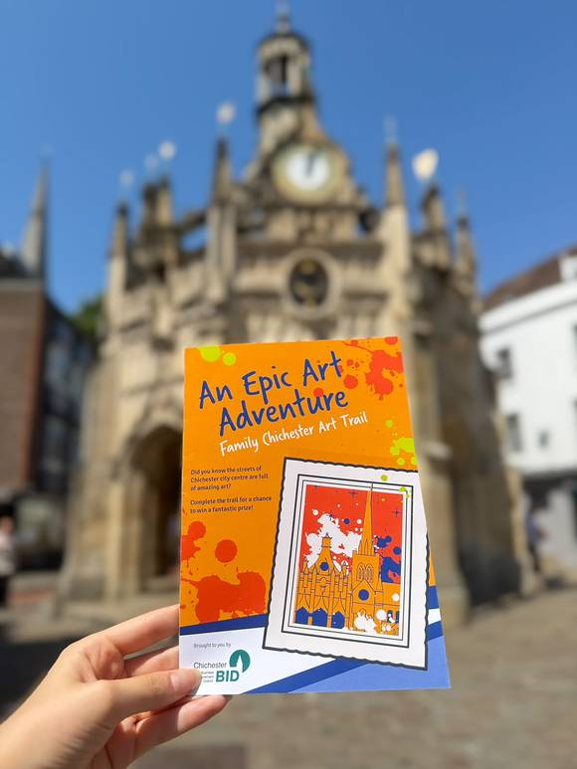
Chichester Family Art Trail
until 1st September - Chichester City Centre
Discover Chichester's vibrant arts and cultural scene with this free Family Art Trail, designed to celebrate a landmark year for the city's cultural organisations. Suitable for all ages, the trail takes families on a colourful journey through the city, visiting venues including Chichester Cathedral, Pallant House Gallery, Oxmarket Contemporary, Graffiti Street and Artisan Gallery.
MORE


Loxwood Joust
15th - 16th August - Loxwood Meadow
Each summer, within the open-world realm of the Kingdom of Loxwood, a great celebration unfolds. The Loxwood Joust. It is a festival of spectacle, story, and participation, where music, laughter, and the clash of steel fill the air. Across three weekends, knights take to the arena, jesters tumble through the crowds, and souls of every kind gather to feast, forge, and revel together beneath the Sussex skies
MORE




Madhurst
1st - 31st August Midhurst
MADhurst is a vibrant community celebration of music, arts and culture in Midhurst, West Sussex, the heart of The South Downs National Park.
Get ready for a vibrant celebration of music, arts and drama as MADhurst returns to Midhurst with a fantastic programme of events and activities. From live performances and exhibitions to workshops and family-friendly fun, theres plenty to look forward to in the months ahead.
MORE




a small and quiet light
21st August -12th September - Minerva Theatre
October 1943. In a small office on the Avenue Foch in Paris, a Gestapo interrogator is questioning a young woman who has been known by many different names: Babuli, Jeanne-Marie, Nora, Madeleine.
As one of the secret agents of Britain's Special Operations Executive and the first female radio operator to be sent undercover into France she has evaded capture far longer than most. But now she has been betrayed. As she faces the fate she has dreaded so long, memories crowd in - a beloved father, a thwarted lover, a gruelling journey to war, and an endless longing for her childhood piano. What has led her here?
a small and quiet light is based on the life of Noor-un-Nisa Inayat Khan (1914-1944), an extraordinarily courageous woman who paid the ultimate price for her heroic fight against fascism.
(See the talk and tour at Tangmere above)
Rehearsal images below
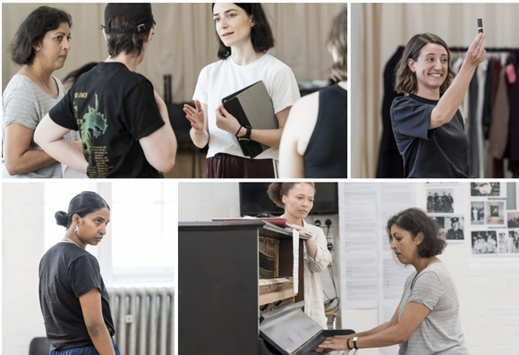




Coldplay Tribute Night for Chestnut Tree House
23rd August - one-0-four, the Hornet, Chichester
Join us for an unforgettable Coldplay Tribute Night in support of Chestnut Tree House. For just £25, you'll enjoy a fantastic night of live music while helping to support the incredible work Chestnut Tree House does for children, young people, and their families. It's the perfect chance to enjoy great songs, great company, and give back to a truly meaningful cause.
Come along, sing your heart out, and help us make a difference. Every ticket sold helps support this amazing charity.
MORE




Granny Square Day 2026
15th August - Resourceful Community Scrapstore, Bognor Regis
Did you know the 15th August each year is designated "Granny Square Day"?
We plan to join thousands of others around the world to celebrate the humble yet versatile Granny Square with a session dedicated to doing just that.
We'll have yarn, patterns and of course tea (or coffee) and biscuits - just bring your crochet hook.
We are happy to help you out if you haven't made a granny square before, but you will need to know how to crochet an English treble, as well as chain stitch and slip stitch. The session will run for two hours - come and stay for the whole thing or just pop in for long enough to make a square.
MORE




Sculpting Day with Alison Pink - Cat
21st August - Pottery Lodge, Chichester
Explore Alison Pinks signature slab-building techniques and learn how to bring character, form, and texture to your creations. With expert guidance and a focus on building from the inside out, youll gain the skills to craft sturdy, expressive pieces, perfect for beginners and improvers alike.
All equipment, tools, and materials are provided, including lunch and hot drinks.
MORE




Perseid Meteor Shower
If, like me ,you had to look this up, you might be interested to learn more about Perseus and why this phenomenon is named after him.
Read the article from the Open University



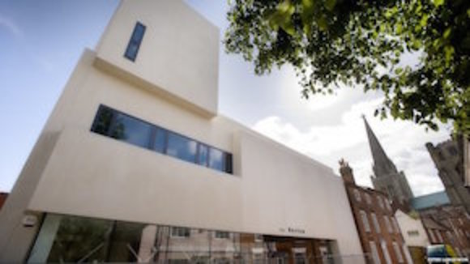
Learning and Community Engagement Office (P/T)
The Novium Museum and Tourist Information Office
Would you like to play an important role in Chichester's award winning The Novium Museum to help us deliver an ambitious programme of learning and community engagement activities?
We are looking for an experienced and self-driven museum or heritage Learning and Community Engagement Officer to join our dedicated and friendly team, based in the centre of Chichester. This position provides an exciting opportunity to support the development and delivery of an ambitious programme of formal and informal learning and engagement activities to all audiences including schools, families, youth, community, students and adult learning groups, both in the museum and the wider community.

Apply by 28/08/2026
MORE INFO AND TO APPLY




WIN Tickets to the Chichester Cathedral Light Show !
If the Perseid meteor shower and solar eclipse on the same day isn't enough, we've got another ray of light to shine into your lives - the spectacular Chichester Cathedral light show!
This year's theme, Illuminating Art, promises to be more magical than ever. Through projection and immersive soundscapes, accompanied by an original score by composer David Harper, the Cathedral's ancient architecture is reimagined in extraordinary ways. Though it might not be opening until October, tickets go fast — and we've got an exclusive opening night pair for you to win . Find out more about the show and early bird booking (just in case!) from link in our bio. Two tickets for the 7.30pm entry on Friday 23 October. Mark your calendars!
Hop over to our Instagram page to enter
Good luck!

Promote Your Event
Add your own event to our calendar - here's how
1. Click the link at the base of the home page "Submit an Event"
2. Create a login account if you don't already have one
3. Complete the form with the details of your event, ensuring that you have added an image and a short description along with the other important information. Please use plain, unformatted text and use the formatting tools in the form.
Kindly note that events will not be made live if they do not include a short text description and image. Images should be .pmg or .jpeg NOT pdf

Newsletters 2026  January week 1  January week 2  January week 3  January week 4  January week 5  February week 1  February week 2  February week 3  February week 4  March week 1  March week 2 | Newsletters 2026  March week 3  March Week 4  April Week 1  April Week 2  April Week 3  April Week 4  Summer of Culture  May Week 1  May Week 2  May Week 3  May Week 4 | Newsletters 2026  June Week 1  June Week 2  June Week 3  June Week 4  July Week 1  July Week 2  Win (Fontwell)  July Week 3  July Week 4  Win (Outdoor Film)  August Week 1  Win (Light Show)



powered by BoxStuff rapportUnsubscribe from this mailing

