
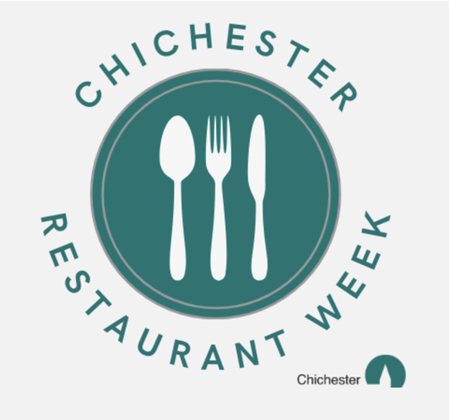
Chichester Restaurant Week returns this month from Monday 12th to Friday 16th and you can enjoy exclusive offers and set-price menus from a range of cafes, tea rooms and restaurants across the city. Read all about it here
We have a busy few weeks ahead as Halloween, Half-Term and Bonfire night all collide. Do be sure to add your events so that we can bring as many opportunities to our subscribers as possible.
It is a period of transition - several major art exhibitions will be changing at the end of the month (see below) and we are now in the final run of A Midsummer Night's Dream and Antigone Exits at the Festival Theatre (see below)
It is also the season finale for horse racing at Goodwood (see below)
A reminder for The Restless Coast at Oxmarket Contemporary this evening (Thursday 8th). At time of writing there are still some tickets available
The transition from summer to autumn is still packed with activities and we bring you a small selection below - from music to food, to history, art and literature.
Much as it seems a bit early to mention the 'C' word some things have to be planned well in advance and the Christmas lights is a case in point. Chichester BID is inviting the public to nominate two inspirational local people to officially switch on the city's Christmas lights on Saturday 21 November 2026. This initiative celebrates people who make a real difference to the local community whether through volunteering, supporting others, going above and beyond in their work or simply being someone whose kindness and contribution deserves recognition. Read how to nominate your local hero here.
Do explore the main website, not only for events but news and articles of interest too. The calendar has hundreds of events listed and here is a quick link for the whole month of October
Vicki
Founder/Editor

Chichester Restaurant Week returns this month from Monday 12th to Friday 16th and you can enjoy exclusive offers and set-price menus from a range of cafes, tea rooms and restaurants across the city. Read all about it here
We have a busy few weeks ahead as Halloween, Half-Term and Bonfire night all collide. Do be sure to add your events so that we can bring as many opportunities to our subscribers as possible.
It is a period of transition - several major art exhibitions will be changing at the end of the month (see below) and we are now in the final run of A Midsummer Night's Dream and Antigone Exits at the Festival Theatre (see below)
It is also the season finale for horse racing at Goodwood (see below)
A reminder for The Restless Coast at Oxmarket Contemporary this evening (Thursday 8th). At time of writing there are still some tickets available
The transition from summer to autumn is still packed with activities and we bring you a small selection below - from music to food, to history, art and literature.
Much as it seems a bit early to mention the 'C' word some things have to be planned well in advance and the Christmas lights is a case in point. Chichester BID is inviting the public to nominate two inspirational local people to officially switch on the city's Christmas lights on Saturday 21 November 2026. This initiative celebrates people who make a real difference to the local community whether through volunteering, supporting others, going above and beyond in their work or simply being someone whose kindness and contribution deserves recognition. Read how to nominate your local hero here.
Do explore the main website, not only for events but news and articles of interest too. The calendar has hundreds of events listed and here is a quick link for the whole month of October
Vicki
Founder/Editor




Music from the Smiling Coast of Africa
9th October - The Nest, Chichester Festival Theatre
Musa Mboob and Xam Xam are from The Gambia, commonly known as the Smiling Coast of Africa, and appear at the Nest performance space at Chichester Festival Theatre on Friday 9 October.
Percussionist and lead vocalist Musa delivers an electrifying fusion of Afro-Manding music and West African rhythms. Blending traditional instruments with modern electric guitars, his sound creates a powerful musical journey across Africa and is renowned for his dynamic stage presence.
MORE...

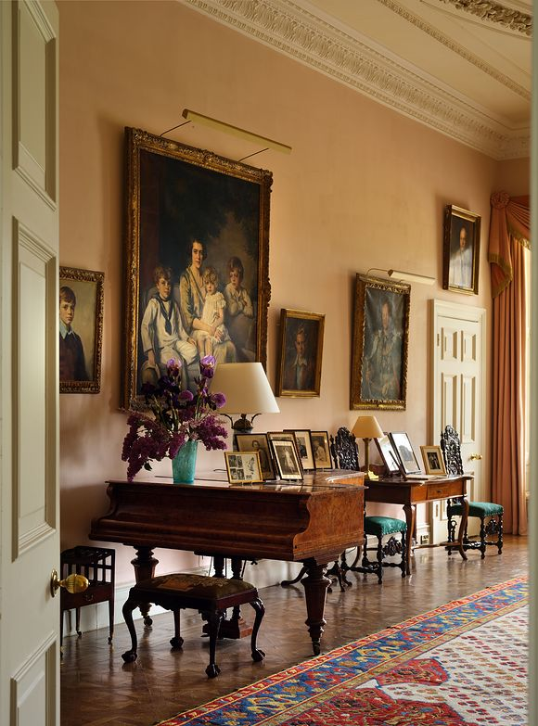
Stansted House: Celebrating the 1920's
10th October - Stansted House
In 1924, Vere Ponsonby, 9th Earl of Bessborough purchased Stansted Park as his family home.
The family regularly entertained guests at Stansted Park in the 1920s, and during this decade, the 9th Earl established the Stansted Theatre, where family and friends performed three times a year to raise money for local charities.
During your visit to Stansted House, you will be welcomed in as if you were a guest of the Bessborough's in the late 1920s. As the sound of the Music Room piano fills the State Rooms, you will see what life was like at Stansted House. Discover more about the famous guests of the Bessborough's as well as the wider Ponsonby family, including Loelia Ponsonby, one of the Bright Young Things of the 1920s and later the Duchess of Westminster, following her marriage in February 1930.
MORE

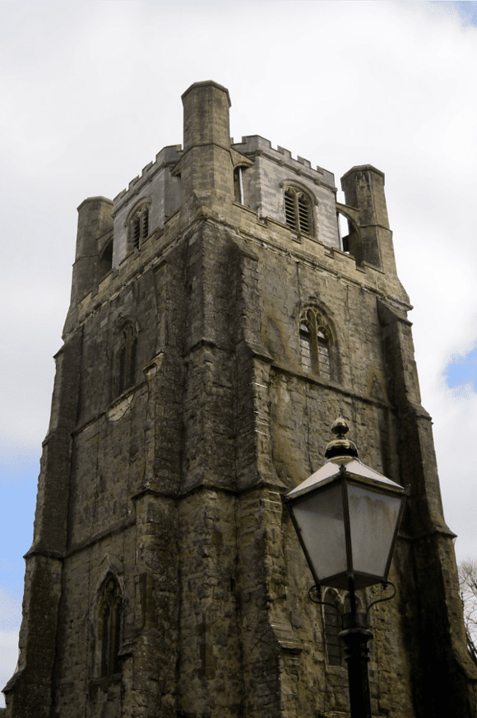
Bell Tower Open Day
10th October - Chichester Cathedral
Chichester Cathedral's Bell Tower, built in the 1400s, has stood as a remarkable testament to the city's rich history and architectural heritage - housing an impressive ring of eight bells, a fixed hour bell, and a historic clock that still marks the passage of time.
Join us for a special Bell Tower Open Day and experience a rare insight into this Grade I listed building. You will be taken through the fascinating history of the tower, from the earliest recorded bell ringing in 1232 to the magnificent 16th-century bells that still chime today.
MORE

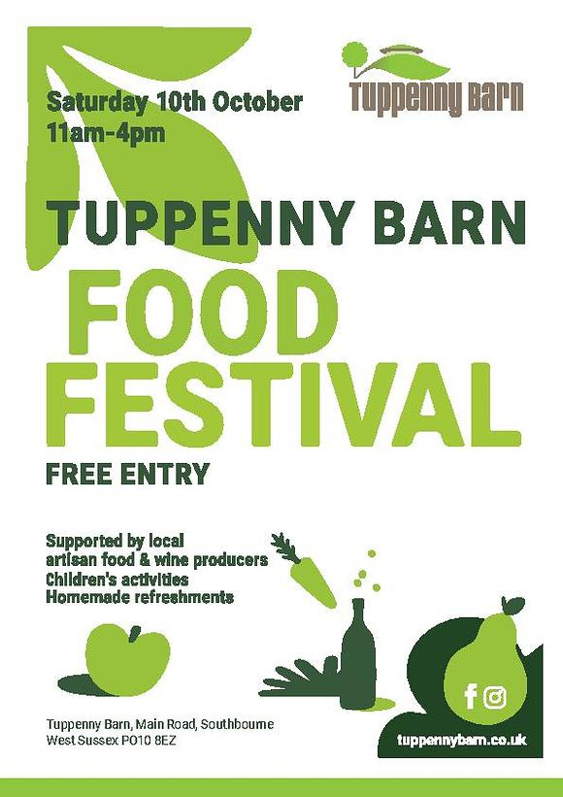
Tuppenny Barn Food Festival
10th October - Tuppenny Barn
Tuppenny Barn Food Festival - Free Entry.
Come and see local food and wine producers, take part in children's activities and sample amazing, homemade, organic refreshments
MORE

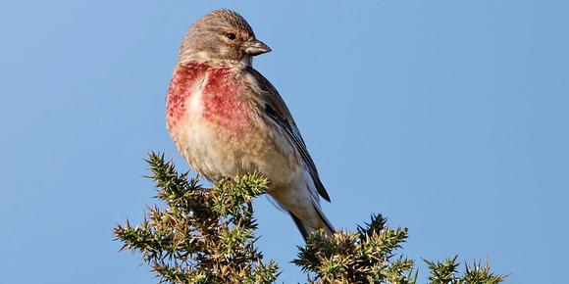
Guided Birdwatching Walk
10th October - RSPB Pagham Harbour
Medmerry Migration Magic
Join enthusiastic and friendly RSPB guides for a birdwatching walk from Earnley Car Park to the Slit Pool and beach through the RSPB's Medmerry Reserve created in 2011. We will be on the lookout for our winter duck and wader visitors as well as migrants still passing through on the way to a warmer climate to over winter. Familiar visitors such as Wigeon, Teal, Snipe, Lapwing and Redshank on the mudbanks. Dartford Warbler, Yellowhammer, Linnet in the gorse. Last year on this walk we were lucky enough to see a Short-eared Owl hunting.
MORE

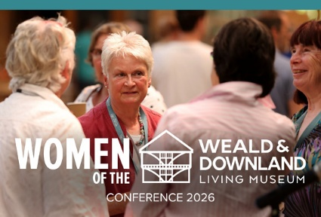
Women of the Weald & Downland Living Museum
10th October - Weald and Downland Living Museum
A conference Celebrating HERstory: Past, Present and Future
Since the Museum opened in 1970, women have played an extraordinary part in its story, building its collections, sharing knowledge and skills, supporting its community and helping to shape the Museum we know today.
Join us for a special one-day conference celebrating their achievements, experiences and lasting impact, and looking ahead to the women who will shape the Museums future.
Through personal stories, reflections and research, well explore HERstories from the past, present and future, with contributions from Dr Anna Clement, Diana Rowsell, Dr Danae Tankard, alongside current staff, volunteers, alumni and Museum visitors.
MORE

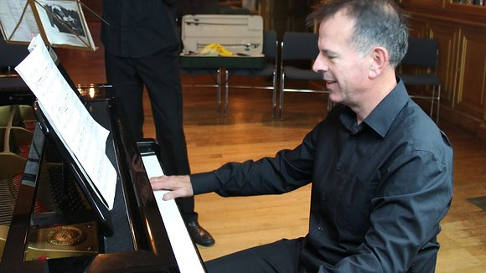
Recital - West Dean Library
10th October -The Old Library, West Dean College
Roy Stratford (Piano), Marina Solaerk (Violin) and Kim Mackrell (Cello).
Titled 'Variations and More' the recital will feature the following pieces:
- Haydn Variations in F minor
- Handel/Halvorsen Passacaglia for Violin and Cello
- Beethoven Piano Trio in Bb op.97 "Archduke"
The recital will be approximately an hour in length.
MORE

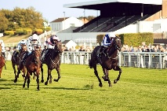
Goodwood Horse Racing - Season Finale
11th October - Goodwood Racecourse
Celebrate Goodwoods final fixture of the season, in a laid back country-style atmosphere
MORE

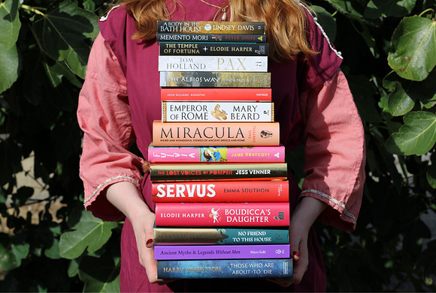
Arts & Literature Festival
9th -11th October - Fishbourne Roman Palace
We are holding our very first Arts and Literature Festival at Fishbourne Roman Palace!
The festival will feature talks and Q&As from award winning authors and historians including Lindsey Davis, Linda Proud-Smith, Andy Burnham, History with Jackson, Dr Jess Venner, Janet Pennington and Kevin Newman.
There will also be several specialist arts and crafts workshops taking place over the 3 days including needle felting, natural inks and eco brushes, and historic writing workshops.
MORE

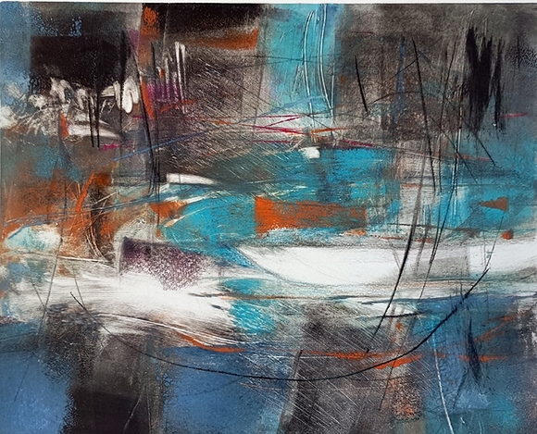
ARTEL Contemporary Art Exhibition 2026
13th - 25th October Oxmarket Contemporary
Thirty years ago, a group of artists from the South Downs came together to share ideas, experiences and inspiration. They called themselves Artel, and the group continues to flourish today. They are delighted to return to Oxmarket Contemporary for their annual exhibition.
This year's exhibition gives each artist the freedom to explore an individual theme, resulting in a lively and varied collection of painting, sculpture, drawing, textiles, printmaking and mixed media.
MORE

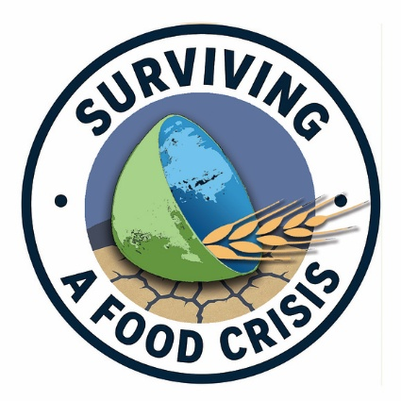
Surviving A Food Crisis
14th October -104 the Hornet, Chichester
Transition Town Chichester and the CANDo groups:
FOOD SECURITY conference: Surviving a Food Crisis.
We have an exciting programme of leading speakers and are inviting a wide range of organisations and individuals involved in food production, distribution, community food initiatives, local government and food partnerships to take part in our workshop sessions.
The conference is designed to bring together people involved in the local food system, as well as those working within the wider food and policy landscape, to consider what needs to change to build greater local food supply, resilience and preparedness and, importantly, to identify practical actions and kick-start a campaign for change.

MORE

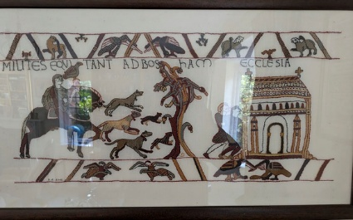
From Bayeux to Domesday
15th October - Friends Meeting House, Chichester
An illustrated talk entitled: From Bayeux to Domesday: Portraits of the Transformation of Sussex by Dr Philip Robinson, former Vice Chancellor of the University of Chichester
Speaking a day before the date of Battle of Hastings and with so much focus on the British Museums coup in bringing the Tapestry itself to London, the talk could not be more timely.
The Historical AssociationMORE



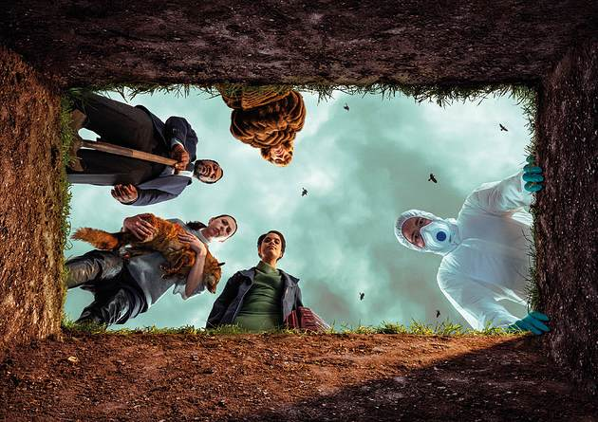
Final Shows of Festival 2026
Chichester Festival Theatre
ends 17th October
ANTIGONE EXITS
Twenty-five centuries after the Antigone of Sophocles, seven performers gather to re-tell the tale of what is buried and what comes of it. Ancient Greece crashes into the contemporary, as Sophocles' classic tragedy shines a scorching light onto our current world.
A MIDSUMMER NIGHT'S DREAM
For our Festival Theatre finale, join us in the exuberant, enchanted world of Shakespeare's A Midsummer Nights Dream, riotously transposed to 1990s Sussex where traditional values are going head to head with the party to end all parties.




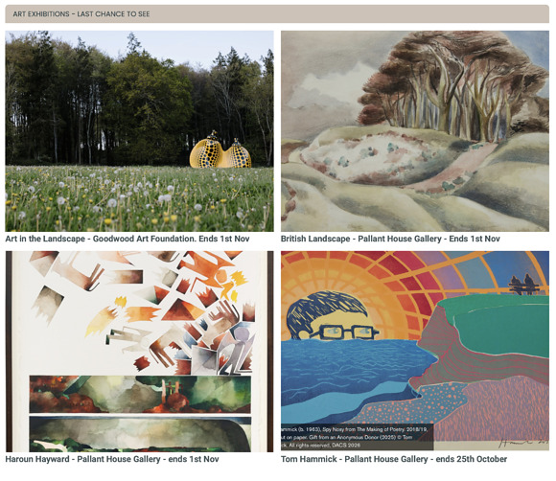
The Last Few Weeks of Various Art Exhibitions
Several major exhibitions are closing in the next few weeks so this is your last chance to see them.
We have brought them all together for you in our Year of Culture section



Local artists are being invited to create new art exploring Chichester Districts past and present as part of an upcoming Culture Spark community art exhibition.
The commissions will be funded and co-ordinated as part of the Culture Spark programme, a Chichester District Council initiative established in 2021 in partnership with Chichester Festival Theatre and Pallant House Gallery.
Individual artists, artistic partnerships, collectives and artists working with community organisations are invited to create artwork inspired by a selection of artefacts from The Novium Museum and Fishbourne Roman Palace. Artists will be able to apply for one of five £750 commissions.
READ THE FULL ARTICLE WITH INFO ON HOW TO PARTICIPATE

Promote Your Event
Add your own event to our calendar - here's how
1. Click the link at the base of the home page "Submit an Event"
2. Create a login account if you don't already have one
3. Complete the form with the details of your event, ensuring that you have added an image and a short description along with the other important information. Please use plain, unformatted text and use the formatting tools in the form.
Kindly note that events will not be made live if they do not include a short text description and image. Images should be .pmg or .jpeg NOT pdf

Newsletters 2026  January week 1  January week 2  January week 3  January week 4  January week 5  February week 1  February week 2  February week 3  February week 4  March week 1  March week 2  March week 3  March Week 4  April Week 1  April Week 2 | Newsletters 2026  April Week 3  April Week 4  Summer of Culture  May Week 1  May Week 2  May Week 3  May Week 4  June Week 1  June Week 2  June Week 3  June Week 4  July Week 1  July Week 2  Win (Fontwell)  July Week 3 | Newsletters 2026  July Week 4  Win (Outdoor Film)  August Week 1  Win (Light Show)  August Week 2  Win (Graylingwell Walk)  August Week 3  August Week 4  September Week 1  September Week 2  September Week 3  September Week 4  October Week 1



powered by BoxStuff rapportUnsubscribe from this mailing

