

Today (1st October) is World Coffee Day. Many cafés are offering special deals on your morning dose of caffeine including Côte Brasserie (see below) and a reminder that at Edge your contribution for your coffee will support the Sussex Snowdrop Trust.
Congratulations to the Children's Bookfest for a great evening with Clare Balding and Kate Mosse when they also announced that Kate Mosse had become President of the charity. (Image beneath)
A reminder that the Chichester Chamber Concerts return with the beginning of their autumn programme this evening (Thursday)
At the weekend there is a wide variety of activities as usual - Chichester City Council are running Chichester in Action - a day of talks, screenings, conversations and activities designed to help residents discover practical ways to protect our environment and respond to climate change. (See below).
Alternatively, for something a bit different you can go tree climbing at Great Ballard, join in the singing with the Leconfield singers or Pause for Peace with the Quakers.
We have open air cinema at Stansted and Oktoberfest comes to Westgate Fields (see below). For a gentle bike ride around the city the traditional community bike ride, Tweed Ride, takes place on Sunday
At the Festival Theatre A Midsummer Night's Dream and Antigone Exits continue to play to standing ovations until the 17th whilst Makebeth provides an introduction to Shakespeare for those aged 5 and over. (see below)
At Pallant House Gallery the current exhibition British Landscapes: A Sense of Place continues alongside Haroun Hayward: Path Through Trees with record attendances. A series of related art history lectures begins on the 7th.
At Chichester Cathedral the library is open to the public once a month. It is a real treasure trove of very rare and valuable works so well worth paying a visit next week (see below)
A further reminder to add your events for half term so that we can help you promote them. (See below for how to do it)
Enjoy the first week of October and see more ideas for the whole month in the calendar
Vicki
Founder/Editor
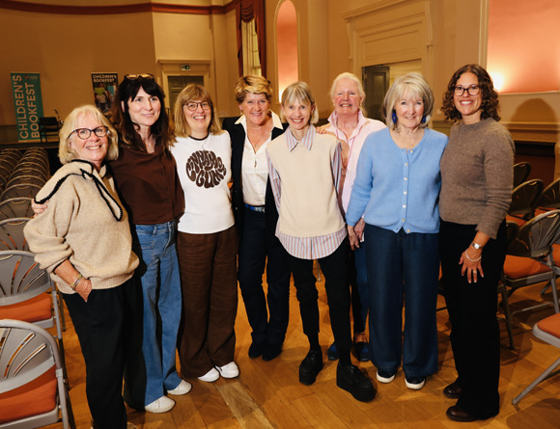

Today (1st October) is World Coffee Day. Many cafés are offering special deals on your morning dose of caffeine including Côte Brasserie (see below) and a reminder that at Edge your contribution for your coffee will support the Sussex Snowdrop Trust.
Congratulations to the Children's Bookfest for a great evening with Clare Balding and Kate Mosse when they also announced that Kate Mosse had become President of the charity. (Image beneath)
A reminder that the Chichester Chamber Concerts return with the beginning of their autumn programme this evening (Thursday)
At the weekend there is a wide variety of activities as usual - Chichester City Council are running Chichester in Action - a day of talks, screenings, conversations and activities designed to help residents discover practical ways to protect our environment and respond to climate change. (See below).
Alternatively, for something a bit different you can go tree climbing at Great Ballard, join in the singing with the Leconfield singers or Pause for Peace with the Quakers.
We have open air cinema at Stansted and Oktoberfest comes to Westgate Fields (see below). For a gentle bike ride around the city the traditional community bike ride, Tweed Ride, takes place on Sunday
At the Festival Theatre A Midsummer Night's Dream and Antigone Exits continue to play to standing ovations until the 17th whilst Makebeth provides an introduction to Shakespeare for those aged 5 and over. (see below)
At Pallant House Gallery the current exhibition British Landscapes: A Sense of Place continues alongside Haroun Hayward: Path Through Trees with record attendances. A series of related art history lectures begins on the 7th.
At Chichester Cathedral the library is open to the public once a month. It is a real treasure trove of very rare and valuable works so well worth paying a visit next week (see below)
A further reminder to add your events for half term so that we can help you promote them. (See below for how to do it)
Enjoy the first week of October and see more ideas for the whole month in the calendar
Vicki
Founder/Editor



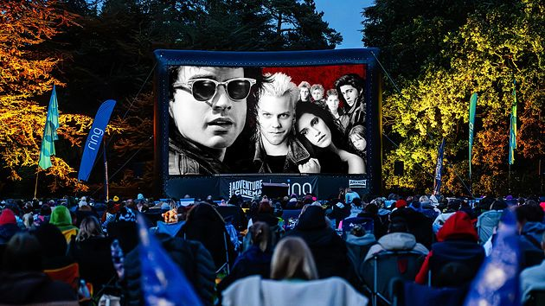

Outdoor Cinema - The Lost Boys

2nd October - Stansted Park
Sleep all day. Party all night. Never grow old. Never die. It's fun to be a vampire.
Watch The Lost Boys on a huge outdoor cinema screen under the stars and dive into the stylish, sun-soaked world of Santa Carla.
Follow brothers Michael and Sam as they move to a seemingly quiet beach town that hides a dangerous secret, its residents include a gang of charismatic, rebellious vampires.
With its iconic 80s soundtrack, dark humour, and cult status style, The Lost Boys is a thrilling vampire classic packed with attitude and atmosphere.
MORE...



Oktoberfest Chichester
2nd - 3rd October - Westgate Fields, Avenue de Chartres, Chichester
The UK's biggest Oktoberfest tour comes to Chichesters Westgate Fields bringing a high-energy Bavarian celebration packed with live oompah bands, traditional music, singalongs and festival entertainment.
Guests can enjoy a Bavarian beer bar, XL steins, gourmet bratwurst and pretzels, alongside a mini trader village, photo booths and themed entertainment including lederhosen dress-up. With VIP table packages available, it promises an unforgettable Oktoberfest-style experience filled with music, food and atmosphere
MORE

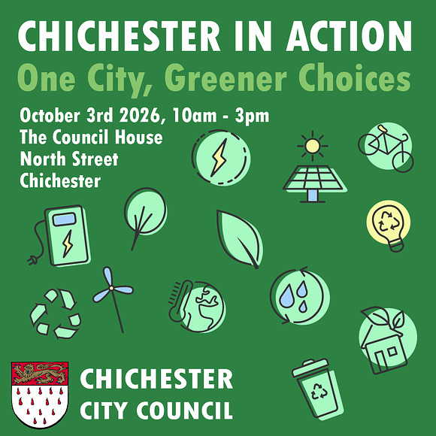

Chichester in Action

3rd October - Council House, North St. Chichester
Want to make greener choices but not sure where to start? Or perhaps you are already making changes and would like to discover what else you can do?
Join Chichester City Council for Chichester in Action: One City, Greener Choices, a day of talks, screenings, conversations and activities designed to help residents discover practical ways to protect our environment and respond to climate change.

MORE



MAKEBETH
4th October - Guildhall, Priory Park
MakeBeth A Joyful, Interactive Retelling of Macbeth for Young Audiences (age 5+)
2 FREE PERFORMANCES at 11am and 2pm
Created by Cardboard Adventures and Shakespeares Globe, in partnership with Chichester Festival Theatre and Leeds Playhouse,
MakeBeth is a playful, interactive theatre show where audiences dont just watch the story - they help create it. Its a craft-along retelling of Shakespeare's Macbeth all brought to life using cardboard, live music, puppetry, and imagination.
MORE

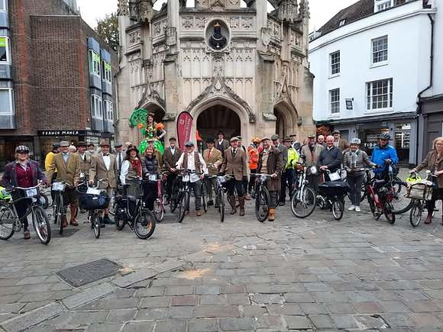

Tweed Ride

4th October - Starts Chichester Market Cross
Chichester's very own annual community bicycle ride
The ride is a leisurely roll around town with a few stops on the way. Come along in your tweeds or 'tweed like/dapper/revival' outfit on any bicycle while enjoying the ride and conversations along the way. The event's costs continue to be covered by the generosity of Mark Simmons, with printing sponsored by CDC.
Arrive from 10am Chichester Cross... sign in, collect your ride number, etc. We aim to leave by 11am.
MORE

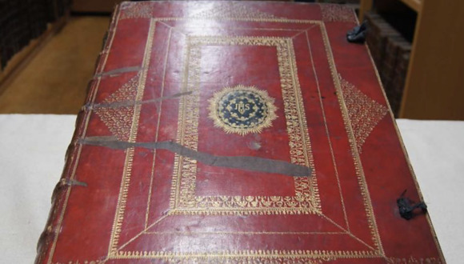

Cathedral Library Open Morning
6th October (first Tuesday of the month) - Chichester Cathedral
There has been a library in the cathedral since medieval times in various locations, but it was moved to its current position and refurbished in 1969 and contains about 10,000 items. The Library suffered much damage during the Reformation and the Civil War, so almost all the books we have today have been acquired since then, some dating back to pre-Reformation times. We have acquired both individual books and whole collections from private libraries and the books cover a range of subjects, not just Bibles, prayer books and works of theology, but books on cookery, art, horticulture, poetry, philosophy and music, to name just a few. We have a number of very rare and valuable works and are still making new additions, a recent example being a book of prints by Marc Chagall. The Library also has some intriguing stained glass windows and unusually well-preserved stone corbels
MORE

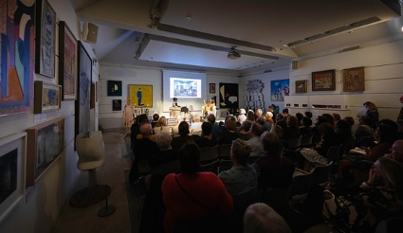

Art History Course
7th October - Pallant House Gallery
Framing the Landscape in 20th Century British Art
Join Pallant House Gallery for a three-part series of engaging art history lectures exploring the British landscape through key movements in 20th century British art. From the revival of printmaking between the wars to the shifting visual languages of Surrealism and abstraction, each session offers fresh perspectives on artists working in a rapidly changing world. Each session includes two illustrated lectures with time for questions, plus a break for refreshments.
MORE

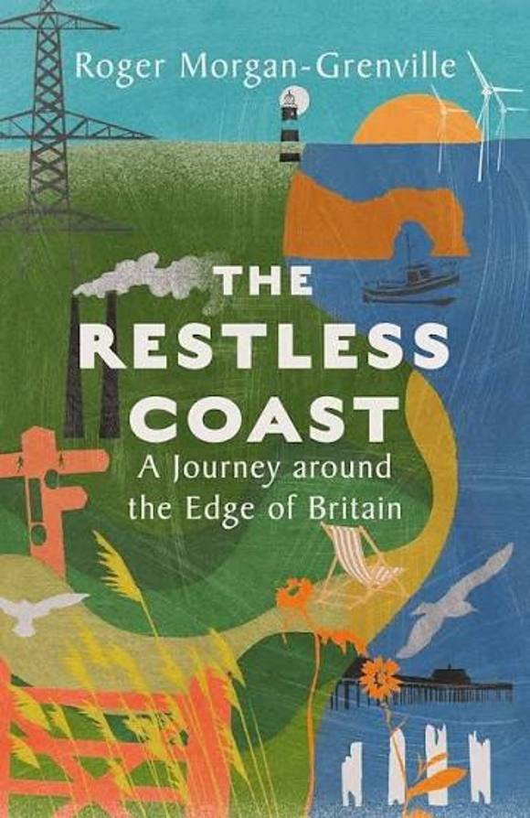

'The Restless Coast'

8th October - Oxmarket Contemporary
An Evening with Roger Morgan-Grenville
The island of Britain has over 10,000 miles of coastline, steeped in history and constantly shifting, changing, adapting and providing.
The Restless Coast is a moving and beautiful account of a journey around it, during which the author sets out to discover its challenges and opportunities, and to talk to its people. Roger Morgan-Grenville addresses the modern challenges that the shoreline faces, and highlights the people who are trying to protect it.
MORE

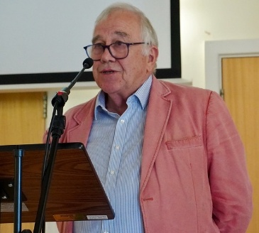

A Furtive Imagination; the funny side of crime
7th October - Boxgrove Village Hall
Simon Brett, our Patron and well known author of crime fiction featuring Charles Paris, Fethering and Mrs Pargeter, will entertain us with his humorous approach to the writing of crime fiction. His work features eccentric characters and intricate plots, offering an entertaining blend of traditional crime fiction with wit and social commentary.
Chichester Literary Society
MORE

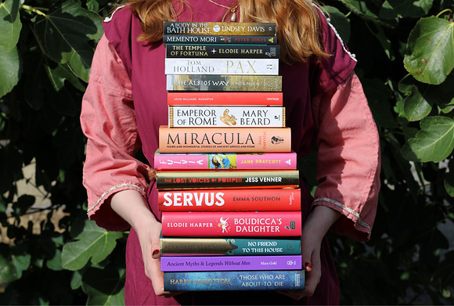

Arts & Literature Festival

9th -11th October - Fishbourne Roman Palace
We are holding our very first Arts and Literature Festival at Fishbourne Roman Palace!
The festival will feature talks and Q&As from award winning authors and historians including Lindsey Davis, Linda Proud-Smith, Andy Burnham, History with Jackson, Dr Jess Venner, Janet Pennington and Kevin Newman.
There will also be several specialist arts and crafts workshops taking place over the 3 days including needle felting, natural inks and eco brushes, and historic writing workshops.
MORE





10:10

10th October - CYE Chidham
Come and fundraise with us on 10th October. Were raising money for our bursary fund supporting payment for up to 40% of the cost of our events to those who need it.
Youre invited to join in with our fundraising day challenge yourself and change lives as you do!
Which adventure will you choose this October?
Fun Run
Cardboard Boat Race
Raft Race
MORE



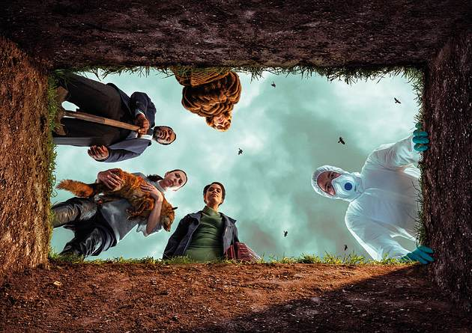

Antigone Exits

until 17th October - Chichester Festival Theatre (Minerva)
Antigone's brother has died in a bloody civil war. The king her uncle has forbidden anyone to bury the body. Antigone is going to bury the body anyway.
Twenty-five centuries after Antigone, seven performers gather to re-tell the tale of what is buried and what comes of it. Ancient Greece crashes into the contemporary, as Sophocles' classic tragedy shines a scorching light onto our current world.
Antigone may be centuries old, but the story remains just as powerful, thousands of years since it was first performed. Nina Segal's bold new adaptation shines a spotlight on the captivating tragedy and draws striking parallels with our current world.
Antigone Exits is now open in the Minerva Theatre for a strictly limited run

MORE
Below: Melody Chikakane Brown in Antigone Exits
photo-Andy-Paradise
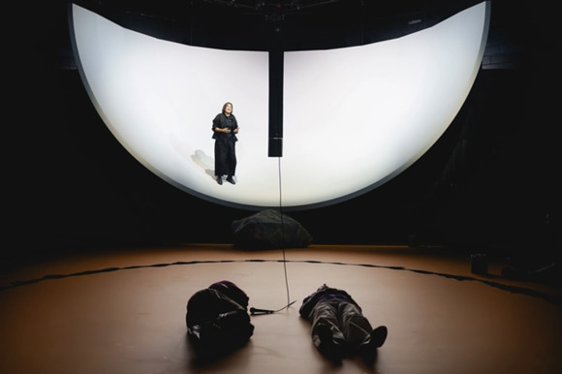



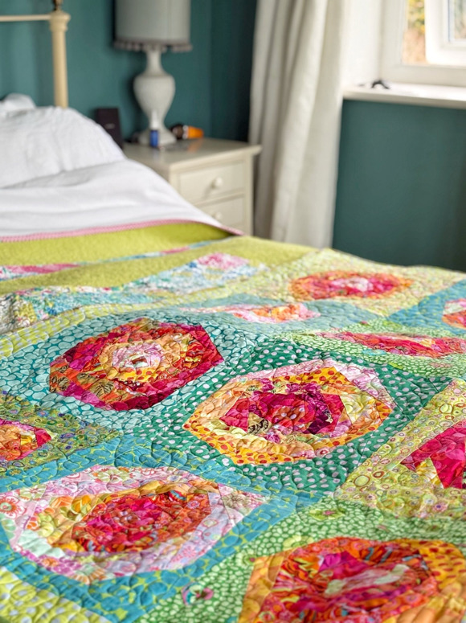

Scrappy Blooms

starts 6th October - Sidlesham
6 Part Monthly Quilting Course with Mel Lewis
Let's use those smaller scrap fabric pieces to make abstract flowers. Learn a very organic way of sewing where we are lead by the shapes of our scraps. We'll organise our scraps into colours and construct beautiful rosettes. By the end of the 6 sessions you should have a quilt top full of blooms. It's a great project for boosting knowledge and experience on colour blocking, and a fun way to use up your scraps!
MORE INFO



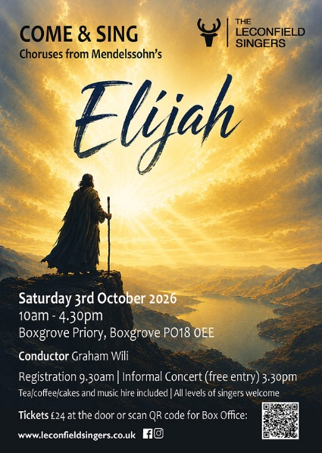

Come and Sing Elijah with The Leconfield Singers

3rd October Boxgrove Priory
Come and join us for a wonderful day of singing under the guidance of Graham Wili.
There will be coffee and cakes and the opportunity to learn or refresh the some of the choruses from Elijah by Mendelssohn
MORE



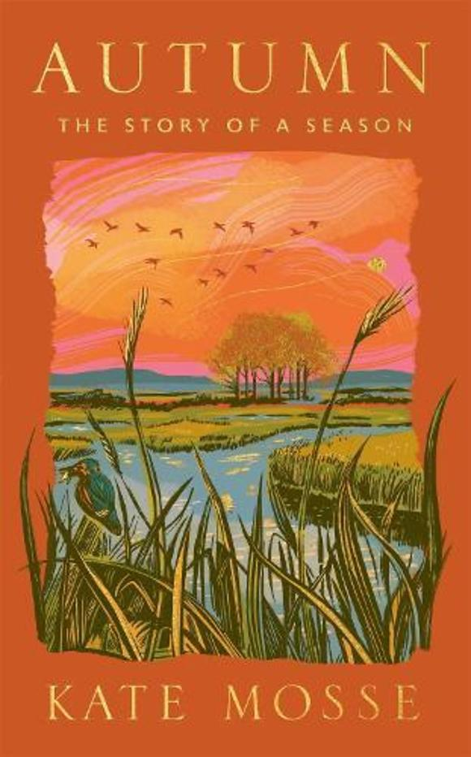
WIN A SIGNED COPY OF 'AUTUMN' BY KATE MOSSE
As we move from our hugely successful summer giveaways what more appropriate way to move into autumn than to win Kate Mosse's new book 'Autumn'?
Recently launched at the Assembly Room in Chichester this is a real 'love-letter to Sussex'
ENTRY IS VIA OUR INSTAGRAM POST





Cote Brasserie - Free Coffee
1st - 2nd October
Good coffee deserves a day of its own. So, to celebrate World Coffee Day, we're treating you to one on us.
From Thursday 1 October to Friday 2 October, just open or download the Côte app and your free coffee offer will be waiting for you.
Fancy making it a proper French coffee break? Add a freshly baked croissant for just £3.*

Promote Your Event
Add your own event to our calendar - here's how
1. Click the link at the base of the home page "Submit an Event"
2. Create a login account if you don't already have one
3. Complete the form with the details of your event, ensuring that you have added an image and a short description along with the other important information. Please use plain, unformatted text and use the formatting tools in the form.
Kindly note that events will not be made live if they do not include a short text description and image. Images should be .pmg or .jpeg NOT pdf

Newsletters 2026  January week 1  January week 2  January week 3  January week 4  January week 5  February week 1  February week 2  February week 3  February week 4  March week 1  March week 2  March week 3  March Week 4  April Week 1  April Week 2 | Newsletters 2026  April Week 3  April Week 4  Summer of Culture  May Week 1  May Week 2  May Week 3  May Week 4  June Week 1  June Week 2  June Week 3  June Week 4  July Week 1  July Week 2  Win (Fontwell) | Newsletters 2026  July Week 3  July Week 4  Win (Outdoor Film)  August Week 1  Win (Light Show)  August Week 2  Win (Graylingwell Walk)  August Week 3  August Week 4  September Week 1  September Week 2  September Week 3  September Week 4



powered by BoxStuff rapportUnsubscribe from this mailing

