
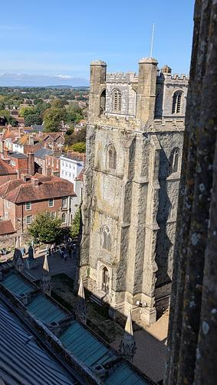 | 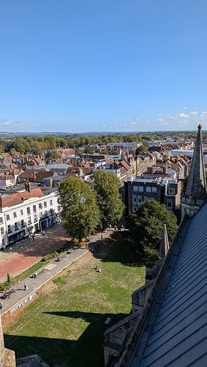

The bird's eye views above were taken by the lucky winner of our Spire Tour giveaway. We are so grateful to all our partners who have helped us create some special visits and performances for our subscribers. This week we are delighted to be able to give you the opportunity to win Kate Mosse's new book Autumn - and what an appropriate time of year to do that.
Kate Mosse will be back in the Assembly room in person next week in conversation with broadcaster Clare Balding - the event is in aid of Children's Bookfest who do such wonderful work introducing our younger residents to the world of books (see below)
Final reminders for a couple of events this evening (Thursday)
Music for a Late Summer's Evening at Stansted House
Talks At Six: Mayor or Lord Mayor, that is the question
At the Festival Theatre A Midsummer Night's Dream has opened to enthusiastic audiences and Antigone Exits opens on Saturday.. Throughout October the theatre is celebrating Black History Month (see below)
Our Year of Culture Section celebrates Shakespeare in different forms - the play, the film, the talk and a lovely introduction to those 5 + with Makebeth.
At Pallant House Gallery the current exhibition British Landscapes: A Sense of Place continues alongside Haroun Hayward: Path Through Trees with record attendances. At Petworth House it is the last chance to see the Expressions in Blue exhibition which closes on the 27th September.
It is worth noting that this week, by chance rather than design, we have more events outside the city centre than in it, which reinforces the fact that the whole area is alive with a range of events and activities - many of them free to attend.
We end with a couple of requests:
First:
NEWSPAPERS DESPERATELY NEEDED for patient bedding at Brent Lodge Wildlife Hospital
If you have newspapers ready to donate please drop them at Brent Lodge Wildlife Hospital Cow Lane Sidlesham PO20 7LN.
Please no stapled or glossy magazines or office paper.
Second:
Half term will soon be upon us - make sure you add any events that you have planned so that we can help you promote them. (See below for how to do it)
Until next week.
Vicki
Founder/Editor
The bird's eye views above were taken by the lucky winner of our Spire Tour giveaway. We are so grateful to all our partners who have helped us create some special visits and performances for our subscribers. This week we are delighted to be able to give you the opportunity to win Kate Mosse's new book Autumn - and what an appropriate time of year to do that.
Kate Mosse will be back in the Assembly room in person next week in conversation with broadcaster Clare Balding - the event is in aid of Children's Bookfest who do such wonderful work introducing our younger residents to the world of books (see below)
Final reminders for a couple of events this evening (Thursday)
Music for a Late Summer's Evening at Stansted House
Talks At Six: Mayor or Lord Mayor, that is the question
At the Festival Theatre A Midsummer Night's Dream has opened to enthusiastic audiences and Antigone Exits opens on Saturday.. Throughout October the theatre is celebrating Black History Month (see below)
Our Year of Culture Section celebrates Shakespeare in different forms - the play, the film, the talk and a lovely introduction to those 5 + with Makebeth.
At Pallant House Gallery the current exhibition British Landscapes: A Sense of Place continues alongside Haroun Hayward: Path Through Trees with record attendances. At Petworth House it is the last chance to see the Expressions in Blue exhibition which closes on the 27th September.
It is worth noting that this week, by chance rather than design, we have more events outside the city centre than in it, which reinforces the fact that the whole area is alive with a range of events and activities - many of them free to attend.
We end with a couple of requests:
First:
NEWSPAPERS DESPERATELY NEEDED for patient bedding at Brent Lodge Wildlife Hospital
If you have newspapers ready to donate please drop them at Brent Lodge Wildlife Hospital Cow Lane Sidlesham PO20 7LN.
Please no stapled or glossy magazines or office paper.
Second:
Half term will soon be upon us - make sure you add any events that you have planned so that we can help you promote them. (See below for how to do it)
Until next week.
Vicki
Founder/Editor





Emsworth's 10th Beer, Wine & Cider Festival

25th - 27th September - Emsworth
Join us for an incredible weekend featuring around 30 delicious cask-conditioned ales from near and far—including fascinating local brews and national award winners—plus excellent ciders and wines by the glass. Best of all? We dont stock anything youll find locally in Emsworth; we source our ales from as far afield as Scotlands Northern Isles!
MORE...

 | 

Wanderlust  29th September - 11th October  Oxmarket Contemporary  Oxmarket are delighted to welcome back Martyn Jones with his exhibition - Wanderlust in the Wilson Gallery. Martyn Jones is a contemporary painter based in Cardiff, Wales. He studied for an MA in Fine Art at Chelsea School of Art, London, and was awarded a Junior Fellowship at Bath Academy of Art, where his tutors included the influential British artists Patrick Heron and Adrian Heath.  MORE | Little White Lines  29th September - 11th October  Oxmarket Contemporary  Sinclair Webster will join us at Oxmarket in our John Rank Gallery for his exhibition Little White Lines. Sinclair grew up in Khartoum, Nairobi and Flanders, where he first began painting. He has exhibited widely, with solo exhibitions in Nairobi, Ypres and Roeselare in Belgium, Cambridge and Edinburgh  MORE

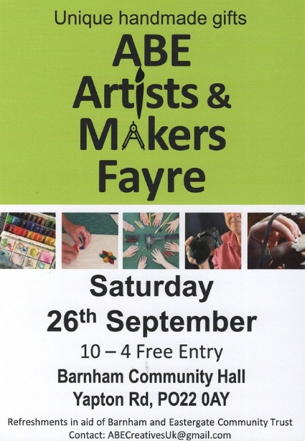

ABE Artists and Makers Fayre
26th September - Barnham
A fantastic opportunity to see 18 fabulous artists under one roof. Anything from jewellery to ceramics to wood to metal to glass. Come and see what's right on your doorstep.
Have a chat with the artists and find out about what they do and where. Some even run workshops where you can learn a new skill or refresh an old one!
MORE



Bognor Regis Puppet Party

26th - 27th September Bognor Regis
Fun-packed and free, Bognor Regis Puppet Party returns on September 26th and 27th 2026.
A whole host of puppet shows, and street entertainers will take over the seafront, sponsored by Bognor Regis Town Council.
Based around the Royal Norfolk Hotel, this free event will star Mr Punch and his world-famous sausage stealing antics in some of the funniest Punch and Judy shows in the country, presented by members of The Punch and Judy Club and in association with Bognor Regis Heritage Partnership.
MORE

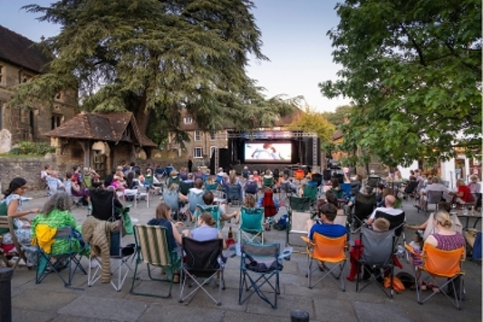

Midhurst Music and Movies on the Square
26th September - Midhurst
This year's Midhurst Music and Movies on the Square returns with a full afternoon of free live music, family fun and open air cinema in the heart of Midhurst. The event begins at midday with Latin inspired performances from talented local musicians and bands. Then comes the first of two big-screen outdoor movies (bring your own chair or rug!). At 2pm Pixar's 'Coco' follows a 12-year-old Mexican boy's journey to overturn a ban on music.
Then after more music, at 7pm there's the hit musical 'La La Land' which tells the story of a romance between a jazz pianist and an aspiring actress as they pursue their dreams in Los Angeles.
MORE

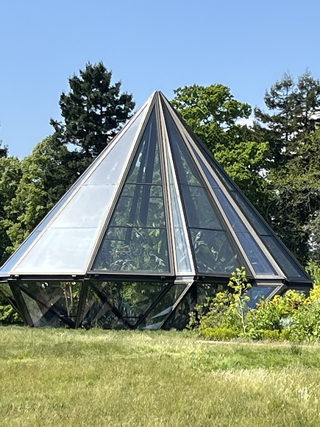

Woolbeding Gardens near Midhurst

24th and 25th September -Woolbeding Gardens
Woolbeding Gardens is a magical National Trust property west of Midhurst which opens on Thursdays and Fridays in summer only and these are the last visits.
MORE



BREAKDOWN - 8 STUDIO PLAYS
25th - 26th September - Bosham
8 NEW Studio plays on a theme of BREAKDOWN from the Funtington Players. Feisty witches to cosmic glitches and everything in between. Not to be missed. £5. Wine and soft drinks bar - cash only. Note:Occasional swearing.
Limited numbers as small venue.
MORE



Chichester Later Life Living Festival
26th September - New Park Community Centre, Chichester
Join us for a FREE, welcoming event designed to help you live well, plan confidently and enjoy later life to the full.
Meet Jess Brown-Fuller MP, explore 28 expert exhibitors and discover support, advice and inspiration for later life.
Free to attend! Refreshments kindly provided by Wellington Grange
MORE

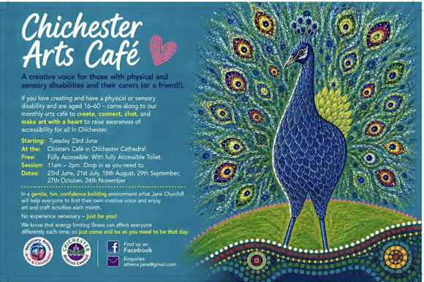

Chichester Arts Cafe

29th September - Cloisters Cafe, Chichester Cathedral
This is a welcoming, inclusive and fully accessible space specially for adults with physical and sensory disabilities to come together to be creative, meet new people and build connections. The monthly get-together is organised by Voluntary Action Arun & Chichester (VAAC) and led by local artist Jane Churchill. The free sessions are designed to provide a relaxed and supportive environment where creativity comes first.
Participants have the opportunity to explore painting, drawing, crafting, writing and other creative activities, regardless of previous experience or artistic ability
MORE



Guitar Concert - Ian Watt
26th September - Regis School of Music, Bognor Regis
Described by Classical Guitar Magazine as a guitarist of outstanding skill and originality, Ian Watt has appeared throughout Europe, the Americas and East Asia. Having first come to international attention with 2nd prize at the highly prestigious Parkening International Guitar Competition (USA) in 2009, where he was hailed by Soundboard magazine as an 18-year-old phenom, he subsequently took 1st prize (along with the audience and junior jury prizes) at the 2011 Heinsberg International Guitar Competition, where he attracted the attention and respect of many of Europes leading guitar soloists.
MORE

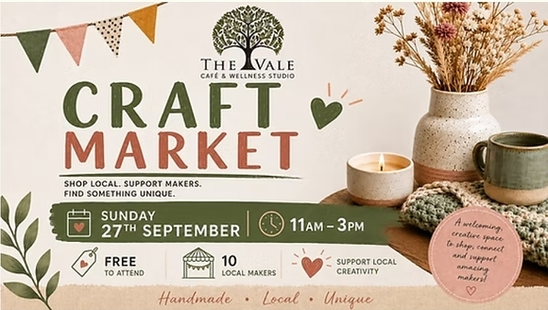

Local Makers Craft Event

27th September - The Vale, West Stoke
Visit us at The Vale Café and Wellness Studio for a special day of shopping and supporting local craft makers.
Coffee, homemade cakes and our fabulous lunch menu also available.
R.S.V.P recommended
MORE



Chaos String Quartet - Chichester Chamber Concerts

1st October - Assembly Room, Chichester
Founded in Vienna in 2019, the quartet embrace chaos as creation itself, the starting point of everything. This idea shapes their music-making, where refined ensemble playing meets fiery energy and adventurous spirit. Their performances are crafted with heart and humour , designed to move, surprise, and ignite the imagination. Their programmes span from Gesualdo over Haydn to Miles Davis, combining classical repertoire with contemporary works, inventive arrangements and improvisation.
SCHUBERT: String Quartet in E flat minor, D87
WEBERN: String Quartet, Op. 28
KORNGOLD: String Quartet no. 2 in E flat major, Op. 26
MORE



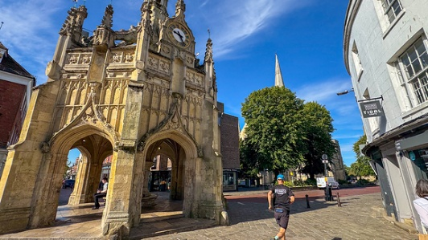

Runners take on Chichester Half Marathon in support of Chichester Cathedral

4th October Chichester
A group of dedicated runners are raising funds for Chichester Cathedral at this year's Chichester Half Marathon 2026, organised by UK Running Events.
The popular event is expected to attract more than 1,500 runners and will take in some of Chichester's most iconic landmarks, including the Cathedral itself, which is also one of the event's official charity beneficiaries.
Team Cathedral are amateur runners who have been training specifically for this event, generously volunteering their time to raise funds and awareness. Every donation made through Team Cathedral supports the Cathedral's care of its historic building, music, education and community work, helping to ensure it remains a place of worship, welcome and wonder for future generations.
READ FULL ARTICLE WITH DONATION LINK

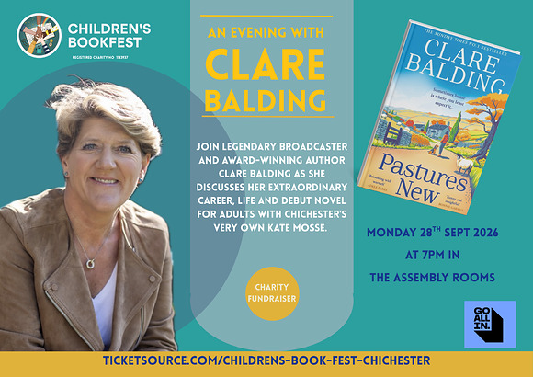

An Evening with Clare Balding | CBF Fundraiser
28th September - Assembly Room, Chichester
Join legendary broadcaster and award-winning author Clare Balding, along with bestselling author and Cicestrian, Kate Mosse, for an evening discussing Clare's extraordinary life and career as her debut novel Pastures New is published in paperback. This is a National Year of Reading event and all proceeds go to support the work of Children's BookFest.
From the courts of Wimbledon to Buckingham Palace to the Traitors Castle, Clare is known to millions on screen for her warmth and humour. Now she brings the same wit and insight to her fiction. Pastures New is a funny and heartwarming novel that captures Clares deep affection for the countryside and the people she meets, which listeners of her BBC Radio 4 series Ramblings are bound to enjoy. A lifelong lover of animals, she also seeks to shine a light on the role they play in our lives through her writing and other projects, which will see her adding an entrepreneurial string to her bow this year.
MORE



Quiz Night | Children's BookFest Fundraiser

25th September - Assembly Room, Chichester
Calling all quizzers! Test your general knowledge at Children's BookFest's first fundraising Quiz Night, with prizes!
Friday 25th September, Doors Open 6:30pm for 7pm start
Bring your own nibbles, there will be a bar for drinks on the night.
Teams of up to six people, £36 per table.
MORE



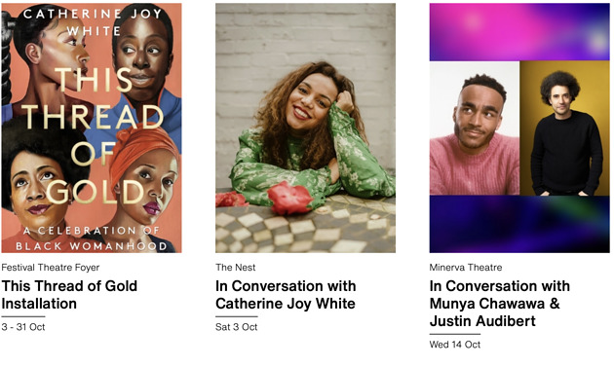

Black History Month

October - Chichester Festival Theatre
October is Black History Month, and to celebrate we are holding events throughout the month to recognise and highlight the contributions of Black artists within the world of theatre. Join us for an inspiring installation and insightful conversations with renowned Black creatives. Discover the events here.



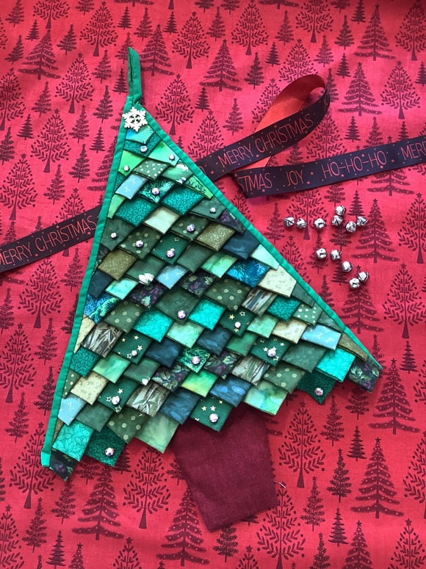

Scrapbusting Fabric Christmas Tree Workshop

30th September - Sidlesham
Join us in September to make this beautiful scrap-busting Christmas Tree wall hanging decoration. Use up your fabric scraps and stash to create the textured surface of the tree, with Lesley guiding you through the construction and finishing of this fun fabric decoration.
The finished tree measures approximately 40cm tall when finished.
MORE INFO





Tree Climbing at Great Ballard

3rd - 4th October Great Ballard, Eartham
Take adventure to new heights with Social Tree Climbers at Great Ballard! Children aged 6+ and adults can climb into the treetops using professional ropes, harnesses and helmets, with expert instructors there to guide them.
No experience is needed - just bring your sense of adventure!
£25 per person
MORE



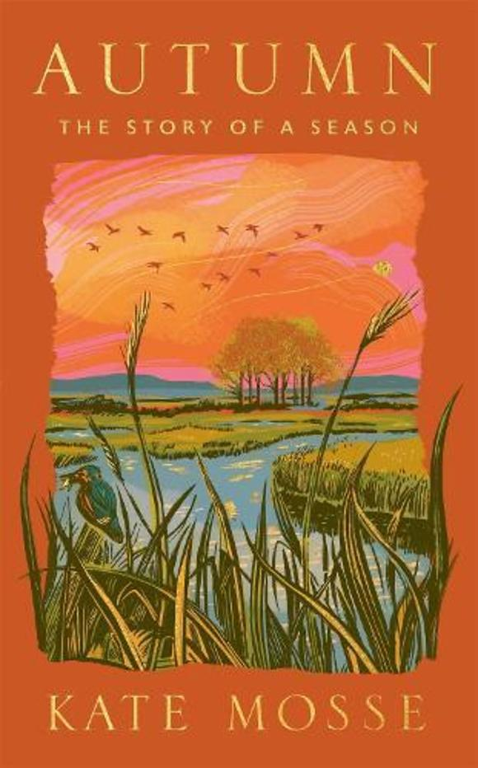
WIN A SIGNED COPY OF 'AUTUMN' BY KATE MOSSE
As we move from our hugely successful summer giveaways what more appropriate way to move into autumn than to win Kate Mosse's new book 'Autumn'?
Recently launched at the Assembly Room in Chichester this is a real 'love-letter to Sussex'
ENTRY IS VIA OUR INSTAGRAM POST



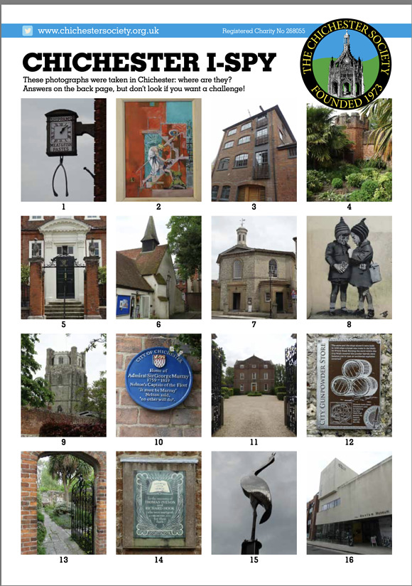

Heritage - I-Spy
For the last week of Heritage month we bring you a quiz from the Chichester Society. See how many locations you can identify from your walks this month.
You can download the full quiz together with a map showing where to find them below

[PDF] I-Spy-Qu​iz.pdf



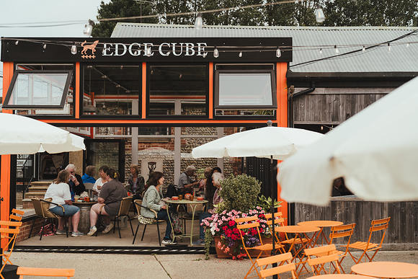

EDGE Tea and Coffee - Free Coffee Day
1st October - Edgcumbe Tea and Coffee, Ford
This International Coffee Day, EDGE Tea & Coffee are proud to announce a special collaboration with The Sussex Snowdrop Trust, a community organisation dedicated to supporting families with children battling serious illness, by giving away free 8oz coffees all day.
Founded to help families with children with cancer and other serious sicknesses, The Sussex Snowdrop Trust has become widely recognised for creating safe, supportive spaces, and assisting families financially and medically. Their work has gained national attention, including recognition and support from the BBC's Tommy Boyd and comedian Hugh Dennis, who are both patrons of the trust.
Known for its award-winning coffee and tea, strong customer service, and deep local roots, EDGE Tea & Coffee are hosting a free coffee day and asking for donations to the trust while helping raise awareness for the important work The Sussex Snowdrop Trust continues to do for families and communities across the UK.

Promote Your Event
Add your own event to our calendar - here's how
1. Click the link at the base of the home page "Submit an Event"
2. Create a login account if you don't already have one
3. Complete the form with the details of your event, ensuring that you have added an image and a short description along with the other important information. Please use plain, unformatted text and use the formatting tools in the form.
Kindly note that events will not be made live if they do not include a short text description and image. Images should be .pmg or .jpeg NOT pdf

Newsletters 2026  January week 1  January week 2  January week 3  January week 4  January week 5  February week 1  February week 2  February week 3  February week 4  March week 1  March week 2  March week 3  March Week 4  April Week 1 | Newsletters 2026  April Week 2  April Week 3  April Week 4  Summer of Culture  May Week 1  May Week 2  May Week 3  May Week 4  June Week 1  June Week 2  June Week 3  June Week 4  July Week 1  July Week 2 | Newsletters 2026  Win (Fontwell)  July Week 3  July Week 4  Win (Outdoor Film)  August Week 1  Win (Light Show)  August Week 2  Win (Graylingwell Walk)  August Week 3  August Week 4  September Week 1  September Week 2  September Week 3



powered by BoxStuff rapportUnsubscribe from this mailing

