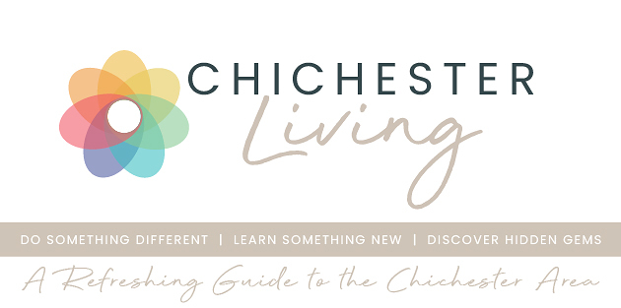
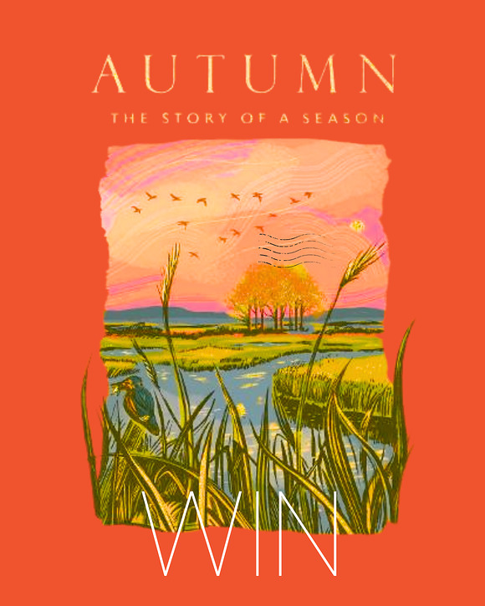
An Autumn Giveaway
Win a signed copy of 'Autumn' by Kate Mosse
How appropriate for an autumn giveaway - a signed copy of 'Autumn' by internationally renowned author and passionate Cicestrian, Kate Mosse.
Described as a 'love-letter to Sussex' it is part of a series commissioned from 4 celebrated authors which is dedicated to the seasons of the year
Read more about Autumn here
ENTER VIA OUR INSTAGRAM PAGE

Good luck!
