
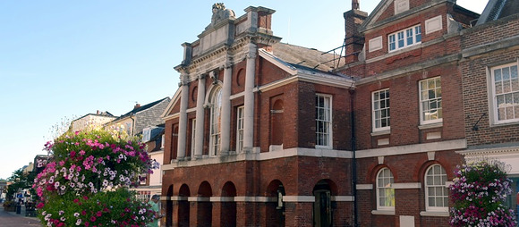
I have to start with an apology - normally our technology behaves itself very well but this week it had a hissy fit and decided that you needed to receive last week's newsletter several times. I can only apologise for the inconvenience and say that the issue has been put right and you should only get this newsletter once.
We enter into Heritage Week this weekend with public buildings open to the public all over the country. The Council House in Chichester( pictured above) is a case in point, being open to the public on Sunday 13th.
We feature some of the special heritage events this week but do remember that there are very many more in the calendar of the website.
At the Festival Theatre the summer Festival reaches its finale with A Midsummer Night's Dream and I'm delighted to give you the opportunity to win a couple of tickets (see below). The draw will take place tomorrow (Friday).
Chichester City Council has launched a survey to gather your thoughts on the importance of History and Heritage. Read more here.
Chichester District Council has issued a release about the review of Local Government Reorganisation and you can read it here.
On a very serious note - today 10th September is marked as World Suicide Prevention Day and the Samaritans have requested that we include an item which you can read below.
Although we are moving out of the summer into autumn there is still a plethora of activities - in fact you will probably have difficulty choosing.
Follow this link to see the calendar of events for the month of September
I hope you enjoy reading these newsletters but I understand that one iteration is enough. :)
Enjoy immersing yourselves in our local heritage.
Vicki
Founder/Editor

I have to start with an apology - normally our technology behaves itself very well but this week it had a hissy fit and decided that you needed to receive last week's newsletter several times. I can only apologise for the inconvenience and say that the issue has been put right and you should only get this newsletter once.
We enter into Heritage Week this weekend with public buildings open to the public all over the country. The Council House in Chichester( pictured above) is a case in point, being open to the public on Sunday 13th.
We feature some of the special heritage events this week but do remember that there are very many more in the calendar of the website.
At the Festival Theatre the summer Festival reaches its finale with A Midsummer Night's Dream and I'm delighted to give you the opportunity to win a couple of tickets (see below). The draw will take place tomorrow (Friday).
Chichester City Council has launched a survey to gather your thoughts on the importance of History and Heritage. Read more here.
Chichester District Council has issued a release about the review of Local Government Reorganisation and you can read it here.
On a very serious note - today 10th September is marked as World Suicide Prevention Day and the Samaritans have requested that we include an item which you can read below.
Although we are moving out of the summer into autumn there is still a plethora of activities - in fact you will probably have difficulty choosing.
Follow this link to see the calendar of events for the month of September
I hope you enjoy reading these newsletters but I understand that one iteration is enough. :)
Enjoy immersing yourselves in our local heritage.
Vicki
Founder/Editor





Tangmere Fair

12th September - Tangmere Village Green
We hope you enjoyed last year's event as much as we did! This year we're back with a classic car show, live music & entertainment, childrens fairground rides, over 50 stalls, free face painting and loads more surprises!
MORE...

 | 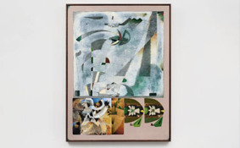

Landscape Walk  12th September - West Dean Gardens  Join Mark Roberts and Haroun Hayward for a circular walk around part of the West Dean Estate to include the Arboretum.  Haroun Hayward's show at Pallant House has come out of the West Dean Residency Programme. Haroun spent 3-weeks at West Dean last summer. Over this period, he spent time working in the Fine Art studios, studied the gardens, and toured the wider Estate  MORE | Haroun Hayward: Path Through Trees  until 1st November - Pallant House Gallery  This exhibition will mark Haroun Hayward's first solo institutional show. Hayward will present a new body of work, created in dialogue with artworks in Pallant House Gallerys collection.  Hayward will create a new series of paintings inspired by the surrounding Sussex landscape, including the atmospheric arboretum at West Dean, where he recently completed a joint residency between West Dean College and the Gallery.  MORE

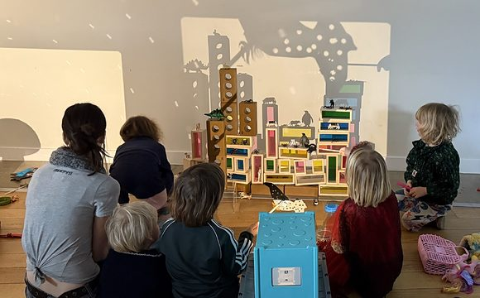

Cine-Mini Workshops
12th September - Chichester Cinema at New Park
A magical first cinema experience especially created for children under five.
Part of Chichester Cinema's A Greener Screen, join Saskia van Roomen of Small World Cinema for a playful introduction to cinema, featuring a collection of short films inspired by the natural world.
Watch trees change shape, travellers become birds and a dogs tail take on a life of its own, before exploring colour, movement, light and shadow through creative sensory play inspired by the films. The films will then be screened again, giving young audiences the chance to spot new details and connections.
MORE

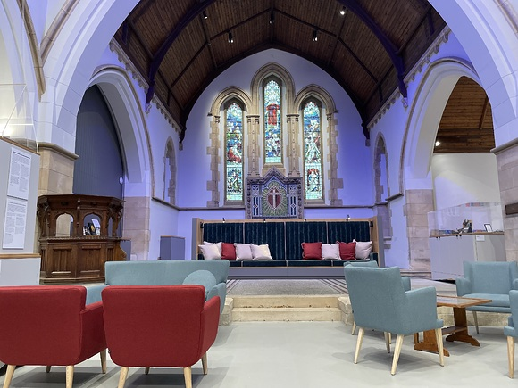

Barone Hopper Film Screening & Chapel Heritage Talk

13th September (other dates available) - Graylingwell
Join us for a special screening of the Barone Hopper film, offering a unique glimpse into the local story it captures. After the film, stay for an engaging tour and talk exploring the rich history of Graylingwell Chapel and its surrounding area.
Local historians will be sharing newly uncovered insights and stories, shining a light on the people and events that shaped this remarkable site. Whether you're a history enthusiast, a film lover, or simply curious about the past, this event offers a rare opportunity to see and learn something new.
MORE

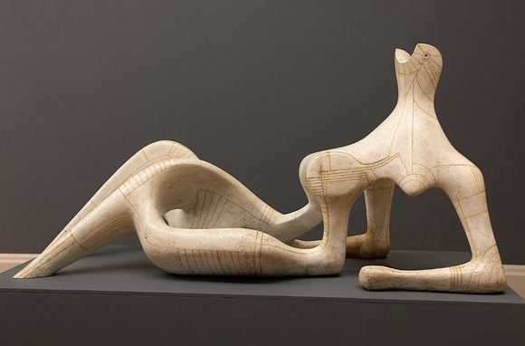

From Jacob Epstein to the Geometry of Fear

16th September - Assembly Room, Chichester
Anna Moszynska traces the exciting trajectory of sculpture in Britain during the first half of the 20th century. Across a diversity of practices - from controversial commissions for architectural embellishments (Jacob Epstein), the embrace of direct carving (Henry Moore and Barbara Hepworth) to the construction of form through welded metal (the Geometry of Fear group, including Reg Butler and Lyn Chadwick) - sculptors of this period played a pioneering role in putting modern, British sculpture firmly on the map (Arts Society Chichester Evening)
MORE

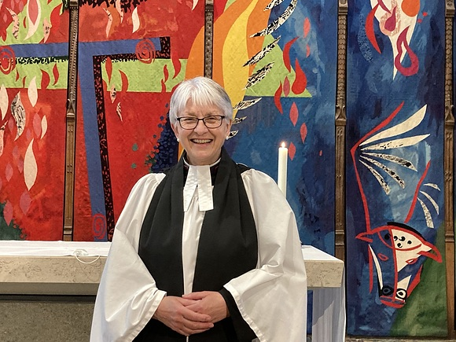

John Piper at Chichester Cathedral

14th September - West Sussex Record Office
In 1966, Chichester Cathedral unveiled one of Britain's most daring post-war art commissions - a vivid tapestry behind its High Altar by celebrated artist and printmaker John Piper (19031992). Join The Reverend Vanessa Baron for a fascinating talk, hosted by West Sussex Record Office, to include: background to the commission to create the tapestry in the Cathedral, with reference to the correspondence held at the Record Office; an overview of Piper's longstanding interest in churches, looking at his photography and stained-glass work; a look at the other influences on the design of the tapestry, most especially his willingness to work with new materials and his collaborative work with other people.

MORE

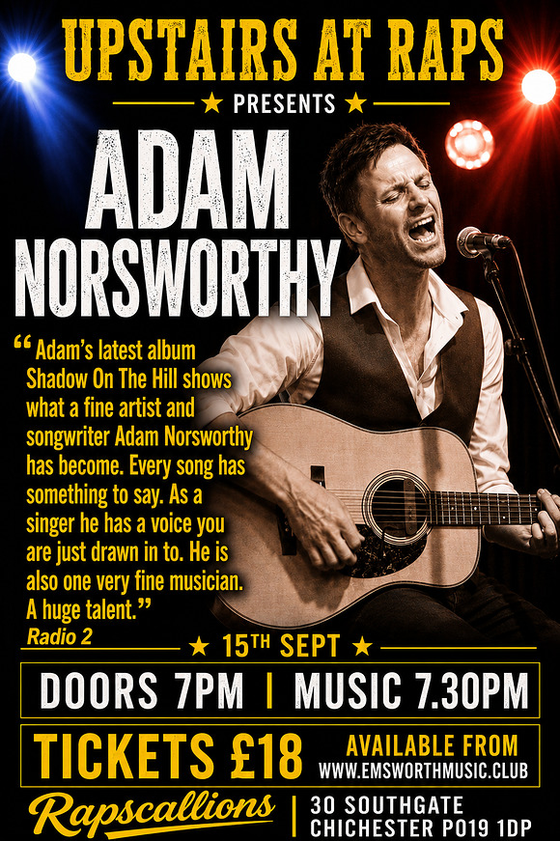

Upstairs @ Raps with Adam Norsworthy
15th September - Rapscallions, Southgate, Chichester
Best known as the guitarist and founder member of British blues/rock headliners THE MILK MEN. Adam has been hailed by many as one of the country's finest and most-respected singer-songwriters and musicians. He is one of the most familiar and widely-respected musicians on the UK's live circuit.

MORE



Heritage Open Days

11th - 13th September - Fishbourne Roman Palace
We are celebrating Heritage Open Days 2026 - England's biggest heritage festival of history and culture - by opening our doors for free for 3 days in September!
For the 11th, 12th and 13th September 2026 Fishbourne Roman Palace, the largest known Roman residential palace north of the Alps is entirely free to visit.
Built around AD 75, it features remarkably preserved mosaics, archaeological remains, reconstructed Roman gardens, and an on-site museum.
MORE



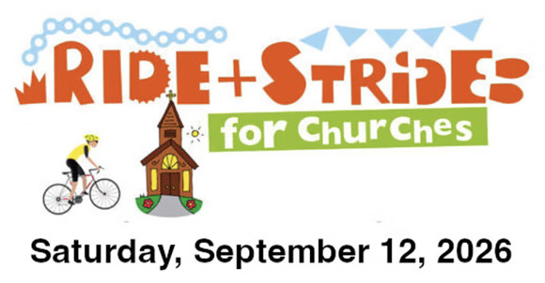

Ride & Stride for Sussex Historic Churches

12th September All across Sussex
Ride + Stride is an annual fun-raising event for historic churches of all denominations giving everyone the chance to explore some of Sussex's unique historic buildings while also raising vital funds. The event is open to all - you don't need to be a churchgoer or affiliated with any particular place of worship. across the country. Register to join the fun and plan a route that fits your time and capabilities. See the link for more details.
MORE

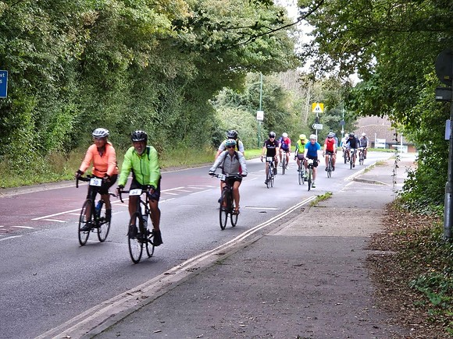

Sage House Sportive 2026
13th September - starts Tangmere
The popular charity cycle event is back on Sunday 13th September, starting once again from Sage House in Tangmere. Organised by The Rotary Club of Bognor Hotham in support of local dementia charity Sage House, the Sportive offers a friendly, welcoming ride for cyclists of all abilities.
Featuring two scenic routes across the beautiful South Downs and West Sussex countryside, a 50-mile challenge for experienced riders, or a shorter 25-mile route.
Both pedal bikes and e-bikes are welcome, making it a great day out for a wide range of ages and abilities
MORE





A Midsummer Night's Dream

18th September - 17th October

Chichester Festival Theatre
Lord, what fools these mortals be!
For our Festival Theatre finale, join us in the exuberant, enchanted world of Shakespeare's A Midsummer Night's Dream, riotously transposed to 1990's Sussex where traditional values are going head to head with the party to end all parties.
It's 1994 in Chichester, and Tory MP Theseus is riding high after shutting down free raves across the county, aided by local Chief Constable Egeus. Four spirited but unhappy young lovers rebel against their stuffy elders rules and take off to the South Downs.
Over the fields, bohemian aristo-landowners Oberon and Titania are organising an illicit rave with naughty fixer Puck when they arent arguing over the affections of The Changeling, a DJ party boy.
Meanwhile, the local Young Conservatives are busy rehearsing a play for Theseus forthcoming wedding, with the slightly over-enthusiastic support of new Club member, Bottom.
As night falls, psychedelic potions lead to startling transformations in the heady haze of freedom and desire. In the South Downs, magic is real. Anything can happen.
Artistic Director Justin Audibert follows his acclaimed Hamlet and hugely popular Festival Theatre production of Redlands, co-directing with Hannah Joss (Choir), in a production which celebrates Shakespeares language while spinning the world of Elizabethan players into full-colour living memory.
Comedian and satirist Munya Chawawa plays Bottom.
MORE





Elmer and Friends: The Colourful World of David McKee

ends 13th September - Novium Museum
Celebrate and explore David McKee's iconic stories through original artworks in this multi-sensory, interactive exhibition, created by Seven Stories - the National Centre for Children's Books.
MORE

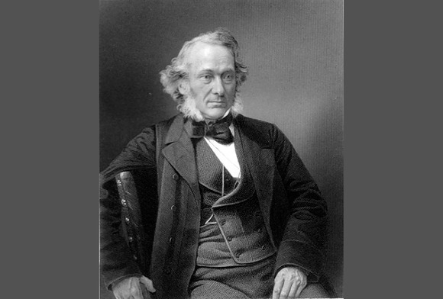

Richard Cobden: Sussex Free Trade Campaigner

ends 13th September - Weald and Downland Living Museum
This exhibition looks at the life of the radical politician, manufacturer and campaigner for free trade, born locally near Heyshott.
He was most renowned for establishing the Anti-Corn Law League which achieved its goal in 1846, therefore this year we celebrate the 180th anniversary of the abolition of these massively unpopular tariffs. Something which echoes with our current global state of affairs.

MORE





Goodwood Education Trust celebrates Golden Jubilee with a golden gathering
Formed in 1976 by the 10th Duke of Richmond, the charity connects children with food, farming and nature, particularly those who are more vulnerable or underserved.
Attendees were welcomed by His Grace, who reflected on his father's legacy, how the Trust has stayed true to founding principles while adapting to the needs of children today, and concluded his father would be very proud of how the charity has grown and evolved. Dr Nicholas Taylor, Headteacher at Chichester High School, spoke about how students take part in Forest School each week, improving confidence, engagement and attendance, and highlighting how much he enjoys hearing about their activities at the Trust. Matthew Baker, Trustee and Partner at NFU Mutual, considered the importance of farming education and hands-on learning, and encouraged funders and businesses to see how their support could make such a difference to children.
READ THE WHOLE ARTICLE


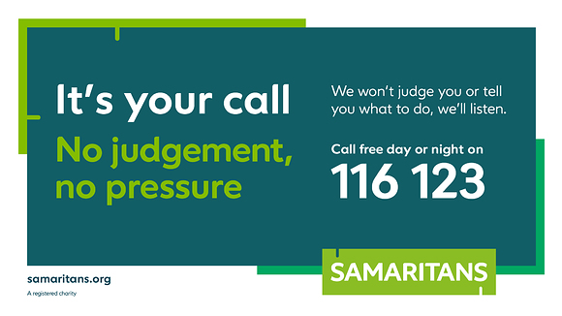

World Suicide Prevention Day - 10th September
1 in 4 of us will experience suicidal thoughts in our lifetime, but these thoughts can be interrupted. That's why Samaritans is marking World Suicide Prevention Day, September 10, with a campaign to encourage the public to interrupt someone if they're concerned, because it could save a life.
MORE INFORMATION



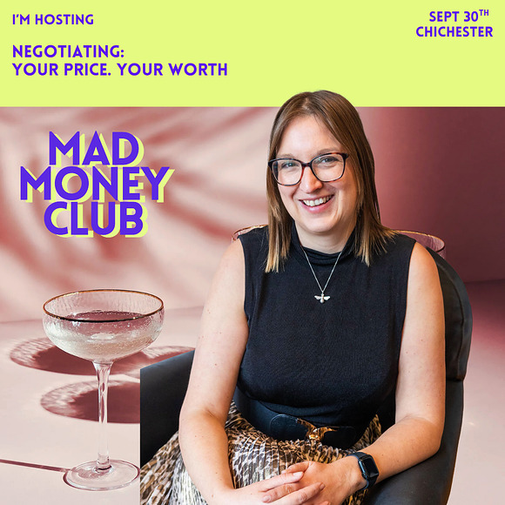

Mad Money Club - Negotiating: Your Price

30th September - Piccolino, South Street, Chichester
Negotiating isn't just about numbers - it's about value, confidence, and the story you tell yourself about what you're worth. For many of us, asking for more stirs a mix of emotions: fear, pride, doubt, ambition - all tangled up with identity and self-belief. The focus on these dinners, is for women to come together and talk about money.
Mad Money Club is a supper club for women who want to talk about money more openly, over great food, and wonderful company. The name is a playful nod to being a little bold "mad" in English" and enjoying good food ("mad" means food in Danish - where this idea began). Each dinner focuses on a different theme, from negotiating, to investing, to money in divorce - framed with one big question to spark conversation. This specific dinner event, focuses on negotiation.
MORE



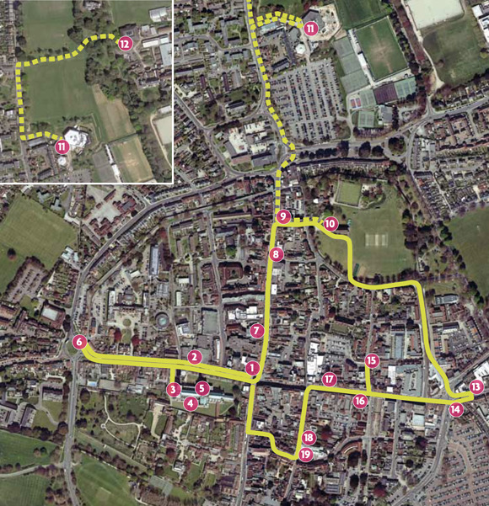

Heritage Walk

Chichester Personalities
Over the centuries many talented people have either lived in Chichester or had close connections with the city. Some of them are still household names, while others have become more obscure. You will find here writers, artists, philanthropists, and holy men. Hopefully you will be inspired to read further about these diverse but talented personalities
Download the walk below

[PDF] Notable ​Chichest​er Peopl​e.pdf





WIN 2 TICKETS: A Midsummer Night's Dream,
19th September - Chichester Festival Theatre
Our last give away for our Summer of Culture is appropriately the Finale of the Festival at our wonderful theatre.
This is Shakespeare, not only in the modern era, but in a setting that is very familiar to us.
Draw closes Friday 11th so you need to move quickly
Hop over to our Instagram page to enter
Good luck!

Promote Your Event
Add your own event to our calendar - here's how
1. Click the link at the base of the home page "Submit an Event"
2. Create a login account if you don't already have one
3. Complete the form with the details of your event, ensuring that you have added an image and a short description along with the other important information. Please use plain, unformatted text and use the formatting tools in the form.
Kindly note that events will not be made live if they do not include a short text description and image. Images should be .pmg or .jpeg NOT pdf

Newsletters 2026  January week 1  January week 2  January week 3  January week 4  January week 5  February week 1  February week 2  February week 3  February week 4  March week 1  March week 2  March week 3  March Week 4 | Newsletters 2026  April Week 1  April Week 2  April Week 3  April Week 4  Summer of Culture  May Week 1  May Week 2  May Week 3  May Week 4  June Week 1  June Week 2  June Week 3  June Week 4  July Week 1 | Newsletters 2026  July Week 2  Win (Fontwell)  July Week 3  July Week 4  Win (Outdoor Film)  August Week 1  Win (Light Show)  August Week 2  Win (Graylingwell Walk)  August Week 3  August Week 4  September Week 1



powered by BoxStuff rapportUnsubscribe from this mailing

