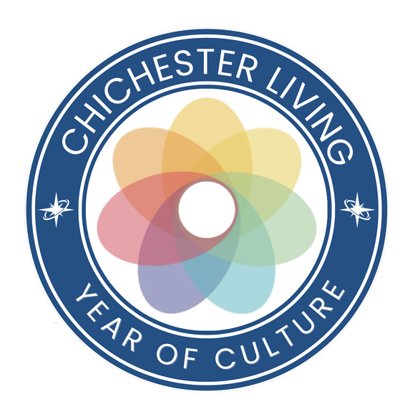
And so...A Summer of Culture becomes a Year of Culture.
As we all know there is so much cultural activity in the area all year round that it deserves its own space on the website. Every month we will have a particular focus.
September is Heritage month and many upcoming events in our calendar will reflect that with walks, talks, exhibitions and several properties open to the public. We will bring a selection of them together in the Year of Culture section.
Events to celebrate the 800 years of the Chichester City Council are underway and our walks for the month of September will feature the heritage walks from the Chichester Society.
We welcome some very well known names this week - Clare Balding supporting the Children's Bookfest charity, Kate Mosse talking to broadcaster Katie Derham about the launch of her new book in which Sussex plays an important role and Alex Polizzi as guest speaker at the Chichester Chamber Event.
In addition Chichester Festival Theatre announces an extraordinarily varied programme over the winter. There is racing at Fontwell and Goodwood, open air theatre and guided tours at Stansted, free entry to Fishbourne Roman palace and a Community Day at Graylingwell with a fabulous range of activities to celebrate their 15 years. Music, wellbeing and craft lessons complete the week.
Just another week in our lovely area.....
We sent you a separate mailing about our very first Chichester Living event. Thank you for the great response - the tour of Street Art and Sculpture sold out in less than 24 hours! If you are interested, do still register your interest, as we will run a waiting list in case of any last minute cancellations and, if there is sufficient interest, we will run it again on another date. So click on the image underneath this text for more info.
We have given away hundreds of pounds worth of visits and tours thanks to our wonderful partners and we also featured this week's giveaway in a separate mailing. For the ultimate Birds Eye view of the city where better than from high up on the cathedral roof? You still have time to enter the competition to win two tickets. (see below)
Please note that the events listed in the mailings are just an introduction to the event to which they link. The photo, the title and the word 'more' all link to the underlying event in the calendar with date, time, location, map and booking links.
Follow this link to see the calendar of events for the month of September
Enjoy....
Vicki
Founder/Editor
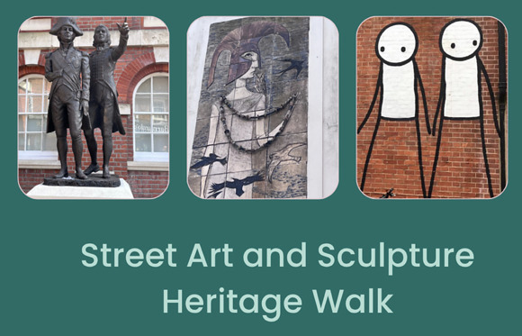
And so...A Summer of Culture becomes a Year of Culture.
As we all know there is so much cultural activity in the area all year round that it deserves its own space on the website. Every month we will have a particular focus.
September is Heritage month and many upcoming events in our calendar will reflect that with walks, talks, exhibitions and several properties open to the public. We will bring a selection of them together in the Year of Culture section.
Events to celebrate the 800 years of the Chichester City Council are underway and our walks for the month of September will feature the heritage walks from the Chichester Society.
We welcome some very well known names this week - Clare Balding supporting the Children's Bookfest charity, Kate Mosse talking to broadcaster Katie Derham about the launch of her new book in which Sussex plays an important role and Alex Polizzi as guest speaker at the Chichester Chamber Event.
In addition Chichester Festival Theatre announces an extraordinarily varied programme over the winter. There is racing at Fontwell and Goodwood, open air theatre and guided tours at Stansted, free entry to Fishbourne Roman palace and a Community Day at Graylingwell with a fabulous range of activities to celebrate their 15 years. Music, wellbeing and craft lessons complete the week.
Just another week in our lovely area.....
We sent you a separate mailing about our very first Chichester Living event. Thank you for the great response - the tour of Street Art and Sculpture sold out in less than 24 hours! If you are interested, do still register your interest, as we will run a waiting list in case of any last minute cancellations and, if there is sufficient interest, we will run it again on another date. So click on the image underneath this text for more info.
We have given away hundreds of pounds worth of visits and tours thanks to our wonderful partners and we also featured this week's giveaway in a separate mailing. For the ultimate Birds Eye view of the city where better than from high up on the cathedral roof? You still have time to enter the competition to win two tickets. (see below)
Please note that the events listed in the mailings are just an introduction to the event to which they link. The photo, the title and the word 'more' all link to the underlying event in the calendar with date, time, location, map and booking links.
Follow this link to see the calendar of events for the month of September
Enjoy....
Vicki
Founder/Editor



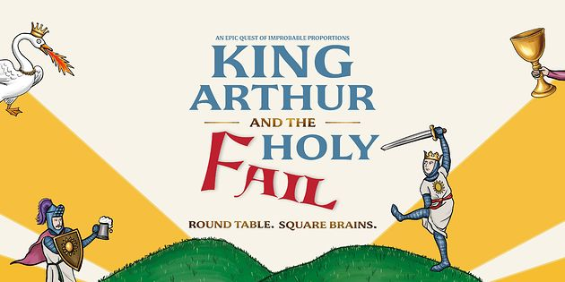
Outdoor Theatre: King Arthur and the Holy Fail
4th September - Stansted Park
The Three Inch Fools present an epic tale of Arthurian adventure and medieval mayhem.
In a land of daring quests, dashing knights, and endless jousting, there lived a would-be hero - waiting in the wings - who went by the name of Arthur. But when Camelot is rocked to its core by a tragic - and frankly improbable - incident involving a large table of an undisclosed shape, Arthur is thrust into the quest of a lifetime
MORE...


Comedy at the Nest
4th September - The Nest at Chichester Festival Theatre
Join us for Comedy at The Nest this September!
Multi-award-winning comedian Jeff Innocent has reached legendary status among his peers and audiences alike by staying at the top of his game for almost three decades. His unique appeal lies in the contrast between his East End 'geezer appearance and demeanour, and his educated, philosophical delivery and culturally relevant subject matter.
Sam Picone serves up sharp observational comedy which cleverly dissects life in modern Britain, all with a knowingly dry wit. Praised by UK comedy luminary Mo Gilligan as a 'natural on stage'. Raajiee Chelliah is a Tamil-Canadian comedian, living in London. She has audiences in stitches with her relatable stories of family life, dating fiascos, and being lactose intolerant. She is a Just For Laughs recording artist 2022-2025, JFL Culture show, featured on CBC Gem New Wave of Standup.
Hosted by Paul Cox.

MORE

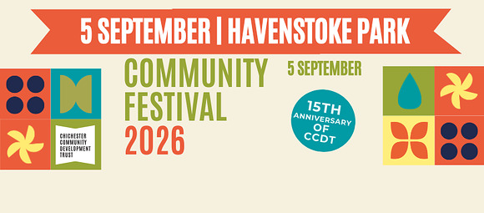
Community Day
5th September - Graylingwell Park
Join us as we celebrate 15 years of CCDT!
We're marking this special milestone with a fantastic Community Day packed with activities, entertainment, and fun for all ages.
Bring the whole family along and enjoy a day of community spirit, children's activities, games, food, and more. Then from 4pm, relax with music and drinks, hosted by Edge, as we celebrate together into the evening.
MORE

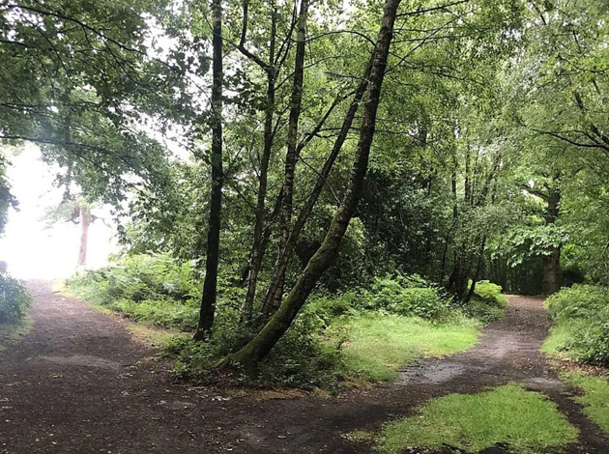
Crossroads and Thresholds Retreat - Danyah Miller
5th September - Fernleigh Chichester
Exploring the Space Between What Was and What's Next
Step away from the everyday and give yourself the space to pause, reflect and reconnect at this deeply nurturing one-day retreat at Fernleigh.
Created for women navigating moments of change, in identity, relationships, purpose, work or family roles this intimate retreat is guided by award-winning storyteller, facilitator and creative guide Danyah Miller. Through gentle storytelling, reflection and guided conversation, youll explore the powerful space between where youve been and where life may be inviting you next.
Release what is passing, honour where you are now, and begin to approach the future with renewed clarity, courage and curiosity.

MORE


Medieval Market Chichester City Council at 800
5th September - Chichester City Centre
Step back in time and experience the sights, sounds and stories of medieval Chichester at our Medieval Market, taking place around the historic Market Cross and Cathedral Green.
Browse stalls selling traditional goods, including eggs, honey and freshly baked breads, while meeting a host of medieval traders, craftspeople and characters from the past.
Visitors can enjoy a range of interactive demonstrations and activities
MORE

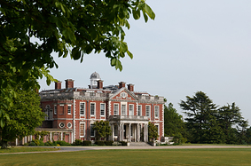 | Tour of Stansted House  6th September - Stansted House  Join one of our knowledgeable tour guides for a Guided Tour of Stansted House.  Discover the family seat of the Earls of Bessborough and explore the beautiful state rooms, furnished as though the 10th Earl was still at home.  Enjoy a true upstairs, downstairs experience as you learn about those who called Stansted Park home before heading downstairs to see the extensive servant quarters, described by one visitor as 'one of the very best I have seen in England.'  MORE

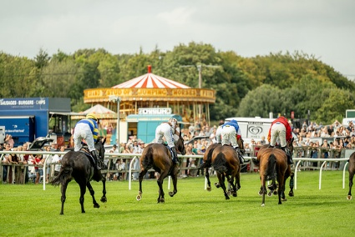
Fontwell Family Festival
6th September - Fontwell Park Racecours
Round off the summer holidays with a fantastic family day out at Fontwell Family Festival!
If you're looking for one last adventure before the new school term begins, Fontwell Park Racecourse has just the thing.
Join them on Sunday 6 September for the Fontwell Family Festival a fun-filled day combining thrilling jump racing with fantastic free entertainment for all ages.

MORE

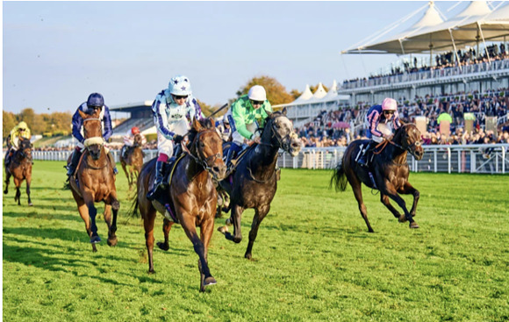
Autumn Racing at Goodwood
8th September - Goodwood
The perfect excuse to escape the office, bring friends, family or work colleagues to enjoy the balmy September afternoons of sporting entertainment amidst the perfect surroundings of the rolling South Downs.

MORE

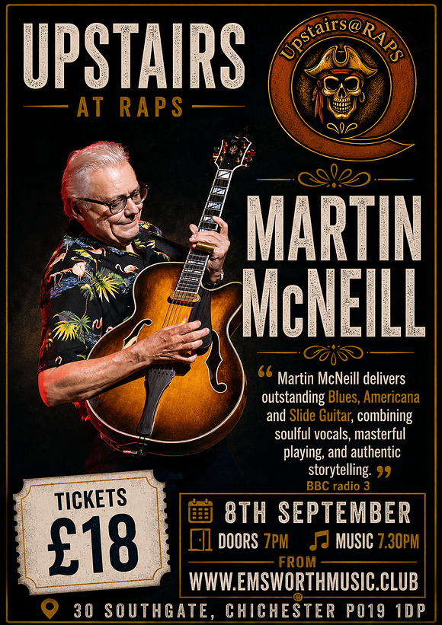
Upstairs @ Raps with Martin McNeill
8th September - Rapscallions, Southgate, Chichester
Martin McNeill delivers a compelling mix of blues, Americana and roots music, powered by soulful vocals and superb slide guitar. Drawing inspiration from the great traditions of American blues while adding his own distinctive touch, Martin combines powerful musicianship with engaging storytelling for an intimate, authentic and thoroughly entertaining live performance.

MORE

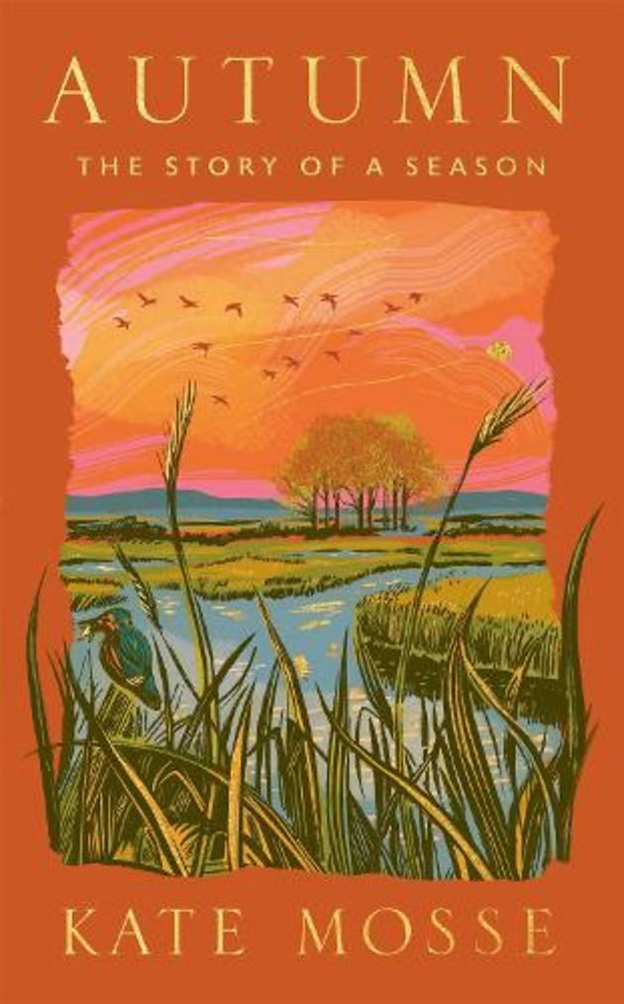
An Evening with Kate Mosse
10th September -Assembly Room, Chichester
Waterstones are delighted to be hosting an evening with renowned Cicestrian Kate Mosse, in conversation with Katie Derham, to celebrate the launch of Kate's brand new book 'Autumn'.
Exploring nature, folklore and history, 'Autumn' is a true love letter to Sussex and an atmospheric portrait of the season from one of our most celebrated writers.
MORE

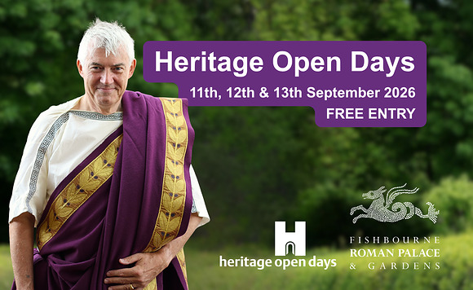
Heritage Open Days
11th - 13th September - Fishbourne Roman Palace
We are celebrating Heritage Open Days 2026 - England's biggest heritage festival of history and culture - by opening our doors for free for 3 days in September!
For the 11th, 12th and 13th September 2026 Fishbourne Roman Palace, the largest known Roman residential palace north of the Alps is entirely free to visit.
Built around AD 75, it features remarkably preserved mosaics, archaeological remains, reconstructed Roman gardens, and an on-site museum.
MORE



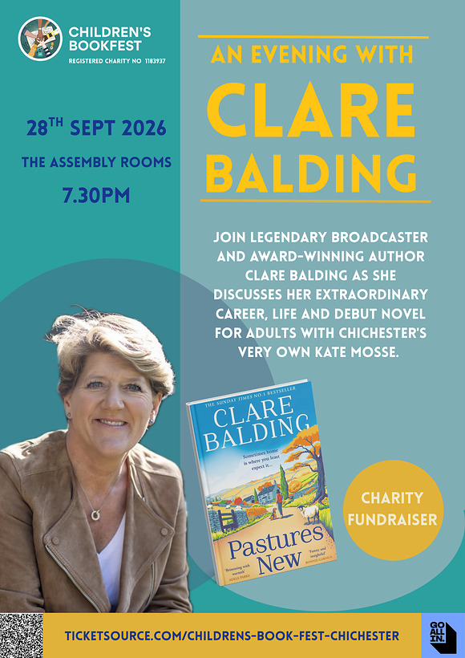
An Evening with Clare Balding
28th September Assembly Room, Chichester
Join legendary broadcaster and award-winning author Clare Balding, along with bestselling author and Cicestrian, Kate Mosse, for an evening discussing Clare's extraordinary life and career as her debut novel Pastures New is published in paperback. This is a National Year of Reading event and all proceeds go to support the work of Children's BookFest.
MORE




Winter 2026/27
Chichester Festival Theatre
This Winter, Chichester Festival Theatre is the place to see some of the country's most exciting touring theatre, music, comedy and dance.
From James Graham's Olivier Award-winning Best New Play Punch and the cult phenomenon turned smash-hit musical Heathers, to imaginative looks at three fascinating trios: the comedians Tommy Cooper, Bob Monkhouse and Eric Morecambe in The Last Laugh, and Labour politicians Roy Jenkins, Denis Healey and Tony Crosland in The Gang of Three both direct from London runs there's a wealth of unforgettable stories. A gripping new production of The Curious Incident of the Dog in the Night-Time featuring Joe McFadden and Charlie Brooks sits alongside Noël Coward's celebrated comedy Present Laughter starring Tracy-Ann Oberman, James Dreyfus and Adrian Lukis.
Booking opens for friends from the 5th September, and for the general public from the 12th September.
MORE



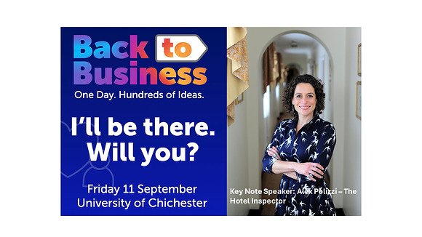
CCCI's Back to Business
11th September - University of Chichester
September is the perfect time for businesses to reset, refocus and reignite growth.
That's why we're excited about Back to Business a brand-new annual event from the Chichester Chamber of Commerce bringing together ambitious start-ups, scaling businesses and established organisations from across Chichester and beyond.
MORE



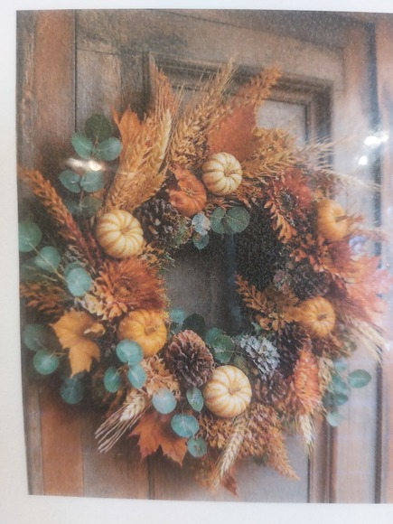
Autumn Wreath Making
17th September - Flower, North St., Chichester
Come along and learn to create and take home a beautiful, natural Autumnal Wreath.
No experience necessary, everything provided.
2 workshops 15.00 - 17.00 and 18.00 - 20.00
MORE




First Read Fridays
4th September - The Nest at Chichester Festival Theatre
Join cast members from our Festival 2026 shows as they table read brand-new scripts for the first time.
Get a glimpse behind the creative process and be the first to hear these new plays out loud brought to life by the talented casts of our Festival productions.
MORE



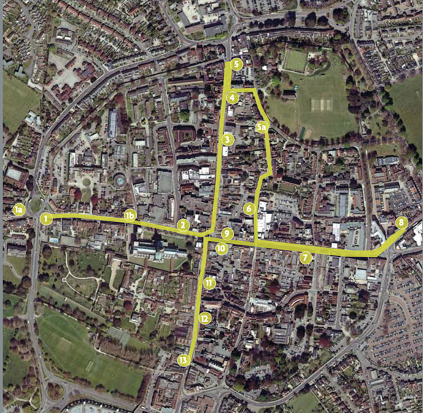
Heritage Walk
Inns, pubs and hotels
Chichester's earliest inns can be traced back to mediaeval times when they catered for pilgrims visiting the shrine of St Richard in the cathedral. Over time they came to serve all types of travellers, who needed rest and food after travelling along the notoriously bad Sussex roads. By the middle of the seventeenth century there were seven inns in Chichester, as well as 50 alehouses, taverns, and other premises that sold drink.
Given the population was only 2,000 people at the time, of whom over half were women and children, it can be seen that Chichester was a boozy city and remained so until the beginning of the twentieth century. Today there are only a dozen public houses in the city centre and no inns. Many of the city's old inns have been converted into restaurants or private accommodation.
Download the walk below
[PDF] pubs and​ inns.pd​f




WIN 2 TICKETS: Spire Tours - Chichester Cathedral
WIN A BIRDS-EYE VIEW OF CHICHESTER!
Were giving away a Cathedral Spire Tour for two people on Wednesday 23rd September at 12 noon
Climb high above Chichester Cathedral and enjoy a truly unforgettable view across the city and surrounding countryside
Hop over to our Instagram page to enter
Good luck!

Promote Your Event
Add your own event to our calendar - here's how
1. Click the link at the base of the home page "Submit an Event"
2. Create a login account if you don't already have one
3. Complete the form with the details of your event, ensuring that you have added an image and a short description along with the other important information. Please use plain, unformatted text and use the formatting tools in the form.
Kindly note that events will not be made live if they do not include a short text description and image. Images should be .pmg or .jpeg NOT pdf

Newsletters 2026  January week 1  January week 2  January week 3  January week 4  January week 5  February week 1  February week 2  February week 3  February week 4  March week 1  March week 2  March week 3  March Week 4 | Newsletters 2026  April Week 1  April Week 2  April Week 3  April Week 4  Summer of Culture  May Week 1  May Week 2  May Week 3  May Week 4  June Week 1  June Week 2  June Week 3  June Week 4 | Newsletters 2026  July Week 1  July Week 2  Win (Fontwell)  July Week 3  July Week 4  Win (Outdoor Film)  August Week 1  Win (Light Show)  August Week 2  Win (Graylingwell Walk)  August Week 3  August Week 4



powered by BoxStuff rapportUnsubscribe from this mailing

