
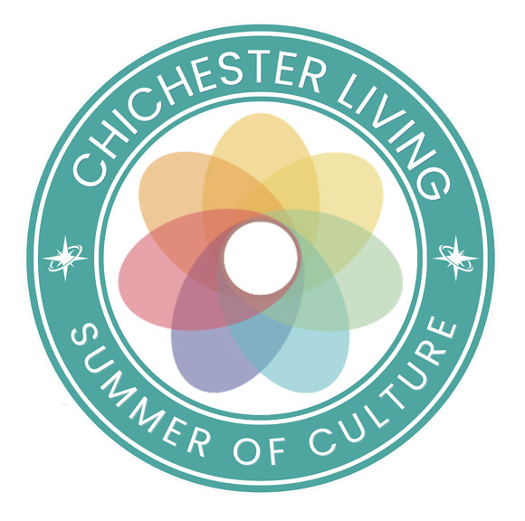
The last week of August is a time of both endings and new beginnings - Summer festivals come to an end and new terms herald new opportunities.
Our 3 months Summer of Culture campaign moves to a close. However this area buzzes with cultural activity all year and we think it is useful to bring all those events together in one space as well as in the main calendar. So a Summer of Culture will become a Year of Culture and that will also allow us to continue to give prominence to our 10 founding partners .
September is Heritage month and many upcoming events will reflect that with walks, talks, exhibitions and several properties open to the public. We will construct a new Heritage Month area on the website to bring those events together. In particular Chichester City Council is celebrating its 800 years anniversary.
Here is a round up of events/opportunities coming to a close in the near future with end dates:
Last chance to see/participate:
Summer at Aldingbourne - 30th August
Summer Holiday Activities - Amberley Museum - 30th August
Garden Explorer Trail - West Dean Gardens - 31st August
Madhurst - Midhurst - 31st August
Arundel Festival of the Arts - 31st August
Family Art Club - Goodwood Art Foundation - 31st August
Chichester Family Art Trail - 1st September
Summer of Adventure - Weald and Downland - 4th September
Summer of Colour - Chichester Cathedral - 4th September
My Fair Lady - Chichester Festival Theatre - 5th September
Paula Rego - Newlands House Gallery - 6th September
Summer Family Trail - Petworth House - 6th September
Last chance to book/enter
Early bird tickets - Chichester Cathedral light show - 31st August
Competition - Tickets for Graylingwell Walk - 28th August

Most art exhibitions continue well into autumn apart from those marked
British Landscapes: A Sense of Place at Pallant House Gallery
Art in the Landscape Goodwood Art Foundation
Expressions in Blue in the park at Petworth House (ends 27th Sept)
Haroun Hayward Path Through Trees- Pallant House Gallery
Richard Cobden: Sussex Free Trade Campaigner - Weald and Downland Living Museum (ends 13th September)
Glowing + Alive - Chichester Cathedral
Elmer and Friends - Novium Museum (ends 12th Sept)
Very many more events are listed in our calendar, along with lots of articles and news items. Follow this link to see the calendar of events for the new month of September

Vicki
Founder/Editor

The last week of August is a time of both endings and new beginnings - Summer festivals come to an end and new terms herald new opportunities.
Our 3 months Summer of Culture campaign moves to a close. However this area buzzes with cultural activity all year and we think it is useful to bring all those events together in one space as well as in the main calendar. So a Summer of Culture will become a Year of Culture and that will also allow us to continue to give prominence to our 10 founding partners .
September is Heritage month and many upcoming events will reflect that with walks, talks, exhibitions and several properties open to the public. We will construct a new Heritage Month area on the website to bring those events together. In particular Chichester City Council is celebrating its 800 years anniversary.
Here is a round up of events/opportunities coming to a close in the near future with end dates:
Last chance to see/participate:
Summer at Aldingbourne - 30th August
Summer Holiday Activities - Amberley Museum - 30th August
Garden Explorer Trail - West Dean Gardens - 31st August
Madhurst - Midhurst - 31st August
Arundel Festival of the Arts - 31st August
Family Art Club - Goodwood Art Foundation - 31st August
Chichester Family Art Trail - 1st September
Summer of Adventure - Weald and Downland - 4th September
Summer of Colour - Chichester Cathedral - 4th September
My Fair Lady - Chichester Festival Theatre - 5th September
Paula Rego - Newlands House Gallery - 6th September
Summer Family Trail - Petworth House - 6th September
Last chance to book/enter
Early bird tickets - Chichester Cathedral light show - 31st August
Competition - Tickets for Graylingwell Walk - 28th August

Most art exhibitions continue well into autumn apart from those marked
British Landscapes: A Sense of Place at Pallant House Gallery
Art in the Landscape Goodwood Art Foundation
Expressions in Blue in the park at Petworth House (ends 27th Sept)
Haroun Hayward Path Through Trees- Pallant House Gallery
Richard Cobden: Sussex Free Trade Campaigner - Weald and Downland Living Museum (ends 13th September)
Glowing + Alive - Chichester Cathedral
Elmer and Friends - Novium Museum (ends 12th Sept)
Very many more events are listed in our calendar, along with lots of articles and news items. Follow this link to see the calendar of events for the new month of September

Vicki
Founder/Editor




Ladies Evening at Fontwell
28th August - Fontwell Park Racecourse
Dress to impress for one of the most glamorous events in the Sussex summer calendar as Ladies Evening returns to Fontwell Park
Enjoy an evening of thrilling live racing, enter the prestigious Style Awards for the chance to win a luxury prize, and soak up the electric atmosphere before dancing the night away with a live Take That tribute performance. The celebrations continue with a DJ set from V2 Radio's Gary Booker, before a spectacular drone show lights up the night sky.

MORE...

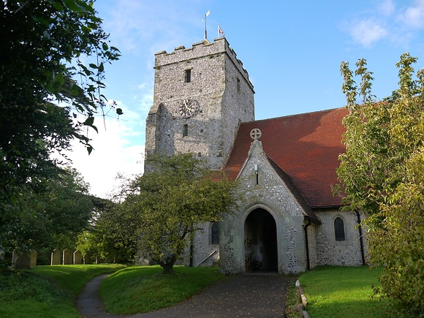
Jazz at St Mary's Burpham
28th August - St Mary's Church, Burpham
Returning to their favourite venue, the beautiful St. Marys Church, Burpham, southern music scene favourites, The Full Circle Quartet, perform music from their latest album, Same Sky, and from their previous two critically acclaimed albums, Open Water (2024) and South Downs Suite (2023).
MORE

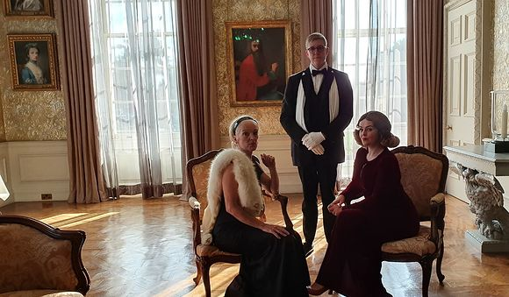
Family Murder Mystery
29th August Stansted House
Calling all budding detectives! Challenge the whole family to crack the Stansted Murder Mystery.
Imagine being invited to a magnificent Country Estate by an enigmatic host but upon arrival with a room full of curious guests, your host is nowhere to be found. The clock is ticking, dark secrets are hiding behind polite smiles, and it is up to you to investigate what happened!
MORE

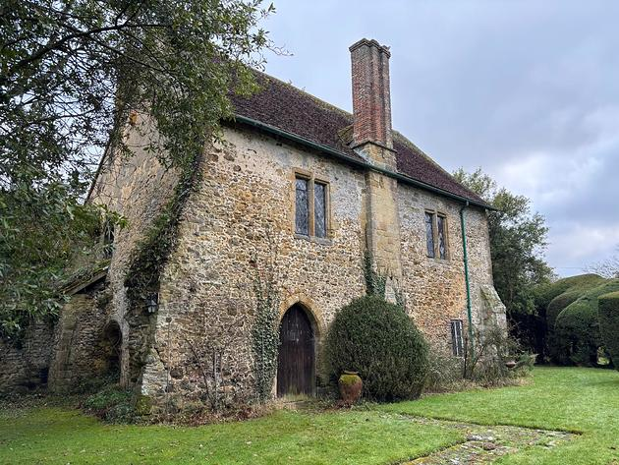
Shulbrede Priory House open weekend
30th - 31st August Shulbrede Priory, Linchmere
Now a private house with wall paintings and a vaulted undercroft, Shulbrede Priory was founded in 1190 for Canons following the rule of St Augustine, and was dedicated to St Mary, the Holy Cross and St Eustace. After the dissolution of the monasteries by Henry VIII, the remaining buildings became a farmhouse and the Manor for the district. Yeomen and tenants of the Cowdray Estate lived here until the Ponsonby family came in 1902. The house is only open to the public four afternoons a year
MORE


Chichester City Arts & Crafts Fair
30th August Chichester City Arts Centre
Discover a wonderful range of work from talented local artists at the Chichester City Arts Centre, a beautiful 200-year-old Grade II listed former church in the heart of central Chichester.
Visitors can explore unique artwork, support local creatives, and enjoy the rich history and character of this stunning venue, including its beautiful gardens.
MORE

 | Lavant CrickFest  30th August - Lavant Village Green  Everyone is welcome at our 7-a-Side Cricket Festival and Family Day.  BBQ, Bar, Ice Creams and loads of Cricketing fun!  MORE

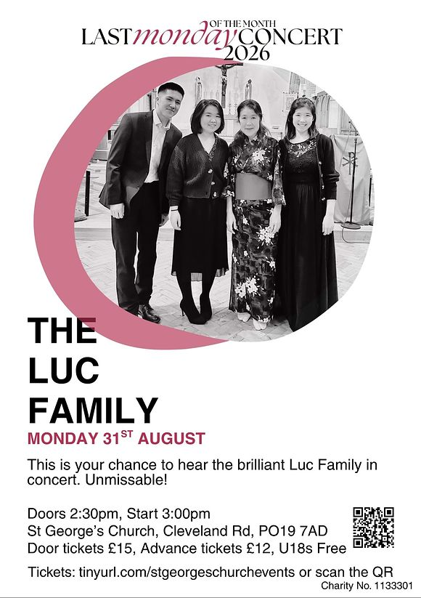
Luc Family Concert
31st August - St George's Church, Whyke
The unmissable return of the incredible Luc family to the stage, with music to inspire, uplift and transport you to other worlds.
Please join us for Celebration of Music with a special guest - award winning pianist Luke Jones. Beethoven, Debussy, Faurè , Chopin, Ravel, Brahms and heart warming Japanese pop songs.
MORE

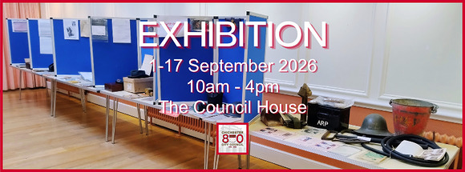
Chichester City Council at 800 Exhibition
1st - 17th September - The Council House, Chichester
The exhibition displays Chichester's civic history, including mayoral events, royal occasions, publications, and memorabilia. Items feature council records, medals, guides, and Jubilee souvenirs.
Labels will explain each exhibit, with special stands for mugs. The displays aim to celebrate civic heritage, with some items potentially combined for efficiency
MORE

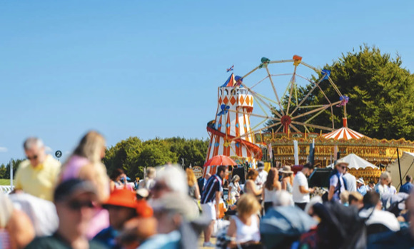
August Bank Holiday Weekend at Goodwood
28th 30th August - Goodwood Racecourse
The three-day racing festival commences with our annual Friday evening fireworks spectacle, the perfect start to a memorable weekend.
Saturday and Sunday bring a nostalgic summer atmosphere with live music, family entertainment and world class racing.
MORE

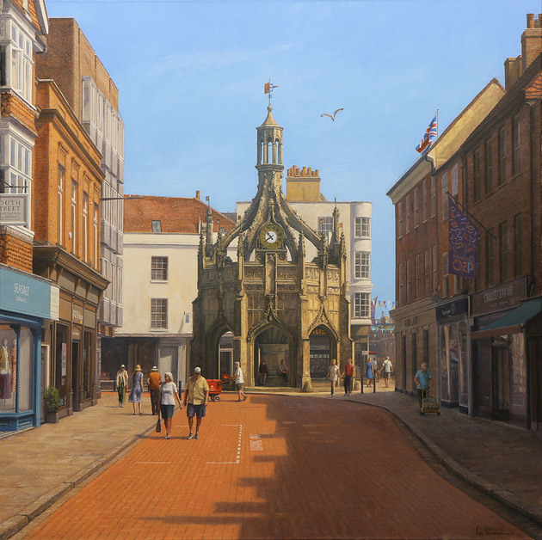
Leo Stevenson - Finding the Centre
1st - 13th September - Oxmarket Contemporary
For more than three decades, Leo Stevenson has built a remarkable career as a professional artist, following a path that has been anything but conventional. While best known as an oil painter, his creative practice has encompassed sculpture, jewellery, restoration, illustration and art history, reflecting a breadth of expertise developed over a lifetime dedicated to making and understanding art.

MORE


CANADA'S 2026 FOLK MUSIC ARTIST OF THE YEAR
3rd September - Westbourne Community Hall
Lennie Gallant has just been named as solo artist of the year in the 2026 Canadian Folk Awards, and as part of his current tour he will be appearing at Wemsfest.
WemsFest has welcomed many top Canadian acts to our locality in recent months, and with sixteen albums and numerous awards to his name Lennie, accompanied by his top quality band, continues this trend.
MORE



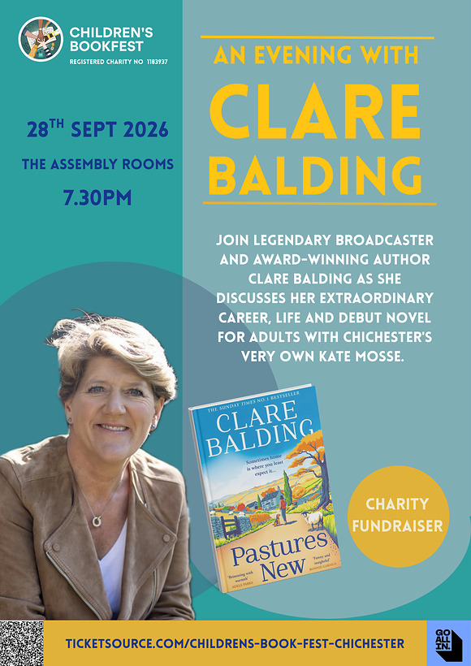
An Evening with Clare Balding
28th September Assembly Room, Chichester
Join legendary broadcaster and award-winning author Clare Balding, along with bestselling author and Cicestrian, Kate Mosse, for an evening discussing Clare's extraordinary life and career as her debut novel Pastures New is published in paperback. This is a National Year of Reading event and all proceeds go to support the work of Children's BookFest.
MORE




Winter 2026/27
Chichester Festival Theatre
Get ready for one of our biggest Winter seasons yet... From acclaimed drama to music, comedy and much more, there's something for every taste in our programme packed full of unmissable shows.
So as our Festival season continues to delight audiences, our Winter season announcement is fast approaching. The full programme will be revealed on Tuesday 1 September, with general booking opening on Saturday 12 September.
One of our supporters? Check the on-sale schedule for your priority booking dates.



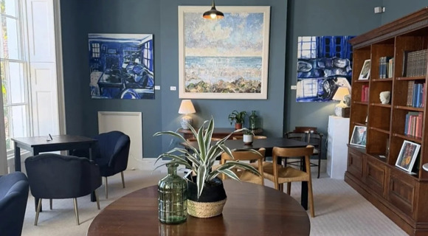
Advanced AI After Hours at Fernleigh
10th September - Fernleigh, Chichester
While most people have tried ChatGPT, far fewer have kept pace with how much AI tools can now do. The capabilities of leading-edge AI tools have moved on enormously in the past year: these systems can now analyse an entire folder of documents on your computer, produce a complex report with little supervision, or even help you build personal software (without you needing to know a line of code).
This series is for people who want to close that gap and get ahead. Three focused evening sessions, held over a relaxed after-work drink, take you from the everyday tools you already know to the highly capable systems those at the frontier of AI are using now.
Highly practical, cutting edge and strictly limited to 12 people maximum, these sessions are led by Professor Ed Stoddard, who is an expert in the practical applications of AI for professionals.
FULL PROGRAMME HERE

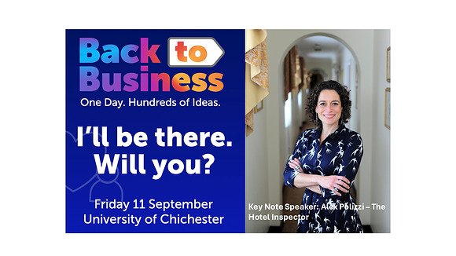
CCCI's Back to Business
11th September - University of Chichester
September is the perfect time for businesses to reset, refocus and reignite growth.
That's why we're excited about Back to Business a brand-new annual event from the Chichester Chamber of Commerce bringing together ambitious start-ups, scaling businesses and established organisations from across Chichester and beyond.
MORE



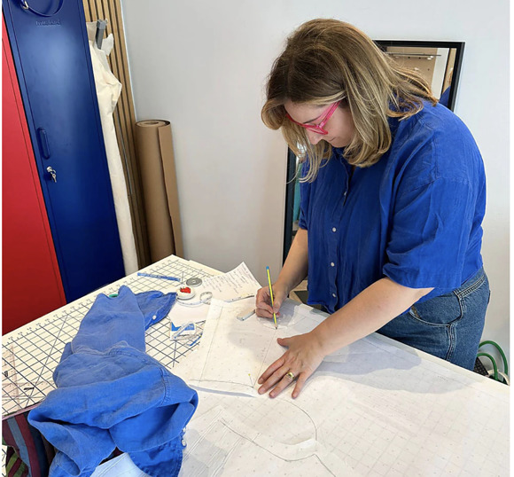
Copy Your Clothes Pattern Drafting Workshop
5th September - Clothkits, Chichester
If you have a favourite garment that is worn out and you just can't find a replacement. Perhaps you wish you could have it in different fabrics or colours - then our Copy Your Clothes workshop is for you!
MORE



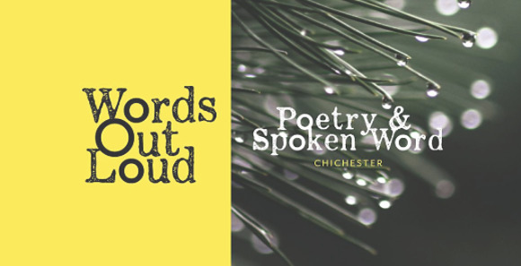
Poetry & Spoken Word Open-Mic
1st September - The Ghost at the Feast, Chichester
Come along and read some of your own poetry or prose, listen to others and share in the joys of the spoken word.
It doesn't matter if this is the first piece you have written or whether you are a seasoned pro, you will find a warm and supportive welcome as you share your work with us out loud.
And if reading out loud is not for you, please do come along and enjoy the atmosphere and listen to the readings.

MORE



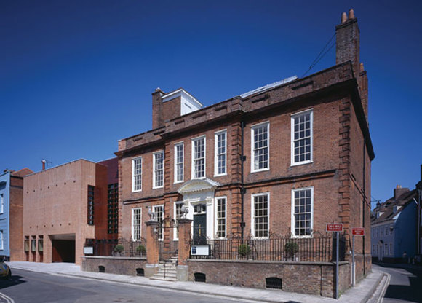
Campaign Director
Pallant House Gallery
Pallant House Gallery is one of the UK's leading centres for modern and contemporary British art, based in Chichester. Founded on the collection bequeathed by Dean Walter Hussey, the Gallery now cares for more than 5,000 works and presents an ambitious programme of exhibitions, learning initiatives, publications and community engagement activities. As it looks to the future, the Gallery is preparing for a major redevelopment that will enhance visitor experience, improve access to its collections and create a new Creative Hub for the South of England.
The Gallery is now seeking to appoint a Campaign Director who will lead the development of the strategy, delivery and oversight of the £20 million capital campaign. Working closely with the Director, Board and senior colleagues, the successful candidate will develop and implement a comprehensive fundraising strategy, cultivate major donors and institutional supporters, and build the relationships and momentum required to realise the Gallerys long-term ambitions. Candidates will bring a strong track record of securing significant philanthropic support, exceptional stakeholder engagement skills, and the strategic leadership capability to deliver a complex capital campaign, ideally within the cultural, heritage or not-for-profit sector.
Apply by 17/09/2026
MORE INFO AND TO APPLY




WIN 2 TICKETS: Walk & Talk History of Graylingwell Chapel
These walks are always a sell out but we've secured two tickets for a lucky follower and a friend to join the last tour of the year
What to expect: Meet at the beautifully restored Graylingwell Chapel and set off on a fascinating guided walk with local historian Greg Slay, exploring the site's history including over a century as Graylingwell Hospital (1897- 2001). You'll finish back at the Chapel with a hot drink and treat from The Chapel Café while you soak up the exhibits
Saturday 12 September, 1- 3pm Graylingwell Chapel, Blomfield Drive, Chichester Usually £12pp but you could go for free
Hop over to our Instagram page to enter
Good luck!

Promote Your Event
Add your own event to our calendar - here's how
1. Click the link at the base of the home page "Submit an Event"
2. Create a login account if you don't already have one
3. Complete the form with the details of your event, ensuring that you have added an image and a short description along with the other important information. Please use plain, unformatted text and use the formatting tools in the form.
Kindly note that events will not be made live if they do not include a short text description and image. Images should be .pmg or .jpeg NOT pdf

Newsletters 2026  January week 1  January week 2  January week 3  January week 4  January week 5  February week 1  February week 2  February week 3  February week 4  March week 1  March week 2  March week 3  March Week 4 | Newsletters 2026  April Week 1  April Week 2  April Week 3  April Week 4  Summer of Culture  May Week 1  May Week 2  May Week 3  May Week 4  June Week 1  June Week 2  June Week 3  June Week 4 | Newsletters 2026  July Week 1  July Week 2  Win (Fontwell)  July Week 3  July Week 4  Win (Outdoor Film)  August Week 1  Win (Light Show)  August Week 2  Win (Graylingwell Walk)  August Week 3



powered by BoxStuff rapportUnsubscribe from this mailing

