
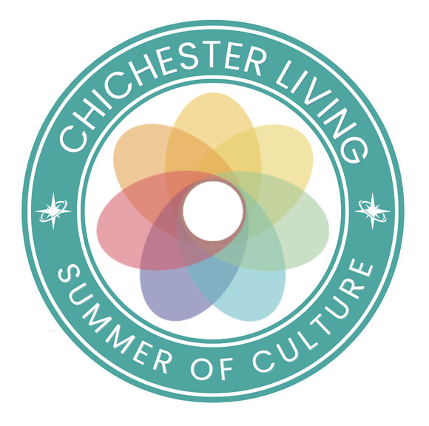
As we approach the last week of our 3 months of the Summer of Culture you have the final chance to attend the film Festival which ends this weekend and the month long Madhurst moves into its last week to end on the 31st.
However, the annual Arundel Festival of the Arts opens on the 22nd and you can experience all things Roman at the Gladiators weekend at Fishbourne Roman Palace. For something more 'recent'', this weekend at the Weald and Downland Living Museum you can discover what life was like during the Civil War.
Looking ahead to the the Goodwood Revival you can find that special outfit at the Kennels Vintage Market (see below)
If you haven't yet seen My Fair Lady (and even if you have...) there are a few tickets left for the special Gala performance on the 28th August - not only do you get to join in a special event of glitz and glamour but you will be helping support the theatre's Stage the Future campaign to help nurture the next generation of theatre. (see below)
We have an unusual mix of events in the newsletter below including what promises to be a spectacular light show at Fontwell. You can also learn about Charcoal burning and budding sculptors can try their hand at casting. Artists can meet up at the Ghost at the Feast at the monthly 'A Creative Space'
The annual Jazzfest is back at New Park on the 27th and on the 28th the annual fireworks display opens the Bank Holiday weekend of racing at Goodwood,
Once a year the charming chapel is open at the Cawley Almshouses and this year marks the 400th anniversary of the chapel's consecration.
The art exhibitions continue with the popular British Landscapes: A Sense of Place at Pallant House Gallery and the Goodwood Art Foundation displays sculpture outdoors with their Art in the Landscape exhibition and Expressions in Blue in the park at Petworth House brings you towering works in ceramics.
Our thanks to all those stakeholders who have supported our competitions and offered tickets to some amazing events. The latest that you will find below is to learn all about the fascinating history of Graylingwell on a walking tour next month. These walks sell out quickly so this is your opportunity to secure your tickets.
Don't forget that this is represents just a few of the events listed in our calendar, along with lots of articles and news item.s Follow this link to see the calendar of events for the rest of August.
Have a great week
Vicki
Founder/Editor
As we approach the last week of our 3 months of the Summer of Culture you have the final chance to attend the film Festival which ends this weekend and the month long Madhurst moves into its last week to end on the 31st.
However, the annual Arundel Festival of the Arts opens on the 22nd and you can experience all things Roman at the Gladiators weekend at Fishbourne Roman Palace. For something more 'recent'', this weekend at the Weald and Downland Living Museum you can discover what life was like during the Civil War.
Looking ahead to the the Goodwood Revival you can find that special outfit at the Kennels Vintage Market (see below)
If you haven't yet seen My Fair Lady (and even if you have...) there are a few tickets left for the special Gala performance on the 28th August - not only do you get to join in a special event of glitz and glamour but you will be helping support the theatre's Stage the Future campaign to help nurture the next generation of theatre. (see below)
We have an unusual mix of events in the newsletter below including what promises to be a spectacular light show at Fontwell. You can also learn about Charcoal burning and budding sculptors can try their hand at casting. Artists can meet up at the Ghost at the Feast at the monthly 'A Creative Space'
The annual Jazzfest is back at New Park on the 27th and on the 28th the annual fireworks display opens the Bank Holiday weekend of racing at Goodwood,
Once a year the charming chapel is open at the Cawley Almshouses and this year marks the 400th anniversary of the chapel's consecration.
The art exhibitions continue with the popular British Landscapes: A Sense of Place at Pallant House Gallery and the Goodwood Art Foundation displays sculpture outdoors with their Art in the Landscape exhibition and Expressions in Blue in the park at Petworth House brings you towering works in ceramics.
Our thanks to all those stakeholders who have supported our competitions and offered tickets to some amazing events. The latest that you will find below is to learn all about the fascinating history of Graylingwell on a walking tour next month. These walks sell out quickly so this is your opportunity to secure your tickets.
Don't forget that this is represents just a few of the events listed in our calendar, along with lots of articles and news item.s Follow this link to see the calendar of events for the rest of August.
Have a great week
Vicki
Founder/Editor



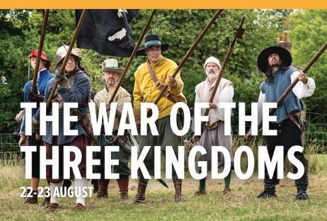
War of the Three Kingdoms
22nd - 23rd August - Weald and Downland Living Museum
Join us for our War of the Three Kingdoms weekend, where you can come along and discover what life was like in the 17th Century as depicted by an English Civil Wars Royalist Garrison, as we welcome back The Wardour Garrison Living History Group
MORE...

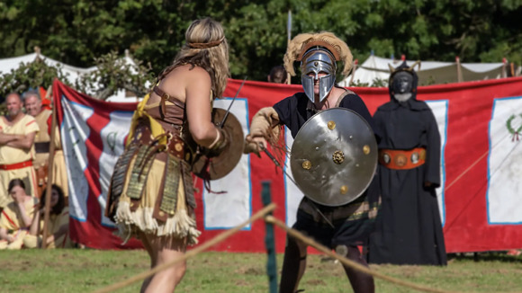
Gladiators! Weekend at Fishbourne Roman Palace
22nd - 23rd August - Fishbourne Roman Palace
Join us for some spectacular gladiatorial combat at Fishbourne Roman Palace! Experience the drama as the Gladiators of Britannia bring the 1st century AD to life. Witness epic clashes, decide fates, and hear tales of their world.
MORE


The Kennels Vintage Market
22nd August The Kennels at Goodwood
The Kennels' Vintage Market is back for another year to get you style-ready for Goodwood Revival. Stalls will be showcasing some of the most beautiful vintage clothing and accessories from bygone eras including beautiful dresses, stunning hats, dapper waistcoats and those perfect little details and accessories to finish off any vintage outfit.
The fabulous Dawn Gracie - vintage expert and style authority will be bringing her irresistible energy to the Vintage Market throughout the day.

MORE


Space Safari - The Drone Light Show
22nd August Fontwell Park Racecourse
For the first time ever in Chichester, experience a spectacular cinematic drone light show under the stars this August.
Space Safari: The Drone Light Show is a breathtaking immersive experience combining hundreds of synchronised drones, cinematic storytelling, music, and family entertainment into one unforgettable evening.
MORE

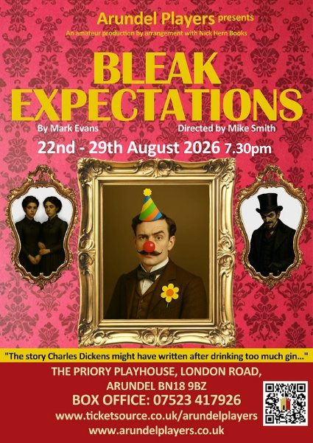
Bleak Expectations
22nd - 29th August Priory Playhouse, Arundel
This play is based on the award winning BBC Radio 4 series
Written by Mark Evans and Directed by Mike Smith
The story Charles Dickens might have written after drinking too much gin.
MORE

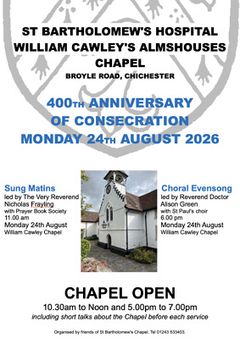 | William Cawley's Almshouse  24th August - William Cawley Almshouse, Northgate, Chichester  Last year saw the 400th anniversary of the founding by William Cawley of his almshouse in Northgate, and 2026 sees the 400th anniversary of the consecration of its chapel  As well as being a philanthropist, William Cawley is also notorious for having been one of the signatories to the death warrant for King Charles I, earning him the local epithet "Cawley the Regicide".  MORE

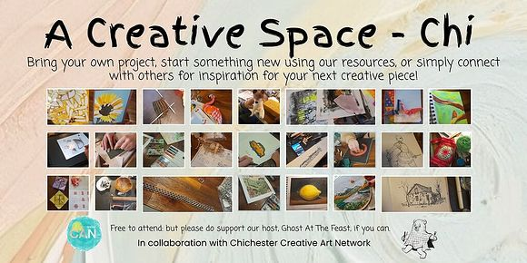
A Creative Space - Chi
25th August - Ghost at the Feast
Bring along your own project, start something new using our resources, or just drop by to meet other local people and pick up some inspiration for your next project.
Creative Space Chi, meets on the 2nd and 4th Tuesday of each month
MORE

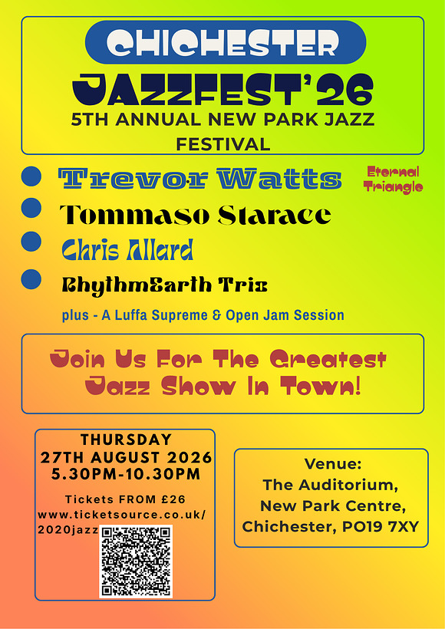
JAZZFEST
27th August - New Park. Centre
New Park Community Centre in Chichester is delighted to welcome JazzFest26 to its Auditorium, bringing an outstanding evening of live jazz featuring internationally acclaimed musicians alongside emerging local talent.
From legendary saxophonist Trevor Watts to international alto star Tommaso Starace, acclaimed guitarist Chris Allard and the groove-driven RhythmEarth Trio, JazzFest26 promises an exciting evening for jazz lovers and anyone looking to experience exceptional live music in the heart of Chichester.
MORE

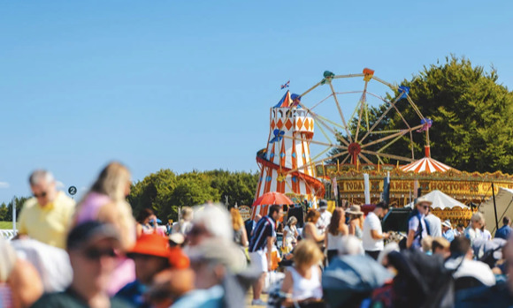
August Bank Holiday Weekend at Goodwood
28th 30th August - Goodwood Racecourse
The three-day racing festival commences with our annual Friday evening fireworks spectacle, the perfect start to a memorable weekend.
Saturday and Sunday bring a nostalgic summer atmosphere with live music, family entertainment and world class racing.
MORE



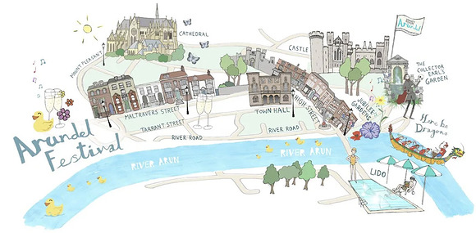
Arundel Festival of the Arts
22nd - 31st August Arundel
Arundel Festival of the Arts is the biggest community event around and one of the most celebrated arts and culture events in the South of England, bringing together an eclectic mix of music, theatre, literature, and community events. With a rich history dating back to 1977, the festival has played a pivotal role in fostering artistic excellence and community spirit. Since its inception by the 17th Duke of Norfolk and local leaders, the Arundel Festival has welcomed renowned cultural figures such as David Hockney, Nigel Kennedy, Julian Lloyd Webber, and Katherine Jenkins.
MORE



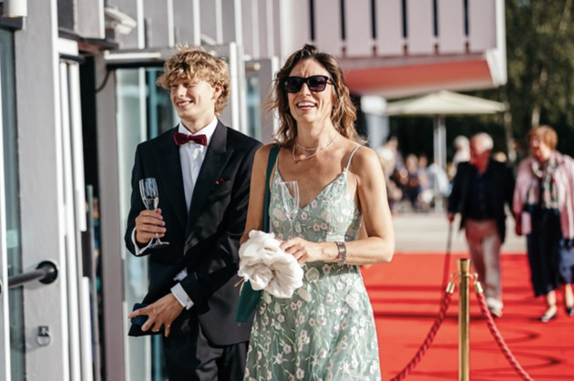
CFT Summer Gala - My Fair Lady
28th August - Chichester Festival Theatre
Wouldn't it be lover-ly… to step into an evening of glitz, glam and glorious theatre? Our annual charity gala provides the perfect opportunity to celebrate our much-loved summer musical
My Fair Lady, with fizz, live music and cast appearances! Dress to dazzle and relish the atmosphere whilst supporting our Stage the Future campaign that aims to nurture the next generation of theatre makers.
Enjoy a fabulous night with CFT whilst supporting the theatre you love! With tickets starting from £15, you're invited to join us ahead of the show from 5.30pm to hear live music, pick up a complimentary glass of prosecco (or soft alternative) and revel in the atmosphere. The show starts at the earlier time of 6.30pm so there's plenty of time to get some snaps with your family and friends before being wowed by My Fair Lady on stage.
MORE...
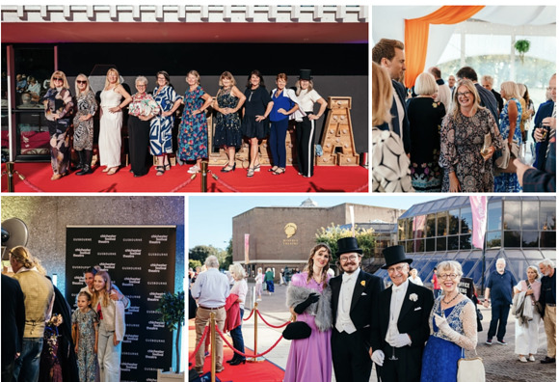



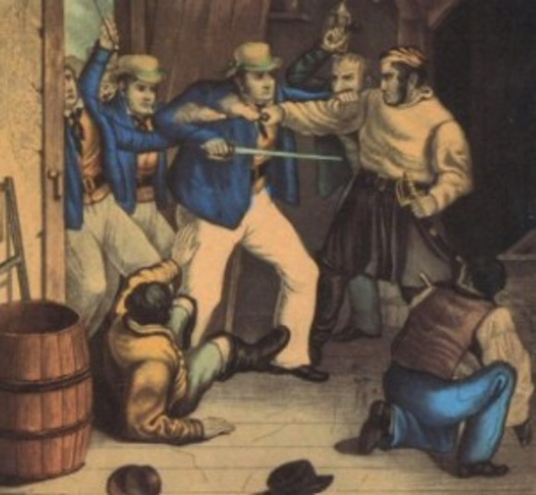
Smugglers in West Sussex
26th August - Sage House, Tangmere
This talk with Historian Chris Hare takes a fascinating look at the widespread smuggling trade that flourished across Sussex in the eighteenth and early nineteenth centuries. Learn why Arundel became an important hub and discover the real stories behind the legends.
In aid of Dementia Support
MORE


The People's Emergency Briefing
27th August - Bassil Shippam Centre
Find out what the experts are saying about the climate and nature emergency.
Film, narrated by Chris Packham, starts 6pm and lasts 50 mins. There will be a brief update (15mins tops) after the film about the political action it has triggered so far, with a call to audience members to nudge their MP to help make a difference.
A special from Talks at Six, hosted by Transition Town Chichester.
MORE



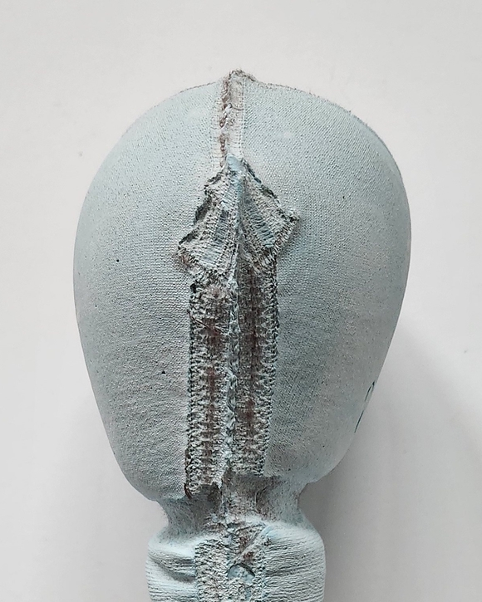
The Art of Casting
22nd August - The Black Barn
Helen Barff is a sculptor and educator based in London. Her practice examines mythologies, superstitions and vanities often reflecting on "the other".
This workshop will give you an insight into how everyday objects can be transformed into sculpture. You will have the opportunity to create your own sculpture, experimenting with using plaster fabrics and found objects whilst being guided through the process by Barff. The workshop emphasises process-led making and will encourage you to think about how material and process shape the work you make.
MORE




Heritage Crafts: Charcoal Burn
29th - 31st August - Weald and Downland Living Museum
Join us as we build and burn the second of our two charcoal fires for the season.
The process of charcoal burning is both art and science a controlled burn requiring close attention and great care. At the Museum, our knowledgeable interpreter Jon Roberts, together with our Interpretation Team, will bring this practice to life for visitors over this weekend.
MORE



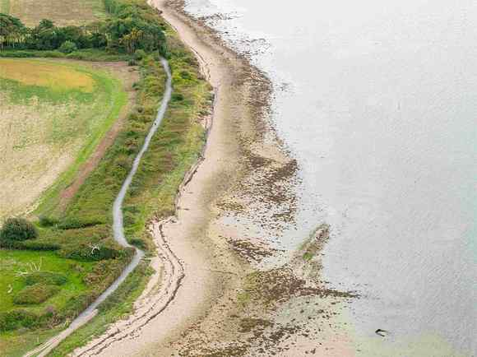
The King Charles III England Coast Path
Officially opened earlier this year around the shores of Chichester Harbour. This section covers 35 miles of coastline from South Hayling in Hampshire to East Head in West Sussex.
It includes a variety of habitats and coastal villages including Emsworth, Bosham and West Itchenor.
Find out more



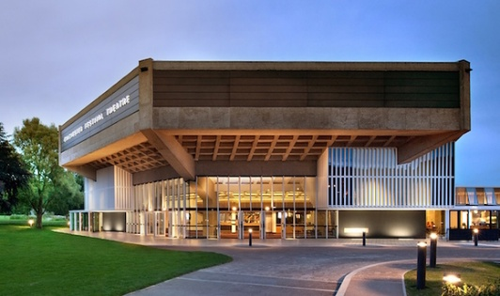
LEAP Co-ordinator
Chichester Festival Theatre
Are you an organised, people-focused administrator who is passionate about the arts and making a difference in your community? We're looking for a LEAP Co-ordinator to join our Learning, Education & Participation (LEAP) team, supporting a year-round programme that engages more than 1,200 children, young people and community members each week. You'll be at the heart of the department, co-ordinating bookings, managing administration, maintaining key systems, and providing vital support to ensure our creative programmes run smoothly.
This is a varied and rewarding role within a collaborative, supportive and values-driven team. Working closely with colleagues across the theatre, you'll be a welcoming first point of contact for participants, schools and partners, helping us deliver inclusive, high-quality experiences that make theatre accessible to everyone. We're looking for someone who is proactive, detail-focused, adaptable and confident managing multiple priorities in a busy environment.

Apply by 27/08/2026
MORE INFO AND TO APPLY




WIN 2 TICKETS: Walk & Talk History of Graylingwell Chapel
These walks are always a sell out but we've secured two tickets for a lucky follower and a friend to join the last tour of the year
What to expect: Meet at the beautifully restored Graylingwell Chapel and set off on a fascinating guided walk with local historian Greg Slay, exploring the site's history including over a century as Graylingwell Hospital (1897- 2001). You'll finish back at the Chapel with a hot drink and treat from The Chapel Café while you soak up the exhibits
Saturday 12 September, 1- 3pm Graylingwell Chapel, Blomfield Drive, Chichester Usually £12pp but you could go for free
Hop over to our Instagram page to enter
Good luck!

Promote Your Event
Add your own event to our calendar - here's how
1. Click the link at the base of the home page "Submit an Event"
2. Create a login account if you don't already have one
3. Complete the form with the details of your event, ensuring that you have added an image and a short description along with the other important information. Please use plain, unformatted text and use the formatting tools in the form.
Kindly note that events will not be made live if they do not include a short text description and image. Images should be .pmg or .jpeg NOT pdf

Newsletters 2026  January week 1  January week 2  January week 3  January week 4  January week 5  February week 1  February week 2  February week 3  February week 4  March week 1  March week 2  March week 3 | Newsletters 2026  March Week 4  April Week 1  April Week 2  April Week 3  April Week 4  Summer of Culture  May Week 1  May Week 2  May Week 3  May Week 4  June Week 1  June Week 2 | Newsletters 2026  June Week 3  June Week 4  July Week 1  July Week 2  Win (Fontwell)  July Week 3  July Week 4  Win (Outdoor Film)  August Week 1  Win (Light Show)  August Week 2  Win (Graylingwell Walk)



powered by BoxStuff rapportUnsubscribe from this mailing

