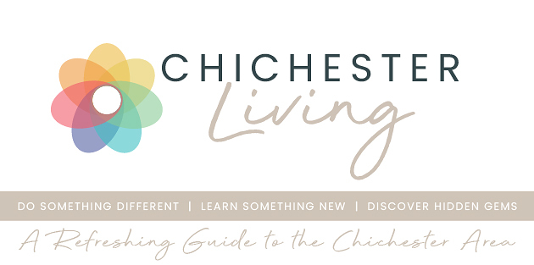
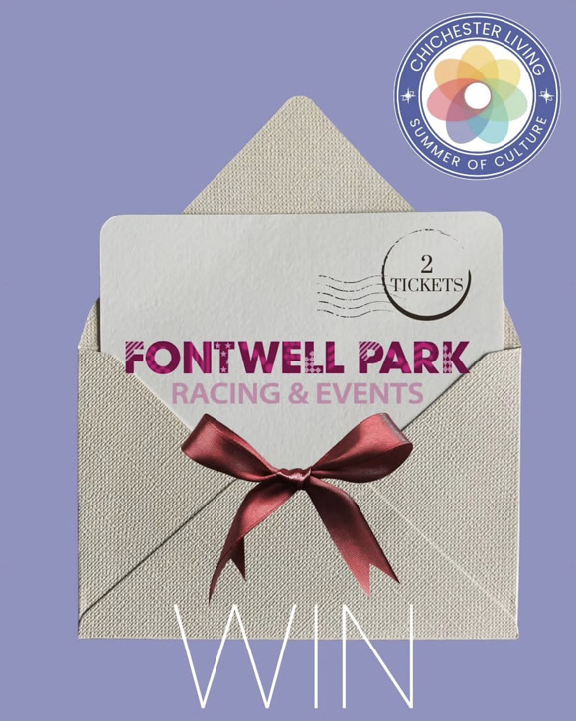
Get your glam rags ready, because we've got a seriously glamorous giveaway for you...
We're giving away 2 pairs of tickets (4 tickets total — 2 winners!) to Fontwell Park's Ladies Evening on Friday 28th August 2026
Think thrilling jump racing, show-stopping Style Awards, a live Take That tribute, DJ sets, and a drone show finale lighting up the summer sky. It's a great night out on the Sussex social calendar — and we want two lucky followers (plus a friend each!) to be there in style.
This link to enter the giveaway
This link to view the event
Good luck!
