
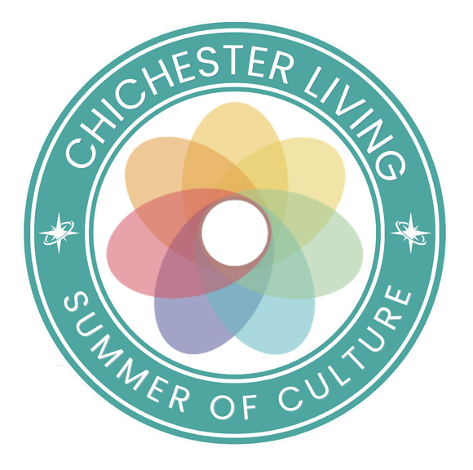
We are now moving into the last month of our Summer of Culture campaign and the events are still coming thick and fast. Just to remind you - on the Summer of Culture page you have quick links to everything in the calendar that falls into these categories:
Art, Crafts, Dance, Film, History and Heritage, Literature, Music and Theatre
In addition we bring events together that share a certain theme - this week you can see a selection of workshops and some open air screenings in Priory Park.
We continue to run giveaways on our Instagram page to celebrate the project with thanks to our generous supporters. See below for how to win a Chichester Gift Card from Chichester BID and a family ticket to the films in Priory Park from Chichester Cinema.
The selection below is as eclectic as ever from art, music and theatre to jousting and dance. You can support charities at Selsey Lifeboat Station and at Goodwood Motor circuit.
In particular we invite you to support the Emergency Services, Armed Forces and Community Day in Oaklands park on the 2nd August.
The 34th International Film Festival has been announced and nominations are now invited for this year's Business Awards run by the Chichester Observer in partnership with Chichester District Council and Chichester BID.
Don't forget to check out all the events, news, experiences and articles on the website. Follow this link to see the calendar of events for the rest of August.

Enjoy your week however you spend it.
Vicki
Founder/Editor

We are now moving into the last month of our Summer of Culture campaign and the events are still coming thick and fast. Just to remind you - on the Summer of Culture page you have quick links to everything in the calendar that falls into these categories:
Art, Crafts, Dance, Film, History and Heritage, Literature, Music and Theatre
In addition we bring events together that share a certain theme - this week you can see a selection of workshops and some open air screenings in Priory Park.
We continue to run giveaways on our Instagram page to celebrate the project with thanks to our generous supporters. See below for how to win a Chichester Gift Card from Chichester BID and a family ticket to the films in Priory Park from Chichester Cinema.
The selection below is as eclectic as ever from art, music and theatre to jousting and dance. You can support charities at Selsey Lifeboat Station and at Goodwood Motor circuit.
In particular we invite you to support the Emergency Services, Armed Forces and Community Day in Oaklands park on the 2nd August.
The 34th International Film Festival has been announced and nominations are now invited for this year's Business Awards run by the Chichester Observer in partnership with Chichester District Council and Chichester BID.
Don't forget to check out all the events, news, experiences and articles on the website. Follow this link to see the calendar of events for the rest of August.

Enjoy your week however you spend it.
Vicki
Founder/Editor




Last Friday concerts
31st July - St George's Church, Whyke, Chichester
The welcome return to the stage of Linda Kelsall-Barnett. An evening of classical guitar favourites delivered with impeccable style
MORE...

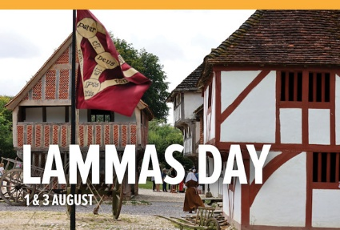
Living History: Lammas Day
1st - 3rd August - Weald and Downland Living Museum
Join us for Lammas Day and immerse yourself in medieval times as we bring history to life as we celebrate blessing the First Fruits of harvest with Black Knight Historical Group, who will be living and working over a Lammas Day Fayre in and around some of the historic buildings at the Museum.
MORE


Chichester Camera Club Annual Exhibition
1st - 8th August Assembly Room, Chichester
The Chichester Camera Club Annual Exhibition takes place at The Assembly Room, North Street, in the centre of Chichester.
Open every day except Sunday, from Saturday 1st August to Saturday 8th August inclusive, from 10.00 am to 5 .00 pm.
MORE


Summer Barn Dance
1st August Aldingbourne Country Centre
Get ready for an evening of foot-stomping fun, live music, and a bouncy castle at our Summer Barn Dance - featuring professional barn dance callers to guide you through every lively step!
Whether you're a confident dancer or a first-timer, our friendly callers will have everyone up and moving. Its the perfect way to celebrate summer with family and friends!

MORE

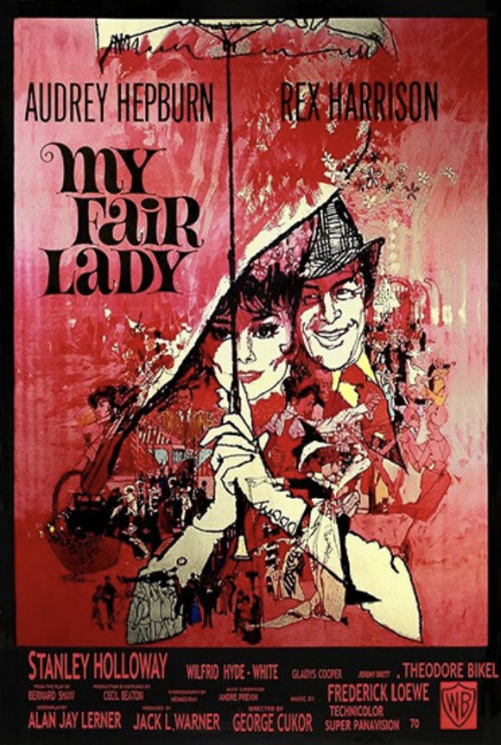
My Fair Lady
2nd August Chichester Cinema at New Park
This is wonderfully stylish (Hepburn is gorgeous), wittily scripted (using much of George Bernard Shaw's Pygmalion source material) and immaculately cast.
It remains a timeless, captivating classic, deserving of a chance to be seen on a big screen.
MORE

 | Emergency Services, Armed Forces and Community Day  2nd August - Oaklands Park Chichester  Returning bigger, better and prouder than ever.  Following the huge success of last years event, we are delighted to confirm that Chichesters Emergency Services, Armed Forces and Community Day is returning in 2026 and this year, it will also be Chichesters official celebration of our Armed Forces.  Join us for a day packed with activities, displays and entertainment for all ages:  MORE


Dance and Beyond
3rd - 7th August Chichester College
Join us for our Dance and Beyond Summer Camp 2026, where every day brings a brand-new adventure packed with dancing, singing, drama, crafts, games and performance fun! Suitable for children aged 4-11 years
Whether your child is already a dancer or simply loves to move, create and make new friends, our summer camp offers a welcoming environment where every child can build confidence, develop new skills and have an unforgettable week.

MORE


Summer Theatre - Pinocchio
4th August - Weald and Downland Living Museum
A wooden puppet runs away, hoping to find fun and adventure, but instead finds demanding bosses, con-artists and peer-pressure. Bombarded by money, games and other attention-grabbing attractions, how can Pinocchio ever become a real boy when even lies told to cover up awkward truths are as plain as the nose on his face?
MORE


Agatha Christie's Marple
5th August Boxgrove Village Hall
Dr Mark Aldridge, Associate Professor of Screen Histories at Solent University, will draw on a range of material, some recently discovered and unpublished, to discuss his book "|Agatha Christie's Marple; Expert on Wickedness".
MORE

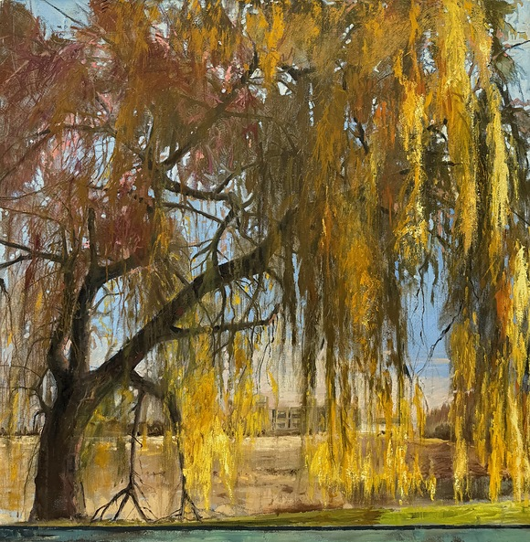
Caron Buckingham-Rhyder - Between Root and Sky
4th - 16th August - Oxmarket Contemporary
Oxmarket Contemporary is delighted to welcome back Caron Buckingham-Rhyder, ten years after her first exhibition with us.
A self-confessed dendrophile, Caron has long been fascinated by trees and their enduring presence in the landscape. Through painting and sculpture, she explores the ways in which trees connect us to place, memory and time.
MORE

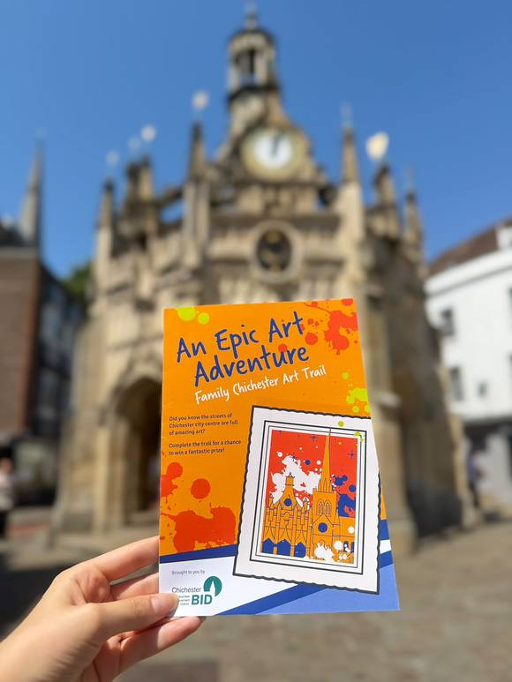
Chichester Family Art Trail
until 1st September - Chichester City Centre
Discover Chichester's vibrant arts and cultural scene with this free Family Art Trail, designed to celebrate a landmark year for the city's cultural organisations. Suitable for all ages, the trail takes families on a colourful journey through the city, visiting venues including Chichester Cathedral, Pallant House Gallery, Oxmarket Contemporary, Graffiti Street and Artisan Gallery.
MORE

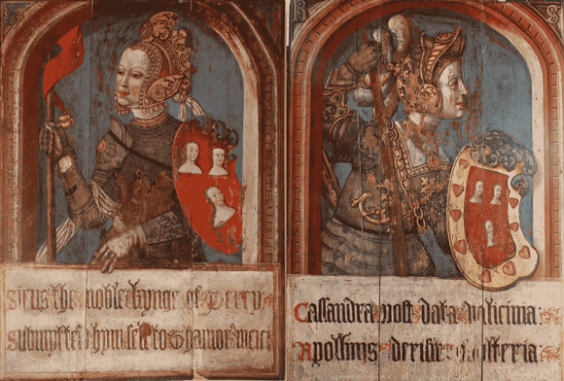
Tudor Cultural Heroines and The Amberley Panels
4th August The Novium Museum, Chichester
This one-hour talk, led by Professor Anthony Musson (Historic Royal Palaces) and Professor Kate Giles (University of York) from the Henry VIII on Tour project, will look at The Amberley Panels in the context of Henry VIIIs Royal Progress to Sussex in July and August 1526
MORE


Selsey Lifeboat Week
until 2nd August. Selsey Lifeboat Station
Lifeboat Week brings together families, visitors and supporters to celebrate the work of the RNLI while raising funds to help save lives at sea.
The events will feature a range of family-friendly activities, entertainment and opportunities to learn more about the RNLI's lifesaving work along our coastline.
MORE




Madhurst
1st - 31st August Midhurst
MADhurst is a vibrant community celebration of music, arts and culture in Midhurst, West Sussex, the heart of The South Downs National Park.
Get ready for a vibrant celebration of music, arts and drama as MADhurst returns to Midhurst with a fantastic programme of events and activities. From live performances and exhibitions to workshops and family-friendly fun, theres plenty to look forward to in the months ahead.
MORE



 | 

Summer Sessions
Wednesdays until 21st August
Whether you're here for a show or just looking to soak up live music on a sunny evening in Chichester, grab a drink and meet us on Oaklands Park for these free sessions.
Conor Clements Band - 31 July 6.15pm
Inspired by an eclectic mix of influences ranging from folk music to modern pop, listeners should expect songs which turn mundane events into whimsical stories. Pulling together classic songwriting elements combined with a modern undertone, Conor weaves together elements of daily life, dreams and romantic memories to create relatable and compelling songs
Fleur & Emily - 7 August 6.15pm
We're Fleur and Emily. We met a few years ago through working at CFT and have since become not only great pals but singing partners too! We'll be singing some jazzy covers and familiar favourites and hope to see you out in the sunshine this summer to join us for some feel-good tunes!



Saywell International Charity Supercar Trackday - Beds for Kids
8th August - Goodwood Motor Circuit
V2 Radio is helping host the Saywell International Charity Supercar Track Day at the Goodwood Racetrack. This is a free event which is perfect for families, petrolheads or anyone looking for a fabulous way to spend a Saturday supporting the local community - and there are cracking raffle prizes to make the day even better!
MORE


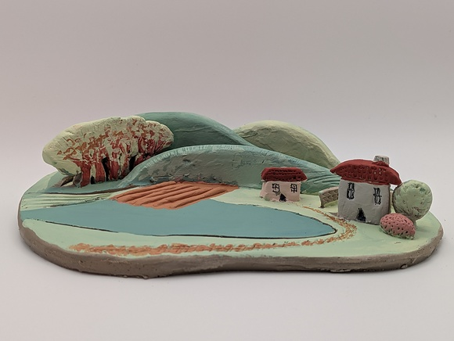
Children's Workshop | Summer Art Club
5th August - Pallant House Gallery
Inspired by Paul Nashs works in British Landscapes: A Sense of Place, come and sculpt a 3D relief clay landscape, with rolling hills, bendy trees, winding rivers, homely houses and even wild animals.
Guided by an experienced artist educator, participants will develop their clay-making skills by learning a range of techniques. These include rolling out a slab, building up the surface, and adding texture and detail, using tools and paint for the finishing touches.
MORE



Loxwood Joust
1st - 16th August - Loxwood Meadow
Each summer, within the open-world realm of the Kingdom of Loxwood, a great celebration unfolds. The Loxwood Joust. It is a festival of spectacle, story, and participation, where music, laughter, and the clash of steel fill the air. Across three weekends, knights take to the arena, jesters tumble through the crowds, and souls of every kind gather to feast, forge, and revel together beneath the Sussex skies
MORE




Marketing and Communications Officer
The Novium Museum and Tourist Information Office
Would you like to play an important role in Chichester's award winning The Novium Museum and Tourist Information Centre?
We are looking for a creative and highly motivated Marketing and Communications Officer to join our dedicated and friendly team, based in the centre of Chichester. This position provides an exciting opportunity to promote the wide range of heritage and tourism services delivered by The Novium Museum and Tourist Information Centre team.
Apply by 13/08/2026
MORE INFO AND TO APPLY



WIN a Family Ticket to Chichester Cinema's Open Air Screenings!
Summer evenings under the stars, popcorn in hand, big screen glowing — it doesn't get much better. We've got a family ticket (2 adults + 2 kids) to give away for Chichester Cinema's open air screenings, and the lucky winner gets to pick from the brilliant films on offer.
Competition closes Wednesday 5th August. Winner will be notified by DM so PLEASE make sure to monitor or we will select another winner. Good luck!
Hop over to our Instagram page to enter

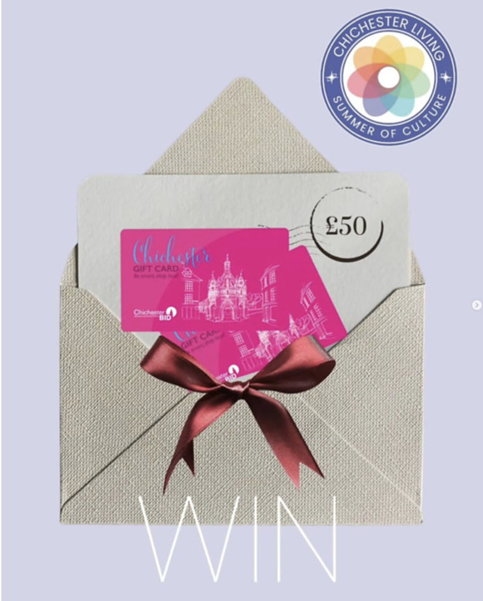
WIN a £50 Chichester Gift Card!
Fancy treating yourself (or someone special) to the best of Chichester? We've teamed up to give one lucky follower a £50 Chichester Gift Card — accepted at over 160 city centre businesses, from independent shops and restaurants to cafés and hair & beauty spots.
Shop local, support local, and make a difference — while treating yourself to something lovely!
With thanks to Chichester BID for their generous support
Closes Friday 7th August
Hop over to our Instagram post to enter

Promote Your Event
Add your own event to our calendar - here's how
1. Click the link at the base of the home page "Submit an Event"
2. Create a login account if you don't already have one
3. Complete the form with the details of your event, ensuring that you have added an image and a short description along with the other important information. Please use plain, unformatted text and use the formatting tools in the form.
Kindly note that events will not be made live if they do not include a short text description and image. Images should be .pmg or .jpeg NOT pdf

Newsletters 2026  January week 1  January week 2  January week 3  January week 4  January week 5  February week 1  February week 2  February week 3  February week 4  March week 1  March week 2 | Newsletters 2026  March week 3  March Week 4  April Week 1  April Week 2  April Week 3  April Week 4  Summer of Culture  May Week 1  May Week 2  May Week 3 | Newsletters 2026  May Week 4  June Week 1  June Week 2  June Week 3  June Week 4  July Week 1  July Week 2  Win (Fontwell)  July Week 3  July Week 4  Win (Outdoor Film)



powered by BoxStuff rapportUnsubscribe from this mailing

