

The summer speeds along.....
Can it really be 'glorious Goodwood' next week? As you would expect there is only limited availability now so do hurry to book if you are planning to go.
The Festival of Chichester has ended for another year with another packed 5 weeks of music, theatre, walks and talks and much more. Time to start thinking about joining the fun next year as the dates have just been finalised : 12th June -18th July 2027
The Petworth Festival is in full swing until the 1st August with many events sold out, so don't miss out. The baton will then be passed to Arundel whose festival begins on the 22nd but with a few pre festival events the previous week.
America 250 at the West Sussex Record office is proving very popular and the next two events to see the American Declaration of Independence are already sold out.
Two deadlines not to miss:
Calling all teenage authors - don't forget the deadline is the 31st July to send your first chapters in to the Children's Bookfest. (See below)
And - applications for the Business Funding programme run by Chichester District Council also need to be submitted by the 31st July. Read more.
Over at the Festival Theatre, the musical, My Fair Lady, is wowing audiences with this well loved classic whilst the thought provoking and award-winning Atlantis offers a completely different theatrical experience and runs until the 15th August.
If you have budding musical theatre stars in your family there is a fabulous opportunity to spend a week exploring all aspects of singing, dancing and acting with the Summer Musical Activity Week - just a few spaces left. (See below)
Don't forget that a website sits behind this missive with loads of events, news, experiences and articles. Follow this link to see the calendar of events for the rest of July

Have a great week
Vicki
Founder/Editor

The summer speeds along.....
Can it really be 'glorious Goodwood' next week? As you would expect there is only limited availability now so do hurry to book if you are planning to go.
The Festival of Chichester has ended for another year with another packed 5 weeks of music, theatre, walks and talks and much more. Time to start thinking about joining the fun next year as the dates have just been finalised : 12th June -18th July 2027
The Petworth Festival is in full swing until the 1st August with many events sold out, so don't miss out. The baton will then be passed to Arundel whose festival begins on the 22nd but with a few pre festival events the previous week.
America 250 at the West Sussex Record office is proving very popular and the next two events to see the American Declaration of Independence are already sold out.
Two deadlines not to miss:
Calling all teenage authors - don't forget the deadline is the 31st July to send your first chapters in to the Children's Bookfest. (See below)
And - applications for the Business Funding programme run by Chichester District Council also need to be submitted by the 31st July. Read more.
Over at the Festival Theatre, the musical, My Fair Lady, is wowing audiences with this well loved classic whilst the thought provoking and award-winning Atlantis offers a completely different theatrical experience and runs until the 15th August.
If you have budding musical theatre stars in your family there is a fabulous opportunity to spend a week exploring all aspects of singing, dancing and acting with the Summer Musical Activity Week - just a few spaces left. (See below)
Don't forget that a website sits behind this missive with loads of events, news, experiences and articles. Follow this link to see the calendar of events for the rest of July

Have a great week
Vicki
Founder/Editor




Come and Meet the Experts!
24th July - Fishbourne Roman Palace
Come and meet our amazing experts on July 24th and experience life as an archaeologist for a day! Meet brilliant experts from all across Sussex, learn about their latest exciting discoveries, and explore some fascinating regional finds.
MORE...


The Ibiza Orchestra Experience
24th July - Westgate Fields, Chichester
Expect iconic Ibiza anthems performed live by a 26-piece orchestra, alongside huge support acts, laser shows, pyrotechnics, fire performers, stilt walkers and a vibrant festival atmosphere for one unforgettable summer night
MORE


The Sausage and Cider Festival
25th July Westgate Fields, Chichester
A full day of live music, food and festival fun, headlined by Scouting for Girls. Festivalgoers can enjoy 30+ cider flavours, craft drinks, and over 20 sausage varieties, alongside live entertainment, eating competitions and a vibrant festival market.
MORE


Summer in Nashville - Country Music Festival
26th July Westgate Fields, Chichester
Expect a full day of live country music, tribute performances celebrating artists like Luke Combs, Dolly Parton and Johnny Cash, plus line dancing, American BBQ, rodeo bull rides, axe throwing and more.
MORE


Shamrock Irregulars Gig
25th July Fernleigh, North Street, Chichester
A magical summer evening filled with the lively sounds of Ireland! Enjoy live acoustic Irish music performed by the talented Shamrock Irregulars.
Weather permitting, the music will fill the lawn, and you can savour a delicious BBQ under the open sky. Bring your friends, relax with a drink, and soak up the atmosphere of great music, good food, and summer vibes.
MORE

 | Sidlesham Fete  25th July - The Church Field, Sidlesham  Whether you're looking for family entertainment, a chance to catch up with friends, discover local organisations, or simply enjoy great music and good food, the Sidlesham Fete has something for everyone.  MORE


Southern Ceramic Group Summer Exhibition
25th July - 9th August The Great Kitchen, Bishops Palace, Chichester
70 local makers are featured at this curated selection of ceramics hosted in the beautiful Great Kitchen, Bishops Palace next to Chichester Cathedral. In excess of 700 individual and unique pieces of work will be exhibited and available for you to purchase on the day.
MORE

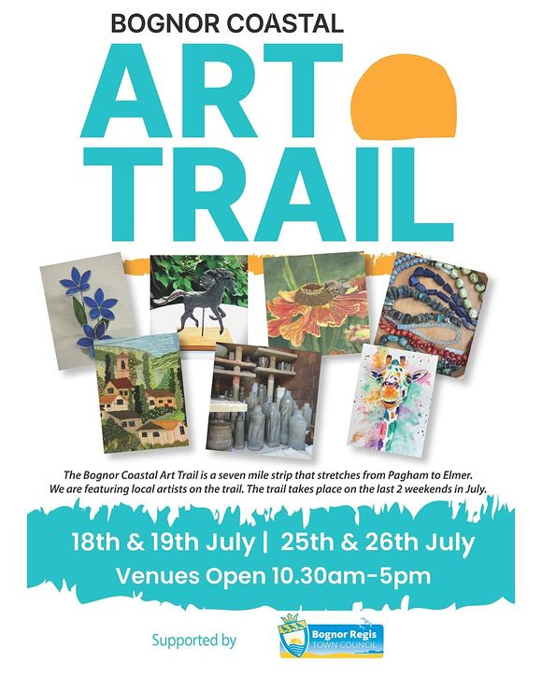
Bognor Coastal Art Trail
25th - 26th July
Bognor coastline - Pagham to Elmer
An incredible display by 35 artists in 24 venues across the Bognor coastline - from Pagham to Elmer. Open Sat 25th and Sunday 26th July 2026 from 10.30am to 5pm each day. You'll find anything from paintings to porcelain, glass to metal to jewellery.
MORE


Qatar Goodwood Festival
28th July - 1st August
The world famous five-day festival, affectionately known as Glorious Goodwood, is one of the undisputed highlights of the British flat racing season. It's a social and sporting occasion like no other, where some of the greatest stars in horse racing are crowned.
MORE


Summer Theatre - The Pirates of Penzance
28th July - Weald and Downland Living Museum
Frederick was born in a leap year on 29th February and is contracted to the Pirate King until his 21st BIRTHDAY, not his 21st year. Can the inept Penzance constabulary protect him? How will he endure a life of crime until he is 84? And will his sweetheart, Mabel, wait for him that long? Packed with hilarious melodrama, sharp satire and glittering wit and as fresh as if it had been written today.
MORE

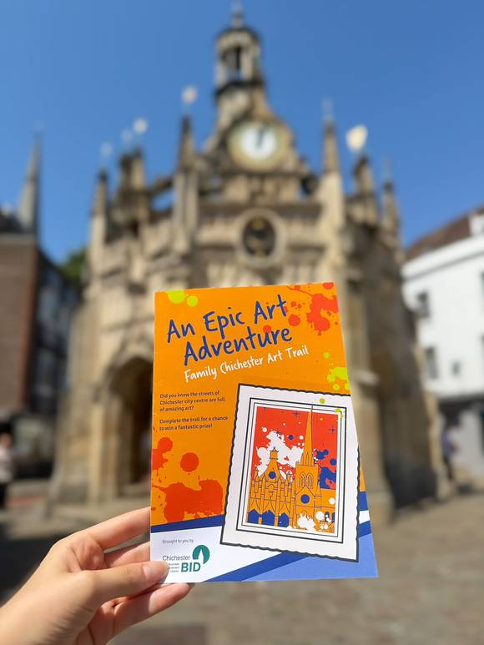
Chichester Family Art Trail
until 1st September - Chichester City Centre
Discover Chichester's vibrant arts and cultural scene with this free Family Art Trail, designed to celebrate a landmark year for the city's cultural organisations. Suitable for all ages, the trail takes families on a colourful journey through the city, visiting venues including Chichester Cathedral, Pallant House Gallery, Oxmarket Contemporary, Graffiti Street and Artisan Gallery.
MORE


Summer Barn Dance
1st August Aldingbourne Country Centre
Get ready for an evening of foot-stomping fun, live music, and a bouncy castle at our Summer Barn Dance - featuring professional barn dance callers to guide you through every lively step!
Whether you're a confident dancer or a first-timer, our friendly callers will have everyone up and moving. It's the perfect way to celebrate summer with family and friends!

MORE

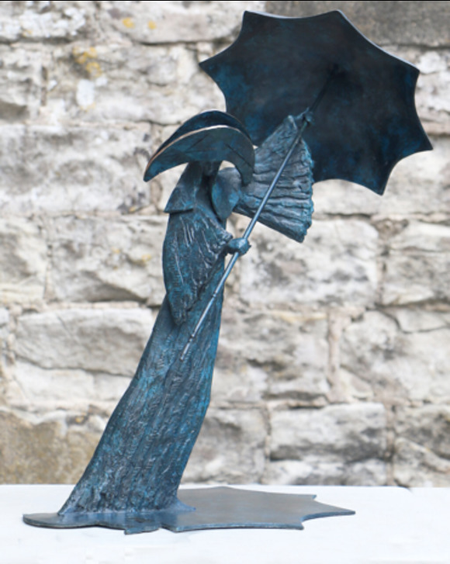
Oxmarket Contemporary 50th Retrospective Exhibition
until 2nd August. Oxmarket Contemporary, Chichester
2026 marks a significant milestone for Oxmarket Contemporary as we celebrate 50 years as an art gallery in Chichester. To commemorate this achievement, we are presenting a major four-week Retrospective Exhibition throughout July, spanning both the John Rank Gallery and the Wilson Gallery.
MORE
Read our 'Discover' article about the gallery


Sundown Sessions At the Pavilion
Fridays and Saturdays until 12th September - The Pavilion, Graylingwell Park, Chichester
A relaxed summer evening to enjoy great cocktails, and delicious deli boards and nibbles. To kick off the evening, we're offering buy one, get one free on all drinks during the first hour, making it the perfect opportunity to meet friends, unwind, and soak up the atmosphere.
MORE




Summer Musical Theatre Activity Week
27th July - 1st August - Chichester Festival Theatre
Join us for our Musical Theatre Activity Week this summer holiday!
A week-long workshop for young people aged 10-14, delivered by leading industry professionals. Participants can explore and develop their acting, singing and dancing skills in a fun, creative environment whilst working towards a short, informal sharing on the Friday. Spend one of the mornings exploring behind the scenes of the Festival Theatre on an official Backstage Tour and an afternoon with some special guests from the cast of our summer musical. Running from 9.30am - 4.30pm on Monday 27 July to Friday 31 July, with a trip to the matinee performance of My Fair Lady on Saturday 1 August (you'll even be treated to a programme and an ice-cream!).
MORE



Women of WW2
28th July - Sage House, Tangmere
Join us for this inspiring talk that uncovers the remarkable stories of ordinary women who rose to extraordinary challenges during the Second World War. The presentation explores the essential roles, sacrifices and responsibilities undertaken by women from all walks of life, highlighting the courage, resilience and determination that proved vital both on the home front and beyond.
MORE


An evening with Robin Cousins
1st August - The Nest at Chichester Festival Theatre
In Aid of the Sussex Snowdrop Trust
Robin Cousins MBE OLY, Olympic Champion and former British & European Champion and World Gold Medalist will deliver an illustrated talk about his fascinating career as a figure skater.
Robin is an inspiration in free skating , he has also been a guest presenter and commentator for BBC Sport, European & World Skating Championships and the Winter Olympics and is a brilliant speaker.
MORE



Stitching & Visible Mending, Boro & Sashiko Workshop
25th July - Clothkits, Chichester
Join us for a Slow Stitch and Visible Mending Techniques class here with the fantastic Charlotte from A Nest of Gentle Makers.
MORE



Drawing the Story - Children's Workshop
25th July - The Novium Museum, Chichester
(for children aged 7-11 years)
Drawings bring stories to life and in this workshop children will develop their drawings based on traditional stories to create a character and a scene from the story.
MORE




Volunteer Opportunities with The Chichester Society
The Chichester Society exists to enhance Chichester and protect its heritage. It is playing an increasingly productive and collaborative part in the fabric of the city. They are looking to fill two posts:
- A General Secretary
The main task is to organise and manage the yearly AGM.
- An Editor of Chi Socs quarterly newsletter
This is collaborative role, since there is a board, largely made up of contributors and ideas people. Specifically, the editor agrees content, chases contributors and achieves the print date.
Enquiries about both posts can be addressed to the Chair, Sir Mark Featherstone-Witty





WIN a £50 Chichester Gift Card!
Fancy treating yourself (or someone special) to the best of Chichester? We've teamed up to give one lucky follower a £50 Chichester Gift Card — accepted at over 160 city centre businesses, from independent shops and restaurants to cafés and hair & beauty spots.
Shop local, support local, and make a difference — while treating yourself to something lovely!

With thanks to Chichester BID for their generous support
Hop over to our Instagram post to enter

Promote Your Event
Add your own event to our calendar - here's how
1. Click the link at the base of the home page "Submit an Event"
2. Create a login account if you don't already have one
3. Complete the form with the details of your event, ensuring that you have added an image and a short description along with the other important information. Please use plain, unformatted text and use the formatting tools in the form.
Kindly note that events will not be made live if they do not include a short text description and image. Images should be .pmg or .jpeg NOT pdf

Newsletters 2026  January week 1  January week 2  January week 3  January week 4  January week 5  February week 1  February week 2  February week 3  February week 4  March week 1 | Newsletters 2026  March week 2  March week 3  March Week 4  April Week 1  April Week 2  April Week 3  April Week 4  Summer of Culture  May Week 1  May Week 2 | Newsletters 2026  May Week 3  May Week 4  June Week 1  June Week 2  June Week 3  June Week 4  July Week 1  July Week 2  Win (Fontwell)  July Week 3



powered by BoxStuff rapportUnsubscribe from this mailing

