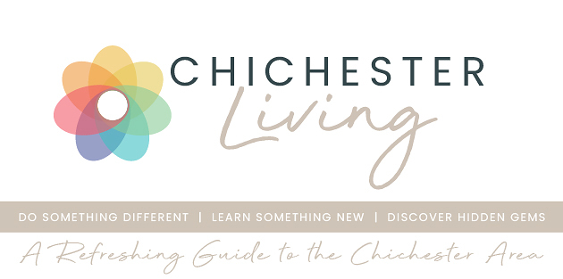
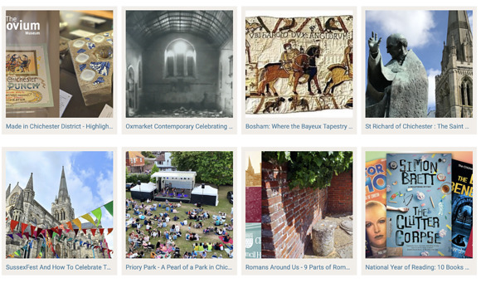
ALL ABOUT US.....
We receive some lovely emails thanking us for the newsletters but, in addition, we have had several people advise/comment that they are too long. So we are shortening it this week and we will just give an introductory sentence against each event. This means that you can quickly scroll down and then click through to learn more for the particular items of interest to you. We will then intersperse these newsletters with irregular one item mailings with special offers, competitions or early bird ticket offers.
Do let us know what you think.
We have made quite a few changes and additions recently so I'm dedicating this space to recap how you can find information and best benefit from Chichester Living.
Discover.....our newly designed blog, renamed Discover is in the image above. It brings you a variety of items about the area - some hidden gems and lesser known facts for you to... discover
Featured Experiences.....a new section bringing you a variety of things to eat, drink, play and enjoy
Summer of Culture.....bringing together all cultural items in the calendar until the 1st September
News...... does what it says on the tin. Press releases and news items from major stakeholders and councils
Anniversaries.... a list of significant anniversaries in 2026 both local and national
Annual Events..... the major fixtures in the local calendar to allow you to plan according.
Directory.... profiles of the major contributors to the site. When they have events in the calendar they also appear against their listing.
Calendar.... literally hundreds of events over the coming months. These can be sorted under different categories which are colour coded. You can filter as either a scrolling view of upcoming events or a month view which is an easy way to check a particular date. You can even combine a category with a month view e.g. all the art events in July.
Enjoy exploring the site
Vicki
(ps - do tell your chums...)
ALL ABOUT US.....
We receive some lovely emails thanking us for the newsletters but, in addition, we have had several people advise/comment that they are too long. So we are shortening it this week and we will just give an introductory sentence against each event. This means that you can quickly scroll down and then click through to learn more for the particular items of interest to you. We will then intersperse these newsletters with irregular one item mailings with special offers, competitions or early bird ticket offers.
Do let us know what you think.
We have made quite a few changes and additions recently so I'm dedicating this space to recap how you can find information and best benefit from Chichester Living.
Discover.....our newly designed blog, renamed Discover is in the image above. It brings you a variety of items about the area - some hidden gems and lesser known facts for you to... discover
Featured Experiences.....a new section bringing you a variety of things to eat, drink, play and enjoy
Summer of Culture.....bringing together all cultural items in the calendar until the 1st September
News...... does what it says on the tin. Press releases and news items from major stakeholders and councils
Anniversaries.... a list of significant anniversaries in 2026 both local and national
Annual Events..... the major fixtures in the local calendar to allow you to plan according.
Directory.... profiles of the major contributors to the site. When they have events in the calendar they also appear against their listing.
Calendar.... literally hundreds of events over the coming months. These can be sorted under different categories which are colour coded. You can filter as either a scrolling view of upcoming events or a month view which is an easy way to check a particular date. You can even combine a category with a month view e.g. all the art events in July.
Enjoy exploring the site
Vicki

(ps - do tell your chums...)



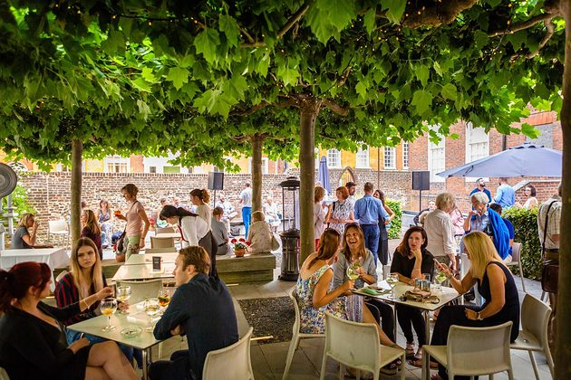
Thursday Lates
16th July - Pallant House Gallery
We stay open until 8.30pm once a month, inviting you to explore the collection and exhibitions after hours. Pallant Café will be open throughout the evening serving food and drinks, and the Pallant House Gallery Bookshop is stocked with art books, prints and gifts.
MORE

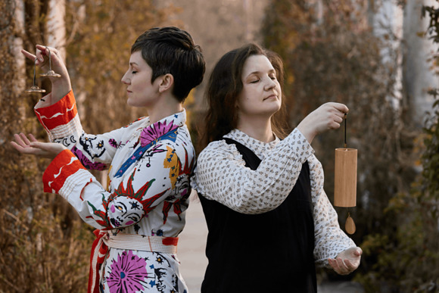
Serene Sounds: Classical Music Sound Bath
18th July - Chichester City Arts Centre
Serene Sounds blends soothing sound bath vibrations with classical voice and piano, featuring music by Debussy, Ravel, and Strauss. Award-winning duo Eleanor Penfold (Soprano) and Elena Toponogova (piano) lead this enchanting, meditative experience.
MORE

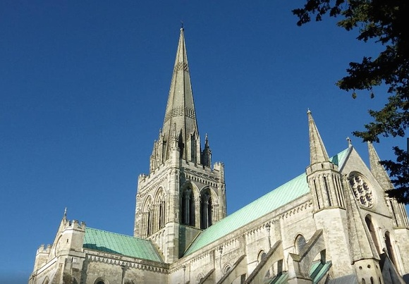
Southern Cathedrals Festival
17th - 19th July Chichester Cathedral
The Festival brings together the combined choirs of Chichester, Salisbury and Winchester Cathedrals for four days of concerts, recitals and services in the Cathedral and venues across the city centre.
MORE

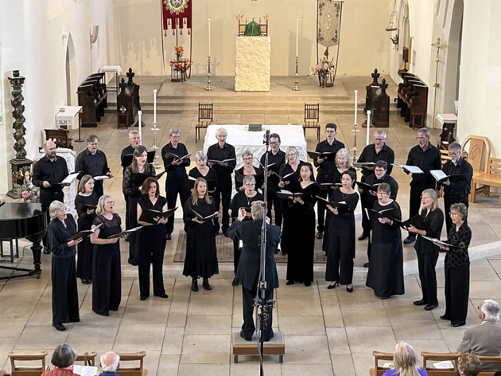
Songs of Hope: 50th Anniversary Concert
18th July Boxgrove Priory Church
The Renaissance Choir is celebrating its 50th anniversary in 2026 with a series of special concerts. The repertoire includes examples of the choir's development over its 50 year life.
MORE

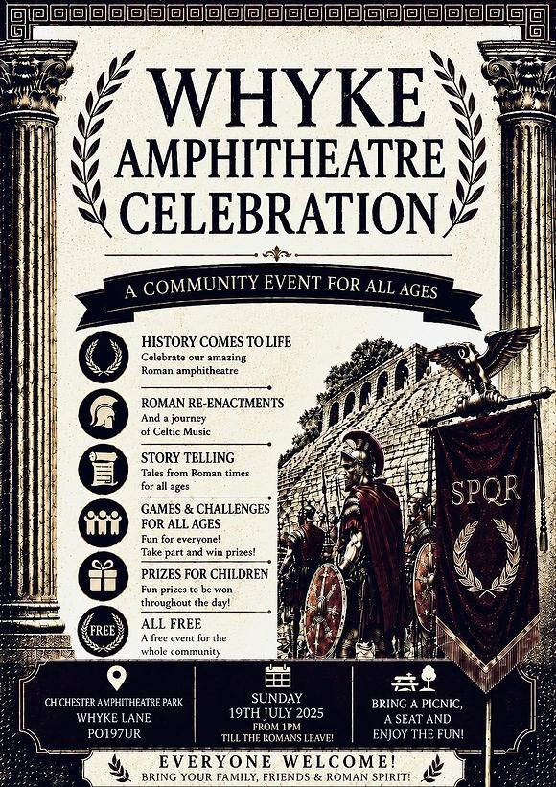
Whyke Amphitheatre Celebration
18th July Chichester Roman Amphitheatre
Whyke Amphitheatre Celebration is a free community event on Chichester Roman Amphitheatre.
Celebrating the long history of the remains of the Amphitheatre situated just outside the city walls
MORE

 | Upstairs @ Raps with The Eddy Smith Duo  21st July - Rapscallions, Chichester  Eddy Smith of Eddy Smith and the 507 captivates with a husky voice, tasteful piano accompaniment and soulful songs that linger long after the final note.  MORE

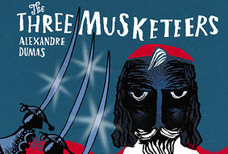
Summer Theatre - The Three Musketeers
22nd July Weald and Downland Living Museum
All for One; One for All! Young DArtagnan is determined to join Athos, Porthos and Aramis as an elite Musketeer of the Kings Guard. Set against a sweeping panorama of 17th century France at war, this production is a whirlwind of scheming, romance and broad comedy and the finest swashbuckling in the business
MORE


Sunlight Trail
23rd July - Starts at the Novium
Summer inspired craft activities across three city centre venues- The Novium Museum, Chichester Cathedral and Chichester Library- including Elmer -themed crafts at The Novium Museum. Choose where to start your trail, you will be emailed the route of your trail before the day.
MORE

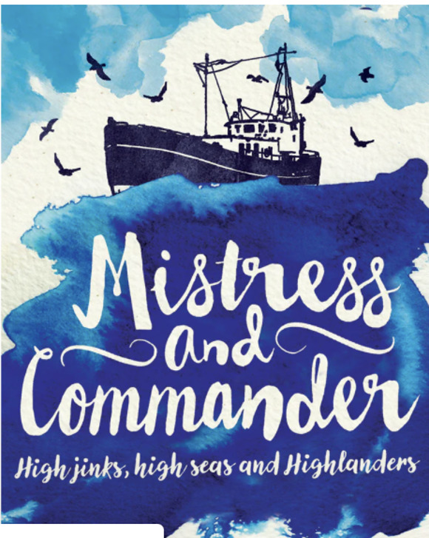
The Job that Made Me, with Amelia Dalton
23rd July - Talks at Six - Bassil Shippam Centre, Chichester
Amelia tells tales from her seafaring life story, an inspiring tale of hope over tragedy taking her from grouse moors and hunt balls of Yorkshire to a life of international expeditions around coasts and islands from the Arctic Circle to Borneo
MORE


The Eights
23rd July - Assembly Room, Chichester
An Evening of wine & conversation with author Joanna Miller. This highly enjoyable novel, with its atmospheric snapshot of Oxford, and celebrating the power of female friendship, is set to become a modern classic.
MORE


The Ibiza Orchestra Experience
24th July Westgate Fields, Chichester
Following a sell-out UK tour in 2025, the Ibiza Orchestra Experience returns to Chichesters Westgate Fields for its biggest show yet.
MORE

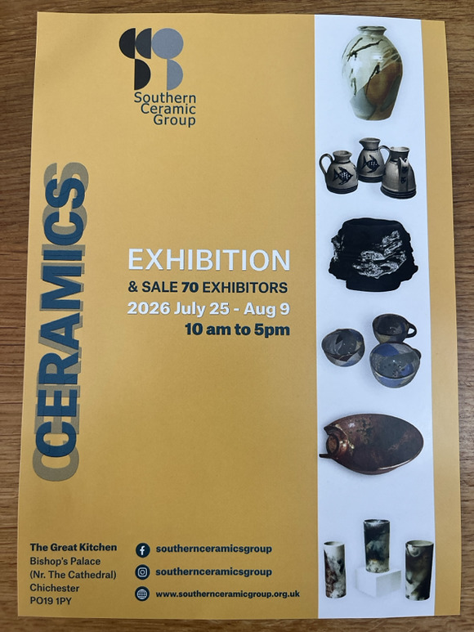
Southern Ceramic Group Summer Exhibition
25th July - 9th August. The Great Kitchen, Bishop's Palace, Chichester
70 local makers are featured at this curated selection of ceramics hosted in the beautiful Great Kitchen, Bishops Palace next to Chichester Cathedral.
MORE


The Sausage and Cider Festival
25th July - Westgate Fields, Chichester
The Sausage & Cider Festival returns to Chichesters Westgate Fields on Saturday 25th July 2026 for a full day of live music, food and festival fun, headlined by Scouting for Girls
MORE




My Fair Lady in all her glory
Through our Summer of Culture project we are able to bring you not only the musical but other associated events - My Fair Lady on Film, A talk about George Bernard Shaw on film and a touch tour of the set for the visually impaired.
MORE



Sage House Summer Fair
25th July - Sage House, Tangmere
Enjoy a wonderful morning of live entertainment from a talented singer, a delicious BBQ, homemade cakes, and a fantastic selection of stalls offering local crafts, gifts and treats.
MORE


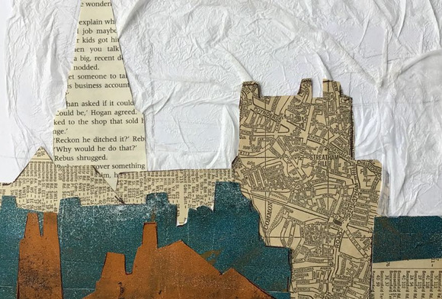
Chichester Collage Workshop
18th July - The Novium, Chichester
Spend a creative day exploring Chichester's historic architecture and creating your own collage artwork, with guidance from local artist Sue Webber throughout
MORE


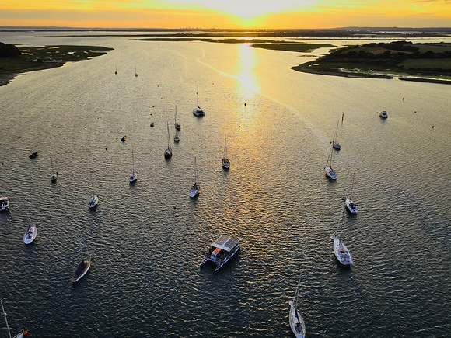
Seascape Painting
18th July - departs Itchenor
A guided boat trip on Solar Heritage. Capture the beauty of Chichester Harbour National Landscape from the water with guidance from local artist, Nic Cowper.
MORE




WIN TICKETS TO FONTWELL PARK'S LADIES EVENING!
Get your glam rags ready, because we've got a seriously glamorous giveaway for you...
We're giving away 2 pairs of tickets (4 tickets total — 2 winners!) to Fontwell Park's Ladies Evening on Friday 28th August 2026
Think thrilling jump racing, show-stopping Style Awards, a live Take That tribute, DJ sets, and a drone show finale lighting up the summer sky. It's a great night out on the Sussex social calendar — and we want two lucky followers (plus a friend each!) to be there in style.
Head over to our Instagram page to enter

Promote Your Event
Add your own event to our calendar - here's how
1. Click the link at the base of the home page "Submit an Event"
2. Create a login account if you don't already have one
3. Complete the form with the details of your event, ensuring that you have added an image and a short description along with the other important information. Please use plain, unformatted text and use the formatting tools in the form.
Kindly note that events will not be made live if they do not include a short text description and image. Images should be .pmg or .jpeg NOT pdf

Newsletters 2026  January week 1  January week 2  January week 3  January week 4  January week 5  February week 1  February week 2  February week 3  February week 4 | Newsletters 2026  March week 1  March week 2  March week 3  March Week 4  April Week 1  April Week 2  April Week 3  April Week 4  Summer of Culture  May Week 1 | Newsletters 2026  May Week 2  May Week 3  May Week 4  June Week 1  June Week 2  June Week 3  June Week 4  July Week 1  July Week 2  Win tickets to Fontwell



powered by BoxStuff rapportUnsubscribe from this mailing

