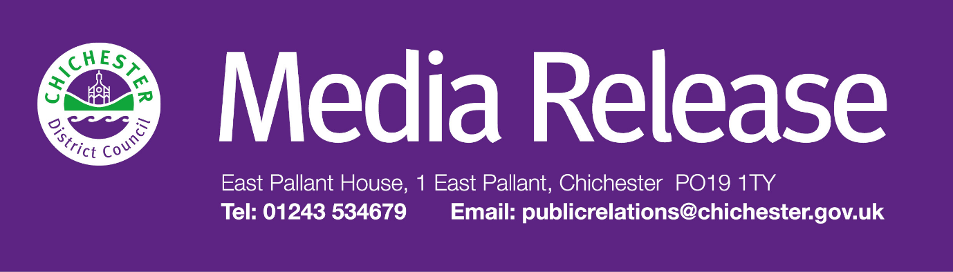
Date of Release: 12 May 2026 Ref: 4592
Government launches further consultation on local government reorganisation in Sussex
The Government has today (12 May) launched a further consultation on options for local government reorganisation in Sussex.
Following feedback from the previous consultation, which opened in November, the Government is now seeking views on two additional options. These are based on modifications to proposals previously submitted by local authorities in Sussex.
The consultation will run until 23.59 on 15 June and can be accessed at: https://consult.communities.gov.uk/local-government-reorganisation/west-sussex-two-unitary-proposal-modification/
In West Sussex, the additional proposal involves the creation of two unitary authorities. One authority would bring together Chichester District, Crawley Borough, Horsham District and Mid Sussex District, serving a population of approximately 566,000. The second would combine Arun District, Adur District and Worthing Borough, with an estimated population of 349,000.
A further option has also been proposed for East Sussex and Brighton & Hove, again based on two unitary authorities. Under this model, Brighton & Hove would be combined with parts of Lewes District, including the wards of East Saltdean and Telscombe Cliffs, Peacehaven West, Peacehaven East, Peacehaven North, and Falmer Parish, creating an authority serving around 308,000 residents. A second authority would include Eastbourne Borough, Hastings Borough, Rother District, Wealden District and the remaining areas of Lewes District, with a population of approximately 537,000.
As part of the consultation, respondents will be asked whether these modified options would deliver more effective unitary local government arrangements than those previously proposed.
All earlier proposals that were previously consulted on remain under consideration. These include the two options put forward by all eight West Sussex councils. One was for a single unitary authority covering the whole of West Sussex, which was supported by West Sussex County Council. The other was for two unitary authorities in West Sussex – one which would include Chichester District, Arun District, Worthing Borough and Adur District and the other covering Horsham District, Mid Sussex District and Crawley Borough. This option was supported by all of the district and borough councils in West Sussex.
Other proposals included a single unitary authority for the East Sussex area, developed collaboratively and supported by most East Sussex councils, as well as a separate proposal from Brighton & Hove City Council suggesting the creation of five unitary authorities across Sussex. This included placing Chichester District with Horsham District and Crawley Borough; Brighton & Hove with parts of Lewes; Eastbourne with Hastings, Rother plus parts of Lewes and Wealden; Mid Sussex District with parts of Wealden and Lewes; and finally, Arun District with Adur District and Worthing Borough.
Responses to both consultations will be reviewed by Ministers ahead of a final decision which is expected in the summer.
Cllr Adrian Moss, Leader of Chichester District Council, said:
“The Government has reviewed the feedback from its previous consultation for local government reorganisation in Sussex and has asked for further evidence and views to ensure that any proposals taken forward reflect the identities, geography and needs of local communities.
“As people will be aware, we have worked closely with all West Sussex councils to develop proposals that meet the Government’s criteria, and these were included in the first consultation. This was shaped by extensive engagement with residents, businesses, community groups, and council staff.
“We are now encouraging people to take part in this further consultation to make their views known on the additional options that are now being considered. This is the final chance for people to have their say before the Government decides on how local government will be reorganised within Sussex.
“Once a decision has been made, we will continue to work to the original timetable, with elections for the new authorities taking place in 2027 ahead of their formal launch in 2028. Until then, it remains business as usual, with residents and businesses continuing to access services as normal.
“We are continuing to work closely with the rest of the councils in West Sussex and are committed to keeping our residents, businesses, partners and staff regularly updated.”
Hard copies of the consultation are available at council offices for those who are unable to respond online. They will also be available at libraries across West Sussex from 19 May.
Further information about local government reorganisation, including more information about the West Sussex Business case can be found at www.chichester.gov.uk/devolution and www.shapingwestsussex.org
For further information, please contact Sarah Parker, Communications Manager on 01243 534537 or by emailing: sjparker@chichester.gov.uk

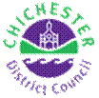 | Terri Foster  Senior Communications Officer  Communications  Chichester District Council

Ext: 21226 | Tel: 01243521226 | tfoster@chichester.gov.uk | https://www.chichester.gov.uk
East Pallant House opening hours: 9am-4pm Monday to Friday

________________________________________________________________________

