

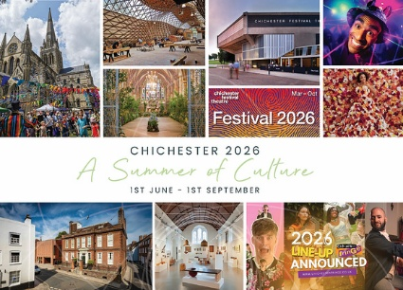
Chichester Living is delighted to launch a new digital space bringing together a wide range of cultural activities across the area.
Under the images below we give a brief description of each section.
The image above is of a postcard that we have had printed to promote the Summer of Culture. If you would like some to send out or display at your venue then get in touch
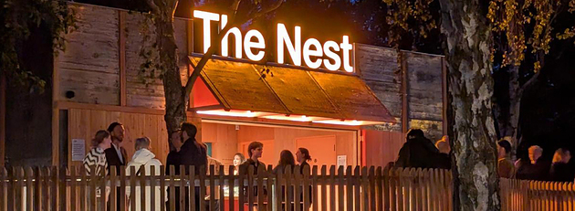
A slide show of images provided by contributors to the Summer of Culture

The 8 categories that will be displayed in this section. Click on any one and you will see those events filtered for you. Combine it with the month view and you will see that category across the month - for example Art in the month of May
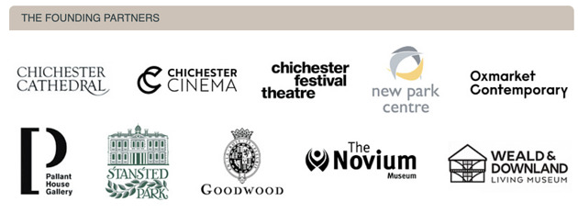
Chichester Living is grateful for the support and encouragement for this project shown by the 10 founding partners above. Their content will provide the backbone of this section and will be supplemented by local festivals and independent performers and artists.

The featured events section above will enable us to spotlight events that have a common theme or are linked in some way. The first local festival of the summer is the Chichester Fringe and we are pleased to spotlight some of their events above. Each image links through to more details of the event. The full Chichester Fringe programme is brought together under a special tag. View it here
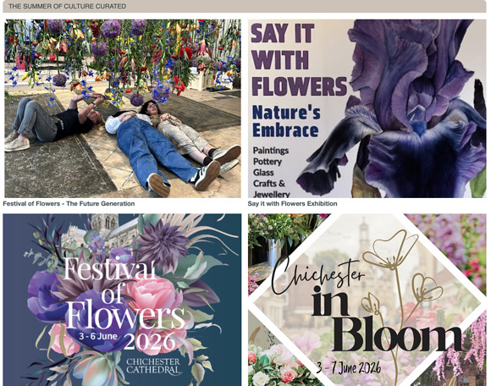
In the final section we are able to curate ideas, articles and events that explore a current theme. We have chosen various articles and events linked to the Festival of Flowers at Chichester Cathedral which celebrates its 30th anniversary this year. Each image links through to the relevant event or article.

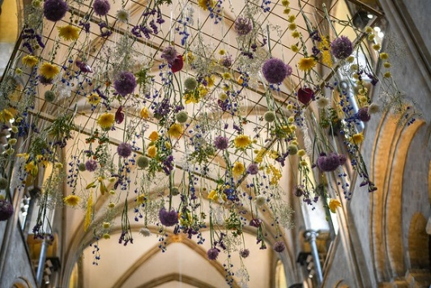
We are so excited to bring you the chance to win a day out for two at the Festival of Flowers!
Help us to spread the word for our new Instagram page and you might be lucky enough to win tickets for you and a guest to see the spectacular flower displays at this beloved biennial event
To enter:
Follow @chichesterliving on Instagram
Like this post
Tag a friend who would like to come too!
Good luck!
Closing date: Midnight UK time on Sunday 24th May
T&Cs. Prize is for 2 x tickets to Chichester Cathedral's Festival of Flowers 2026 for any day of the Festival (3-6 June 2026).
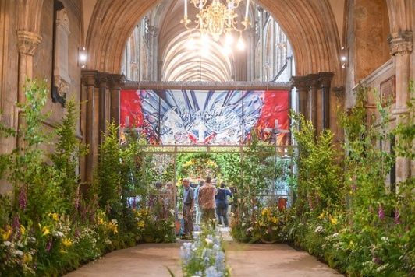
Chichester Living would like to express thanks to Chichester City Council for their support for this project.
powered by BoxStuff rapportUnsubscribe from this mailing

