

Friday Farmers" Market
We will be back at the farmers market tomorrow (Friday 3rd) to promote the Summer of Festival, the Festival of Chichester and many other events besides. Do come and say hallo between 10.00 and 13.00
Competitions
We continue our Summer of Culture giveaways each week with tickets to some great experiences.
Last chance to win a family ticket to Elmer as the draw closes at midday on Friday 3rd. We are also delighted to offer you the opportunity to win two tickets to Atlantis at the Festival Theatre.
See below for more details. Our thanks to both the Novium and the Festival Theatre for their kind support.
Cost Effective
As well as winning some tickets there are some cost effective events below - in particular the Summer Street Party which returns to the City centre on the 5th July (see below) and is completely free of charge.
Stansted House are hosting a Pay What You Can Day (see below) and continue to offer 50% entry tickets to the this beautiful Edwardian mansion on 19, 20 & 21 July for Chichester Living newsletter subscribers. To book your tickets, please click here. At the checkout, please enter the code ChiLiving26 to apply the 50% discount. Pre-booked tickets only.
In addition there are lots of free art shows and open days at the Chichester Yacht Club and the new Reformed Pilates.
4th July
This date has special significance this year as it is the 250th Anniversary of the Signing of the Declaration of Independence. There are various opportunities to view it at the West Sussex Record office which are very popular but you may still get some availability.
Read our blog article about how the "Sussex Declaration' was discovered
You can also hear some stirring music from the Portsmouth Baroque Choir to celebrate the anniversary. (see below)
Heading for the Beach?
Make the most of your day by the seaside and read our essential guide to local beaches
Chichester Cathedral Light Experience
This wonderful event will return to the Cathedral in October and explore the theme Illuminating Art and it is already proving popular. In case you missed our correction last week (sorry..) there are still some early bird tickets available. You can check availability here
Chichester Festival Theatre
45 years continues at the Minerva until the 11th July and we don't have long to wait until this year's musical My Fair Lady which opens on the 6th July. In the meantime check out the item below to find out how you can experience the Edinburgh Fringe without ever leaving Sussex.
Elsewhere you can sample outdoor theatre at Stansted House and at the Pergola theatre at West Dean
The Bayeux Tapestry
Tickets are now on sale for later in the year in London to view this extraordinary piece of art and craftsmanship. See our article below to see how the story started very close to home.
Business Grants
Chichester District Council has allocated £90,000 to three grant schemes, one aimed at supporting start-up businesses, another designed to support projects that help small businesses grow and strengthen sustainability, and a third scheme that is aimed at helping businesses invest in areas such as innovation and technology. More details here
And finally
This is where I have to remind you that the newsletter is just a smattering of everything going on in the area. Check out the month of July for lots more and even though we have hundreds of events we don't carry everything so make sure you add your event too. (see below for how to do it)
Vicki
Founder/Editor

Friday Farmers" Market
We will be back at the farmers market tomorrow (Friday 3rd) to promote the Summer of Festival, the Festival of Chichester and many other events besides. Do come and say hallo between 10.00 and 13.00
Competitions
We continue our Summer of Culture giveaways each week with tickets to some great experiences.
Last chance to win a family ticket to Elmer as the draw closes at midday on Friday 3rd. We are also delighted to offer you the opportunity to win two tickets to Atlantis at the Festival Theatre.
See below for more details. Our thanks to both the Novium and the Festival Theatre for their kind support.
Cost Effective
As well as winning some tickets there are some cost effective events below - in particular the Summer Street Party which returns to the City centre on the 5th July (see below) and is completely free of charge.
Stansted House are hosting a Pay What You Can Day (see below) and continue to offer 50% entry tickets to the this beautiful Edwardian mansion on 19, 20 & 21 July for Chichester Living newsletter subscribers. To book your tickets, please click here. At the checkout, please enter the code ChiLiving26 to apply the 50% discount. Pre-booked tickets only.
In addition there are lots of free art shows and open days at the Chichester Yacht Club and the new Reformed Pilates.
4th July
This date has special significance this year as it is the 250th Anniversary of the Signing of the Declaration of Independence. There are various opportunities to view it at the West Sussex Record office which are very popular but you may still get some availability.
Read our blog article about how the "Sussex Declaration' was discovered
You can also hear some stirring music from the Portsmouth Baroque Choir to celebrate the anniversary. (see below)
Heading for the Beach?
Make the most of your day by the seaside and read our essential guide to local beaches
Chichester Cathedral Light Experience
This wonderful event will return to the Cathedral in October and explore the theme Illuminating Art and it is already proving popular. In case you missed our correction last week (sorry..) there are still some early bird tickets available. You can check availability here
Chichester Festival Theatre
45 years continues at the Minerva until the 11th July and we don't have long to wait until this year's musical My Fair Lady which opens on the 6th July. In the meantime check out the item below to find out how you can experience the Edinburgh Fringe without ever leaving Sussex.
Elsewhere you can sample outdoor theatre at Stansted House and at the Pergola theatre at West Dean
The Bayeux Tapestry
Tickets are now on sale for later in the year in London to view this extraordinary piece of art and craftsmanship. See our article below to see how the story started very close to home.
Business Grants
Chichester District Council has allocated £90,000 to three grant schemes, one aimed at supporting start-up businesses, another designed to support projects that help small businesses grow and strengthen sustainability, and a third scheme that is aimed at helping businesses invest in areas such as innovation and technology. More details here
And finally
This is where I have to remind you that the newsletter is just a smattering of everything going on in the area. Check out the month of July for lots more and even though we have hundreds of events we don't carry everything so make sure you add your event too. (see below for how to do it)
Vicki
Founder/Editor




Living History: Early Anglo-Saxon Life
4th - 5th July Weald and Downland Living Museum
Step back more than 1,400 years and experience the sights, sounds and stories of early Anglo-Saxon England.
For one special weekend, we welcome the renowned Wulfheodenas living history group as they recreate life in the 6th and 7th centuries within an authentic Anglo-Saxon encampment. Visitors will have the rare opportunity to explore a living, breathing reconstruction of the early medieval world, brought to life by some of the UKs most respected historical interpreters.
Wander through the camp and discover how communities lived, worked and travelled during a transformative period of British history. Meet warriors, craftspeople and families as they demonstrate traditional skills, explain archaeological discoveries, and share insights into daily life in Anglo-Saxon England.


Shine & Rise gathering and Fire Walk
4th - 5th July - Green Door Centre, Bosham
This weekend gathering is all about empowerment and finding the tools to assist you in navigating these exciting yet turbulent times.
A small event with speakers, workshops, stalls, food, music, laughter and even a fire walk on Saturday night.
We are coming together to focus on our light, our frequency, our energy and our positivity so that we can then shine and rise in peace and harmony.
Workshops:
Family Constellations - Shamanic Journeying - Yoga - Meditation - Foraging - Light language - Dowsing - Qi Gong - Sound Healing - Crystal Healing - Singing/chanting (Mog Fry) - Breathwork


Native Birds in Oil: A painting workshop with Jo Shepherd
4th July The Black Barn, Priors Lease Lane
Jo Shepherd is a fine artist and educator. She primarily works with oil paint and it interested in the natural world.
This workshop centres around Shepherd's paintings of birds where she will introduce you to her practice of oil painting. <="" span="">>span class="NormalTextRun SCXW46025804 BCX0">. Whilst painting, you will be surrounded by the diverse flora and fauna of Matt Black Barns grounds. You will begin by learning the fundamentals of oil painting including colour mixing, brush handling and paint application and go on to create your own painting of a bird in the brilliant landscape that is West Sussex.


A Kiwi Drops In
4th July Tangmere Military Aviation Museum,
Join us for a fascinating talk on the incredible true story of Kiwi RNZAF pilot Jim Hayter DFC and Bar, who survived against astonishing odds during the Second World War after being shot down over Kent. Presented by Geoff Piper, this engaging and humorous talk combines meticulous research with a fully illustrated presentation featuring colourised wartime photographs, bringing Hayter's remarkable story of courage, resilience and survival to life

 | 

Chichester Art Society
until 5th July Oxmarket Contemporary
Oxmarket are delighted to once again welcome The Chichester Art Society (CAS) to both our galleries. CAS is a thriving society for local artists since its foundation in 1939. This year's exhibition follows a long standing tradition of exhibitions since the first one held in 1940; open to artists of all abilities; professional and amateur - all that is required is enthusiasm and a love of art and creativity.
The CAS exhibition is a showcase of a wide range of contemporary and original art works including paintings in a range of mediums, prints and 3D sculptures and designs by our members. All works will be available for sale giving visitors to the exhibition an opportunity to own a unique artwork.

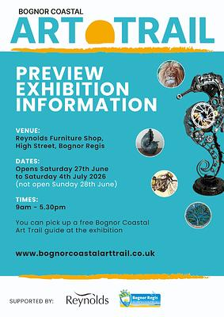 | Bognor Coastal Art Trail Preview event  until 4th July Reynolds Furniture Store, Bognor Regi  An amazing Preview Exhibition before the actual Trail in July (18/19/25/26). Reynolds have been kind enough to host the Preview event which runs from Sat 27th June until Saturday 4th July. It will be stewarded by the Committee and/or artists during the week. The Preview will be open from 9am-5.30pm each day (except Sunday) so pop along and see some of the work by the artists who will be on the Trail. Collect a guide at the same time so you can plan your visit during the Trail. It's amazing to see how many artists live right on your doorstep, all using different disciplines so there will be lots to see


American Choral Music on the 250th Anniversary of American Independence
4th July - St George's Church, Chichester
On the 250th anniversary of the American Declaration of Independence, Portsmouth Baroque Choir present a programme of American Choral Music, from William Billings to Eric Whitacre.
In between there is music from Aaron Copland, Charles Ives, Randall Thompson and Samuel Barber. The main work is Morton Lauridsen's Lux Aeterna.


Chichester's Summer Street Party and Cross Market and More
5th July - Central Chichester
Get ready for an unforgettable day of entertainment and community spirit as the Chichester's Summer Street Party and the Cross Market & More arrive on Sunday 5 July. Taking place from 10am until 4pm in all four streets of Chichester city centre, the vibrant street party organised by Chichester District Council promises something for everyone, bringing together live performances, hands-on activities, and exciting attractions for all ages. The event will also feature a bustling artisan market, offering unique, handmade goods from independent makers, ideal for discovering one-of-a-kind gifts and treats.
Visitors can enjoy a programme of live music throughout the day, showcasing talented local performers and offering the perfect summer soundtrack. Families are at the heart of the celebration, with an incredible lineup of activities designed to entertain and inspire younger visitors. Highlights include face painting, magic shows and the chance to meet adorable alpacas.
For those seeking action and creativity, the event will boast a Nerf arena, interactive LEGO building area, and a wide range of family games to keep everyone entertained on the Cathedral Green. Traditional funfair favourites, including carousels, and live performances from Theatre UK, will add to the festive atmosphere.


Smith Brothers Exhibition
7th - 10th July - The Council House, North Street, Chichester
To celebrate the 250th anniversary of George Smith's passing, Chichester City Council has refreshed the Ante Room and unveiled an expanded display of artworks by the renowned Smith Brothers of Chichester. This enhanced collection offers both residents and visitors a chance to rediscover these much loved local artists.
From Tuesday 7 July to Friday 10 July, enjoy open access to the newly added pieces and learn more about the works you may already know.
The installation is permanent, so you'll be able to return and explore it again whenever the room is available.
The Exhibition will be open 10am - 4pm


Sussex Rural Writers
8th July - Chichester City Arts Centre
Between 1880 and 1914 there was a remarkable outpouring of prose and poetry that took Sussex, and especially the South Downs, as a point of inspiration. This talk will local at the work of Richard Jefferies, W.H.Hudson, Rudyard Kipling, Sheila Kaye-Smith, and many other writers who lived in or visite

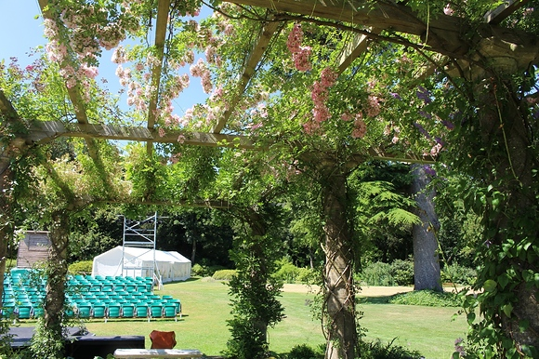
Pergola Open Air Theatre
29th June - 11th July West Dean
Enjoy an enchanting summer evenings theatre with six performances of Shakespeare's everlasting popular masterpiece alternating with Ayckbourn's classic comedy.
Tickets available on the night at the Pergola Theatre entrance or in advance by email
Come to this glorious setting at this ever popular venue and enjoy two contrasting and entertaining shows to lift your spirits on a summers evening.
You are welcome to bring your own picnics from 5-30 pm Please see West Dean Gardens website for further info re picnics and restaurant.
A Midsummer Nights Dream June 29th July 1st July 3rd July 7th July 9th and July 11th
Living Together June 30th July 2nd July 4th July 6th July 8th and July 10th


Reformed Pilates - Taster Day
11th July Fernleigh, Chichester
Visit Reformed Pilates at Fernleigh for their launch event on Saturday 11 July to take a look around, meet the Reformed team and try their beautiful new studio for just £10. Plus, there will be exclusive opening-day membership offers available for those who sign up on the day.
Reformed Pilates full timetable begins the very next day, Sunday 12th July, with a mix of:
- Screen-led Reformer Pilates
- Instructor-led Reformed Pilates
- Barre
- Mat Pilates
Whether youre completely new to Pilates or already love reformer, they would love to welcome you.

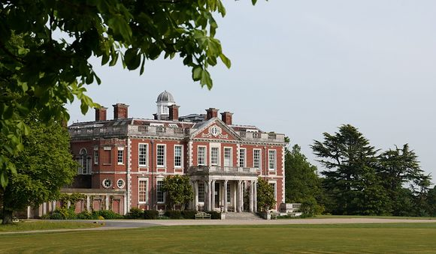
Stansted House- Pay What You Can Day
7th July Stansted House
Visit Stansted House on Tuesday 7 July and enjoy an Upstairs, Downstairs experience as you explore the family seat of the Earls of Bessborough.
Discover the beautiful State Rooms, once used by the family to entertain guests, before venturing downstairs to explore the fully furnished and extensive Servants Quarters.
The Stansted Park Foundation is a charity and we rely on our visitors and the Friends of Stansted Park to help us care for this beautiful Grade II* Listed Edwardian House, Grade I Listed Chapel, and 2000 acres of ancient forest and parkland.
Please donate what you feel you are able to and help us to preserve this beautiful estate for all to enjoy.
Admission to Stansted House is usually £10 an adult and £8 for concessions.
Prebooking for this event is advised. The House and Chapel will be open between 11am-2pm, with last admission to the House at 1pm.

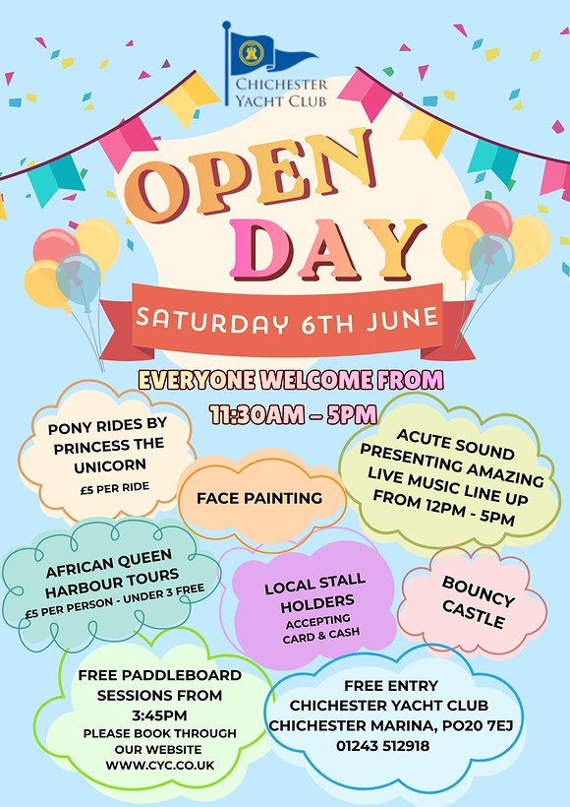
Chichester Yacht Club Open Day
11th July - Chichester Marina, Birdham Road, Chichester
Join us for a fun-filled family day at the marina! Everyone Welcome, free entry. Pony rides by Princess the Unicorn (£5 per ride), face painting, bouncy castle with live music from Acute Sound (12pm 5pm).
We will hold FREE paddleboard sessions from 3:45pm; 3 sessions, subject to weather & availability please book via our what's on page hereand African Queen Harbour Tours (£5 per person under 3s free, pay on embarkation).
Local stall holders accepting card & cash
EXCLUSIVE OPEN DAY OFFER - Save a massive £165 with NO joining fee when you sign up for membership on the day!


OLAYÁ : Brazilian Music at Lordington
12th July Lordington Park
At the forefront of UK's world music scene, OLAYÁ is a female-led flute & percussion band inspired by Northeastern Brazilian bandas de pifanos (bamboo flutes), forró tunes and vocal harmonies blending jazz, soul, rock, and diverse Brazilian genres for a quirky take on a traditional sound.
LIVE MUSIC: 3 pm 5 pm with interval (garden opens at 1.30 pm for picnicking) Bring your own low chairs, rugs, cushions, picnics, sunhats, sunglasses, raincoats and umbrellas and booze if you wish.
This event is for all ages. Children may come for free with adult supervision.




Edinburgh Fringe Previews
Various dates in July - The Nest @ Chichester Festival Theatre
You don't need to go to Scotland to get a taste of the Edinburgh Fringe as many are being performed at our very own Nest, a selection of which you can see here.
There is a special multi buy offer too:
Save when you book the same number of tickets for our Edinburgh Fringe Previews
- 2 shows = 20% off
- 3+ shows = 25% off




Supporting the Sussex Snowdrop Trust
Arundel Castle Cricket Club T10 Villages Cricket
5th July Arundel Castle Cricket Ground
Watch Aldwick, Arundel Grasshoppers, Fernhurst and Madehurst play thanks to Monan Gozzett Solicitors.
A quintessential pastime at this most beautiful ground with refreshments available, live music, raffle and cricket!
Arundel Castle Cricket Ground is a 3.5-acre amphitheatre built in 1895 by the 15th Duke of Norfolk and is renowned as one of the most beautiful cricket grounds in the world. Set amidst the Sussex Downs and with stunning views over the Arun valley, it is overlooked by Arundel Castle.
Free entry
Gates open at 9.30 a.m.



The Sewing Bee Techniques Workshop
4th July - Clothkits, Chichester
Ready to take your sewing to the next level? This practical, technique-packed workshop is designed to help you build a toolkit of professional dressmaking skills that will elevate your makes, whether youre sewing garments, homeware, or accessories.
What you'll learn:
- How to sew a variety of seam finishes including basic, curved, piped and overlocked seams.
- Essential construction techniques such as darts, facings, tailor tacks, zips, bias binding and buttonholes.
- More advanced skills such as understitching and setting in sleeves
- When and why to use each method for the best finish.



Bosham: Where the Bayeux Tapestry Begins
One of the world's greatest works of art doesn't begin in Normandy or at the Battle of Hastings. It begins beside Chichester Harbour.
Most people know the Bayeux Tapestry tells the story of the Norman Conquest of England in 1066. But few realise that its opening scenes are set just a few miles from Chichester, in the beautiful harbour village of Bosham.
Before the armies marched, before arrows flew over Hastings, and before William became the Conqueror, the story begins quietly in a Saxon village that many of us know and love today.
Read the full story



Last chance - closes Friday 3rd July at midday
This Summer of Culture giveaway is a colourful one — we're giving away a family ticket (admits 2 adults + up to 3 children) to Elmer and Friends: The Colourful World of David McKee at The Novium Museum
Elmer and Friends brings the late author and illustrator's family favourites to life with original illustrations and multi-sensory, interactive displays — it's the perfect rainy (or sunny!) day out for little ones and grown-ups alike
Head over to our Instagram page to see how to win


Win tickets to Atlantis at Chichester Festival Theatre!
We're giving away 2 tickets to see Atlantis at CFT on Saturday 18 July at 7.15pm, as part of this year's Summer of Culture.
A family drama about a Welsh coastal community on the frontline of the climate crisis, it's tender, urgent and darkly funny.
Not to be missed!
Enter via our Instagram post
Close midday Friday 10th July

Promote Your Event
Add your own event to our calendar - here's how:
1. Click the link at the base of the home page "Submit an Event"
2. Create a login account if you don't already have one
3. Complete the form with the details of your event, ensuring that you have added an image and a short description along with the other important information. Please use plain, unformatted text and use the formatting tools in the form.
(Kindly note that events will not be made live if they do not include a short text description and image. Images should be .png or .jpeg NOT pdf)

Newsletters 2026  January week 1  January week 2  January week 3  January week 4  January week 5  February week 1  February week 2  February week 3 | Newsletters 2026  February week 4  March week 1  March week 2  March week 3  March Week 4  April Week 1  April Week 2  April Week 3  April Week 4 | Newsletters 2026  Summer of Culture  May Week 1  May Week 2  May Week 3  May Week 4  June Week 1  June Week 2  June Week 3  June Week 4



powered by BoxStuff rapportUnsubscribe from this mailing

