
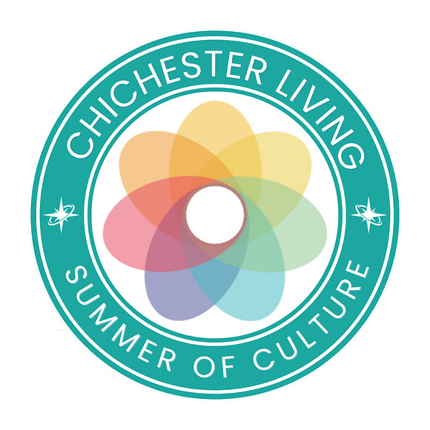
It is week four of our Summer of Culture project and we continue to focus on the Festival of Chichester which is now in full swing. The image above is an icon for you to add to your web or social posts if you are running events that fall into the categories covered by our summer long project (make sure they are added to our website too). At the base of this newsletter is another version which we would love you to use to show your support for our cultural summer. We have other colours too - so just get in touch.
Competitions and an offer
So far during our Summer of Culture project we have happy winners for the Festival of Flowers, My Fair Lady, Pallant House Gallery and the Summer Festival at Stansted. This week we are looking to local families and give you the opportunity to win a family ticket to Elmer at the Novium (see below for how to enter).
Thank you to the Novium for their generosity this week
In addition Stansted Park is offering 50% entry tickets to the this beautiful Edwardian mansion on 19, 20 & 21 July for Chichester Living newsletter subscribers. To book your tickets, please click here. At the checkout, please enter the code ChiLiving26 to apply the 50% discount. Pre-booked tickets only.
With grateful thanks to Stansted House for their kind offer.
Chichester Cathedral Light Experience
This October this wonderful event will return to the Cathedral and explore the theme Illuminating Art and it is already proving popular. At time of writing early bird adult tickets are sold out but still available for Child Admission
Cathedral Volunteers
Do you have some time that you could give to the Cathedral? See below for more details and an event on the 27th to find out more.
English Wine Week
This annual campaign runs until the 28th June and we bring you some ways to celebrate it without having to go too far (see below)
BBC - The Repair Shop
Are you a fan? If so, you might like to get a sneak peek inside Court Barn at the Weald and Downland Living Museum where it is filmed. This weekend it will be open for visitors to the museum to have a look.
Chichester Festival Theatre
Over at Oaklands Park 45 years continues at the Minerva until the 11th July and rehearsals are now underway for this year's well loved musical My Fair Lady. (see below)
Last Chance to Bid
The online auction for the art works displayed at New Park will close on the 30th. Please support it if you can as the proceeds will provide vital support for the Raise the Roof campaign at this much loved venue. (see below)
The usual reminders
There are, quite literally, hundreds of events in our calendar so this newsletter can only bring you a very small sample. Here is the month view for June showing all events and you can also filter according to the categories displayed.
If you are organising an event do add it to the calendar - see the base of this mailing for how to do it.
Also - do invite your friends/family/colleagues to sign up for the newsletter so we can reach an even wider audience
Vicki
Founder/Editor
It is week four of our Summer of Culture project and we continue to focus on the Festival of Chichester which is now in full swing. The image above is an icon for you to add to your web or social posts if you are running events that fall into the categories covered by our summer long project (make sure they are added to our website too). At the base of this newsletter is another version which we would love you to use to show your support for our cultural summer. We have other colours too - so just get in touch.
Competitions and an offer
So far during our Summer of Culture project we have happy winners for the Festival of Flowers, My Fair Lady, Pallant House Gallery and the Summer Festival at Stansted. This week we are looking to local families and give you the opportunity to win a family ticket to Elmer at the Novium (see below for how to enter).
Thank you to the Novium for their generosity this week
In addition Stansted Park is offering 50% entry tickets to the this beautiful Edwardian mansion on 19, 20 & 21 July for Chichester Living newsletter subscribers. To book your tickets, please click here. At the checkout, please enter the code ChiLiving26 to apply the 50% discount. Pre-booked tickets only.
With grateful thanks to Stansted House for their kind offer.
Chichester Cathedral Light Experience
This October this wonderful event will return to the Cathedral and explore the theme Illuminating Art and it is already proving popular. At time of writing early bird adult tickets are sold out but still available for Child Admission
Cathedral Volunteers
Do you have some time that you could give to the Cathedral? See below for more details and an event on the 27th to find out more.
English Wine Week
This annual campaign runs until the 28th June and we bring you some ways to celebrate it without having to go too far (see below)
BBC - The Repair Shop
Are you a fan? If so, you might like to get a sneak peek inside Court Barn at the Weald and Downland Living Museum where it is filmed. This weekend it will be open for visitors to the museum to have a look.
Chichester Festival Theatre
Over at Oaklands Park 45 years continues at the Minerva until the 11th July and rehearsals are now underway for this year's well loved musical My Fair Lady. (see below)
Last Chance to Bid
The online auction for the art works displayed at New Park will close on the 30th. Please support it if you can as the proceeds will provide vital support for the Raise the Roof campaign at this much loved venue. (see below)
The usual reminders
There are, quite literally, hundreds of events in our calendar so this newsletter can only bring you a very small sample. Here is the month view for June showing all events and you can also filter according to the categories displayed.
If you are organising an event do add it to the calendar - see the base of this mailing for how to do it.
Also - do invite your friends/family/colleagues to sign up for the newsletter so we can reach an even wider audience
Vicki
Founder/Editor



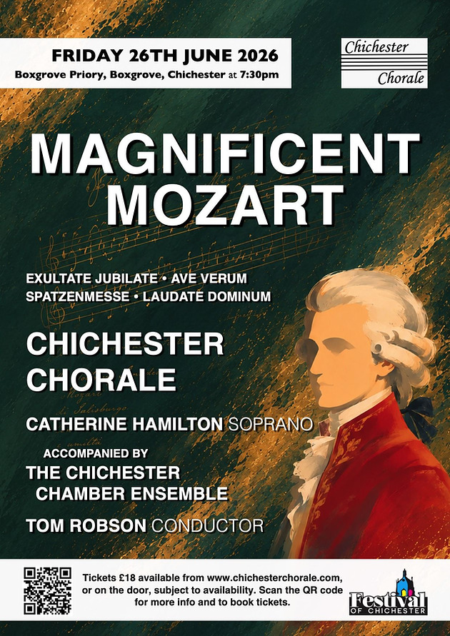
Magnificent Mozart - The Chichester Chorale
28th June Boxgrove Priory
Join Chichester Chorale and soprano Catherine Hamilton for an evening of Mozart in the stunning Boxgrove Priory Church. Programme to include Exsultate, Jubilate (K165), Laudate Dominum (from K339), Missa Brevis in C Major (Spatzenmesse K220) and Litaniae Lauretanae(K109). Accompanied by The Chichester Chamber Ensemble and conducted by Tom Robson.
Catherine Hamilton grew up in Chichester and at the age of ten was the first singer to be awarded a Junior Exhibitioners scholarship in the history of the Royal Academy of Music. She enjoys an international career spanning opera, oratorio, recitals, and musical theatre, and is delighted to be returning to Chichester to join Chichester Chorale for this concert.
Chichester Chorale, founded in 2004 by Arthur Robson and Mark Wardell, return for their annual concert as part of the Festival of Chichester in the idyllic setting of Boxgrove Priory. They are joined by The Chichester Chamber Ensemble and conducted by their Musical Director since 2019, Tom Robson.


Chichester Jazz Club
26th June - The Pallant Suite Chichester
A wonderful sextet of high-quality musicians brought together by Chichester Jazz Club for the Festival of Chichester.
Hannah Horton Saxophones
Roger Beaujolais Vibraphone
Rosie Frater-Taylor Guitar
David Newton Piano
Andrew Cleyndert Double Bass
Alex Goodyear Drums

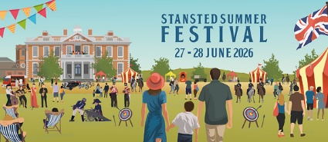
Stansted Summer Festival
27th - 28th June Stansted House and Gardens
Head to Stansted Park to enjoy its 6th annual Summer Festival an eclectic weekend of family fun, quirky entertainment and a little bit of the eccentric, all set within a quintessential English country estate.
Marvel at the Napoleonic Reenactors and experience the thrill of battle as a 2000-strong army of reenactors demonstrates cavalry charges and musketry drills. Between the reenactments, you can stroll through their living history camp and discover what life was like for those fighting in the Napoleonic Wars.
Feeling competitive? Get together with your family and friends and enjoy traditional garden games and mini golf before having a go at archery.
Plus, browse the selection of food and drink vendors and treat yourself to something tasty before relaxing back on a deckchair and taking in performances from one of the singers or bands.
Inside the Edwardian mansion you can explore the family seat of the Earls of Bessborough and enjoy a true Upstairs, Downstairs experience.


ABE Artists and Makers Summer Open Studios
27th - 28th June Barnham, Eastergate, Walberton and Westergate
Discover the ABE Artists and Makers Summer Open Studio Trail, a celebration of local creativity showcasing the work of 17 artisans across five venues within the Six Villages area.
This self-guided trail offers a rare opportunity to visit working studios, meet the makers, and explore a diverse range of handcrafted work including jewellery, ceramics, textiles, painting, printmaking, sculpture, woodwork, and contemporary craft. Visitors can gain an insight into the creative process, learn about the inspiration behind the work, and purchase directly from the artists themselves.
Whether you are looking for original art, unique handmade gifts, or simply an inspiring day out, the Summer Open Studio Trail provides a welcoming opportunity to discover the wealth of creative talent thriving within our local community.
Free entry.

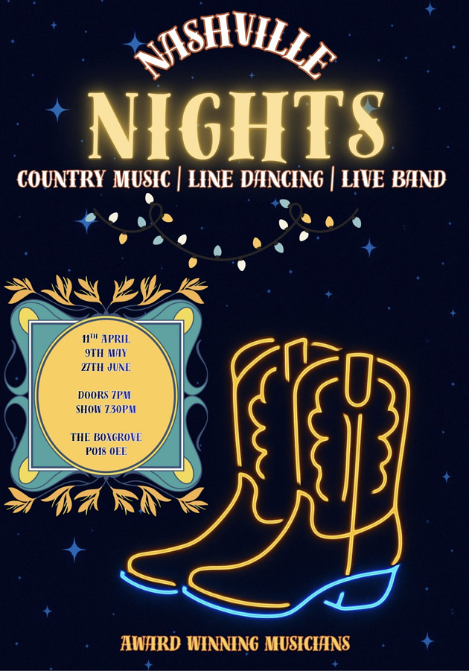
Nashville Nights
27th June Boxgrove
Yall ready for a boot-stompin good time? Nashville Nights brings live country music, classics from Shania, Dolly, Lee Ann Womack, and a touch of Elvis! Beginner-friendly line dances, hand-jive and seated versions let everyone join in. Boots and hats welcome but not required. Yeehaw!
Yall ready for a night of boots, hats, and big country fun? Nashville Nights is comin to The Boxgrove, and it's gonna be a rip-roarin, toe-tappin evening you wont forget! We've got live music all the way, from classic country hits by legends like Shania Twain, Dolly Parton, and Lee Ann Womack, to a little Elvis magic thrown in just for fun. And don't worry - the band is also serving up a few original country songs, bringing fresh tunes to a night already bursting with energy.

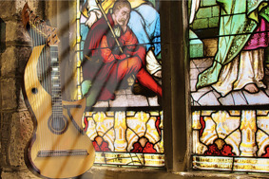 | Strings Of Light  27th June Boxgrove Priory  Secrets of the Harp Guitar  International award-winning guitarist and composer Jon Pickard presents a rare and spellbinding performance on 23 string Harp-Guitars Classical, folk and original compositions. Shimmering textures, lyrical storytelling. A truly immersive musical journey.  Strings Of Light will transport audiences back to a time when bards would play music and tell stories around a fire. The music creates atmosphere as much as it creates form, surrounding the listener and encouraging imagination to take over. Rooted in an instrument with over 300 years of history, the harp-guitar carries echoes of early European traditions while revealing possibilities that still feel startlingly new.


Cocktail Night - Katie Brown Live Music
27th June - Fernleigh, Chichester
Join us for an elegant summer evening at Fernleigh with an exclusive Cocktail Night featuring live music from Katie Brown.
Hosted in our stylish bar and café space, the evening will combine expertly crafted cocktails with the exquisite sound of Katies voice as she performs.

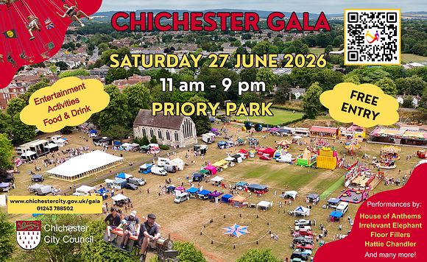
Chichester Gala 2026
27th June - Priory Park, Chichester
Join us for the city's biggest free outdoor event, packed with live entertainment, great food and drink, local traders, and activities for all ages.
Entertainment From 11am, enjoy a full programme of local talent including childrens entertainers, rock bands, dance groups, and more. The Community Stage runs until 5.30pm, with main stage performances continuing through to 9pm.
Main Stage Line-Up Floor Fillers 90s/00s dance anthems, disco and pop classics
Irrelevant Elephant soulful South Coast jazz funk House of Anthems
live Ibiza style club classics to close the night
Family Activities Miniature railway rides, Circus Tent, Classic car show featuring vintage favourites, Traditional fairground rides and games
Food, Drink & Traders Enjoy a great mix of local popup food and drink, from ice creams to hearty meals. Explore a variety of independent traders in the stalls and inside the Guildhall, offering unique items to browse and take home.
Community Involvement Local charities and voluntary groups will be on site to share information about their services and upcoming events.

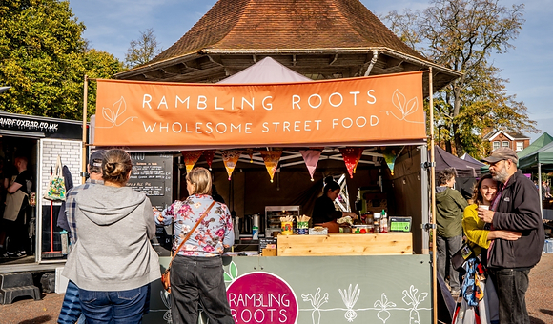
Sussex Biodiversity & Regenerative Food Festival
28th June - East Street, Chichester
The Sussex Biodiversity & Regenerative Food Festival is launching this June. Join us on East Street & North Street in Chichester for a free festival that brings together and celebrates the growers, producers and organisations that contribute to a regenerative local food system and a wilder, more nature-filled region.
Youll find a collection of regenerative & organic growers, bakers, makers, street food vendors, crafters, charities, community groups, demos and more!
The areas of focus for this years event are:
- Regenerative, organic & agroecological food production
- Nature, wildlife & landscape regeneration
- Organic gardening and heritage seeds & plants
- Sustainable and natural fibres
- Community engagement in the natural world
- Fermented and preserved foods
- Local artisanal crafts

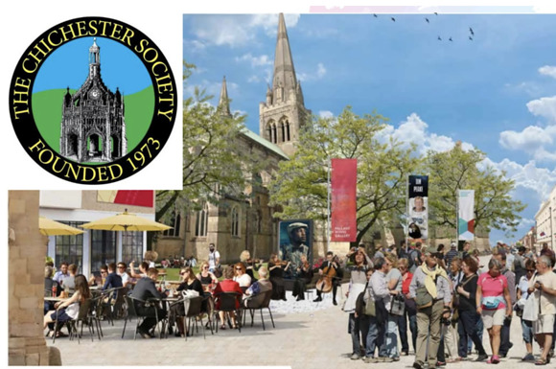
Chichester Society: Regeneration in the City
29th June - Assembly Room, Chichester
Our annual summer forum is an information sharing event about significant local issues, and our topic this year is regeneration.
Speakers from our local authority will take us through details of the long-awaited Public Realm Improvement Scheme to upgrade Chichesters North and East Street.
The project, now agreed and fully funded, aims to replace degrading historic brick paving, improve accessibility, and introduce new urban greening and planting. It will also address the issues around digital connectivity and is looking at improvements in Wayfinding.
We are fortunate that our main speakers from WSCC are directly responsible for the design and implementation, and as long-time Chichester residents are passionate about the project:
Greg Ockwell (Programme Manager, Delivery) & David Lambert (Project Manager, Highways).
Tickets - Free of charge but booking is essential
Image: An impression of West Street pedestrianised with space for eating out, art and performances and other leisure activities.

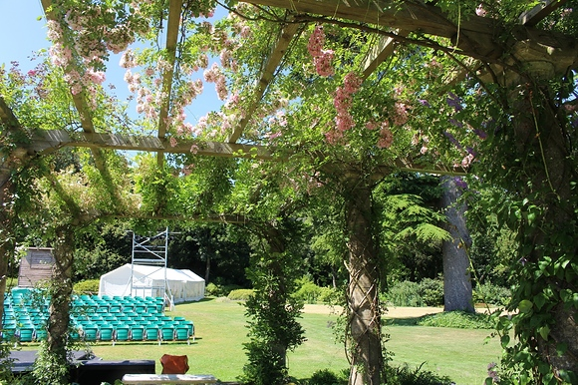
Pergola Open Air Theatre
29th June - 11th July West Dean
Enjoy an enchanting summer evenings theatre with six performances of Shakespeare's everlasting popular masterpiece alternating with Ayckbourn's classic comedy.
Tickets available on the night at the Pergola Theatre entrance or in advance by email
Come to this glorious setting at this ever popular venue and enjoy two contrasting and entertaining shows to lift your spirits on a summers evening.
You are welcome to bring your own picnics from 5-30 pm Please see West Dean Gardens website for further info re picnics and restaurant.
A Midsummer Nights Dream June 29th July 1st July 3rd July 7th July 9th and July 11th
Living Together June 30th July 2nd July 4th July 6th July 8th and July 10th


Outdoor Theatre: The Great Gatsby
1st July Stansted Park
We are delighted to welcome This is My Theatre Company to Stansted Park with their family-friendly adaptation of F. Scott Fitzgerald's much-loved story - packed with glamour, guile and plenty of gorgeous music - that will be sure to captivate audiences of all ages.
Step into the roaring 1920s, where the champagne flows, the jazz trumpet blows, and the American Dream gleams with irresistible allure. This electrifying stage adaptation of F. Scott Fitzgeralds timeless novel brings Jay Gatsbys glittering world to life a place of opulence, obsession, and heartbreak.

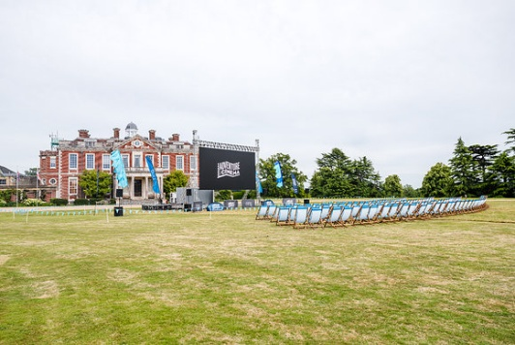
Outdoor Cinema: Dirty Dancing
3rd July Stansted Park
Nobody puts baby in the corner!
Get ready for an unforgettable night of music, romance, and legendary dance moves as Dirty Dancing lights up the big screen under the stars.
Sing along to the iconic soundtrack, soak up the atmosphere, and enjoy this classic movie, starring Patrick Swayze and Jennifer Grey, in a magical outdoor cinema setting.
Plus music to enjoy before the movie with a soundtrack of specially curated songs.



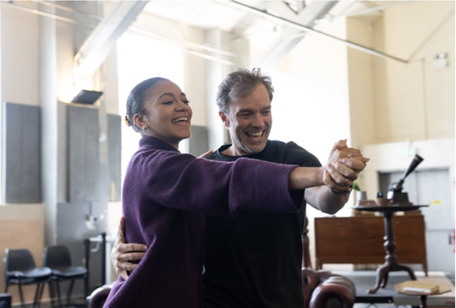
My Fair Lady
A sneak peek inside the rehearsal room for My Fair Lady in the new trailer and photos. My Fair Lady runs for a strictly limited time in the Festival Theatre from 6 July 5 September.
After wowing audiences in Magic earlier this year, Hadley Fraser makes a welcome return as fastidious phonetics professor Henry Higgins. Keziah Ibe makes her professional debut as Covent Garden flower girl Eliza Doolitte, who dreams of a rosier future.
When Higgins encounters Eliza, he makes a wager with esteemed colleague and friend Colonel Pickering that he can transform her into a lady who wont seem out of place at any high society occasion.
Whilst Eliza embarks on a journey of transformation and discovery, Higgins, too, is changed by his relationship with her.
My Fair Lady is packed with classic songs, including The Rain in Spain, I Could Have Danced All Night, With a Little Bit of Luck and Wouldnt It be Loverly.
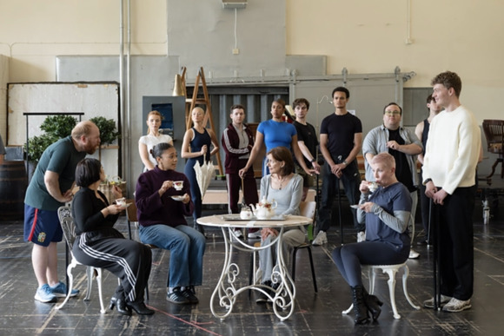



Last chance to bid this weekend
Silent Art Auction
Ends 30th June. Expo at New Park Centre and Bidding Online
The month-long auction forms part of the Centre's ambitious RAISE THE ROOF (RTR) campaign, which aims to raise £450,000 to replace the roof of its historic Victorian building, securing the future of one of the citys most valued creative spaces.
The Silent Art Auction runs throughout June, showcasing a diverse collection of donated artworks from artists across the region. Visitors are invited to place bids across the exhibition period, with final bids closing on 30 June.
All proceeds will go directly towards the RTR campaign.

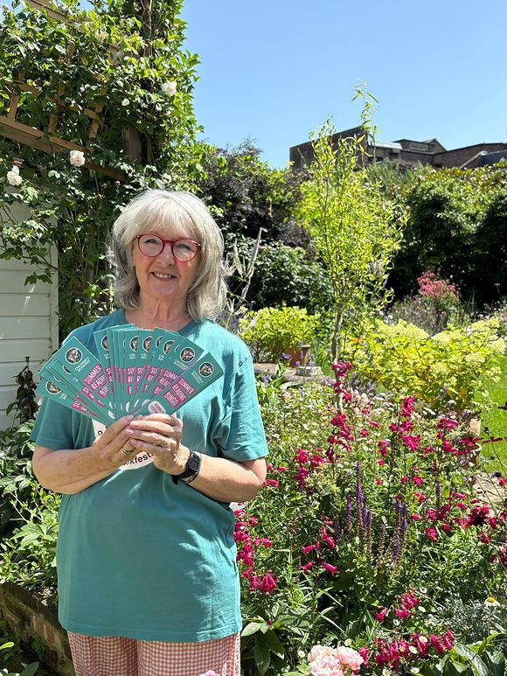
CHILDREN'S BOOKFEST LAUNCHES FREE SUMMER READING BINGO BOOKMARK
Local charity Children's BookFest (CBF) is inviting families to discover that reading is everywhere this summer with the launch of a free summer reading bingo bookmark.
Supported by Chichester Festival Theatre, the campaign features a colourful bookmark, which folds out into an illustrated bingo card encouraging children to tick off nine different types of reading activity throughout the summer holidays. From maps and menus to recipes, subtitles and song lyrics, the challenge is designed to show children that reading can be found everywhere.
Children who complete the bingo card can enter a prize draw to win book tokens.
Read more about it here



Paper Peony Workshop
27th June - Jam Cafe, Chichester
Join Clare of Petal & Bird for a couple of hours paper creativity and learn to make your own paper Peony.
Clare will take you through the process step by step, no previous experience is required
- Workshop starts at 4pm and runs for approximately 2 hours
- Materials provided
- £40 per person
Workshop takes place upstairs in Jam cafe, 33 Southgate, Chichester, PO19 1DP.


 |  | 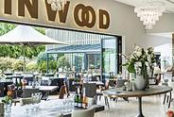

English Wine Week - West Sussex and Champagne
Did you know that the South Downs shares its geology with France's most celebrated wine region? The chalky soils, gentle south-facing slopes and cool maritime climate of West Sussex mirror the conditions of the Côte des Blancs in Champagne, making it particularly well-suited to the classic sparkling wine grape varieties. Sussex wine even has its own PDO (Protected Designation of Origin), putting it in the same official category as Cornish Clotted Cream and Jersey Royal Potatoes.
Read our blog item with some suggestions of how to celebrate English Wine Week close to home.



This week's Summer of Culture giveaway is a colourful one — we're giving away a family ticket (admits 2 adults + up to 3 children) to Elmer and Friends: The Colourful World of David McKee at The Novium Museum
Elmer and Friends brings the late author and illustrator's family favourites to life with original illustrations and multi-sensory, interactive displays — it's the perfect rainy (or sunny!) day out for little ones and grown-ups alike
Head over to our Instagram page to see how to win
 | 


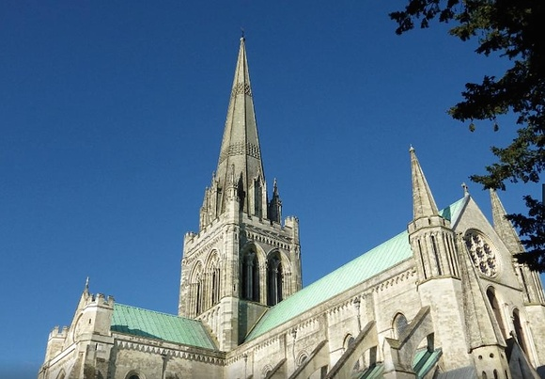
Volunteering at Chichester Cathedral
Do you enjoy meeting people and sharing the Cathedral's rich history?
Do you like being part of a team?
Then Cathedral Welcomer may be the perfect volunteer role for you!
Come along to our Welcomers' Recruitment Event in the Cathedral from 10 - 12 noon on Saturday 27th June to find out how you can get involved. Cathedral Welcomers will be on hand, to tell you more about what inspired them to volunteer and to provide an insight into the skills needed for providing a warm and sensitive welcome to visitors.
Another way to participate in providing a memorable welcome is by serving them in the Cathedral shop.
Our Retail Assistants are ambassadors for the Cathedral, welcoming and serving customers, providing information, operating the tills, selling tickets to Guided Tours and more.
Any questions? Contact our Volunteer Co-ordinator: Carolyn Atkinson

Promote Your Event
Add your own event to our calendar - here's how:
1. Click the link at the base of the home page "Submit an Event"
2. Create a login account if you don't already have one
3. Complete the form with the details of your event, ensuring that you have added an image and a short description along with the other important information. Please use plain, unformatted text and use the formatting tools in the form.
(Kindly note that events will not be made live if they do not include a short text description and image. Images should be .png or .jpeg NOT pdf)

Newsletters 2026  January week 1  January week 2  January week 3  January week 4  January week 5  February week 1  February week 2  February week 3 | Newsletters 2026  February week 4  March week 1  March week 2  March week 3  March Week 4  April Week 1  April Week 2  April Week 3  April Week 4 | Newsletters 2026  Summer of Culture  May Week 1  May Week 2  May Week 3  May Week 4  June Week 1  June Week 2  June Week 3




powered by BoxStuff rapportUnsubscribe from this mailing

