
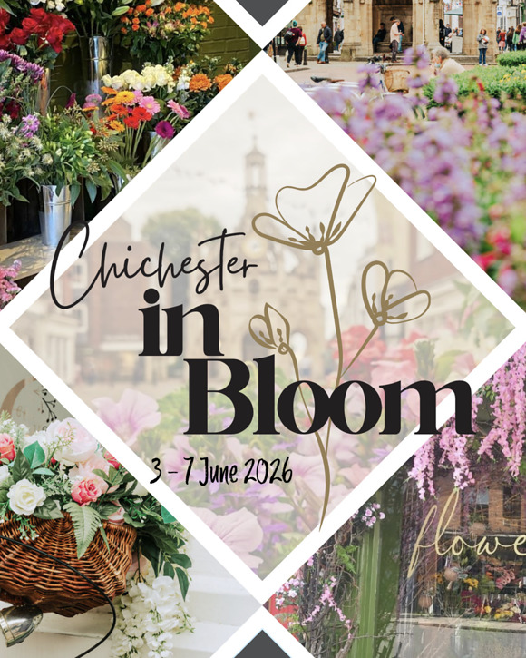
Flowers galore, openers at the Festival theatre and Pallant House Gallery, family racing, 3 Friday nights, and 40's day at Tangmere - just a selection of what's on soon.
Summer has arrived with a vengeance accompanied by some lovely events that herald a fantastic few months of activities.
The wonderful Festival of Flowers opens at the Cathedral next week and Chichester BID is bringing the city into full bloom with Chichester in Bloom.This is a new city-wide initiative to celebrate the 30th anniversary of the renowned Festival of Flowers and will extend its spirit beyond the Cathedral walls and into the city centre, with businesses transforming their shopfronts into a trail of floral creativity. Read more
Bringing the great outdoors inside is the new major exhibition at Pallant House Gallery which starts this week and celebrates British Landscapes - A Sense of Place. (see below). You can experience a real garden at Lordington House and paint your own art work at Fernleigh (see below) whilst more art of the photographic kind is on display at Oxmarket Contemporary (see below)
At Chichester Festival Theatre 'Atonement' opens this week and the cast has been announced for My Fair Lady later in the summer. (see below)
The Chichester Fringe opens on the 30th - we carry the full programme under this special tag and don't forget that booking is open for the Festival of Chichester and the Petworth Festival.
The Chichester Cinema at New Park has announced the dates for the 34th International Film Festival (7th - 23rd August) and is offering local residents and businesses the opportunity to support it. Read more here
Next week we launch our Summer of Culture Initiative - take a peek at the page and you will see Chichester Fringe events brought together as well as various items that celebrate the Festival of Flowers.
In order to promote all the cultural events through the summer we will have a stand in the portico in front of the Council House on Friday market mornings through June/July/August from 9-12. You are invited to come along to say hallo, bring your flyers and brochures and join in the conversation to promote your event. Even if you are not running an event it would be good to see you.
As part of this initiative we will be giving away prizes every week through June to end August. Our first prize has been issued (tickets for the Festival of Flowers) and on Monday we will launch the next competition. This is being run on Instagram so do pop over there and get involved with @chichesterliving.
In the calendar you will find lots more opportunities to be entertained and to learn a new skill. Here is the month view for June in all its colourful glory.
If you are organising an event do add it to the calendar - see the base of this mailing for how to do it.
Until next week
Vicki
Founder/Editor

Flowers galore, openers at the Festival theatre and Pallant House Gallery, family racing, 3 Friday nights, and 40's day at Tangmere - just a selection of what's on soon.
Summer has arrived with a vengeance accompanied by some lovely events that herald a fantastic few months of activities.
The wonderful Festival of Flowers opens at the Cathedral next week and Chichester BID is bringing the city into full bloom with Chichester in Bloom.This is a new city-wide initiative to celebrate the 30th anniversary of the renowned Festival of Flowers and will extend its spirit beyond the Cathedral walls and into the city centre, with businesses transforming their shopfronts into a trail of floral creativity. Read more
Bringing the great outdoors inside is the new major exhibition at Pallant House Gallery which starts this week and celebrates British Landscapes - A Sense of Place. (see below). You can experience a real garden at Lordington House and paint your own art work at Fernleigh (see below) whilst more art of the photographic kind is on display at Oxmarket Contemporary (see below)
At Chichester Festival Theatre 'Atonement' opens this week and the cast has been announced for My Fair Lady later in the summer. (see below)
The Chichester Fringe opens on the 30th - we carry the full programme under this special tag and don't forget that booking is open for the Festival of Chichester and the Petworth Festival.
The Chichester Cinema at New Park has announced the dates for the 34th International Film Festival (7th - 23rd August) and is offering local residents and businesses the opportunity to support it. Read more here
Next week we launch our Summer of Culture Initiative - take a peek at the page and you will see Chichester Fringe events brought together as well as various items that celebrate the Festival of Flowers.
In order to promote all the cultural events through the summer we will have a stand in the portico in front of the Council House on Friday market mornings through June/July/August from 9-12. You are invited to come along to say hallo, bring your flyers and brochures and join in the conversation to promote your event. Even if you are not running an event it would be good to see you.
As part of this initiative we will be giving away prizes every week through June to end August. Our first prize has been issued (tickets for the Festival of Flowers) and on Monday we will launch the next competition. This is being run on Instagram so do pop over there and get involved with @chichesterliving.
In the calendar you will find lots more opportunities to be entertained and to learn a new skill. Here is the month view for June in all its colourful glory.
If you are organising an event do add it to the calendar - see the base of this mailing for how to do it.
Until next week
Vicki
Founder/Editor




Atonement
29th May - 20th June Chichester Festival Theatre
On an English country estate during the blazing summer of 1935, 13 year-old Briony Tallis witnesses a passionate scene between her elder sister Cecilia and the son of their housekeeper, Robbie. In a disastrous desire for drama but only a dim understanding of its impact, Briony makes an accusation which will fatally alter Cecilia and Robbie's lives and many others too for which she will spend the rest of her life trying to atone.
Stretching from the 1930''s through the Second World War to the present day, Ian McEwan's dazzling masterpiece was shortlisted for the Booker Prize and voted by Time Magazine and the Guardian as one of the 100 greatest novels of the past century.


Sir John Mystery
29th May - Cowdray Ruins
Be a detective at our Cowdray Ruins mystery experience.
Sir John has returned to his Medieval Manor only to find trouble has struck. Can you help unravel the mystery that surrounds the Cowdray Ruins? This years mystery experience is entirely new, offering fresh clues and challenges even for those who have attended before.
Join us for a fun, interactive mystery experience with local historian Paul Ullson. Follow clues, hear fascinating stories, and take part in hands-on activities as you explore the intriguing history of Cowdray Ruins together. Following the event, the Cowdray Heritage Visitor Centre will be open, offering a selection of hot and cold beverages along with a variety of refreshments available for purchase — providing an ideal opportunity to relax and reflect on your discoveries.
Recommended for ages 7 and upwards. Children must be accompanied by an adult. Please note that, as this is primarily a children's event, some creative licence may be used with historical facts. Children under 3 are free but please register for a ticket.

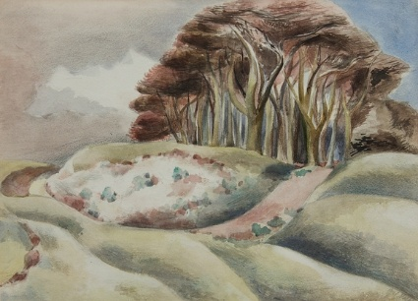
British Landscapes: A Sense of Place
30th May-1st November Pallant House Gallery
This major exhibition will bring the British landscape to life through the eyes of some of the 20th century's most inspiring artists. It will explore works from 1910 to 1970 that reimagined the countryside and coastlines of the British Isles as powerful symbols of cultural identity, creativity and resilience in a turbulent century.
The exhibition will capture how landscapes reflected changing ways of life, national identity and wartime anxieties. Drawn from the Gallery's renowned Modern British collection and prestigious long-term loans, British Landscapes: A Sense of Place will showcase works by celebrated figures and offers a fresh look at how art reflected the shifting landscape of a nation.

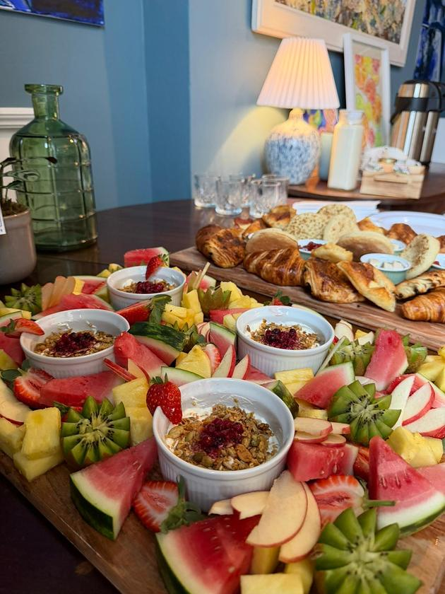
Paint and Brunch
31st May - Fernleigh, Chichester
Join professional artist and tutor Sue Cooper for a fun and relaxing morning of painting custom designed watercolour monograms with a beautiful and delicious Fernleigh brunch served alongside.
Included:
· All materials
· Buffet Breakfast with pastries and fruit
· Tea and Coffee
£45 per person

 | The Music of The Lord of the Rings  30th May - Chichester Cathedral  Experience the majestic and timeless music of the legendary Lord of the Rings films in a breathtaking concert that will transport audiences straight into the heart of Tolkiens universe. Howard Shore's iconic soundtrack has captivated millions worldwide.  Performed by the modern orchestra Mystery Ensemble, this magical evening will transport you instantly into the heart of Tolkien's universe, where elves, hobbits, and dwarves roam.


Swing for Victory Tangmere 40s Day!
31st May - Tangmere Military Aviation Museum
A full day of nostalgia and entertainment. Whether you're a seasoned jiver, a history enthusiast, or simply looking for a great family day out, there's something here for everyone.
Expect toetapping performances, beautifully restored military and civilian vehicles, re-enactors bringing the era to life, and plenty of opportunities to immerse yourself in the style and culture of the 1940s.
Visitors are warmly encouraged to dress in their best vintage outfits it all adds to the magic of the day.

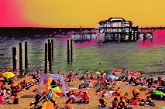
Stephen Bushnell - The Alphabet Collections
until 7th June - Oxmarket Contemporary
Oxmarket are delighted to welcome Stephen Bushnell to Oxmarket for a 2 week exhibition. Stephen was born and grew up in London and worked for Local Government until moving to West Sussex in 1997.
Stephen has always owned a camera and was excited to make the move from 35mm film to his first digital camera in 2004.
Having completed a photography course in 2016 Stephen decided to work towards making photography a key part of his life. In 2019 he started work on his first major photography project, which as a priority in his life, shaped what has now become his Alphabet Collections.

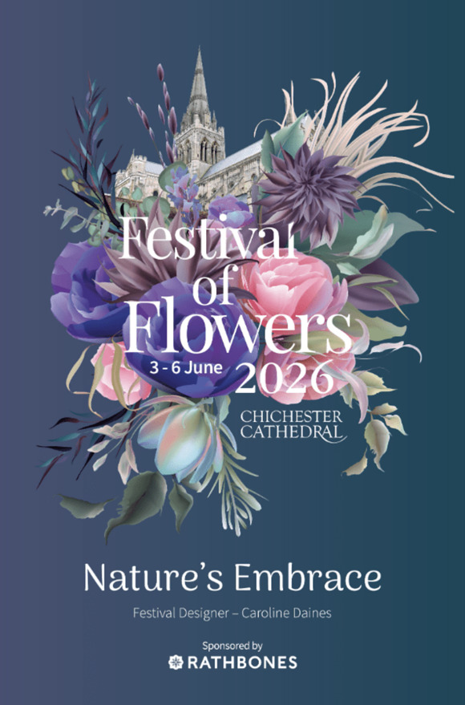
Festival of Flowers
3rd - 6th June Chichester Cathedral
Experience a breathtaking celebration of nature and artistry as over 50,000 flowers transform the Cathedral with colour, scent and beauty.
Discover over 60 stunning floral arrangements, handcrafted by talented florists and flower enthusiasts from across the county, and enjoy an exclusive exhibition by celebrated sculptor Philip Jackson.
Whether you're a passionate gardener or simply love the splendour of flowers, this unforgettable Festival promises inspiration, delight and wonder at every turn.

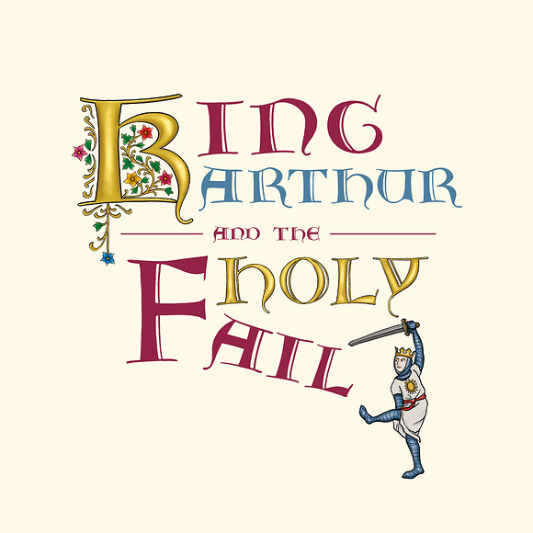
King Arthur and the Holy Fail
3rd June - Stansted House Park
The Three Inch Fools present an epic tale of Arthurian adventure and medieval mayhem.
In a land of daring quests, dashing knights, and endless jousting, there lived a would-be hero - waiting in the wings - who went by the name of Arthur. But when Camelot is rocked to its core by a tragic - and frankly improbable - incident involving a large table of an undisclosed shape, Arthur is thrust into the quest of a lifetime.
Will he bravely battle through blistering cold and scorching fire to save his beloved realm, or will he crumble as fate refuses to cooperate? Destiny awaits, chivalry calls, and the quest to end all quests begins. Saddle up - things are about to get legendary.
This is a picnic event, please bring your own low back seating, food and drink.
The show will go ahead in all but the very worst of weather so please come prepared!



3 Friday Nights

2nd, 12th and 19th June - Goodwood Racecourse
Featuring a unique combination of racing and music, Three Friday Nights hosts a series of unforgettable evenings across June. Dance the night away in the Parade Ring as the sun sets.

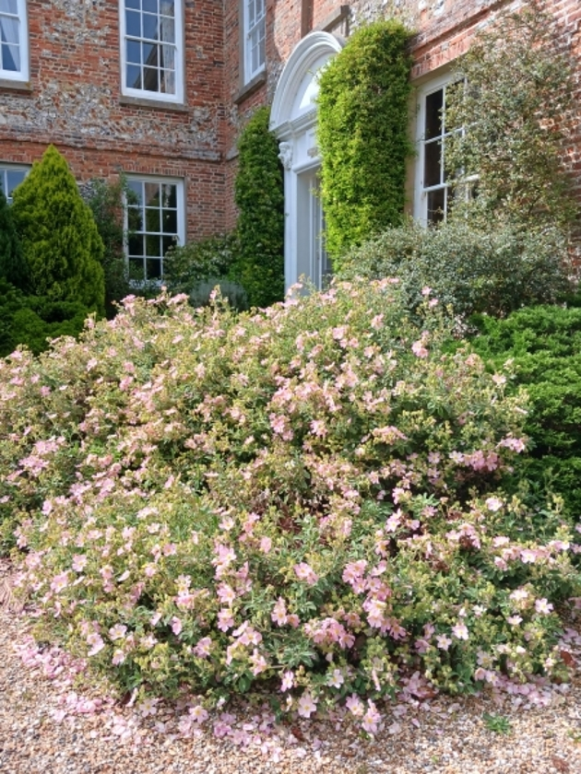
Garden open in aid of National Garden Scheme
6th - 7th June - Lordington House, Lordington
Early C17 house (not open) and walled gardens in South Downs National Park. Clipped yew, lawns, borders and fine views. Informal sunken garden. Vegetables, fruit and poultry in kitchen garden. Over 100 roses planted since 2008. Trees both mature and young. Lime avenue planted in 1973 to replace elms. Wildflower meadow outside walls, accessible from garden.
£7 for adults, children free. Refreshments in aid of Rural Refugee Network.


South Downs Food Festival
6th -7th June Stansted House Park
Held in the stunning grounds of Stansted Park Estate, the mansion provides a spectacular backdrop to the festival, which has quickly become a highlight of the UK's culinary calendar.
Stroll through our vibrant marketplace, where farmers, foragers, fermenters, and artisan makers showcase the best seasonal fruits, vegetables, and handcrafted delights. Indulge in charcuterie and cheeses, kombucha and kefir, burgers and beerall while celebrating the incredible ingredients of the South Downs.
Highlights of the 2025 South Downs Food Festival included an impressive street food lineup that brought the best of Hampshire and Sussex together with global influences from Mexican tacos and Vietnamese banh mi to smoky brisket, hog roasts, Wagyu burgers, sushi, and handmade fishcakes - washed down with top-tier English sparkling wine courtesy of a local vineyard, craft ales and scrumptious ciders. A true feast for the senses and you can expect even more in 2026!
Join cookery demonstrations, live fire BBQ and kids activities as we inspire the next generation to feast on fun, healthy and delicious food, and enjoy talks from producers, chefs and authors.



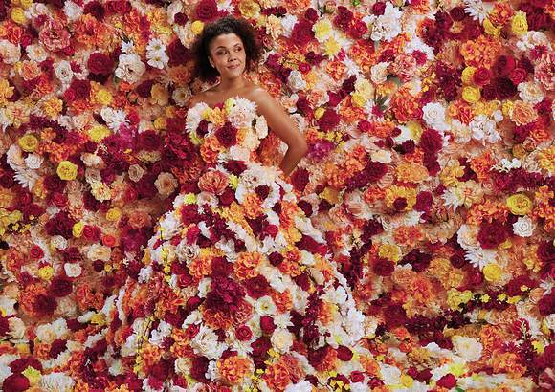
Full company announced for Chichester Festival Theatre's first ever production of MY FAIR LADY
A brand-new production of Lerner & Loewe's glorious, evergreen musical My Fair Lady which has never before been produced at Chichester will be directed by Rachel Kavanaugh and run from 6 July 5 September.
Hadley Fraser (Magic, The Pajama Game, City of Angels) plays Henry Higgins, with Keziah Ibe making her professional debut as Eliza Doolittle. Ben Culleton is Freddy Eynsford-Hill; Tony Jayawardena plays Colonel Pickering; Belinda Lang plays Mrs Higgins; Gary Milner is Alfred Doolittle; Finty Williams is Mrs Pearce. They are joined by Jonathan Bourne, Nic Cain, Shani Cantor, Mark DArcy, Talia Duff, Nicholas Duncan, Zack Guest, Joe Henry, Jennifer Louise Jones, Ella Kora, Reuben Lally, TJ Lloyd, Maggie Lynne, Anna McGarahan, Kody Mortimer, Rachel Stanley and Jessica Vaux.
Read full article



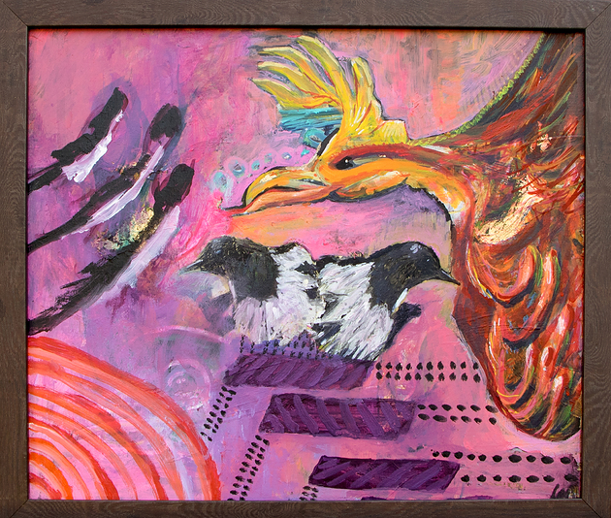
Silent Art Auction in aid of Raise the Roof campaign
1st - 30th June
A major community art initiative in Chichester is gaining momentum this summer, as New Park Centre announces the secured donation of an original artwork from acclaimed local artist Louise Duggan, alongside a growing collection of contributions from artists across the region.
The month-long auction forms part of the Centres ambitious RAISE THE ROOF (RTR) campaign, which aims to raise £450,000 to replace the roof of its historic Victorian building, securing the future of one of the citys most valued creative spaces.
Louise Duggan, an internationally exhibited painter and mixed media artist based in Chichester, has donated an original artwork to the auction, reflecting her ongoing support of the local creative community and the opportunities that enable artists to share their work.
The Silent Art Auction will run throughout June, showcasing a diverse collection of donated artworks from artists across the region. Visitors will be invited to place bids across the exhibition period, with final bids closing on 30 June. All proceeds will go directly towards the RTR campaign.


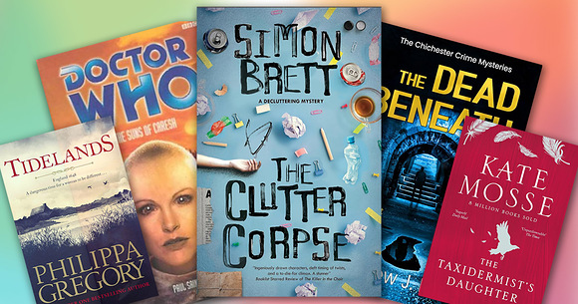
Do you know how many novels take inspiration from Chichester and the surrounding area?
We have put together a selection for you to try during this National Year of Reading - read our blog article. Do you know of any others?
If you want to combine reading with a decent cup of coffee, we've got that covered too in a range of indie cafés. Here are some suggestions




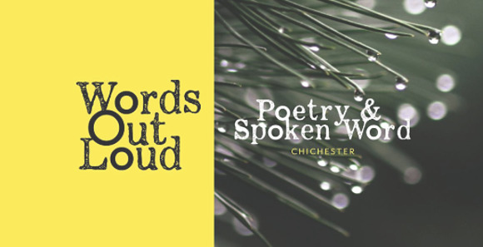
Poetry and Spoken Word Open-Mic
2nd June (every first Tuesday). The Ghost at the Feast, Chichester
Come along and read some of your own poetry or prose, listen to others and share in the joys of the spoken word.
The event is free to attend and open to anyone, but a £3.00 donation made on the door would be very much appreciated.
It doesn't matter if this is the first piece you have written or whether you are a seasoned pro, you will find a warm and supportive welcome as you share your work with us out loud.
And if reading out loud is not for you, please do come along and enjoy the atmosphere and listen to the readings.
The Ghost at the Feast has a variety of indie kitchen outlets and bars, so plenty to choose from to eat and drink throughout the evening, as well.
Arrive from 6pm to order drinks and snacks. Open-Mic starts at 6:30pm.



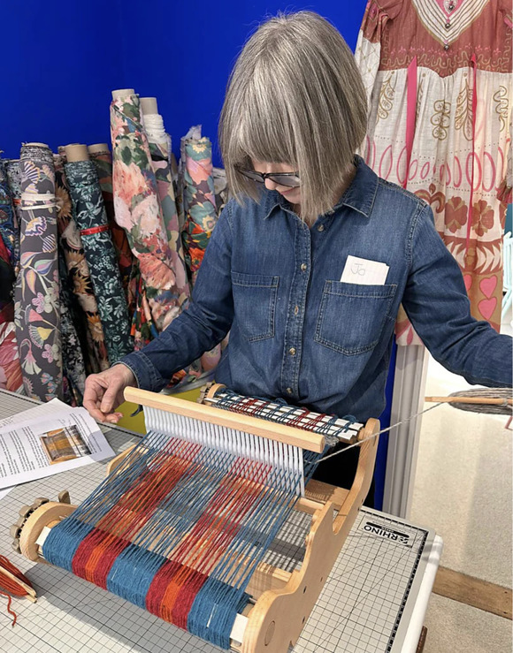
Beginners Weaving Day with a Rigid Heddle Loom
13th June - Clothkits, Chichester
Rigid heddle looms are a fantastic entry point into the world of weaving textiles. They are simplified versions of classic large looms and allow you to weave a length of cloth. Once you have mastered the basics, weaving with wool and the world of textile weaving is at your fingertips!
This day is aimed at beginners. Using pre-warped Ashford rigid heddle weaving looms, we will learn the basic principles of weaving so that you come away knowing your warp from your weft and your pick from your sett!



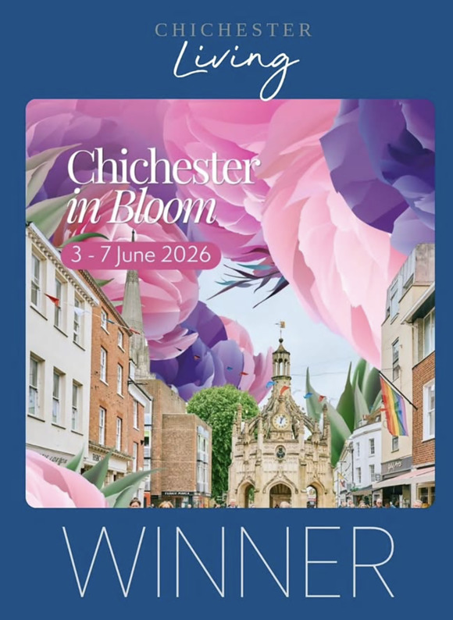
We are delighted to announce that we have a winner for our competition for two tickets to the Festival of Flowers. We hope that she and her Mum have a lovely day.
On Monday we will be announcing our next competition so stay tuned to our Instagram page @chichesterliving to find out more.



A Selection of upcoming Networking Events
3rd June - Small business networking Crouchers Hotel
4th June - Networking at The Bosham Inn
4th June - Chichester Business Networking
5th June - First Friday Breakfast
5th June - First Friday Networking - Lunchtime

We are endeavouring to bring you a selection of networking events in the area each week. Some organisations require membership but usually allow you to try before you buy, some are pay as you go, and some are completely free of charge.

Promote Your Event
Add your own event to our calendar - here's how:
1. Click the link at the base of the home page Submit an Event"
2. Create a login account if you don't already have one
3. Complete the form with the details of your event, ensuring that you have added an image and a short description along with the other important information. Please use plain, unformatted text and use the formatting tools in the form.
(Kindly note that events will not be made live if they do not include a short text description and image. Images should be .png or .jpeg NOT pdf)

Newsletters 2026  January week 1  January week 2  January week 3  January week 4  January week 5  February week 1  February week 2 | Newsletters 2026  February week 3  February week 4  March week 1  March week 2  March week 3  March Week 4  April Week 1 | Newsletters 2026  April Week 2  April Week 3  April Week 4  Summer of Culture  May Week 1  May Week 2  May Week 3



powered by BoxStuff rapportUnsubscribe from this mailing

