
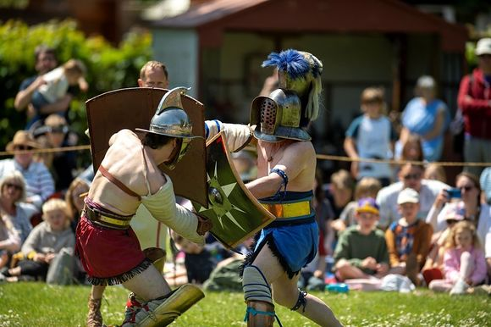
Half term activities, Art trail, racing at Goodwood and Fontwell, Chichester Pride, Art and Food, Flowers and Seals.
It's half term next week and there is plenty to keep our younger residents entertained especially learning about life here through the ages. We start with the Romans and Celts with events at Fishbourne Roman Palace, the Novium and the great re-enactment day at Priory Park (see below)
We then move on to the Saxons at the Weald and Downland who are also running a weekend of Victorian entertainment. You can step back in time too at Stansted House as the house will be open to visitors and children have free entry (see below). Even our walk of the week has an historical theme.
Chichester Pride is now an annual fixture and will be filling the city on Saturday with a colourful parade followed by entertainment at Westgate Fields.
It's the second and final weekend of the Chichester Open Studios art trail so do make the most of this lovely annual event and get to as many of the 116 venues as you can!
For horse-racing fans we bring you the May fixture at Goodwood and a Family Race Day at Fontwell.
There is art at the cathedral, a new ceramics exhibition opening at Petworth and a chance to bid for a work of art in the Silent auction in aid of New Park's Raise the Roof campaign.
Take a trip out on the water with the express purpose of watching the seals with an expert to give you a commentary. A lovely peaceful way to have a break from all the activities happening this weekend.
The South Downs Food festival will soon be upon us with a whole host of activities in the lovely grounds of Stansted House.
Danyah Miller is running a day of creativity in early June inspired by the Festival of Flowers (see below)
If you would like the opportunity to win a pair of tickets to the Festival of Flowers we remind you that to kick off our Summer of Culture in early June we are offering the opportunity to win 2 free tickets. (See below for how to enter)
This missive is getting longer and longer but we still only scratch the surface of what is going on in the area - see more in the month view of the calendar.
If you are organising an event you are welcome to add it - see the base of this mailing for how to do it.
Have a great week.
Vicki
Founder/Editor

Half term activities, Art trail, racing at Goodwood and Fontwell, Chichester Pride, Art and Food, Flowers and Seals.
It's half term next week and there is plenty to keep our younger residents entertained especially learning about life here through the ages. We start with the Romans and Celts with events at Fishbourne Roman Palace, the Novium and the great re-enactment day at Priory Park (see below)
We then move on to the Saxons at the Weald and Downland who are also running a weekend of Victorian entertainment. You can step back in time too at Stansted House as the house will be open to visitors and children have free entry (see below). Even our walk of the week has an historical theme.
Chichester Pride is now an annual fixture and will be filling the city on Saturday with a colourful parade followed by entertainment at Westgate Fields.
It's the second and final weekend of the Chichester Open Studios art trail so do make the most of this lovely annual event and get to as many of the 116 venues as you can!
For horse-racing fans we bring you the May fixture at Goodwood and a Family Race Day at Fontwell.
There is art at the cathedral, a new ceramics exhibition opening at Petworth and a chance to bid for a work of art in the Silent auction in aid of New Park's Raise the Roof campaign.
Take a trip out on the water with the express purpose of watching the seals with an expert to give you a commentary. A lovely peaceful way to have a break from all the activities happening this weekend.
The South Downs Food festival will soon be upon us with a whole host of activities in the lovely grounds of Stansted House.
Danyah Miller is running a day of creativity in early June inspired by the Festival of Flowers (see below)
If you would like the opportunity to win a pair of tickets to the Festival of Flowers we remind you that to kick off our Summer of Culture in early June we are offering the opportunity to win 2 free tickets. (See below for how to enter)
This missive is getting longer and longer but we still only scratch the surface of what is going on in the area - see more in the month view of the calendar.
If you are organising an event you are welcome to add it - see the base of this mailing for how to do it.
Have a great week.
Vicki
Founder/Editor




Chichester Open Studios Art Trail
23rd - 25th May
With 164 artists showing in 116 venues this is the second of the two weekends featuring local artists.
Pick up your Guide from local shops, leisure centres, libraries, stations, hairdressers and more or even check the website to plan your route.
There is some amazing talent in this area from the Downs, to West Wittering, Southbourne to Barnham to Yapton to Bognor. We all look forward to welcoming you through our doors where we will show you where the magic happens and where we create.
Download the trail below
[PDF] chichest​er-open-​studios-​trail-gu​ide-2026​.pdf

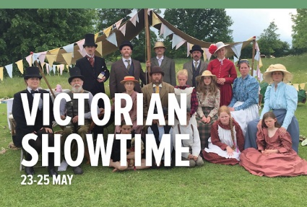
Living History: Victorian Showtime
23rd - 25th May - Weald and Downland Living Museum
Join us for three days of extraordinary Victorian showtime entertainment, as we are joined by Melford Hys Companie, as they showcase their Victorian Travelling Show.

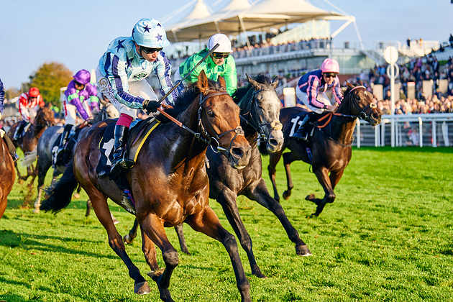
Goodwood Horseracing - May Festival
22nd - 23rd May - Goodwood
Two thrilling days of competitive horseracing are headlined by three valuable listed races. Whether it be a Classic contender or Group 1 campaigner, a host of high-class horses has started the season at the May Festival

 | CYE Families Weekend  22nd - 25th May Chidham  A memorable weekend designed to facilitate faith in the family; the CYE Families weekend is a mixture of water sports, land activities, silly games, spiritual input and delicious food

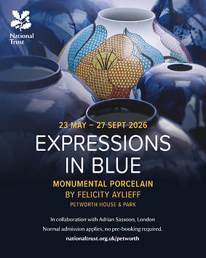
Expressions in Blue: Monumental Porcelain by Felicity Aylieff
23rd May - 27th September
Petworth House
This exhibition invites visitors to experience Petworth anew, with these towering works positioned in the Capability Brown landscaped park and throughout the house.
Continuing Petworth's rich history of inspiring contemporary artists, Aylieff has created several new pieces, exhibited here for the first time. Highly decorative floral fencai enamelled vessels take reference from intricate wood carvings by Grinling Gibbons, while other sculptures draw on Petworth's magnificent collection of 17th-century Chinese porcelain.


Chichester Pride
23rd May - Central Chichester and the front lawn of Chichester College
Chichester Pride is back for its fifth year to celebrate individuality, inclusivity, diversity, respect and unity within our city. All members of the LGBTQ+ community and its allies are invited to enjoy our colourful parade through the city centre in the morning followed by our annual festival on the front lawn of Chichester College where attendees can enjoy a main stage packed with quality entertainment, food, drink and a range of fabulous stalls to browse!
A day of celebration, fun, colour and unity which no-one should miss

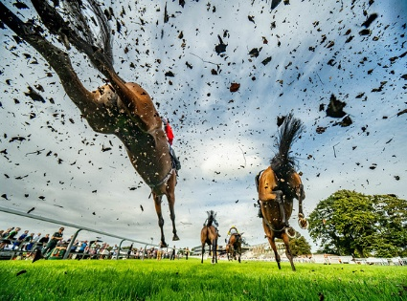
Fontwell Park Family Festival Raceday
24th May Fontwell Park Racecourse
Following its hugely popular debut last year, Fontwell Park Racecourse welcomes back its Family Festival Raceday for an action-packed Bank Holiday weekend celebration.
This fun-filled event combines the thrill of live jump racing with a full day of family entertainment — with even more included in the ticket price. Families can enjoy a vibrant festival atmosphere across the racecourse, with:
- Traditional fun fair rides
- Face painting
- A live entertainment stage with performances and interactive shows
- Energetic and inclusive children's fitness classes

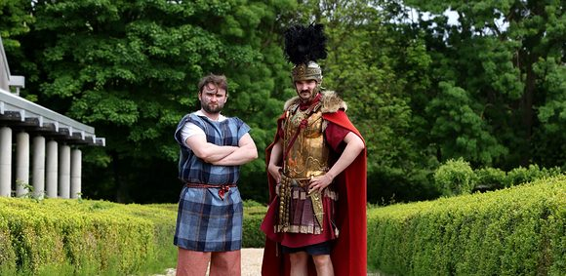
May Half Term: Celts and Romans
25th-29th May Fishbourne Roman Palace
Visit Fishbourne Roman Palace this May half term to celebrate all things Celts and Romans.
These two communities lived side-by-side 2,000-years-ago, trading goods, ideas and cultural practices. From fashion to food, we've got lots of fantastic activities for families visiting Fishbourne Roman Palace this half term.
Step into the world of Celts and Romans!
Get creative and have fun with a range of exciting activities for all ages. Explore models of Celtic and Roman buildings to compare the different ways the two communities lived. Build your own roundhouse or Roman villa to take home. Try out ancient board games and then get crafty and make your own game counters. Try traditional wool spinning and dress up like a Roman.

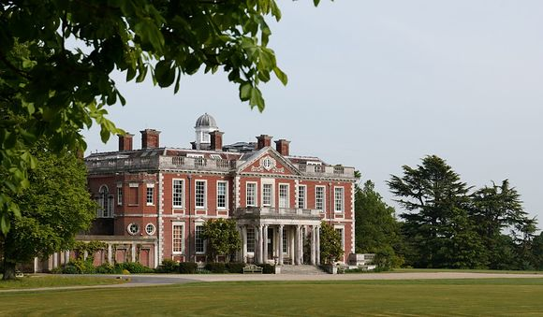
May Bank Holiday House Opening
25th May - Stansted House
Visit Stansted House this May Bank Holiday and enjoy an Upstairs, Downstairs experience as you explore the family seat of the Earls of Bessborough.
Discover the beautiful State Rooms, once used by the family to entertain guests, before venturing downstairs to explore the fully furnished and extensive Servants Quarters. The Chapel of St Paul will also be open to visitors.
Children can also visit Stansted House for free, with a special trail around the State Rooms and Servants Quarters to enjoy and the opportunity to play traditional games in the Servants Hall.


Saxon Life May Half Term Activities
26th -28th May Weald and Downland Museum
Immerse yourself in the Saxon period this May half term!
Travel back 1,000 years and experience history like never before.
This May half term, embark on an unforgettable, hands-on adventure into the Saxon age at the Weald & Downland Living Museum. From mysterious riddles to ancient crafts, thrilling storytelling to real archaeological discovery—theres something to spark every imagination.


Roman Re-enactment Day
28th May - Priory Park
Bring Roman Chichester to life at this free family event in Priory Park
A highlight of Chichester Roman Week, Roman Re-enactment Day is packed with live action, hands-on activities and plenty to see throughout the day
Watch leading Roman living history group Legio Secunda Augusta recreate the sights and sounds of the ancient world through a series of live shows and talks. Find out how Roman soldiers trained and fought, explore crime and punishment in Roman Britain, learn about the realities of slavery in Roman society, and enjoy the drama of a gladiator show
There's lots for families to enjoy throughout the day, too. Children can try free Latin taster sessions with Fishbourne Roman Palace in The Guildhall, while Red Fox Archery will be offering have-a-go archery for £5 per person.
There's no need to book in advance for this free event - just come along and enjoy

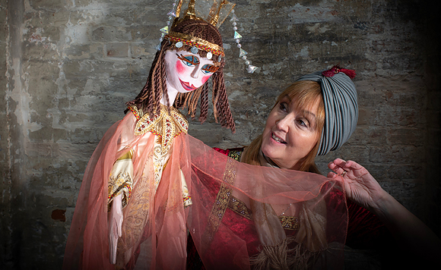
Roman Storytelling with Red Sauce Theatre
27th May - The Novium Museum, Chichester
We're currently changing our exhibitions. See below for room closures during this period.
New Wing: The first floor of the New Wing will be closed from the 10 30 May 2026.
Historic House: The Historic House will remain open, allowing you to see both our collection artworks and our new exhibition, 'Pop and the Figure'.
Print Room: This will remain open, allowing you to see our new exhibition, 'From Bawden to Hockney: The Dennis Andrews and Christopher Whelen Collection'.
Please be aware, spot closures may occur to facilitate the moving of artworks.
During our exhibition changeover, admission is half price.
We will be open as normal from the 30 May 2026 with our new season of exhibitions!

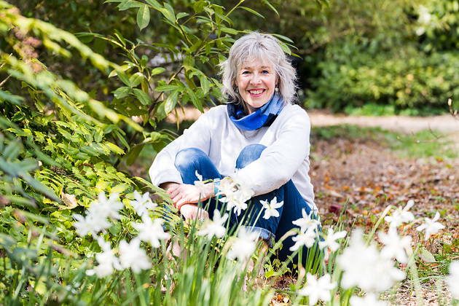
Personal Stories with Danyah Miller
3rd June - Fernleigh, North Street, Chichester
An Introduction to Shaping and Telling Your Own Tale
Join us at Fernleigh for a captivating day of creativity and connection with award-winning storyteller and author Danyah Miller.
Inspired by the Festival of Flowers, this immersive workshop invites you to uncover and shape a personal story sparked by memories of nature, trees, flowers, landscapes and the moments that have quietly shaped your life. With Danyah's expert guidance, you'll learn how to transform those memories into a meaningful story you can share, perform, or treasure.



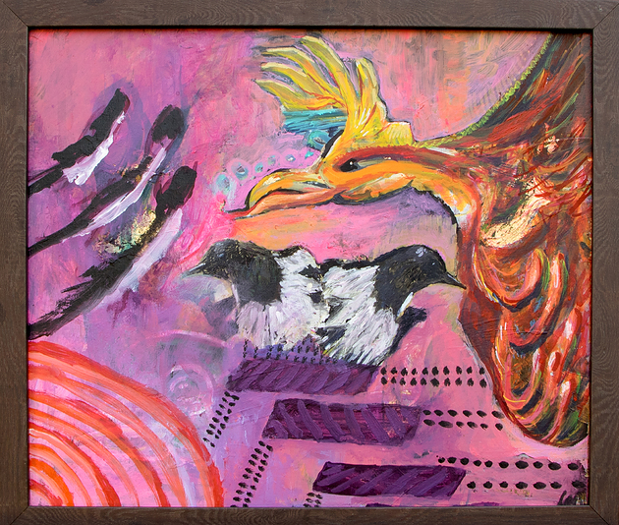
Silent Art Auction in aid of Raise the Roof campaign
1st - 30th June
A major community art initiative in Chichester is gaining momentum this summer, as New Park Centre announces the secured donation of an original artwork from acclaimed local artist Louise Duggan, alongside a growing collection of contributions from artists across the region.
The month-long auction forms part of the Centres ambitious RAISE THE ROOF (RTR) campaign, which aims to raise £450,000 to replace the roof of its historic Victorian building, securing the future of one of the citys most valued creative spaces.
Louise Duggan, an internationally exhibited painter and mixed media artist based in Chichester, has donated an original artwork to the auction, reflecting her ongoing support of the local creative community and the opportunities that enable artists to share their work.
The Silent Art Auction will run throughout June, showcasing a diverse collection of donated artworks from artists across the region. Visitors will be invited to place bids across the exhibition period, with final bids closing on 30 June. All proceeds will go directly towards the RTR campaign.




South Downs Food Festival
6th - 7th June Stansted Park
A spectacular weekend of food, drink, and celebration.
For 2026, we are thrilled to be working with our charity partners Chefs in Schools as we support their school food revolution, through tastier, more nutritious school dinners and food education. Across the weekend, we will be raising funds for Rowans Hospice, as we champion the region's finest producers.
Held in the stunning grounds of Stansted Park Estate, the mansion provides a spectacular backdrop to the festival, which has quickly become a highlight of the UK's culinary calendar.
Stroll through our vibrant marketplace, where farmers, foragers, fermenters, and artisan makers showcase the best seasonal fruits, vegetables, and handcrafted delights. Indulge in charcuterie and cheeses, kombucha and kefir, burgers and beerall while celebrating the incredible ingredients of the South Downs.
Highlights of the 2025 South Downs Food Festival included an impressive street food lineup that brought the best of Hampshire and Sussex together with global influences from Mexican tacos and Vietnamese banh mi to smoky brisket, hog roasts, Wagyu burgers, sushi, and handmade fishcakes - washed down with top-tier English sparkling wine courtesy of a local vineyard, craft ales and scrumptious ciders. A true feast for the senses and you can expect even more in 2026!
Each year, the festival explores a different theme from the legacy of Elizabeth David to the future of food in schools. For 2026, we present a theme close to our hearts and palates: The Italian Influence on British Food Culture. Learn how Italian food has influenced farmers and producers since Roman times, from the introduction of asparagus to the spectacular vineyards that take in the sunshine on the southern slopes of the Downs.
Join cookery demonstrations, live fire BBQ and kids activities as we inspire the next generation to feast on fun, healthy and delicious food, and enjoy talks from producers, chefs and authors.



Art Tour at the Cathedral
27th May - Chichester Cathedral
As well as being a centre of worship and a beautiful building, the Cathedral is home to a significant collection of art, designed to inspire and challenge visitors.
Medieval wall paintings and sculpture reliefs sit alongside Victorian glass work and contemporary art, all helping to enrich and beautify Chichester Cathedral.

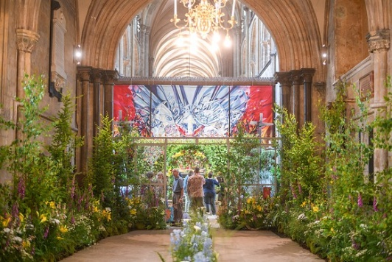
Win 2 tickets to the Festival of Flowers!
We are so excited to bring you the chance to win a day out for two at the Festival of Flowers!
Help us to spread the word for our new Instagram page and you might be lucky enough to win tickets for you and a guest to see the spectacular flower displays at this beloved biennial event
To enter:
Follow @chichesterliving on Instagram
Like this post
Tag a friend who would like to come too!
Good luck!
Closing date: Midnight UK time on Sunday 24th May
T&Cs. Prize is for 2 x tickets to Chichester Cathedral's Festival of Flowers 2026 for any day of the Festival (3-6 June 2026).



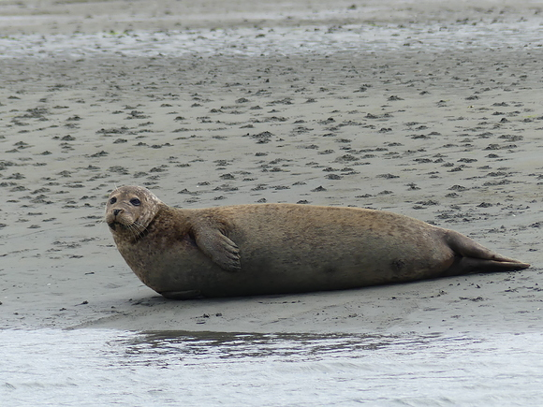
Seal Safari Boat Trip on Solar Heritage
27th May Itchenor Jetty
Experience the wonderful seals and natural beauty of Chichester Harbour on our eco-friendly solar-powered boat, Solar Heritage. A trip aboard offers a quiet and peaceful way to enjoy the harbour and the perfect way to observe the special seals in their natural habitat. One of our wonderful seal experts will be on board to provide commentary as you travel and answer any questions you may have.
The boat is open-sided with superb views of the seals and beautiful panoramic harbour views


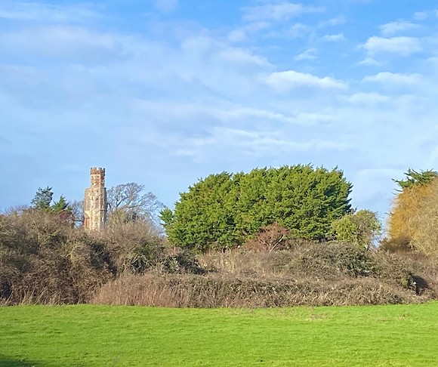
Countess and the Crown
28th May - Between Havant and Walderton
An 8.2 mile, mostly flat and linear walk following in the footsteps of a remarkable Tudor noblewoman whose life bridged the Wars of the Roses and Henry VIII's Reformation. Few periods in English history were more dramatic. Her story is one of navigating the delicate balance between deep religious conviction and loyalty to the Crown


University of Chichester
Several roles for talented professionals with a background in further education. Check out this link for more information on each role.
Closing date 1st June 2026



A Selection of upcoming Networking Events
26th May - Acorn Networking Arundel
26th May - Chichester Small Business Networking at The Apuldram Centre
27th May - Acorn Networking Ashling Park
28th May -Littlehampton Business Networking
29th May - Informal networking meeting in Westbourne
We are endeavouring to bring you a selection of networking events in the area each week. Some organisations require membership but usually allow you to try before you buy, some are pay as you go, and some are completely free of charge.

Promote Your Event
Add your own event to our calendar - here's how:
1. Click the link at the base of the home page Submit an Event"
2. Create a login account if you don't already have one
3. Complete the form with the details of your event, ensuring that you have added an image and a short description along with the other important information. Please use plain, unformatted text and use the formatting tools in the form.
(Kindly note that events will not be made live if they do not include a short text description and image. Images should be .png or .jpeg NOT pdf)

Newsletters 2026  January week 1  January week 2  January week 3  January week 4  January week 5  February week 1 | Newsletters 2026  February week 2  February week 3  February week 4  March week 1  March week 2  March week 3  March Week 4 | Newsletters 2026  April Week 1  April Week 2  April Week 3  April Week 4  Summer of Culture  May Week 1  May Week 2



powered by BoxStuff rapportUnsubscribe from this mailing

