

Photo by Toby Adamson
Yes it's Goodwoof weekend!
This weekend we have two annual fixtures in the local calendar - the barking event that is Goodwoof and the first weekend of the Chichester Open Studios art trail. (see below). There are only limited tickets still available at time of writing for Goodwoof, so don't delay.
The Government has now launched a further consultation on options for local government reorganisation in Sussex. This will be open until the 15th June and all residents are invited to have their say. Read the full article
At Chichester Festival Theatre Eclipse Magic closes on the 16th May and Eclipse runs until the 6th June. Rehearsals are well underway for Atonement (see below)
At Pallant House Gallery there is half price entry until the next major exhibition opens on the 30th May - a good opportunity to visit the main house and two smaller exhibitions (see below)
Also - as we are in Mental Health Awareness week West Dean Gardens are kindly offering a week of free entry until the 17th to help you enjoy the peace and tranquility of their beautiful site.
Tickets are on sale for various festivals - Chichester Fringe, Petworth Festival and the Festival of Chichester. We already carry the full programme for the Fringe under a special tag on the events page and the complete listings for Petworth and Chichester are gradually being added. Save the date for two great fundraisers for the Arundel Festival (see below)
We remind you that to kick off our Summer of Culture in early June we are offering 2 free tickets to the lovely Festival of Flowers at the Cathedral. See below for how to enter
In addition we bring you another eclectic mix of music, crafts, art and the chance to get out on the water with Solar Heritage or at CYE (see below). However this only scratches the surface of what is going on in the area - see more in the month view of the calendar.
If you are organising an event you are welcome to add it - see the base of this mailing for how to do it.
Have a great week.
Vicki
Founder/Editor

Photo by Toby Adamson
Yes it's Goodwoof weekend!
This weekend we have two annual fixtures in the local calendar - the barking event that is Goodwoof and the first weekend of the Chichester Open Studios art trail. (see below). There are only limited tickets still available at time of writing for Goodwoof, so don't delay.
The Government has now launched a further consultation on options for local government reorganisation in Sussex. This will be open until the 15th June and all residents are invited to have their say. Read the full article
At Chichester Festival Theatre Eclipse Magic closes on the 16th May and Eclipse runs until the 6th June. Rehearsals are well underway for Atonement (see below)
At Pallant House Gallery there is half price entry until the next major exhibition opens on the 30th May - a good opportunity to visit the main house and two smaller exhibitions (see below)
Also - as we are in Mental Health Awareness week West Dean Gardens are kindly offering a week of free entry until the 17th to help you enjoy the peace and tranquility of their beautiful site.
Tickets are on sale for various festivals - Chichester Fringe, Petworth Festival and the Festival of Chichester. We already carry the full programme for the Fringe under a special tag on the events page and the complete listings for Petworth and Chichester are gradually being added. Save the date for two great fundraisers for the Arundel Festival (see below)
We remind you that to kick off our Summer of Culture in early June we are offering 2 free tickets to the lovely Festival of Flowers at the Cathedral. See below for how to enter
In addition we bring you another eclectic mix of music, crafts, art and the chance to get out on the water with Solar Heritage or at CYE (see below). However this only scratches the surface of what is going on in the area - see more in the month view of the calendar.
If you are organising an event you are welcome to add it - see the base of this mailing for how to do it.
Have a great week.
Vicki
Founder/Editor



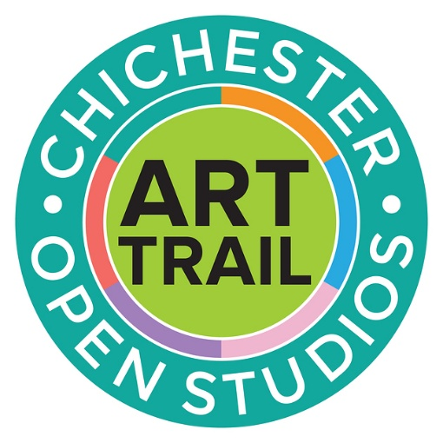

Chichester Open Studios Art Trail

16th May - 17th May and 23rd - 25th May
With 164 artists showing in 116 venues these will be two weekends that you won't want to miss in your calendar. The Chichester Open Studios Art Trail is nearly upon us - have you spotted the road signs?! The Trail is on 16th/17th, 23rd/24th and 25th May*
Pick up your Guide from local shops, leisure centres, libraries, stations, hairdressers and more or even check the website to plan your route. With the Snapshot now over at the Oxmarket hopefully you will now be able to plan your route to see as many artists as possible. There is some amazing talent in this area from the Downs, to West Wittering, Southbourne to Barnham to Yapton to Bognor. We all look forward to welcoming you through our doors where we will show you where the magic happens and where we create.
Download the trail below

[PDF] chichest​er-open-​studios-​trail-gu​ide-2026​.pdf


Multi Activity Days
16th - 17th May - CYE Chidham
Our best option if you want to have a go at everything! Usually, a combination of one water activity and one land activity; multi-activity days allow us the flexibility to choose our activities based on the conditions on the day ensuring that you get the best possible experience.
A great opportunity to meet new people and try something new and an excellent introduction to water sports. NB: Activities may be repeated on consecutive days.



Emsworth Loves Local Small Business Market
16th May - Emsworth
Join us at Emsworth Methodist Church for a lovely day celebrating small businesses, community and creativity. Our market brings together a carefully curated selection of independent traders, offering unique handmade goods, thoughtful gifts and beautiful treats all made with passion by local makers.
By visiting our market, you're directly supporting small businesses within our community, helping them grow and thrive. We're also proud to be supporting our charity partner, Brent Lodge Wildlife Hospital, whose incredible work cares for injured and orphaned wildlife across the region.
Emsworth itself makes the perfect backdrop for a day out, with its charming harbour, independent shops and welcoming cafés just a short stroll away. Whether you're shopping for something special or simply enjoying the atmosphere, your visit helps strengthen our local community and supports causes that truly matter.

 | Saxon Drawing Workshop  16th May The Novium Museum, Chichester  Explore The Novium Museum's Saxon handling collection and explore a range of objects up close, observing their shapes, patterns and textures.  In this two-hour workshop with local artist Sue Webber, youll create your own drawings inspired by the collection, working at your own pace in a relaxed and supportive setting. This workshop is suitable for all levels, whether youre completely new to drawing, or looking to build experience and confidence. '



Upstairs @ Raps with Greg Coulson and Mat Day
19th May Upstairs at Raps
Upstairs at Raps presents Greg Coulson and Mat Day. Greg Coulson is a musical powerhouse. An expressive singer/songwriter who blends soul and classic rock with the groove of Blues funk and jazz. Mat Day will be a familiar face to blues audiences as the lead guitarist with many bands. Mat has just started his own project The Mat Day Band

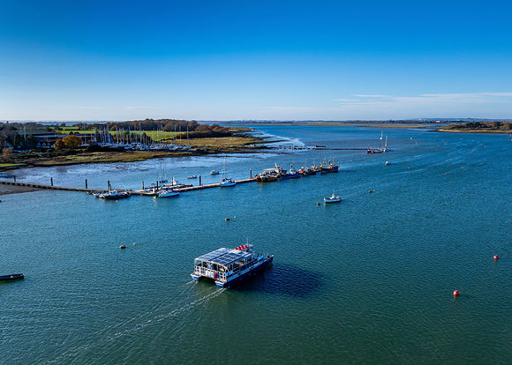

Guided bird-watching boat trip on Solar Heritage
16th May. Itchenor Jetty
Returning for a seventh event at the world renowned Goodwood Racecourse in the heart of the picturesque Sussex Downs, 95 exhibitors, each of whom you will be able to meet, will be situated throughout the main hall of The March Stand with 3000+ artworks for purchase.
Spread over 3 days starting Friday 8th May at our Opening Night, visitors will be the first to view the collections of artists work along with complimentary wine before the event opens at the weekend to the general public. Prices of art starts from as little as £50 for prints and smaller works to over £3,000 for outstanding masterpieces, so there will be something to suit every budget.
We are thrilled to be continuing our collaboration with Sussex Wildlife Trust, a conservation charity who cares about protecting the wonderfully rich natural life that is found in our Sussex towns, countryside and coast. Visitors can purchase original artworks kindly donated by our exhibitors, each work priced at £50 with all proceeds going to the charity.

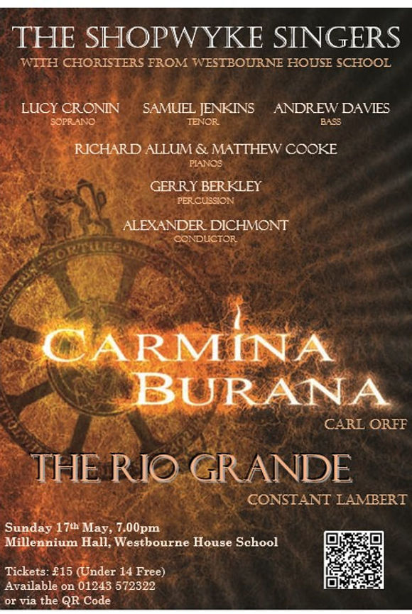

Carmina Burana - The Shopwhyke Singers
17th May. Westbourne House School, Shopwhyke
Carmina Burana performed by the Shopwhyke singers under musical director Alex Dichmont.
Tickets - £15 (under 14s Free)
Available on 01243 573322 or via the QR code in image
Millenium Hall, Westbourne House School

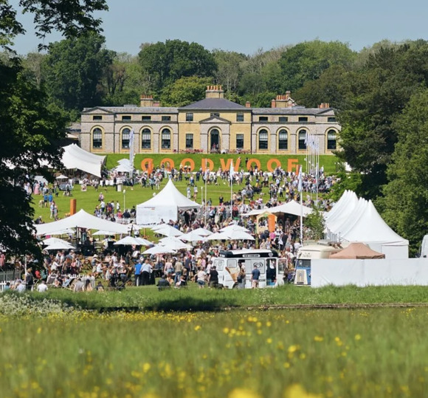

Goodwoof
8th - 10th May Petworth Park Marquee
Goodwoof is a dog event like no other. With all activities included in your ticket price, Goodwoof offers the chance to celebrate everything we love about our canine companions

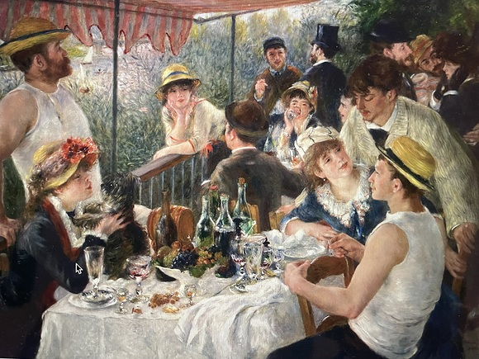

Bottoms Up: the story of alcohol in art

20th May - Assembly Rooms, Chichester
Ian Swankie gives a talk about alcohol and intoxication in art. Since the early Romans and Greeks, alcohol has been an important subject for artists. He examines the way drink and drinking are depicted, the social messages portrayed, the happy and unhappy consequences, and how alcohol affected the lives of many artists, their families and friends.
The Arts Society Chichester Evening

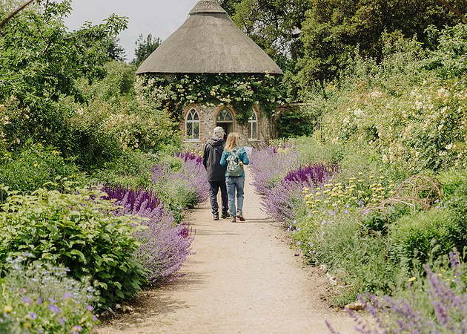
West Dean Gardens supporting Mental Health
Enjoy free entry to West Dean Gardens from 11-17 May to support Mental Health Awareness Week. Take peaceful walks, reflect quietly, and spend time in nature.
The Gardens Kitchen will be open all week, serving dishes inspired by seasonal produce.
No booking required.
Price FREE


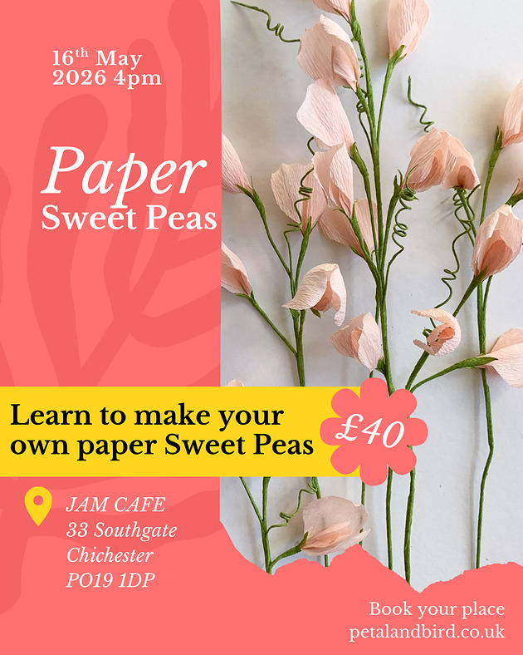
Paper Sweet Pea Workshop with Petal and Bird
16th May -Upstairs at Jam Cafe
Join Clare of Petal & Bird for a couple of hours paper creativity and learn to make your own paper Sweet Peas.
Clare will take you through the process step by step, no previous experience is required
- Workshop starts at 4pm and runs for approximately 2 hours
- Materials provided
- £40 per person

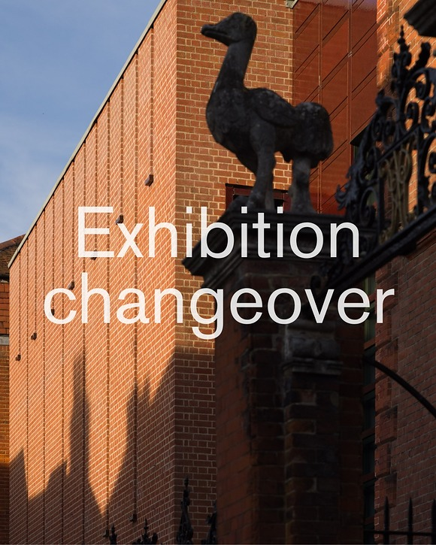
until 30th May - Pallant House Gallery
We're currently changing our exhibitions. See below for room closures during this period.
New Wing: The first floor of the New Wing will be closed from the 10 30 May 2026.
Historic House: The Historic House will remain open, allowing you to see both our collection artworks and our new exhibition, 'Pop and the Figure'.
Print Room: This will remain open, allowing you to see our new exhibition, 'From Bawden to Hockney: The Dennis Andrews and Christopher Whelen Collection'.
Please be aware, spot closures may occur to facilitate the moving of artworks.
During our exhibition changeover, admission is half price.
We will be open as normal from the 30 May 2026 with our new season of exhibitions!



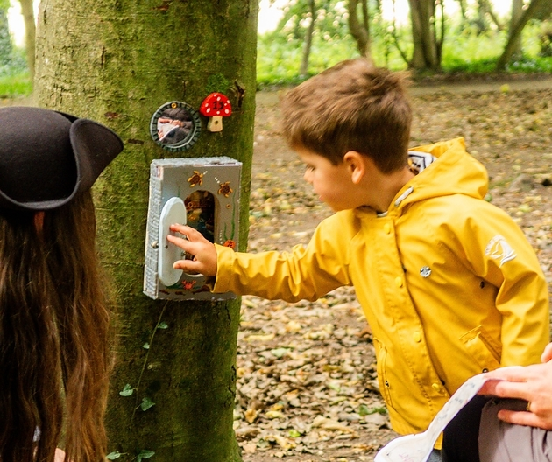
Pixies & Pirates May Half Term
23rd - 31st May - Aldingbourne Country Centre
Set sail for the Aldingbourne Country Centre, for a fun half term for pre-schoolers and primary-aged children!
Activities throughout the week includes: Bubble Show, Potion Making, Animal Experiences, Craft Activities, Sword & Wand Making & Training, Fairy Doors in our Woodland Walk, and so much more!
- Aldingbourne Country Centre, PO18 0JP
- No booking needed - just turn up on the day
- See more: www.aldingbournecountrycentre....
We are a charity supporting adults with learning disabilities and autism to live independent lives.



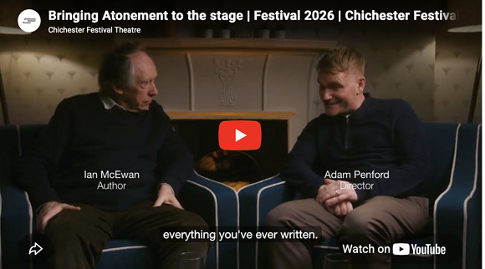

Atonement
29th May - 20th June Chichester Festival Theatre
Bringing Atonement to the Stage. Follow the link in the image to watch author Ian McEwan and director Adam Penford in conversation.
Images below of the rehearsals in action
Stretching from the 1930s through the Second World War to the present day, Ian McEwan's dazzling masterpiece was shortlisted for the Booker Prize and voted by Time Magazine and the Guardian as one of the 100 greatest novels of the past century.
This world premiere stage adaptation is by Christopher Hampton, whose many plays and adaptations also include The Philanthropist and Les Liaisons Dangereuses, which won the Olivier and Evening Standard Awards for Best Play.
Siân Phillips returns to Chichester to play the older Briony Tallis; her distinguished stage work includes the Olivier and Tony Award-nominated Marlene and Olivier-nominated Cabaret, and on screen I, Claudius. Miriam Petche (HBO/BBC's Industry) plays Cecilia, and Jasper Talbot (Redlands) plays Robbie.
Adam Penford, Artistic Director of Nottingham Playhouse where his recent work includes James Graham's award-winning Punch, also in the West End and on Broadway, makes a welcome return to Chichester following his 2023 production of The Sound of Music.
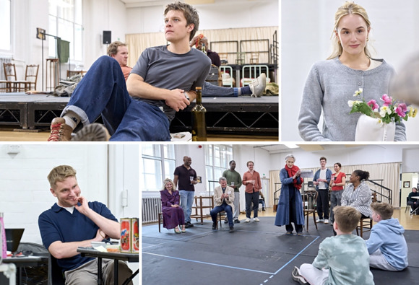


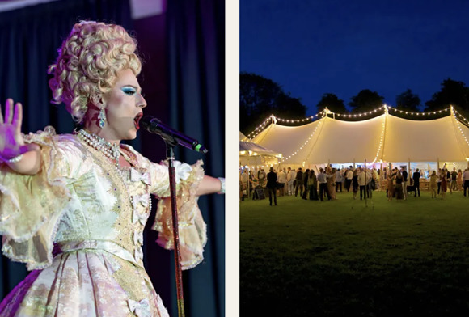
Fundraisers for the Arundel Festival of the Arts
Arundel Castle
12th June - Party at the Castle
Step into a magical night of glamour, entertainment, and celebration at our Annual Castle Fundraiser on the Lower Lawns of Arundel Castle. This year, we invite you to truly dress to impress and enjoy an unforgettable evening in a stunning setting.
13th June - Going Country at the Castle
Get ready for a night of toe-tapping fun at our Barn Dance Fundraiser! Whether youre a seasoned dancer or have two left feet, this is your chance to let loose, have a laugh, and enjoy a fantastic evening with friends old and new. With a live band and expert caller to guide you every step of the way, youll be swinging, spinning, and stomping in no time. Plus, well be mixing things up with some line dancing favourites, so everyone can join in the fun.
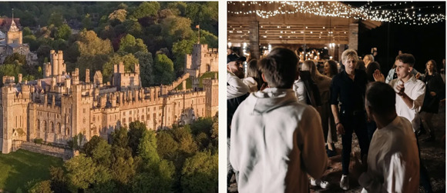

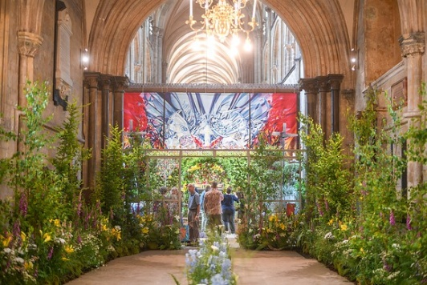
Win 2 tickets to the Festival of Flowers!
We are so excited to bring you the chance to win a day out for two at the Festival of Flowers!
Help us to spread the word for our new Instagram page and you might be lucky enough to win tickets for you and a guest to see the spectacular flower displays at this beloved biennial event
To enter:
Follow @chichesterliving on Instagram
Like this post
Tag a friend who would like to come too!
Good luck!
Closing date: Midnight UK time on Sunday 24th May
T&Cs. Prize is for 2 x tickets to Chichester Cathedral's Festival of Flowers 2026 for any day of the Festival (3-6 June 2026).





Ceroc Chichester - Weekly Social Parter Dancing Classes
Every Tuesday - Assembly Rooms Chichester
Ceroc Chichester - weekly Social Partner Dancing classes on a Tuesday evening! Whether you're looking to get in shape, learn a new skill, or simply meet new friends, Ceroc is the perfect way to do it all!
Join us on a Tuesday evening at The Assembly Room, The Council House, North Street, (RH19 1LQ) - you don't need to book and you don't need to come with a partner. Beginners are welcome every week!




A Selection of upcoming Networking Events
18th May - Chichester Networking at Chichester Grange
18th May - Harbour Networking
19th May - Chichester Evening Networking - Bosham Inn
20th May - Chichester Chamber of Commerce, Business Breakfast
22nd May - Chichester Small Business Networking - Crouchers Hotel
We are endeavouring to bring you a selection of networking events in the area each week. Some organisations require membership but usually allow you to try before you buy, some are pay as you go, and some are completely free of charge.

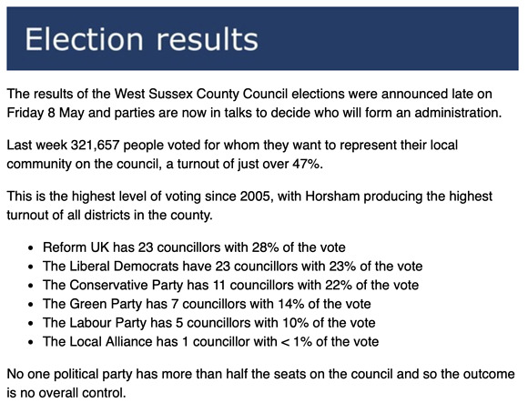
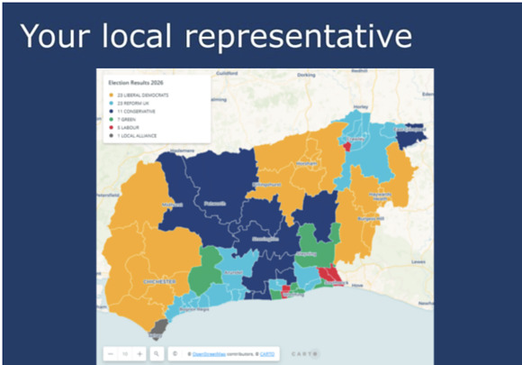

Promote Your Event
Add your own event to our calendar - here's how:
1. Click the link at the base of the home page Submit an Event"
2. Create a login account if you don't already have one
3. Complete the form with the details of your event, ensuring that you have added an image and a short description along with the other important information. Please use plain, unformatted text and use the formatting tools in the form.
(Kindly note that events will not be made live if they do not include a short text description and image. Images should be .png or .jpeg NOT pdf)

Newsletters 2026  January week 1  January week 2  January week 3  January week 4  January week 5  February week 1 | Newsletters 2026  February week 2  February week 3  February week 4  March week 1  March week 2  March week 3  March Week 4 | Newsletters 2026  April Week 1  April Week 2  April Week 3  April Week 4  Summer of Culture  May Week 1



powered by BoxStuff rapportUnsubscribe from this mailing

