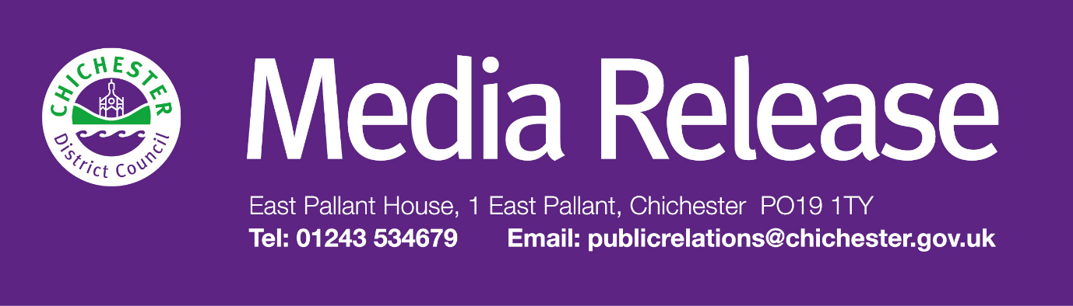
Date of Release: 21 April 2026 Ref: 4587
Community invited to help shape new exhibition at The Novium Museum

The Novium Museum in Chichester is inviting local people to help shape a new exhibition about the lives and achievements of women connected to Chichester District.

Thanks to a £117,266 grant from The National Lottery Heritage Fund, the museum is developing a headline exhibition, ‘ChichestHER: Their Story, Our Inspiration’, which will open in October 2026.

The exhibition forms part of a two-year project to uncover and share the stories of remarkable women from across the district. Their work and achievements have helped shape local life, but their stories have not always received the attention they deserve.

As part of this work, the museum is inviting local people to take part in a focus group at The Novium Museum on Friday 8 May 2026, 1.30pm – 3.30pm.

The focus group will give participants the chance to be involved with the exhibition development by sharing ideas and offering feedback on the proposed exhibition content and design. No previous experience of working or volunteering in museums is needed – the museum is simply looking for people with an interest in the subject and a willingness to share their views.

Places are limited, and anyone who would like to take part should register their interest at www.thenovium.org/chichesther/focus-groups by Friday 1 May 2026.

‘ChichestHER: Their Story, Our Inspiration’ will bring together research, oral histories, community collaboration and creative work to present a fuller picture of women’s lives across Chichester District.

Amanda Rogan, Manager of The Novium Museum and Tourist Information Centre, said: “This exhibition will tell stories that deserve to be better known across Chichester District. We want to hear from local people as we develop it, so that the exhibition reflects the community and speaks to the people who live here now. Taking part in the focus group is a great way to help shape the exhibition, and we hope people will get involved.”

To find out more about the ChichestHER project, visit www.thenovium.org/chichesther

For further information, please contact Clare Hawkin, Senior Communications Officer, on 01243 534679 or
by emailing chawkin@chichester.gov.uk

