

Thanks to the South Downs Planetarium for this image of earth taken by Reid Wiseman, Commander of the Artemis II mission. Read more about this image on the Planetarium website. Please note that the Planetarium is closed for public shows during April and May as they carry out some refurbishments to celebrate their 25th anniversary. We wish the astronauts a safe return.
Back on earth - the BFG will end its run on the 11th April along with the trail of dreams which is the result of the BID, the Festival Theatre and local businesses working together. Read more here. Magic opens at the theatre on the 24th April and you can read below how actor Hadley Fraser has had to learn a few tricks himself.
It is your last chance to see Erasure at the Goodwood Art Foundation, the Jane Bown exhibition at Newlands House Gallery, Petworth and the Easter Art trail in 4 local cafes.
At Pallant House Gallery the William Nicholson Exhibition has had over 25,000 visitors in its first few months and the Glowing+ Alive display at the Cathedral celebrates 60 years since the installation of the vibrant John Piper tapestry.
At Goodwood there is only limited availability at time of writing for the members meeting 18th/19th April and tickets are flying off the shelves for the Stapleford Supercar Show at Stansted House on the 31st May.
The annual tulip festival is now open throughout the gardens of Arundel Castle. The online booking system is currently unavailable so best to get there early to limit waiting time. Sunshine, early blossoms and flowers in a magnificent setting - no wonder it is popular.
Some of the Easter activities mentioned in the mailing before Easter are still running this weekend and you can check them out in the last newsletter.
Wishing you al a sunny week.
Vicki
Founder/Editor


Will Rendle

11h April - The Nest at Chichester Festival Theatre
Will Rendle AKA "King Willy Will" is a restless romantic with a guitar, carving melody from memory and truth.
Best known as the wild-hearted frontman of British cult quintet Will and the People, a father of three boys and a fiercely independent creative, his solo work strips it all backjust voice, strings, and story.
Intimate, raw, and full of crooked beauty, these songs walk the line between light and shadow, hope and heartbreak. Fresh off a string of shows in the UK with his band, he will be playing a one off special intimate show at The Nest.
He's not used to an interval, so, expect the unexpected.

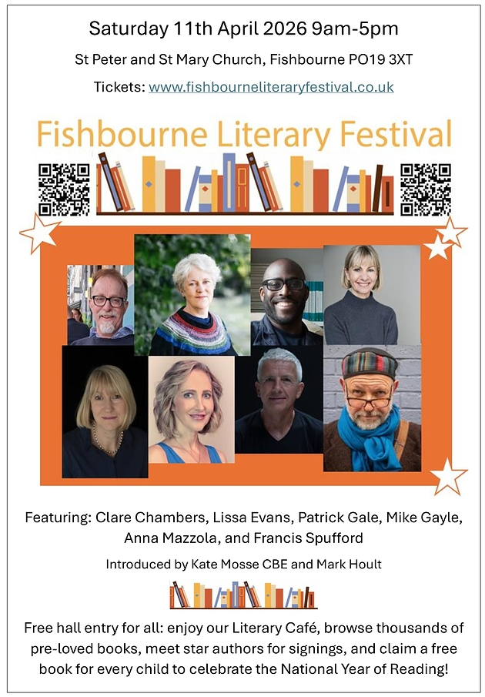

Fishbourne Literary Festival
11th April - St Peter and St Mary Church, Fishbourne
Meet star authors for signings, browse thousands of pre-loved books, enjoy the Literary Café and claim a free book for every child to celebrate the National Year of Reading
FREE ENTRY TO HALL FOR ALL
Tickets to hear the authors' talks have sold out
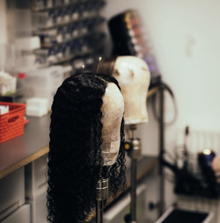 | Family Friendly Backstage Tours  11th April Chichester Festival Theatre  Join one of our Family Friendly Backstage Tours, perfect for 7 - 11 year-olds.  Our 60-minute guided tour is a brilliant way to explore how theatre is made! Discover our backstage spaces, how we create our shows and experience our famous Festival Theatre stage*. Find out about the theatres beginnings and come away with oodles of fantastic facts about what happens behind the scenes today. Plus there will be chances to get hands-on with props and try on costumes used in previous productions - lots of fun.


The Perfect Murder
14th - 18th April West Ashling and Funtington District Hall
The Perfect Murder, adapted from a story by Jeffrey Archer by Hugh Janes, is an intriguing drama. Is it in fact the perfect murder?
Come along and discover for yourself.
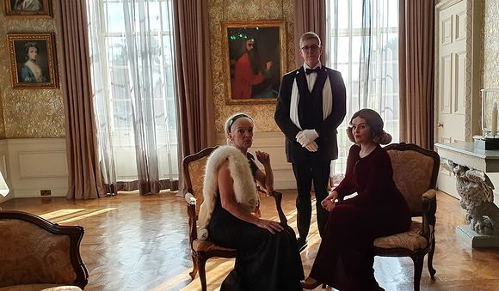

Family Murder Mystery: Step Into a World of Secrets
11th April Stansted House
Calling all budding detectives! Challenge the whole family to crack the Stansted Murder Mystery.
Kick off the evening with lashings of tea, biscuits, and ginger beer as you meet the suspects.
Once you realize your host is missing, your family will have exactly one hour to explore the house by torchlight, interrogate the characters, and piece together the clues. Finally, you will all assemble in the Servants Hall to voice your theories and see if you caught the culprit!
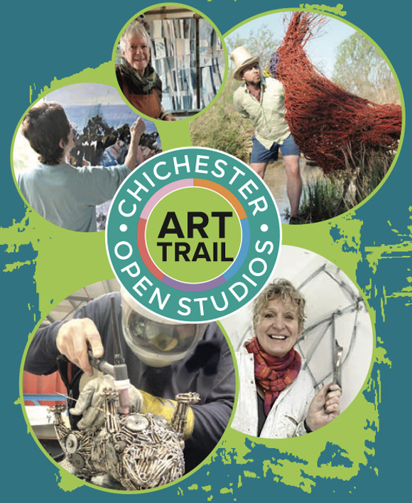

Oxmarket Contemporary
14th - 26th April
Oxmarket are delighted to welcome back Chichester Open Studies (COS) for their 25th anniversary with a Snap-Shot Exhibition in our John Rank and Wilson Galleries. This exhibition promises an intriguing preview of the artistic diversity and creativity that will be on display during the Art Trail.
The highly anticipated Chichester Open Studios Art Trail returns this spring, promising two inspiring weekends filled with creativity, discovery, and community. Running across 116 venues, this years Trail features an impressive 164 artists, making it one of the most significant events in the Chichester areas art calendar.
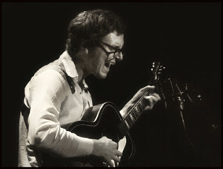

Bluegrass in the Barn
11th April. Cobnor
Two of the USA's most accomplished Bluegrass musicians play a special show in Cobnor on Saturday 11 April.
Jacob Jolliff (mandolin) and Michael Daves (guitar) are over in the UK for Sore Fingers Week which attracts top Bluegrass and Old Timey players from all over Europe to perform and give workshops from April 6-10 at Lord Wandsworth College near Hook in North Hampshire. By sheer coincidence they had a day free on Saturday 11 April and approached WemsFest Director Mark Ringwood as he had previously arranged UK work permits for them a few years ago. Within days a venue had been sorted out and tickets put on sale. The Barn at Cobnor Point, Chidham, PO18 8TE will host the concert at 8pm on the 11th and the two musicians will also perform a special instore set at Harbour Records in Emsworth at 1pm on the same day.

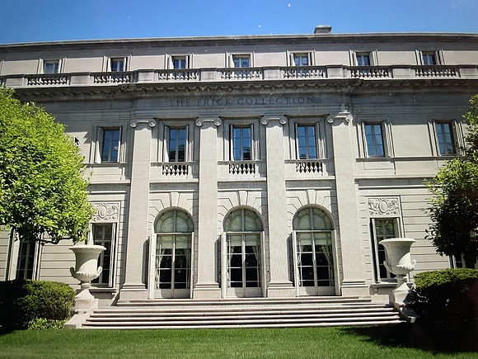

Lecture: The Frick Collection, New York
15th April Assembly Rooms, Chichester
Hilary Williams guides us through one of the world's finest-quality museums, a testament to the taste of steel magnate, Henry Clay Frick.
His collection belongs largely to the early 20th century 'gilded age' of American connoisseurship. Frick died on the eve of WW1, having bought some of the best pieces of art in Europe and Amercia. This includes outstanding French furniture, enamels, porcelain, and paintings by Bellini, Van Eyck, Holbein, Titian, Rembrandt, Vermeer, Van Dyck, Rubens, El Greco, Velazquez, Renoir, Turner and Constable. Illustration: The Frick Collection, New York.
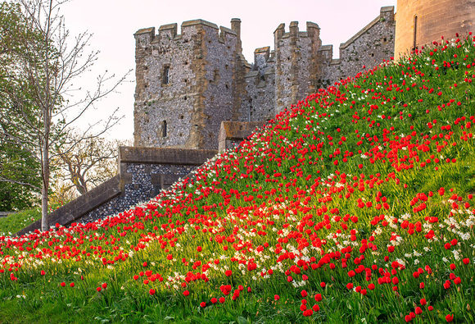

Arundel Castle Tulip Festival

April Arundel Castle
The 2026 Tulip Festival is now on throughout the gardens, grounds and landscape with different areas of tulips at their best each week.
The iconic steep banks of the Castle look stunning with red tulips (including Ile de France, Oxford & Apeldoorn) in flower and more coming out each day. Over 250 pots of tulips are bursting with colour throughout the grounds and gardens. The beautiful tulips within the landscape include Purple Dream, Burgundy, Golden Oxford and yellow Apeldoorn. Within the Collector Earls Garden and Walled Gardens there is an array of colourful tulips. In the Wild Flower Garden (by the Thatched Round House) and Cut Flower Garden (with over 20 different named tulips) stunning tiered displays provide a sea of colour. Beautiful Pink Impression tulips surround and reflect in the water of the rill. In the Tropical Borders varieties include Suncatcher, Olympic Flame & El Nino. Amongst all the colours of the Stumperies you will spot Amazing Parrot, Tinka & Acuminata tulips.

Thursday Late | Art of Appearance
16th April Pallant House Gallery
Join us in April for a Thursday Late event looking at the art of appearance.
In a special talk (tickets sold separately), celebrated curator and aesthete Stephen Calloway invites us into the fascinating world of self-fashioning revealing how William Nicholsons evolving persona, captured in portraits and photographs across his long career, became one of his most enduring works of art.
There will be a Library show and tell session, a curators tour of William Nicholson,life drawing with award winning artist Wendy Barratt and a studio drink and draw workshop.
Thanks to the South Downs Planetarium for this image of earth taken by Reid Wiseman, Commander of the Artemis II mission. Read more about this image on the Planetarium website. Please note that the Planetarium is closed for public shows during April and May as they carry out some refurbishments to celebrate their 25th anniversary. We wish the astronauts a safe return.
Back on earth - the BFG will end its run on the 11th April along with the trail of dreams which is the result of the BID, the Festival Theatre and local businesses working together. Read more here. Magic opens at the theatre on the 24th April and you can read below how actor Hadley Fraser has had to learn a few tricks himself.
It is your last chance to see Erasure at the Goodwood Art Foundation, the Jane Bown exhibition at Newlands House Gallery, Petworth and the Easter Art trail in 4 local cafes.
At Pallant House Gallery the William Nicholson Exhibition has had over 25,000 visitors in its first few months and the Glowing+ Alive display at the Cathedral celebrates 60 years since the installation of the vibrant John Piper tapestry.
At Goodwood there is only limited availability at time of writing for the members meeting 18th/19th April and tickets are flying off the shelves for the Stapleford Supercar Show at Stansted House on the 31st May.
The annual tulip festival is now open throughout the gardens of Arundel Castle. The online booking system is currently unavailable so best to get there early to limit waiting time. Sunshine, early blossoms and flowers in a magnificent setting - no wonder it is popular.
Some of the Easter activities mentioned in the mailing before Easter are still running this weekend and you can check them out in the last newsletter.
Wishing you al a sunny week.
Vicki
Founder/Editor



Will Rendle
11h April - The Nest at Chichester Festival Theatre
Will Rendle AKA "King Willy Will" is a restless romantic with a guitar, carving melody from memory and truth.
Best known as the wild-hearted frontman of British cult quintet Will and the People, a father of three boys and a fiercely independent creative, his solo work strips it all backjust voice, strings, and story.
Intimate, raw, and full of crooked beauty, these songs walk the line between light and shadow, hope and heartbreak. Fresh off a string of shows in the UK with his band, he will be playing a one off special intimate show at The Nest.
He's not used to an interval, so, expect the unexpected.

Fishbourne Literary Festival
11th April - St Peter and St Mary Church, Fishbourne
Meet star authors for signings, browse thousands of pre-loved books, enjoy the Literary Café and claim a free book for every child to celebrate the National Year of Reading
FREE ENTRY TO HALL FOR ALL
Tickets to hear the authors' talks have sold out

Family Friendly Backstage Tours
11th April Chichester Festival Theatre
Join one of our Family Friendly Backstage Tours, perfect for 7 - 11 year-olds.
Our 60-minute guided tour is a brilliant way to explore how theatre is made! Discover our backstage spaces, how we create our shows and experience our famous Festival Theatre stage*. Find out about the theatres beginnings and come away with oodles of fantastic facts about what happens behind the scenes today. Plus there will be chances to get hands-on with props and try on costumes used in previous productions - lots of fun.

The Perfect Murder
14th - 18th April West Ashling and Funtington District Hall
The Perfect Murder, adapted from a story by Jeffrey Archer by Hugh Janes, is an intriguing drama. Is it in fact the perfect murder?
Come along and discover for yourself.

Family Murder Mystery: Step Into a World of Secrets
11th April Stansted House
Calling all budding detectives! Challenge the whole family to crack the Stansted Murder Mystery.
Kick off the evening with lashings of tea, biscuits, and ginger beer as you meet the suspects.
Once you realize your host is missing, your family will have exactly one hour to explore the house by torchlight, interrogate the characters, and piece together the clues. Finally, you will all assemble in the Servants Hall to voice your theories and see if you caught the culprit!

Oxmarket Contemporary
14th - 26th April
Oxmarket are delighted to welcome back Chichester Open Studies (COS) for their 25th anniversary with a Snap-Shot Exhibition in our John Rank and Wilson Galleries. This exhibition promises an intriguing preview of the artistic diversity and creativity that will be on display during the Art Trail.
The highly anticipated Chichester Open Studios Art Trail returns this spring, promising two inspiring weekends filled with creativity, discovery, and community. Running across 116 venues, this years Trail features an impressive 164 artists, making it one of the most significant events in the Chichester areas art calendar

Bluegrass in the Barn
11th April. Cobnor
Two of the USA's most accomplished Bluegrass musicians play a special show in Cobnor on Saturday 11 April.
Jacob Jolliff (mandolin) and Michael Daves (guitar) are over in the UK for Sore Fingers Week which attracts top Bluegrass and Old Timey players from all over Europe to perform and give workshops from April 6-10 at Lord Wandsworth College near Hook in North Hampshire. By sheer coincidence they had a day free on Saturday 11 April and approached WemsFest Director Mark Ringwood as he had previously arranged UK work permits for them a few years ago. Within days a venue had been sorted out and tickets put on sale. The Barn at Cobnor Point, Chidham, PO18 8TE will host the concert at 8pm on the 11th and the two musicians will also perform a special instore set at Harbour Records in Emsworth at 1pm on the same day.

Lecture: The Frick Collection, New York
15th April Assembly Rooms, Chichester
Hilary Williams guides us through one of the world's finest-quality museums, a testament to the taste of steel magnate, Henry Clay Frick.
His collection belongs largely to the early 20th century 'gilded age' of American connoisseurship. Frick died on the eve of WW1, having bought some of the best pieces of art in Europe and Amercia. This includes outstanding French furniture, enamels, porcelain, and paintings by Bellini, Van Eyck, Holbein, Titian, Rembrandt, Vermeer, Van Dyck, Rubens, El Greco, Velazquez, Renoir, Turner and Constable. Illustration: The Frick Collection, New York

Arundel Castle Tulip Festival
April Arundel Castle
The 2026 Tulip Festival is now on throughout the gardens, grounds and landscape with different areas of tulips at their best each week.
The iconic steep banks of the Castle look stunning with red tulips (including Ile de France, Oxford & Apeldoorn) in flower and more coming out each day. Over 250 pots of tulips are bursting with colour throughout the grounds and gardens. The beautiful tulips within the landscape include Purple Dream, Burgundy, Golden Oxford and yellow Apeldoorn. Within the Collector Earls Garden and Walled Gardens there is an array of colourful tulips. In the Wild Flower Garden (by the Thatched Round House) and Cut Flower Garden (with over 20 different named tulips) stunning tiered displays provide a sea of colour. Beautiful Pink Impression tulips surround and reflect in the water of the rill. In the Tropical Borders varieties include Suncatcher, Olympic Flame & El Nino. Amongst all the colours of the Stumperies you will spot Amazing Parrot, Tinka & Acuminata tulips.

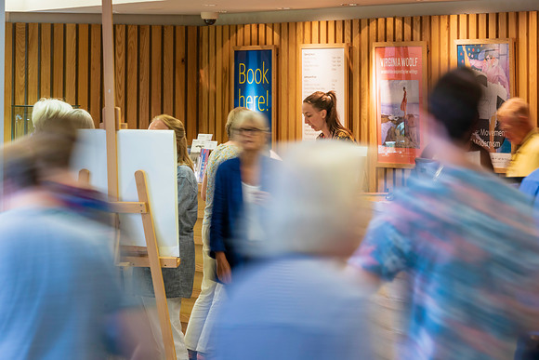
Thursday Late | Art of Appearance
16th April Pallant House Gallery
Join us in April for a Thursday Late event looking at the art of appearance.
In a special talk (tickets sold separately), celebrated curator and aesthete Stephen Calloway invites us into the fascinating world of self-fashioning revealing how William Nicholsons evolving persona, captured in portraits and photographs across his long career, became one of his most enduring works of art.
There will be a Library show and tell session, a curators tour of William Nicholson,life drawing with award winning artist Wendy Barratt and a studio drink and draw workshop.



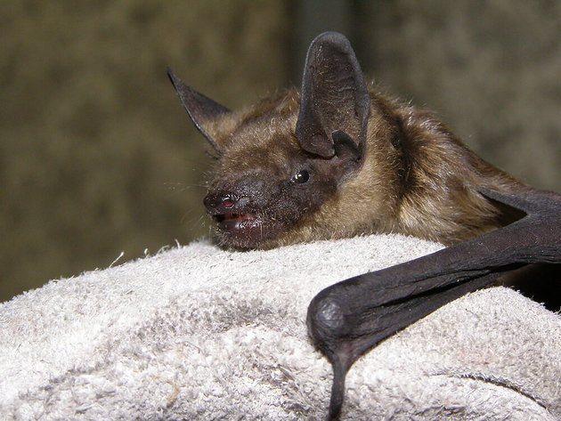
Bats - Super Heroes of the Night
23rd April - Bassil Shippam Centre Chichester
Nik Knight illustrates the fascinating lives of these elusive creatures. Capable of catching flying insects in total darkness and living up to 25 years.
Nik is chairman of the Board of Trustees of the Hampshire Bat Group and his chosen charity is The Bat Conservation Trust
The Bat Conservation Trust is the leading non-governmental organisation in the United Kingdom solely devoted to the conservation of bats and the landscapes on which they rely.



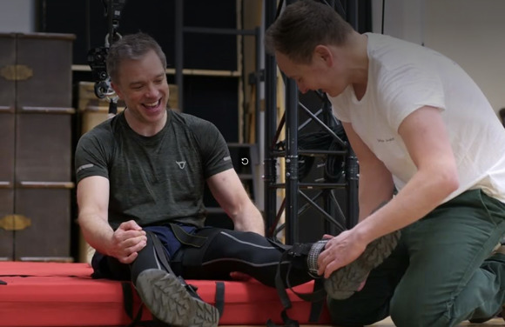
Hanging with Houdini: Hadley Fraser in rehearsals for Magic
Magic opens 24th April
Rehearsals for David Haig's exciting new play Magic are well underway and we can safely say that this production will be reaching new heights; literally in Hadley Fraser's case as he takes on the role of history's greatest escapologist, Harry Houdini. Based on his unlikely but fascinating relationship with Sherlock Holmes' author Arthur Conan Doyle, this world premiere explores these two 20th century icons and how their conflicting beliefs on spiritualism lead to fractures in their friendship.
We couldn't have a show about Houdini without recreating some of his most exhilarating effects. Take a look inside the rehearsal room as Hadley prepares to be suspended.
Watch the trailer of Hadley Fraser upside down




Urban - Equinox
Until 30th May GraffitiStreet, West Street, Chichester
GraffitiStreet presents Urban Equinox, an exhibition bringing together an international selection of contemporary street artists whose practices explore the quiet tension between contrast, balance, and transformation. Inspired by the spring equinox, the fleeting moment when day and night fall into alignment, the exhibition unfolds as a reflection on equilibrium within the urban landscape.
Across the works, visual languages emerge in which nature and the built environment, control and spontaneity, and fragility and strength exist not in opposition, but in a state of continuous exchange.




Discover Roebuck Estates
14th April Cavavin, Chichester
Roebuck Estates & Sushi Pairing
Join us for an evening of exceptional English sparkling wine from the stunning vineyards of Petworth, West Sussex. Crafted from classic Champagne grape varieties and shaped by the South Downs unique terroir, Roebuck Estates wines are all about elegance, balance, and vintage expression.We'll be pairing these beautiful wines with fresh, expertly prepared sushi from Little Fish a combination that truly lets both shine.
Spaces are limited and this one will fill quickly, so dont miss out!




A Selection of Networking Events
The week of 10th - 17th April
10th April First Friday Breakfast
10th April First Friday Lunchtime Network
13th April Small business networking Apuldram
14th April Small business evening networking. The Bosham Inn
14th April Chichester Chamber of Commerce Meeting Aldingbourne Trust
We are endeavouring to bring you a selection of networking events in the area each week. Some organisations require membership but usually allow you to try before you buy, some are pay as you go, and some are completely free of charge.




Volunteer TimeBank | Chichester area (hybrid/remote)
Youth Project Coordinator (Part-Time) for the Young Ambassadors Programme (YAP)
Help shape the future of young people in your community
Volunteer TimeBank is launching an exciting new programme in Chichester and West Sussex, designed to give young people real work experience, confidence, and direction.
We are looking for a Youth Project Coordinator to help bring the Young Ambassadors Programme (YAP) to life.
This is a flexible, part-time role where you will work closely with young people, local charities, and community partners, helping to build something meaningful from the ground up.
Contact us for more information or to apply
Read more about the work of the Volunteer TimeBank here

Promote Your Event
Add your own event to our calendar - here's how:
1. Click the link at the base of the home page Submit an Event"
2. Create a login account if you don't already have one
3. Complete the form with the details of your event, ensuring that you have added an image and a short description along with the other important information. Please use plain, unformatted text and use the formatting tools in the form.
(Kindly note that events will not be made live if they do not include a short text description and image. Images should be .png or .jpeg NOT pdf)

Newsletters 2026  January week 1  January week 2  January week 3  January week 4  January week 5 | Newsletters 2026  February week 1  February week 2  February week 3  February week 4 | Newsletters 2026  March week 1  March week 2  March week 3  March Week 4



powered by BoxStuff rapportUnsubscribe from this mailing

