

Chichester Living presents a Summer of Culture
We are delighted to announce that Chichester Living is bringing you a new digital showcase of a unique cultural offering across the city of Chichester and the surrounding countryside.
World class theatre, music, dance and art together with numerous festivals covering film, literature, music and much more, are all set in various locations across this beautiful and historic area from the Sussex Downs to the sea.
This will be launched Friday 1st May and we will send a separate mailing tomorrow to outline the plans.
In the meantime we bring you another eclectic mix of events in the near future. Many items promoted last week are happening this weekend so we encourage you to look at last week's mailing as a reminder.
Thank you to all of those who offered to distribute our What's On poster (details also in last week's mailing). They are starting to pop up around Chichester so thank you for helping to spread the word even further.
Until tomorrow for a special delivery....
Vicki
Founder/Editor

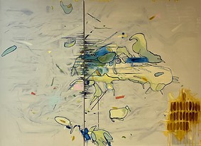 | 

Oxmarket Contemporary until 10th May

Robyn Jacobs - Expedition
Robyn has a multi-disciplined practice in mediums such as drawing, painting, film and 3D. Her work concerns itself with physical and psychological interpretation of place and engages with materiality and process within the context of site and/or activity. Accumulation and rhythm, layering and building are some of the techniques used in order for the work to take form. Robyn's New Zealand background and local history inform her ideas and are embedded in the outcomes.

Where The Art Is
Oxmarket are delighted to welcome the art group Where The Art Is in our Wilson Gallery. The artists are part of a larger weekly art group who come from very different working backgrounds and are a diverse but collaborative group. The group is guided by two highly experienced, talented teachers who nurture their creativity.

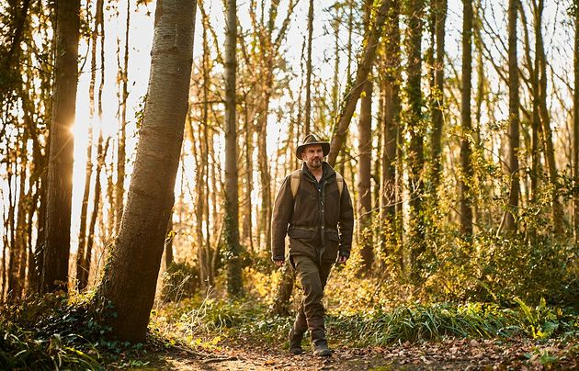

The Natural Navigator
6th May - Goodwood Education Centre
Our team here at the Goodwood Education Trust are hugely excited that Tristan Gooley, the Natural Navigator, will be joining us on Wednesday 6th May.
In the totally appropriate setting of our acres of semi-ancient woodland, in an informal conversational style, Tristan will explore natural navigation as a discipline of observation. Drawing on landscape, sky and climate, Tristan he will reveal how close attention to nature deepens our sense of direction and place
All proceeds from this event will go to the Trust, to ensure more children and young people, particularly those who are vulnerable or underserved, can be connected with nature

Chichester Living presents a Summer of Culture
We are delighted to announce that Chichester Living is bringing you a new digital showcase of a unique cultural offering across the city of Chichester and the surrounding countryside.
World class theatre, music, dance and art together with numerous festivals covering film, literature, music and much more, are all set in various locations across this beautiful and historic area from the Sussex Downs to the sea.
This will be launched Friday 1st May and we will send a separate mailing tomorrow to outline the plans.
In the meantime we bring you another eclectic mix of events in the near future. Many items promoted last week are happening this weekend so we encourage you to look at last week's mailing as a reminder.
Thank you to all of those who offered to distribute our What's On poster (details also in last week's mailing). They are starting to pop up around Chichester so thank you for helping to spread the word even further.
Until tomorrow for a special delivery....
Vicki
Founder/Editor



Oxmarket Contemporary until 10th May

Robyn Jacobs - Expedition
Robyn has a multi-disciplined practice in mediums such as drawing, painting, film and 3D. Her work concerns itself with physical and psychological interpretation of place and engages with materiality and process within the context of site and/or activity. Accumulation and rhythm, layering and building are some of the techniques used in order for the work to take form. Robyn's New Zealand background and local history inform her ideas and are embedded in the outcomes.

Where The Art Is
Oxmarket are delighted to welcome the art group Where The Art Is in our Wilson Gallery. The artists are part of a larger weekly art group who come from very different working backgrounds and are a diverse but collaborative group. The group is guided by two highly experienced, talented teachers who nurture their creativity.

The Natural Navigator
6th May - Goodwood Education Centre
Our team here at the Goodwood Education Trust are hugely excited that Tristan Gooley, the Natural Navigator, will be joining us on Wednesday 6th May.
In the totally appropriate setting of our acres of semi-ancient woodland, in an informal conversational style, Tristan will explore natural navigation as a discipline of observation. Drawing on landscape, sky and climate, Tristan he will reveal how close attention to nature deepens our sense of direction and place
All proceeds from this event will go to the Trust, to ensure more children and young people, particularly those who are vulnerable or underserved, can be connected with nature

 | Emsworth Arts Trail  2nd - 4th May  The Arts Trail continues over its second weekend. 100 artists will open their studios and venues to the public . The Emsworth Arts Trail has a broad range of artists from Painters Printmakers Sculptors and Photographers .  This is an important event for Emsworth and brings business to the rest of the town. We look forward to seeing you !

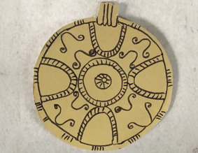

Saxon Jewellery Workshop
2nd May The Novium Museum
Take a closer look at the detailed patterns and decoration found on Saxon jewellery in this hands-on workshop with local artist Sue Webber. You'll create your own version of a Saxon brooch, inspired by historic designs in The Novium Museum collection.
All materials are provided, and the session is suitable for beginners, as well as those with more experience.

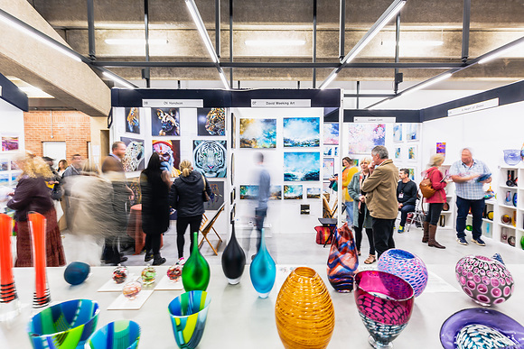

Sussex Art Fair
8th - 10th May. Goodwood Racecourse
Returning for a seventh event at the world renowned Goodwood Racecourse in the heart of the picturesque Sussex Downs, 95 exhibitors, each of whom you will be able to meet, will be situated throughout the main hall of The March Stand with 3000+ artworks for purchase.
Spread over 3 days starting Friday 8th May at our Opening Night, visitors will be the first to view the collections of artists work along with complimentary wine before the event opens at the weekend to the general public. Prices of art starts from as little as £50 for prints and smaller works to over £3,000 for outstanding masterpieces, so there will be something to suit every budget.
We are thrilled to be continuing our collaboration with Sussex Wildlife Trust, a conservation charity who cares about protecting the wonderfully rich natural life that is found in our Sussex towns, countryside and coast. Visitors can purchase original artworks kindly donated by our exhibitors, each work priced at £50 with all proceeds going to the charity.

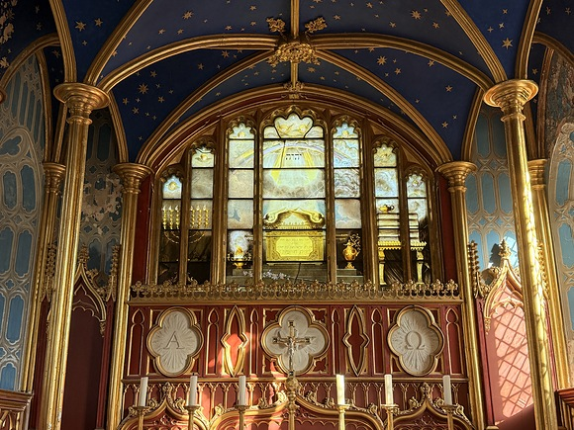

Candlelit Comedy at Stansted Park
8th May. Stansted House (Chapel)
For one night only, St Pauls Chapel will transform into a candlelit comedy club - intimate, atmospheric, and unlike anything you've experienced before.
Three top-tier comedians, Tiff Stevenson, Matt Bragg, and Paul McCaffrey who have BBC credentials including Live at the Apollo, Mock the Week and Russell Howard's Good News, will take the stage in one of Hampshires most striking historic spaces - where side splitting stories echo through the same walls that once inspired Keats.
Two sittings: 7:00pm and 9:15pm


Heritage Crafts: Try a Trade
9th - 10th May - Weald and Downland Living Museum
Help us keep our heritage crafts alive as we host two days of activities especially for children to Try a trade as they explore our Museum heritage trades and crafts

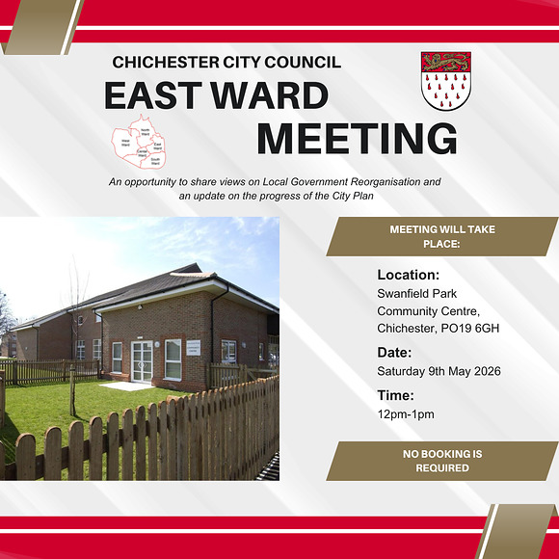

East Ward Residents Meeting
9th May Swanfield Park Community Centre, Chichester, PO19 6GH
Chichester City Council will be hosting a series of Ward Meetings across all five wards: North, East, South, West and Central.
These meetings will give residents the opportunity to hear directly from their City Councillors about the latest developments in local government reorganisation and what these changes could mean for the Parish of Chichester.
Councillors will also provide an update on progress with the City Plan. Following the presentations, residents will have the chance to share their views on both the reorganisation proposals and the City Councils work on the City Plan.

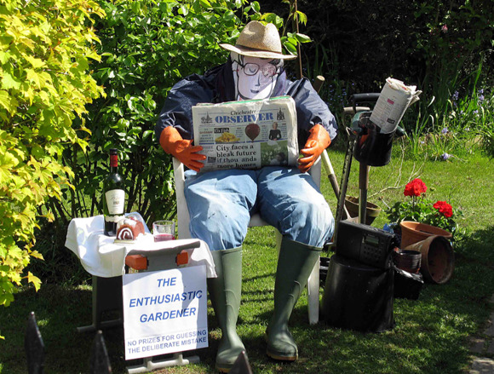

Oving Scarecrow Day 2026

9th May - Oving
This year we will have Sussex Steel Band, Morris dancers, The Community Garden, choirs, Oving Folk band, Ukulele band, Shore Things Band, Dancers, Archery, Classic cars, Tractor/trailer rides, Fire engine,
Refreshments -sandwiches, homemade cakes & Cream Teas in the hall, Ice creams, Hot dogs, Burgers and pancakes, Pimms and strawberries, plenty of craft stalls, face painting and roving entertainers and inside and outside St Andrew's Church, Oving.
There will be lots of Scarecrows to view all over the village too




Huge congratulations to the Last Friday Club on their 10th anniversary and to Debbie and Emily for all their help to solopreneurs and small businesses
Last Friday Club presents: Chichester Festival of Business
1st May - The Nest at Chichester Festival Theatre
Whether you've been part of the Last Friday Club since the very beginning or you've never heard of us - welcome. This is for freelancers, small business owners, side-hustlers and anyone building something they care about.
We're marking a decade of community, connection and kazoo-worthy wins with a morning you won't want to miss.




Charity Golf Day

6th May - Cowdray
Join St Wilfrid's for a day of golf while supporting a great local cause.
The golf day is a very friendly and relaxed event and can be as competitive as you wish amongst your teams.
We invite teams of four players to take part but, if you would like to attend as an individual, well happily find you a friendly team to join.
The day starts at 8.30am with registration in the foyer, followed by bacon rolls & coffee in the bar and a briefing with the team from Cowdray Park, where maps will be provided. The 18-hole course commences with a shotgun start at 10am in which all players start at the same time across the 18-holes.





Dial 1 for UK
Every night in New Delhi, Uday Kumar (UK) answers panicked calls to the Goldmine Crypto GB Helpline fantasising about being British himself, filling his YouTube channel with visions of a sophisticated new life of affluence, fish and chips and tea with the royals. Then, a chance conversation one tea break reveals how he might make it all a reality. At dawn a mere week later, he leaves the call centre forever and boards his first ever flight, to take his place amongst the English.
What happens next is the subject of Mohit Mathur's hilarious and poignant one-man-play of high hopes humbled in Hounslow and an influencer stripped of influence amidst the brutal reality of the UK care sector, asking how and why, each year, hundreds of young men like UK vanish without trace.
A rare chance to rethink much you've assumed about those who hope to live amongst us in a first piece from an exciting new playwright and West End performer, in collaboration with one the UK's most experienced theatre makers.
Stay after the show for a Q&A with writer and performer Mohit Mathur. Free to attend, just stay in your seat at the end of the show.

Eclipse: inside rehearsals and meet the writer
Our season of brand-new writing in the Minerva Theatre opens with John Mortons sharply observed, witty and touching new play, Eclipse. Take a look behind the scenes in the new rehearsal photos and read more from John about writing his first stage play after a celebrated career in radio and television.
Read full article



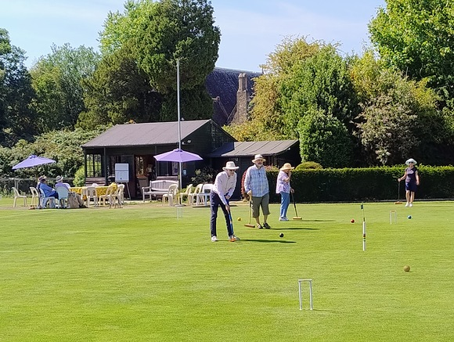

Try Croquet at Rother Valley Croquet Club
9th May Duncton GU28 0JY
If the idea of some gentle competition, a little very light exercise and the opportunity to make new friends all in a beautiful rural setting appeals to you then croquet may be what youre looking for.
Rother Valley Croquet Club, based in Duncton just south of Petworth is looking to welcome new members for the 2026/27 season. Were running a free taster session on SATURDAY 9th MAY from 10.30am 1.00pm. Weve got all the kit youll need plus free parking, tea, coffee and probably cake. Just bring your flat soled shoes and a big smile.



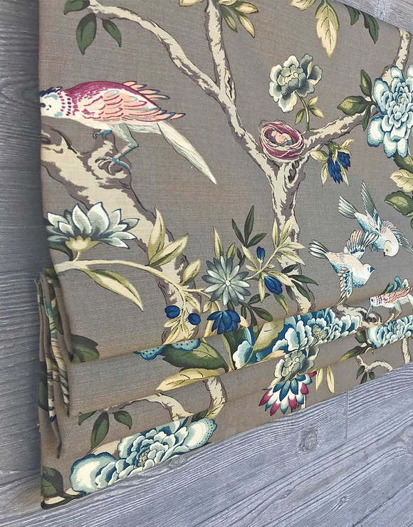

How to Make a Roman Blind Workshop
6th May - Clothkits, Chichester
Join our full-day workshop to learn how to make lined and interlined Roman blinds.
What you'll learn
- How to measure your window accurately
- Calculating fabric quantities and allowing for pattern repeats
- Understanding rod pocket placement and dowel positioning
- Stitching Roman blinds neatly by hand
- Using the key hand-sewn stitches needed for a professional finish
- Corded blind construction
- Mounting a blind onto a fabric-covered wooden batten
- Creating a lined and interlined Roman blind sample 60x100cm
- Working to current safety standards
- Gaining the confidence to make Roman blinds at home with comprehensive notes




A Selection of upcoming Networking Events
1st May - Last Friday Club - Festival of Business
1st May - First Friday Breakfast
1st May - First Friday Network
6th May - Chichester networking at The Fox Goes Free
7th May - Chichester Business Networking - May
9th May - East Ward Residents Meeting
12th May - CCCI Members Meeting - Fontwell Park Racecourse
13th May - Corporate Ladies Club - Ashling Park
We are endeavouring to bring you a selection of networking events in the area each week. Some organisations require membership but usually allow you to try before you buy, some are pay as you go, and some are completely free of charge.

Promote Your Event
Add your own event to our calendar - here's how:
1. Click the link at the base of the home page Submit an Event"
2. Create a login account if you don't already have one
3. Complete the form with the details of your event, ensuring that you have added an image and a short description along with the other important information. Please use plain, unformatted text and use the formatting tools in the form.
(Kindly note that events will not be made live if they do not include a short text description and image. Images should be .png or .jpeg NOT pdf)

 | Newsletters 2026  February week 1  February week 2  February week 3  February week 4  March week 1 | Newsletters 2026  March week 2  March week 3  March Week 4  April Week 1  April Week 2  April Week 3
  Newsletters 2026
  January week 1
  January week 2
  January week 3
  January week 4
  January week 5



powered by BoxStuff rapportUnsubscribe from this mailing

