

Can you help??
You may remember that at Chichester Living we were working with Chichester City Council on providing the 'what's on' feed to a trial of electronic information boards. Sadly one of those boards was vandalised and smashed to pieces within a few days of being installed and it was decided to take the info boards down and halt the trial.
At Chichester Living we are committed to pushing the message out as widely as possible so that all the contributors to the site will reach as wide an audience as possible. So we have developed a very low tech version of spreading the word - a poster!
The above image really does what it says on the tin. If you have a venue, a window, a counter or a noticeboard where you can display this notice it would be a good result for everyone. Below there is a version that you can download. Otherwise drop us a mail to request a printed version. This version is A4 - if you would like a larger one then get in touch.
There are two QR codes - one links through to the top of the events page to show what is happening today and the other links to the sign up page for our weekly newsletters. The urls are shown below the codes so that people can be assured that it is not some kind of scam.
If you are giving this poster for display to someone who is not yet familiar with Chichester Living there is also an introductory letter for download below.
I've taken up all the preamble to the newsletter with this - but I hope you will agree that spreading the word is important for everyone who contributes content to the site, and if we all do just a little to help with that it will make a really big difference.
Thanking you in advance for sharing
Vicki
Founder/Editor
[PDF] Chichest​er Livin​g Poster

[PDF] Introduc​tion to ​Chichest​er Livin​g.pdf

Can you help??
You may remember that at Chichester Living we were working with Chichester City Council on providing the 'what's on' feed to a trial of electronic information boards. Sadly one of those boards was vandalised and smashed to pieces within a few days of being installed and it was decided to take the info boards down and halt the trial.
At Chichester Living we are committed to pushing the message out as widely as possible so that all the contributors to the site will reach as wide an audience as possible. So we have developed a very low tech version of spreading the word - a poster!
The above image really does what it says on the tin. If you have a venue, a window, a counter or a noticeboard where you can display this notice it would be a good result for everyone. Below there is a version that you can download. Otherwise drop us a mail to request a printed version. This version is A4 - if you would like a larger one then get in touch.
There are two QR codes - one links through to the top of the events page to show what is happening today and the other links to the sign up page for our weekly newsletters. The urls are shown below the codes so that people can be assured that it is not some kind of scam.
If you are giving this poster for display to someone who is not yet familiar with Chichester Living there is also an introductory letter for download below.
I've taken up all the preamble to the newsletter with this - but I hope you will agree that spreading the word is important for everyone who contributes content to the site, and if we all do just a little to help with that it will make a really big difference.
Thanking you in advance for sharing
Vicki
Founder/Editor

[PDF] Chichest​er Livin​g Poster

[PDF] Introduc​tion to ​Chichest​er Livin​g.pdf



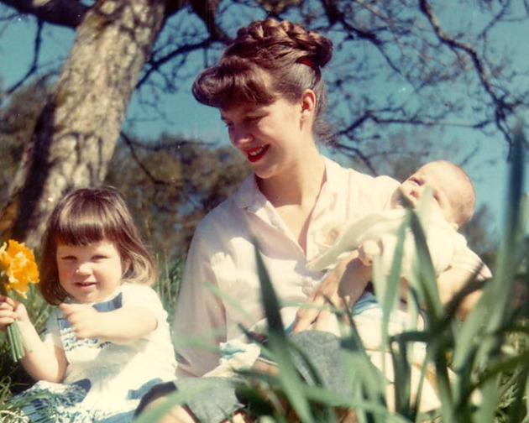

The Daffodil Days - an evening with author Helen Bain

24th April - The Assembly Room, Chichester
Join us for an evening of conversation with Helen Bain, author of The Daffodil Days, a beautifully descriptive, lyrical novel depicting a pivotal year in the marriage of one of literature's most infamous power-couples, Ted Hughes and Sylvia Plath.
It is an intimate portrait of this enigmatic pair, focusing on Sylvia, an imposing, highly educated American woman - as seen through the eyes of her rural neighbours, the shopkeepers, the church bell-ringers, the GP and the postman, in the cloistered Devon community of the 1960s that she has chosen as her home.
Praise for The Daffodil Days
"an astonishing achievement" The Guardian
"moving and accomplished" The Times
This event forms part of The Sussex Bookshop's programme of highlighting emerging authors of note. Helen will be answering questions and signing copies of The Daffodil Days after the event. Ticket price includes a complimentary drink.



The Consort of 12: Marsh and the Age of Reason
26th April - Assembly Room, Chichester
On Saturday 18 April, at 6.00pm, Chichester's period instrument ensemble the Consort of Twelve will give a concert in the Assembly Room, North Street, focusing on Chichester's John Marsh. The programme will include a harpsichord duet by Marsh, a cello concerto by English composer John Garth, and soprano Lucy Cox will sing Mozart's famous Exsultate Jubilate and Boccherini's beautiful Stabat Mater. Selections from Marsh's Jane Austen-like Journals will be read out during the concert.
Local historian Alan Green will lead a walk entitled On the Trail of John Marsh, Chichesters Gentleman Composer, starting at 2.00pm outside Pallant House and eavesdropping on the rehearsal for the concert.

 | Emsworth Arts Trail  25th - 26th April  Over two weekends 25th - 26th April and 2nd 4th May 2026 . 100 artists will open their studios and venues to the public . The Emsworth Arts Trail has a broad range of artists from Painters Printmakers Sculptors and Photographers .  This is an important event for Emsworth and brings business to the rest of the town. We look forward to seeing you !



Living History: The Toll House Reimagined
25th - 26th April Weald and Downland Living Museum
Come and explore our Living History event in our Toll House from Beeding, as we showcase our exhibit as it has undertaken restoration work along with a re-interpretation of the historic garden

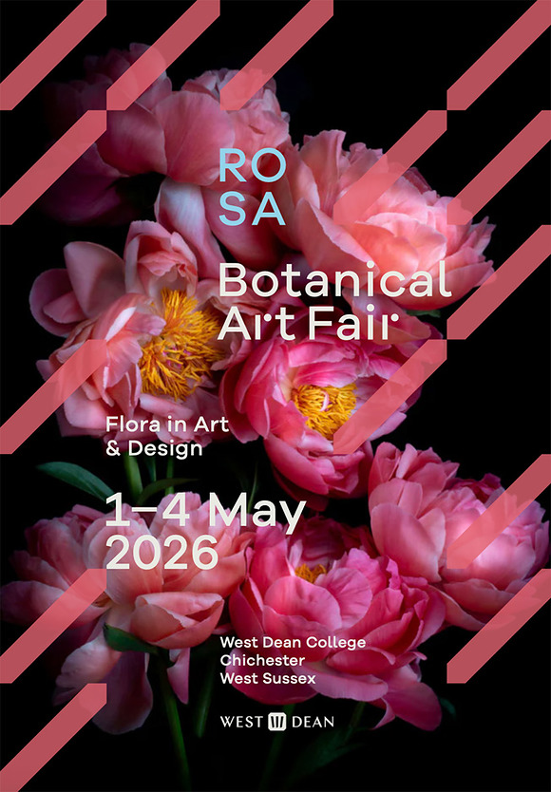

ROSA Botanical Art Fair
1st - 4th May.
ROSA Botanical Art Fair is a spring celebration of flora in art and design showing work by some of the UKs leading artists.
Paintings, photographs, textiles, ceramics, prints, sculpture, digital work and installations take you on an artistic voyage through the botanical world.
Plan a full day at West Dean to visit this spectacular event, new for 2026. Discover an elegant Art + Design Fair on the front lawn with stands presenting first-rate Modern and contemporary works for sale. Explore curated exhibitions and installations throughout the grand historic rooms at West Dean House. Take a walk through the Sculpture Garden and immerse yourself in horticultural displays in the award-winning estate gardens.
Look out for the programme of performance, talks and tours. Book yourself into a West Dean college taster session.



Horse Racing at Goodwood - Season Opener
1st - 2nd May. Goodwood Racecourse
Goodwood gallops into its first fixture, with high-quality action on the track featuring two valuable listed contests; The Daisy Warwick Stakes and The Conqueror Stakes, attracting exciting fillies and mares



Comedy at The Nest with Laura Lexx
1st May. The Nest at Chichester Festival Theatre
Headlining the show is the brilliant comedian, writer and actor Laura Lexx.
Opening the show is the hilarious David Ward, a regular MC and headliner in stand-up comedy clubs across the UK and Europe.
Joining them is winner of the Loaded Laftas Rising Star Award, Jason Patterson.
All hosted by the hysterical Matthew McAloone.



International Mini Rugby Series
2nd - 3rd May Chichester College
Join us for the 16th annual International Mini & Youth Rugby Series in Chichester on the 2nd & 3rd May 2026! This exciting event brings together youth teams from across the UK and beyond, offering a unique opportunity to compete against new opponents and create unforgettable memories.
Westgate Fields, Chichester College

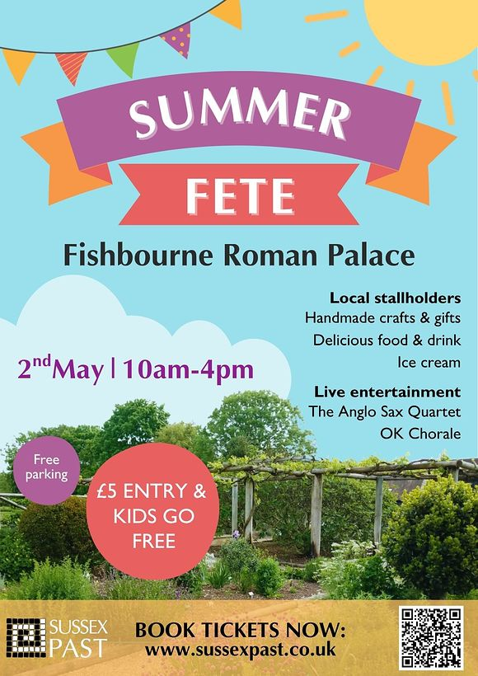

Summer Fete

2nd May Fishbourne Roman Palace
Celebrate the start of summer at the Summer Fete at Fishbourne Roman Palace a fun, family-friendly day out filled with local crafts, live music, and delicious food.
Taking place on Saturday 2 May from 10am to 4pm, the fete will feature a variety of local stallholders offering handmade crafts and gifts, alongside tasty food and drink and plenty of sweet treats, including ice cream.

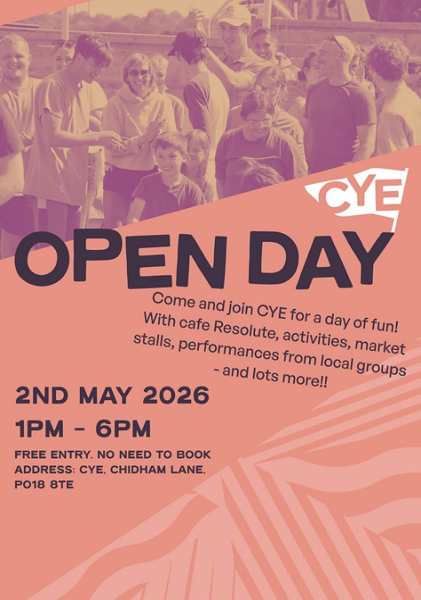

CYE Open Day
2nd May CYE Chidham
Come and join CYE for a day of fun! With a cafe on our ship TS Resolute, activities, market stalls, performances from local groups and lots more!





The Snowdrop Trust - Annual Castle Estate Park Charity Walk

10th May - Arundel Castle Park
Join us for a fabulous family day out in the breathtaking Arundel Castle Estate Park on Sunday 10th May! This is your chance to explore areas of the estate not usually open to the public, thanks to the kind permission of the Duke of Norfolk. Take part in a beautiful walk through stunning countryside, choosing between a gentle 1-mile route, fully accessible for wheelchairs, or a more scenic and challenging 5-mile route through the South Downs. Every child who takes part will receive a special medal to celebrate their achievement.
Dogs on leads are more than welcome and will receive a Snowdrop bandana.
The fun doesnt stop with the walk! Spend the day enjoying delicious homemade cakes at our famous tea tent, trying your luck at the toy and bear tombola, and taking part in our exciting raffle. There will be live music to set the perfect atmosphere, Tractor trailer rides and games organised by Arundel Cricket Castle Foundation.



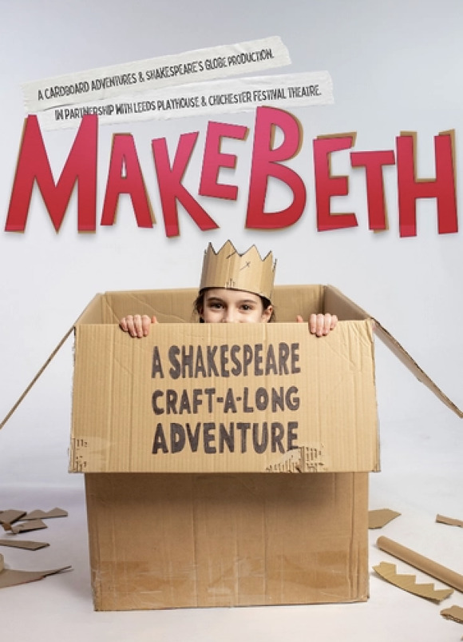

MakeBeth

9th May Chichester Festival Theatre
Cardboard Adventures is thrilled to announce by award-winning playwright Hannah Khalil - a brand-new, interactive craft-a-long retelling of Shakespeares Macbeth, created for families and young audiences aged 7+, and brought to life entirely with the recycled cardboard magic of Sam Wilde. This exciting make-along production is created by Cardboard Adventures and Shakespeares Globe, in partnership with Chichester Festival Theatre and Leeds Playhouse, continuing a shared commitment to making classic stories accessible, imaginative and fun for new generations.
Directed by Ian Nicholson, and designed by multi award winning Sam Wilde, MakeBethbursts with live music, puppetry, and hands-on creativity, MakeBeth transforms Shakespeares darkest tragedy into a joyful, laugh-out-loud cardBARD adventure.
Children must be accompanied by an adult during the session.
Stephen Pimlott Building

Casting has been announced for the world premiere of Ian McEwan's Atonement
Casting has been announced for the world premiere of Ian McEwan's Atonement, adapted for the stage by Christopher Hampton, which runs at Chichester Festival Theatre from 29 May 20 June, directed by Adam Penford.
Siân Phillips will play the older Briony Tallis, with Miriam Petche (Industry) as Cecilia and Jasper Talbot (Redlands) as Robbie. The company also includes James Backway, Tom Chapman, Isabella Dempster (as the young Briony), Yanexi Enriquez, Debra Gillett, Gabin Kongolo, Natasha Magigi and Jonathan Oliver.
Read full article



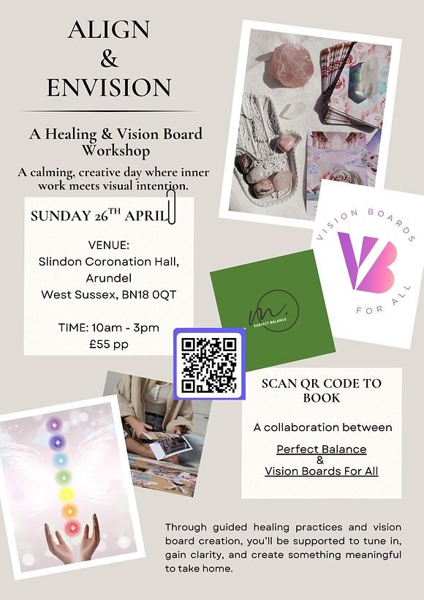

Align & Envision - A healing & Vision Board Workshop
26th April Slindon Coronation Hall, Arundel, BN18 0QT
A calming, creative day where inner work meets visual intention. Through guided healing practices and vision board creation, you will be supported to tune in, gain clarity, and create a visual reminder to take home.



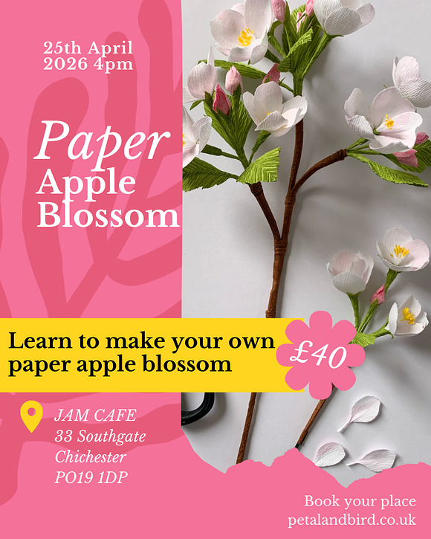

Paper Apple Blossom Workshop with Petal and Bird
25th April - Jam Cafe, Southgate, Chichester
Join Clare of Petal & Bird for a couple of hours paper creativity and learn to make your own paper Apple Blossom.
Clare will take you through the process step by step, no previous experience is required
- Workshop starts at 4pm and runs for approximately 2 hours
- Materials provided
- £40 per person




A Selection of Networking Events
The week of 27th April - 1st May
1st May - Last Friday Club - Festival of Business
1st May - First Friday Breakfast
1st May - First Friday Network
We are endeavouring to bring you a selection of networking events in the area each week. Some organisations require membership but usually allow you to try before you buy, some are pay as you go, and some are completely free of charge.

Promote Your Event
Add your own event to our calendar - here's how:
1. Click the link at the base of the home page Submit an Event"
2. Create a login account if you don't already have one
3. Complete the form with the details of your event, ensuring that you have added an image and a short description along with the other important information. Please use plain, unformatted text and use the formatting tools in the form.
(Kindly note that events will not be made live if they do not include a short text description and image. Images should be .png or .jpeg NOT pdf)

Newsletters 2026  January week 1  January week 2  January week 3  January week 4  January week 5 | Newsletters 2026  February week 1  February week 2  February week 3  February week 4  March week 1 | Newsletters 2026  March week 2  March week 3  March Week 4  April Week 1  April Week 2



powered by BoxStuff rapportUnsubscribe from this mailing

