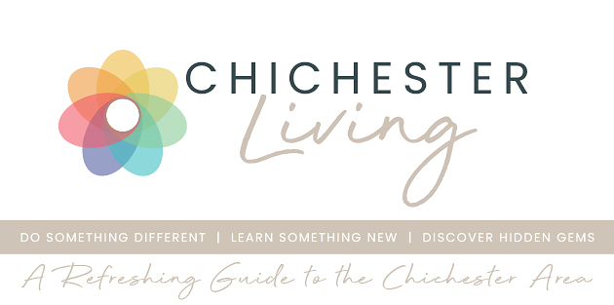

Chichester City Council is organising residents meetings in 5 wards (see below) ahead of the upcoming elections. It is particularly important to be well informed and that your voice is heard as we move into this period of local government re-organisation.
It's a big week for local festivals - the Festival of Chichester programme has been announced and booking is now open for Chichester Fringe and the Petworth Summer Festival
Goodwood Art Foundation has a special £5 entry until the 27th April. While the galleries close in preparation for the Summer Programme, you can take this quieter moment to explore the 70 acre landscape and enjoy the restaurant.
The John Hitchens exhibition at Moncrieff Bray Gallery has been extended for another weekend 24th -25th April and the very popular William Nicholson exhibition at Pallant House Gallery moves into its final weeks.
Throughout the summer Goodwood House is open for tours and tea on certain Sundays and Mondays (see below). A similar tour is available every month at West Dean - only waiting lists are available for April and May so be sure to book ahead for June
Don't forget that it is the farmer's market this Friday (17th) in Chichester and in Petworth on Saturday 25th April.
Lastly a couple of reminders
1. That if you want to see your event listed in our calendar you can submit it yourself - see below for how to do it.
2. That a quick way to check what's happening on a given date is to look at the monthly view where all events are colour coded. Follow this link to see the whole month of April
Until next week
Vicki
Founder/Editor

