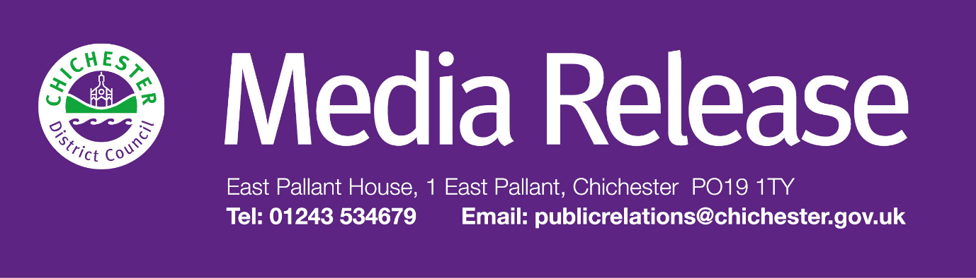

Date of Release: 6 March 2026 Ref: 4556

£5.74 council tax rise per year for the average taxpayer is agreed to protect vital services in Chichester District

Chichester District councillors have agreed to increase the average council tax bill by £5.74 a year for a Band D property in order to protect vital services across the district.

The decision was made at Chichester District Council’s Full Council meeting on 3 March 2026, where the 2.99% rise was agreed for 2026 to 2027. This means that the average Band D council taxpayer will pay £197.80 a year for the council’s 80 plus services. This amounts to around 54 pence a day.

As part of the budget spending plan for the year, councillors also agreed to put aside an additional £250,000 to help support a small number of one-off strategic projects over the next financial year to help support local communities.

These include more money for the council’s General Grants Fund which is administered by the Grants and Concessions Panel which helps fund a variety of community and business projects across the district. The council will also be working on a project to implement a place making narrative linked to regeneration strategy; attending the UK REiiF business networking event which helps promote and highlight what the district has to offer; organising an event for businesses across the district plus extra funding for the council’s Economic Development Grant programmes.

In addition, the council will also pay for a series of projects that were previously funded using money allocated through the UK Shared Prosperity Fund. These will include £40,000 for graffiti removal; £75,000 to support events and the evening and night-time economy; £30,000 for community cultural events through the Culture Spark initiative; £30,000 for business network building and £150,000 for business grants.

Chichester District Council collects all the council tax but only keeps around an 8% share of this. The other 92% is then distributed to West Sussex County Council (77%); The Sussex Police and Crime Commissioner (11%); and parish councils (4%). Each of these public service providers make decisions about its council tax increases independently.

Councillor Adrian Moss, Leader of Chichester District Council and Cabinet Member for Growth and Property, says: “We always aim to keep council tax as low as we can, and we continue to be one of the lowest charging authorities in the area.

“We still face challenges from inflation, the cost-of-living crisis and current world events which will continue for the foreseeable future. Despite this however, I am pleased that as a council we are still investing in projects and services whilst achieving a balanced budget and a surplus.

“We will continue to fund our vital Supporting You service to assist those who are experiencing cost of living related issues. This year’s budget also includes a number of initiatives to help support businesses and boost growth, which in turn will help improve the lives of our residents. It’s also really important that we support community projects and businesses with their projects so that they can continue to develop and support their communities.

“I would like to highlight that this council remains financially stable: we are debt-free, and our financial resources are strong. We continue to be proactive in reviewing our finances. We do this on a monthly basis involving teams across the council in order to ensure that we can protect valuable community services and invest in our priority projects.”

For more information, and to read a copy of this year’s budget, go to: www.chichester.gov.uk/budgetsspendingandperformance

Anyone in the district who is struggling is urged to contact the Supporting You Team, who can help people access a wide range of assistance including financial help to pay bills, help with housing, and health and wellbeing support.

In addition, the team can also signpost people to our other partner organisations when they feel this is appropriate, such as Arun and Chichester Citizens Advice, Arun and Chichester Food Partnership and the Community Hub. The team can be contacted by emailing supportingyou@chichester.gov.uk or calling 01243 534860. Information is also available online at: www.chichester.gov.uk/supportingyoucampaign

Every day, Chichester District Council provides more than 80 different services. These range from emptying bins, checking food hygiene standards, cleaning the streets, looking after the coastline, caring for parks and open spaces, and providing support and reassurance to the vulnerable — to name just a few services.

For further information, please contact Clare Hawkin, Senior Communications Officer on 01243 534537 or by emailing chawkin@chichester.gov.uk

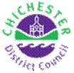 | Terri Foster  Senior Communications Officer  Communications  Chichester District Council

Ext: 21226 | Tel: 01243521226 | tfoster@chichester.gov.uk | https://www.chichester.gov.uk
East Pallant House opening hours: 9am-4pm Monday to Friday


