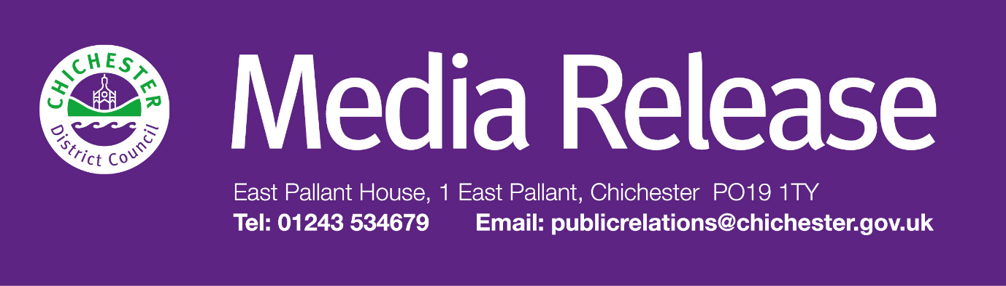
Date of Release: 12 March 2026 Ref: 4577

Roll out of food waste collection service starts on time and on schedule in Chichester District

A brand-new weekly food waste recycling service is now starting to be rolled out across the Chichester District and is on schedule.

Kitchen caddies and outdoor food waste bins have started to be delivered to households as part of a phased approach which is taking place from now until May.

Residents receiving the bins have also been provided with a roll of liners to get them started and instructions on how to use the bins. Residents can now also check their food waste collection dates online at: www.chichester.gov.uk/checkyourbinday

“This project is a huge undertaking but we would like to reassure residents that our roll-out preparations are well-advanced and that deliveries of bins and caddies are on schedule,” says Cllr Mark Chilton, Cabinet Member for Finance, Corporate Services and Chichester Contract Services at Chichester District Council. “Over the next few weeks, we’ll be delivering caddies and bins to every individual property across our 300-square-mile district, and I would ask residents to please bear with us while we complete this phase of the roll-out.

“A phased approach means that we are doing this on an area-by-area basis and so not everyone’s collections will start at the same time, which is why it’s really important that people go online to check their collection days, which may be different to their regular waste and recycling collections. By the end of May, approximately 90% of households in the district will be receiving the new service which is fantastic news.

“Collections for communal properties that share bins, which account for around 10% of households within the Chichester District, will start slightly later in the year as putting into place food waste collections from these types of properties needs more time to prepare. We’ll release more information on this nearer the time.

“All councils in England that do not already offer a food waste collection service must have one in place. This will be a significant change and promises to bring substantial benefits to our district — especially as around a third of the average rubbish bin in the Chichester District is food waste.

“The service will be very easy to use, and regardless of how little food waste a household produces, it all counts, so we would encourage everyone to use it no matter how much food waste they generate. We want to recycle more and waste less — and every household can play a part.”

Residents will be able to find out more information in the next edition of the council’s Initiatives magazine, which will go out to all households in the district at the beginning of April. The council is also issuing regular updates on social media and there is a wealth of information on the council’s dedicated web page, which contains all the latest guidance and frequently asked questions: www.chichester.gov.uk/food-waste

Residents can receive live updates about the new service, including collection start dates, by downloading the free Chichester District Council app from the Apple App Store or Google Play Store. To find out more about the app, people can visit: www.chichester.gov.uk/chichesterdcapp

Collection dates are available at: www.chichester.gov.uk/checkyourbinday

If residents do not receive their new bin and caddy by their first collection date then they are asked to register this by filling in an online form at:
www.chichester.gov.uk/food-waste-rollout-information

Once the service begins, residents will simply need to place food waste — such as plate scrapings, peelings, and tea bags — into their kitchen caddy. When full, the contents should be emptied into the outdoor food waste bin, ready for weekly collection.

Food waste includes uneaten food and plate scrapings; dairy products, such as cheese and eggs; bread, cakes and pastries; raw meat, cooked meat and bones. It also includes tea bags, coffee grounds, cooked vegetables, peelings, fish, pasta, rice, and beans.

Once collected, food waste will be recycled at an anaerobic digestion facility in Horsham where it will be used to generate natural forms of energy, such as biogas and bio fertilisers. This is a much more efficient and environmentally friendly way of processing food waste. To watch the full recycling journey visit: www.chichester.gov.uk/what-happens-to-your-food-waste
For further information, please contact Clare Hawkin, Senior Communications Officer on 01243 534679 or

by emailing chawkin@chichester.gov.uk

