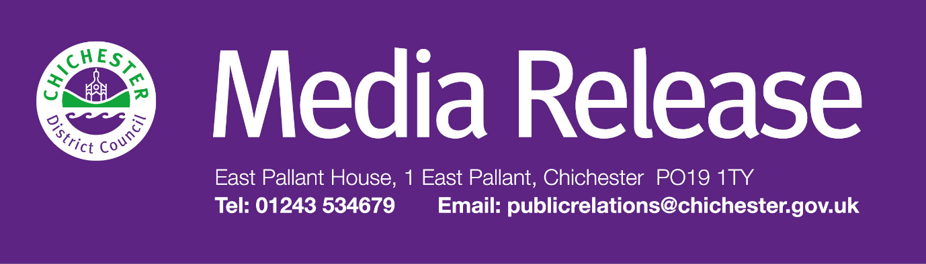

Date of Release: 25 March 2026 Ref: 4581

West Sussex Councils issue update on reorganisation decision

West Sussex local authorities had been expecting a decision from the Government on local government reorganisation by the end of March. Today, (25 March 2026) the Government issued an update confirming that no decision has yet been made on which unitary solution should be taken forward in Sussex. Instead, they have announced that they will be running a second consultation on proposals covering the whole of Sussex.

The new consultation will see two variations on the proposals already submitted by Sussex local authorities. The first proposed modification is moving Chichester District Council into a unitary with Crawley Borough Council, Horsham District Council and Mid Sussex District Council. Leaving a second unitary in West Sussex comprising Arun District Council, Adur District Council and Worthing Borough Council.

The second modification would see boundary changes moving wards in Falmer, Peacehaven and Saltdean from Lewes District Council in East Sussex to Brighton & Hove City Council.

The consultation will begin after the local elections in May, and a decision is expected in the summer after the consultation period closes, and new representations are considered. The overall timescale for reorganisation remains the same, with elections to the new shadow unitary authorities expected in May 2027 preparing for the new authorities to formally launch in April 2028.

“The delay is very disappointing, as the ongoing uncertainty reduces the time available for planning and preparation on the final decision and heightens the risks to delivering a smooth transition for our residents,” says Cllr Adrian Moss, Leader of Chichester District Council.

“All councils in West Sussex remain committed to working together in the best interests of our communities, and we will continue to collaborate closely as we await further clarity from Government. The consultation information and further details will be shared by the councils as they become available.

“We will continue to keep our communities well informed throughout this important process and will provide regular updates.”

The government statement is available at: https://questions-statements.parliament.uk/written-statements/detail/2026-03-25/hcws1455 and the latest correspondence is available here: https://assets.publishing.service.gov.uk/media/69c3d6e4cdfd19de13d0f59e/SoS_-_Letter_to_Sussex_Leaders_25.03.26.pdf

For further information please contact Sarah Parker, Communications Manager by emailing sjparker@chichester.gov.uk or calling 01243 534537.

Editor’s Notes

Pre-election period
The pre-election period is a time of heightened sensitivity in the runup to elections or referendums. During this period, local authorities and central government departments must take particular care to avoid any activity that could influence, or be perceived to influence, the outcome of an election. This includes:
- avoiding major policy announcements
- not issuing material which could affect public support for a political party
- ensuring public resources are not used in ways that could affect electoral competition.
These restrictions apply until the close of polls on 7 May.
You can find more information on pre-election period restrictions at: https://commonslibrary.parliament.uk/research-briefings/sn05262/

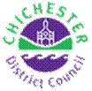 | Sarah J Parker  Communications Manager  Communications  Chichester District Council

Ext: 21273 | Tel: 01243521273 | sparker@chichester.gov.uk | https://www.chichester.gov.uk
East Pallant House opening hours: 9am-4pm Monday to Friday

