District Dispatch
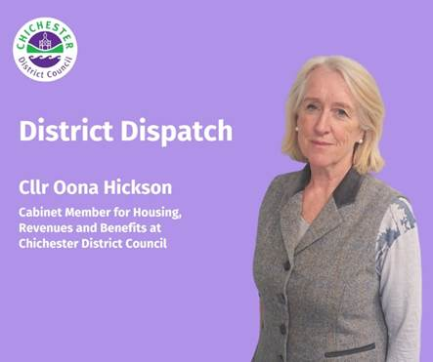
Many of you will shortly receive your council tax bill, and I’d like to use this opportunity to explain how this helps support essential services across the district.

Although we collect your council tax, Chichester District Council only keeps around 8% of this amount. Of the 92% remaining, 77% goes to West Sussex County Council, around 11% goes to Sussex Police and roughly 4% goes to parish councils. Each authority makes its own decisions about any changes.

You may be surprised to know that if you’re a Band D taxpayer, we charge you just £3.69 a week for the 80 plus services we provide across 303 square miles. We empty your bins, check food hygiene standards, licence taxis, clean your streets, care for our parks and open spaces, and provide vital housing support to residents, including ensuring safe living conditions, preventing homelessness, and helping to deliver affordable homes.
To protect vital services for our residents, we have increased the average tax bill by less than 11 pence a week for a Band D property. This means that the average council taxpayer will pay £5.74 more than last year for the services we provide each day.

If you have questions about your council tax bill, you can find answers to frequently asked questions here: www.chichester.gov.uk/counciltaxfaqs. You can also contact our team directly through our designated e-form: www.chichester.gov.uk/make-a-taxation-enquiry. If you don’t have online access, please call: 01243 534501.

You can also view your council tax bill online using our My Account service. It’s quick and easy to create an account — simply visit www.chichester.gov.uk/myaccount, select ‘my council tax’ and then ‘sign in or register for an account’. Where you can, please consider choosing paperless billing as this helps us make a positive impact on our environment.

Paying by direct debit is now our most popular method of payment. It is safe, secure, easy to set up, and helps us to save money too. Visit: www.chichester.gov.uk/payabill or call 01243 534880 (with your reference number to hand).

We know that the cost of living continues to be challenging, particularly for people on low incomes. Our Council Tax Reduction Scheme provides support for those who need it most, offering up to 100% off the total cost of council tax. We also operate a Discretionary Scheme to support those affected by the banded scheme, including people receiving Universal Credit and care leavers. If you or someone you know is struggling, please consider applying at: www.chichester.gov.uk/applyforbenefit.

Our dedicated Supporting You Team is also here to help if you’re facing financial difficulties. The team provides tailored support for residents dealing with multiple challenges. You can contact them by visiting: www.chichester.gov.uk/supportingyou; emailing: supportingyou@chichester.gov.uk; or calling: 01243 534860.

We’ve also been making businesses aware of changes to the way business rates are calculated. As a council, we do not set business rates or keep all of the money — some is kept locally, and some is passed to the Government. Every three years, the government updates the rateable values of non-domestic properties across the country, and these updated values are used to calculate business rates. The latest values will come into effect this year.

As part of the calculation, a number of tax rates — known as multipliers — are applied to the rateable value. This year, the government has changed the method, introducing five different multipliers instead of two. This allows for differences between business sizes and sectors. It’s important for businesses to be aware that if their rates increase significantly after revaluation, reliefs will be available to spread increases over several years. Businesses can find more information at www.chichester.gov.uk/businessrates2026, and our team is here to help with any questions. You can contact them at www.chichester.gov.uk/make-a-taxation-enquiry.

Our teams are here to support you, so please don’t hesitate to reach out if you need help or have any questions.

Best Wishes
Oona Hickson
Cabinet Member for Housing and Revenues and Benefits at Chichester District Council

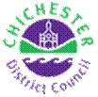 | Terri Foster  Senior Communications Officer  Communications  Chichester District Council

Ext: 21226 | Tel: 01243521226 | tfoster@chichester.gov.uk | Fax: 01243776766 | https://www.chichester.gov.uk
East Pallant House opening hours: 9am-4pm Monday to Friday

