
Welcome to the February 2026 edition of our Residents’ eNewsletter.
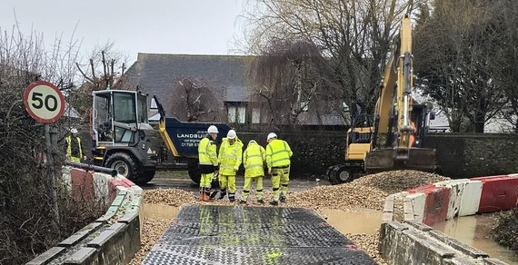
Responding to flooding on our roads
We’re working hard to respond to incidents of flooding on the roads in West Sussex and help keep our highways moving.
Above-average rainfall has put significant pressure on parts of the county.
Teams are out unblocking the drains and gullies we’re responsible for as part of our year-round programme, with 2,000 cleared since the start of February alone.
In that time, crews also completed more than 1,500 pothole repairs, working extended hours to respond as quickly as possible to increased demand.
Unfortunately, there were two incidents this week where a member of our team suffered abuse.
This behaviour is unacceptable and the council will protect our officers who work tirelessly to support communities.
Pictured: Contractors on site at Sack Lane off Shripney Road installing a temporary ramp over floodwaters.
Get the latest news

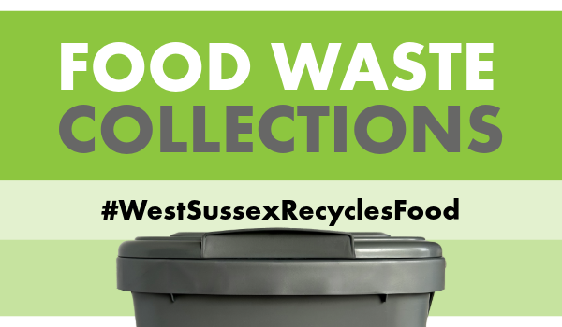
... are coming to West Sussex
New separate food waste collection services are being introduced across West Sussex, following new legislation introduced by central government.
Residents will be able to recycle food waste including tea bags, plate scrapings and crusts – even items that can’t be composted, like bones and cooked meat.
These collections can help highlight how much food is thrown away in UK households and support you to cut down on waste. Reducing food waste could also save you money by helping you buy only what you need and make the most of leftovers.
Find out more information on food waste recycling here, where you can also enter your postcode to find details for your area.
Watch our video to find out what can be recycled


Free wellbeing support in our libraries
Did you know our libraries have year-round activities, services, and resources to improve your emotional, physical, and mental wellbeing?
To celebrate Wellbeing Month this March in libraries we’re holding special ‘Live Well for Longer’ events where you can get a health and hearing check, get information on future independence and care as you age, and even pick up a new pair of safe, comfy, slip-free slippers.
All year round you can borrow blood pressure monitors to use at home for up to 3 weeks to check your heart health, reminiscence packs to help with dementia care, and of course thousands of books and eBooks - as reading for pleasure is proven to reduce stress and boost your wellbeing.
More information


Have your say on wraparound childcare
Our Early Years and Childcare team have launched a survey to understand families’ experiences of wraparound childcare for primary school-aged children.
Your views will help them understand what local families need and how they can improve access to high-quality childcare before and after the school day.
The anonymous survey, which closes on 22 February, asks about what is working well, what could be improved, and how provision could better meet the needs of local families.
Take part in the survey

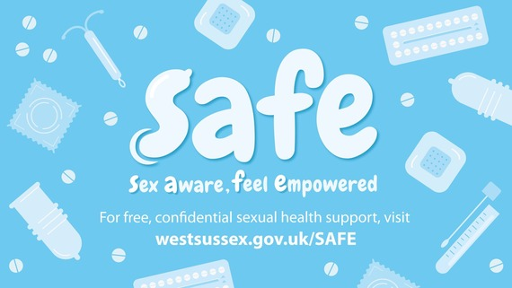
Testing for HIV and other STIs
Our SAFE (Sex Aware, Feel Empowered) webpage is the go-to place for trusted information on testing for Sexually Transmitted Infections (STIs), including HIV, and contraception options - so you can quickly and easily find advice and local services.
This HIV Testing Week (9 to 15 February) we’re reminding everyone that HIV testing and treatment is provided to anyone free of charge on the NHS and many clinics can give you the result on the same day.
Home testing and home sampling kits are also available.
If you are having sex with new or casual partners, you may be eligible for PrEP. This drug is free and stops HIV transmission during sex.
More information


New stretch of Coast Path opens
A new 35-mile section of the King Charles III England Coast Path has opened, giving walkers unprecedented access to the stunning coastline of Chichester Harbour.
When complete, the national trail will span almost 2,700 miles, becoming the world’s longest managed coastal path.
With funding from Natural England and Defra, the county council has upgraded paths around the harbour with improved surfacing, clearer signage and new boardwalks.
Video credit: © Natural England / Strong Island Media
More information


Make a difference for a child in care
We’re looking for volunteers to become Independent Visitors - friendly faces who spend time with children aged 8 to 17 who are looked after by the county council and won’t be returning home.
It’s all about fun and friendship and doing activities the young person enjoys and building a positive connection, expenses are covered to a set amount.
You can find out more by visiting our website or attending one of our Information Sessions linked below:
- Monday 27 April at 7pm
- Tuesday 28 April at 12.30pm.
More information


Find out about fostering
In West Sussex, the need for more people to consider fostering – from part-time (offering stayovers one weekend a month) to helping a young person aged 16+ prepare for adulthood – has never been greater.
If you have ever wondered whether you could offer stability and safety to a local child, then join our fostering team at an information event near you, between 25 February and 19 March.
You’ll learn about the reasons children come into care and hear first-hand from local foster carers and supported lodgings hosts about the positive impact they have on children and young people (and that the children have on them!), as well as viewing a short film about fostering.
Events are in Worthing, Haywards Heath, Chichester and Crawley.
Book your free place here



Head to our Newsroom to find all the latest news.
- Our proposed budget for the year ahead will go before Full Council on Friday 20 February for final approval. Proposals to address a budget gap of £16.3m and balance the budget were set out at an earlier Performance and Finance Scrutiny Committee, before going to a meeting of the Cabinet. The Full Council meeting will be held in public at County Hall, Chichester, and can be viewed online via a webcast.
- Sussex has reached a significant milestone in its devolution journey, with government putting forward formal plans to create the Sussex & Brighton Combined County Authority this spring and elect a mayor in 2028.
- A Bognor Regis shop owner has been ordered to pay £105,000 after being sentenced at Portsmouth Crown Court for repeatedly selling counterfeit cigarettes and illegal vapes.
- Our firefighters have issued a warning after attending a fire in Shoreham caused by an e-bike battery, and remind residents about the fire risks associated with microwavable wheat bags following an incident in Worthing.
- Tell us what you think of proposed improvements on South Road in Haywards Heath. Survey closes: 2 March 2026.
- Increase your skills and awareness on the road as a biker, pillion rider and/or general road user by booking on to a free Biker Down course on 26 February at Horsham Fire Station & Training Centre.
- We’re highlighting the signs of kidney cancer and the importance of early diagnosis. Symptoms can include blood in your urine, a persistent back or side ache, ongoing tiredness, night sweats and unexplained weight loss. If symptoms don’t go away, contact your GP. Kidney Cancer UK also offers a free confidential support line for patients, families and carers.
- The first 6 months of the Waste Prevention Community Grant Fund programme saw successful projects collectively divert over 60 tonnes of waste – roughly equivalent to the weight of 10 male elephants.
- It’s LGBTQ+ History Month and you can find a booklist compiled by our Library Service, and a blog post by our Record Office about the fascinating history of ‘Tommie and Betty’ a female couple who lived in Worthing for many years.
- We’ve reached 1m journeys with the Stagecoach Service 500. The service, which launched in 2023 as part of our Bus Service Improvement Plan, links passengers between Chichester and Littlehampton to essential services, work and leisure. To celebrate, passengers can travel for free on the Service 500 on 14 and 15 February, redeemable via the Stagecoach Bus app. Click through for details and get on board.

Our Library Service has a new website, catalogue and app.
You can search the catalogue, reserve items, access free eBooks, eAudiobooks and eMagazines.
If you’re not already a library member, you can now sign up for a library card online.
Did you receive this eNewsletter from a friend? Sign up here.


