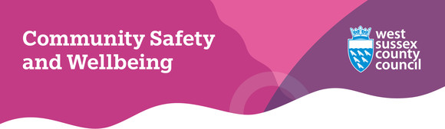
Welcome to our February 2026 newsletter

© The Holocaust Memorial Day Trust
Standing together against hate in West Sussex
Holocaust Memorial Day took place on Tuesday 27 January and was a moment for people across the nation to come together, remember the persecutions of the past and stand against hatred and prejudice today.
Hate incidents and hate crimes occur when an individual is subjected to hostility or prejudice by another person because of their perceived or actual race/ethnicity, disability, religion, sexual orientation, or gender identity.
If you or someone you know has experienced anything like this, support is available through the Hate Incident Support Service delivered by Victim Support Sussex.
Whether you're a victim, witness or third party, you can make a report and get help from specialist caseworkers who can provide confidential advice and guidance to anyone affected by hate.
West Sussex County Council | Report a hate crime


Free boxing sessions available for 11–17-year-olds
If you know a young person aged 11-17 who lives in or around Bognor Regis, Haywards Heath, Lancing or Worthing, then WBC Cares UK, in partnership with the Sussex Violence Reduction Partnership, is running free boxing sessions with qualified England boxing coaches until the end of March 2026.
The sessions are taking place in the following locations:
- Bognor Regis: VK Gym, 14 Durban Road, PO22 9QT. Monday and Friday: 3.30pm to 5pm.
- Haywards Heath: Redwood Centre (Clair Hall), Perrymount Road, RH16 3DN. Tuesday and Friday: 3.30pm to 5pm.
- Lancing: Lancing Youth Hub, Monks Recreational Ground, 13 Crabtree Lane, BN15 9PP. Monday, Tuesday and Thursday: 2.30pm to 6.30pm.
- Worthing: Peak Boxing Worthing, 13 Southcourt Road, BN14 7DF. Tuesday and Thursday: 3.30pm to 4.45pm.
Everyone's welcome to come along and have a go and there is no need to book or attend every session.
For more information, you can email info@wbccaresuk.org or call 07947 450323.
WBC Cares UK | Improving lives through boxing

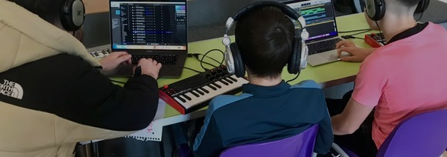
Free music mentoring for young people in West Sussex
Young people aged 11 to 17 in West Sussex can access free one-to-one support through AudioActive’s SHIFT programme designed for young people who may be struggling, feeling peer pressure, or facing challenges at home or school.
More than 300 local children have already taken part, building confidence, learning new skills and receiving support tailored to their needs.
The project is a randomised controlled trial, which means that while some young people will receive music mentoring, others may be offered a different type of support.
If you're a parent or carer who thinks their child might benefit from SHIFT, you can fill out an online referral form on the AudioActive website until Sunday 31 May 2026. Young people can also self-refer in the same way.
AudioActive | SHIFT programme

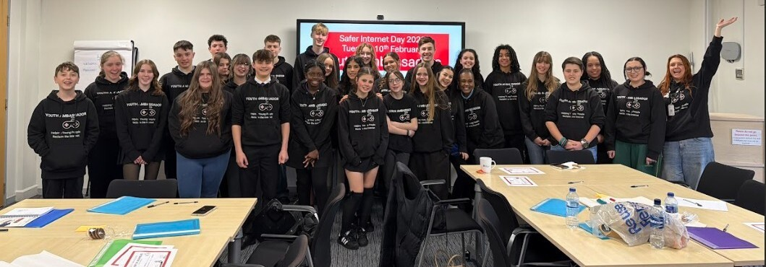
The Sussex Youth Ambassadors on Safer Internet Day. Photo courtesy of the Sussex Police and Crime Commissioner's office.
Youth Ambassadors think under-16s social media ban 'would be a good idea'
Last Tuesday (10 February), two of our Digital Safety and Fraud Prevention Officers visited the Sussex Police and Crime Commissioner's office to deliver online safety and privacy training to the Sussex Youth Ambassadors.
The group met to mark Safer Internet Day and learn more about current online safety topics, such as responsible AI use, virtual reality and TikTok.
Our officers session covered age ratings for games and social media, privacy settings and healthy online behaviours. The group were also invited to share their views on the potential under-16s social media ban.
This evoked a lively discussion with plenty of feedback suggesting it would be a good idea, but there should still be education for younger children so if they are subject to a ban they still learn about the dangers of social media.
To find out more about how the day went, you can visit the Sussex Police & Crime Commissioner website.
Sussex Police & Crime Commissioner | Celebrating Safer Internet Day

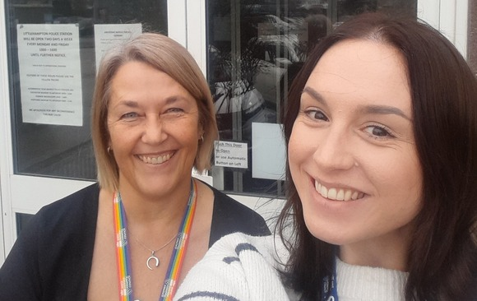
From left to right: Independent Sexual Violence Advisors (ISVAs) Jeanette and Kayleigh
Services unite to support survivors of sexual violence
Sexual abuse and sexual violence awareness week took place earlier this month (2-8 February) and the county council’s incredible team of Independent Sexual Violence Advisors, or ISVAs for short, were based at Littlehampton Police Station on Thursday 5 February.
As part of their work, ISVAs support victim/survivors of domestic abuse where there is an ongoing criminal investigation or court proceedings, offering emotional support and guidance while helping them navigate the criminal justice process.
By working out of police stations across the county on a regular basis, the ISVAs can create vital bonds with Sussex Police colleagues and gain valuable knowledge that will help the team support the people they work with in these situations. These collaborations are something all partners strongly value and take pride in.
If you, or someone you know has experienced sexual violence or abuse, WORTH are here to help when you’re ready.
West Sussex County Council | WORTH Services


Learn how you can stay safe online for free
Our Digital Safety & Fraud Prevention team have the following online safety and fraud awareness sessions available which are free to attend - both in-person and online:
- A brief introduction into Artificial Intelligence (AI) - A 45-minute online course which is a clear introduction to what AI is, how it works and how it's used.
- Are you scam savvy? - A one and a half hour in person session at Bognor Regis Library on Tuesday 12 May at 10am looking at the rise in scams, including telephone, courier and romance fraud and what you can do to stop yourself becoming a victim.
- Child Sexual Abuse Material: Can you spot it? - This one and a half hour online session explores what it is, the importance of the language we use, and the impact AI has on ensuring the continued safety of our children and young people.
To find out available dates and to book your place, visit Eventbrite.
Eventbrite | Digital Safety & Fraud Prevention


The UK Government is consulting on a new licensing system for knife sales - a measure that could save lives and prevent tragedies.
The information gathered will help inform evidence-based policy advice and future decisions by the Home Secretary and Ministers.
The consultation is open to the public and there is still time to have your say as it closes on Tuesday (24 February 2026) at 11.59pm.
Licensing for knife sales

Nearly half of retail staff say they are attacked or abused once a week. It causes serious damage to businesses and employee wellbeing.
That's why Neighbourhood Watch developed free online Neighbourhood Safety Training modules available for businesses and shops.
If you own, manage or work in a business or retailer, you can sign up for the training on their website.
Free Neighbourhood Safety Training



