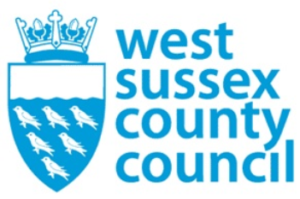

news release
03 February 2026

Next steps for budget and new combined authority agreed by Cabinet

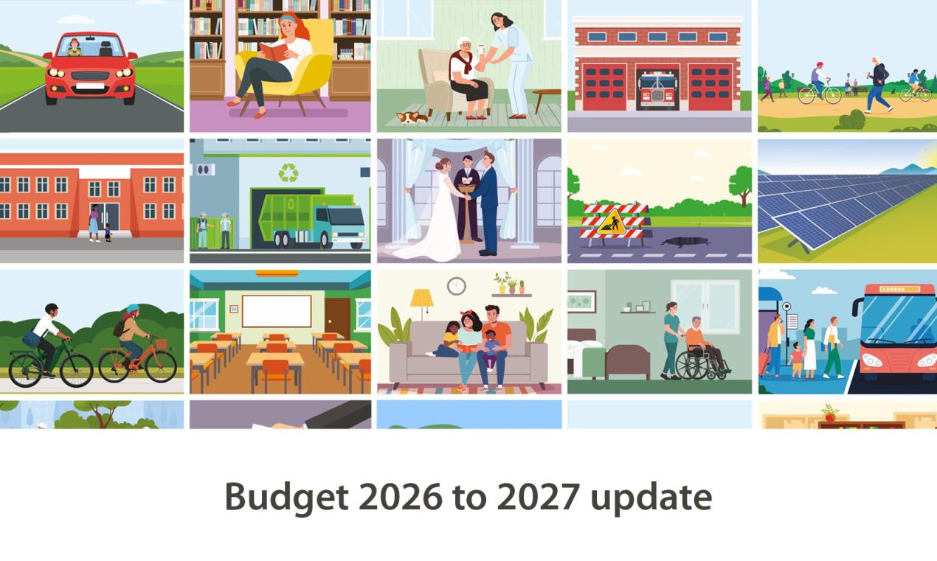
West Sussex County Council’s Cabinet has agreed the next steps for its proposed balanced budget, which includes significant capital investment and increased net investment in key services for communities. The Cabinet also reaffirmed its commitment to the devolution process, which will see the creation of a new combined authority for the whole of Sussex.
The decisions made at a meeting at County Hall, Chichester, today (Tuesday 3 February) follow confirmation from Government that the Sussex & Brighton Combined County Authority will be created this May, with the first mayoral election due to take place in May 2028.
The new combined authority will see powers and funding transferred from national to local government to provide strategic leadership on issues such as economic growth, highways and transport, housing, and public safety.
Cllr Paul Marshall, Leader of West Sussex County Council, said: “The new combined authority will bring additional investment into the region whilst providing us with a voice at national level. Sussex delivers huge economic benefit to the country, and the creation of this new combined authority will only strengthen this.”
The county council will continue to work with East Sussex County Council and Brighton & Hove City Council on the devolution process, ahead of the anticipated legal creation of the new authority in the spring.
The Cabinet also agreed the next steps for its balanced budget for the year ahead at today’s meeting. The proposed budget will now go before Full Council on Friday 20 February for final approval. The Full Council meeting will be held in public at County Hall, Chichester, and can be viewed online via a webcast.
Proposals for a balanced budget were set out at the Performance and Finance Scrutiny Committee last week.
The Cabinet meeting heard that the county council is expected to spend £2.3 billion on day-to-day services in 2026-27 as follows:
- £1,346.7m Managing schools and education, children’s social care and support
- £577.2m Caring for adults and keeping people healthy
- £90.1m Protecting the environment, recycling and waste disposal
- £84.6m Maintaining our roads and providing transport
- £83.8m Running our organisation
- £72.8m Fire and Rescue services and supporting communities
- £5.8m Supporting the local economy
- £61.9m Financing our capital programme and other corporate items
This includes a gross revenue increase of £65.1m to meet increasing demand pressures and costs, particularly in social care, home to school transport, and special educational needs and disabilities.
Actions have been taken to successfully balance the draft budget for the coming year, despite the added pressure of the Government reducing funding by £30m over the next 3 years and redistributing the funds elsewhere in the country.
Councillor Jeremy Hunt, Cabinet Member for Finance and Property, said: “We are proud that we have been able to balance the budget for the year ahead without cuts to frontline services or a reliance on reserves.
“We have managed to find savings of £30.4m but to balance our books we have no choice but to increase council tax by 4.99% - as Government assumes we will have this additional revenue when it allocates funding to us.
“Despite this challenging process we are confident our limited resources, which are aligned with the priorities in Our Council Plan, will provide effective services which offer maximum value for our residents.”
You can read more about the budget setting process at www.westsussex.gov.uk/budget and learn more about devolution and the creation of the new strategic combined authority at www.westsussex.gov.uk/campaigns/future-of-local-government-in-sussex
To hear regular updates please sign up to receive updates from the county council via email.

Ends
Notes to editors:
See our press release issued on 28 January 2026 for further background on the budget: Next steps for West Sussex County Council budget set out following scrutiny committee meeting - West Sussex County Council

For further information please contact the news desk on 0330 222 8090 or email pressoffice@westsussex.gov.uk.
For urgent out-of-hours enquiries please call 07767 098415.
 

Click to Unsubscribe

