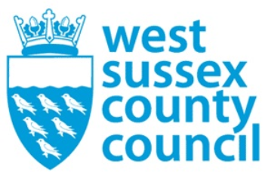

news release
09 February 2026

County Council urges residents not to drive through flooded roads

Whilst the council understands the frustration road closures caused by flooding present to drivers, driving through them can cause further issues including delaying opening the road, pushing water into residential homes as well as potentially negating the driver’s insurance should their car break down due to water ingress.
It is also dangerous to those highway operatives who are on site to try and resolve the issue. This morning, one of our highways team members was struck by a white Land Rover which forced its way through a road closure. Luckily the operative was not injured but the incident has been reported to the police and any witnesses are urged to contact the police on 101.
Our officers are there to help, they are not there to be abused either verbally or physically, and we urge the public to recognise this. We want to resolve the issues faced due the adverse weather as much as the public and ask for patience whilst we do so.
​
For further information please contact the news desk on 0330 222 8090 or email pressoffice@westsussex.gov.uk.
For urgent out-of-hours enquiries please call 07767 098415.
 

