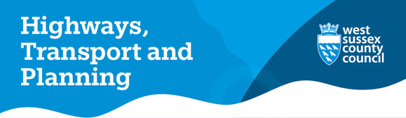
January’s record Rainfall and What It Means for Our Roads
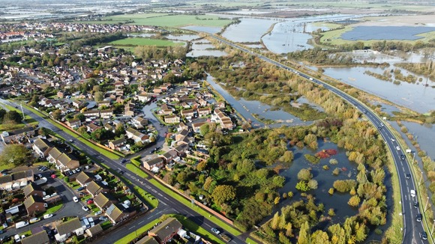
January has brought an extraordinary amount of rainfall to West Sussex - in fact, the highest levels we’ve seen in many years. This prolonged, intense wet weather has a direct impact on the condition of our roads. When the ground becomes saturated, water seeps into small cracks in the road surface. As temperatures fluctuate and vehicles pass over these weakened areas, the surface begins to break apart, leading to potholes forming more quickly and in greater numbers.
This year, we’ve recorded the highest number of pothole reports since 2011. While this reflects the challenging weather conditions, it also shows how proactive our residents have been in letting us know when something needs attention.
We want to extend a sincere thank you to everyone who has taken the time to report issues. Your vigilance helps us respond faster and keep our network as safe as possible.
We also want to recognise and thank our highways teams who have been working tirelessly, often in difficult, wet, and cold conditions, to repair defects and keep the county moving where possible.
West Sussex County Council says abuse of its officers needs to stop
Council Leader Cllr Paul Marshall has issued a statement in response to the recent assault and abusive language council workers have been receiving.
He said: "Let me be clear, any attack on our officers, whether verbal or physical, is unacceptable. Our officers are out across the county through all weathers, day and night, fixing the problems we’re seeing where they can or working to keep the public safe where they can’t.
“Before you comment or take action, take a moment to think how you would feel if someone threatened you verbally or physically simply because you are doing your job."
Read the full statement here

New 35-mile coastal path opens along Chichester Harbour
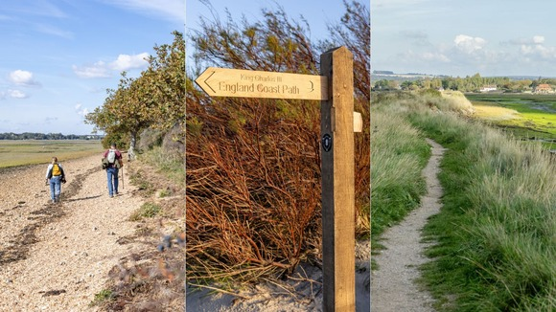
Photo credit: © Natural England Strong Island Media
A new 35-mile section of the King Charles III England Coast Path has opened, giving walkers unprecedented access to the stunning coastline of Chichester Harbour.
When complete, the national trail will span almost 2,700 miles, becoming the world’s longest managed coastal path.
With funding from Natural England and Defra, the county council has upgraded paths around the harbour with improved surfacing, clearer signage and new boardwalks.
Read more

Arun local cycling and walking infrastructure plan

Arun District Council is developing a Local Cycling and Walking Infrastructure Plan (LCWIP) to help make walking, wheeling and cycling safer, easier and more attractive for everyday journeys. Many people will not have come across an LCWIP before, so this consultation provides an opportunity to explain what it is, why it matters, and how you can help shape it.
An LCWIP is a long-term plan that identifies where improvements are needed to support active travel. This includes walking, cycling, and wheeling. Wheeling is a term used nationally to describe people who use wheelchairs, mobility scooters, pushchairs, or other non-motorised wheeled aids. Alongside walking, wheeling and cycling, the LCWIP will also consider the needs of horse riders, particularly in rural parts of the district where bridleways and multi-use paths play an important role in connecting communities. The council wishes to ensure the plan reflects the needs of all non-motorised users wherever possible.
To take part, please visit Arun District Council's Arun Local Cycling and Walking Infrastructure Plan project webpage (opens in new window)
Since January 2025 we have trained 51 riders via One-to-One Cycle Training
Our one-to-one training programme continues to be a success around the county. Both adults and children have one to one training with our dedicated cycle instructors, who have helped them from learning to ride to becoming more confident on the roads.
If you're new to cycling or returning to it after a break, book a one-to-one cycle training course for any age group @ https://www.westsussex.gov.uk/roads-and-travel/road-safety/one-to-one-cycle-training/
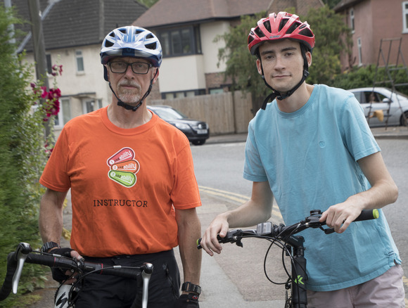
Highway Improvement Works
We are undertaking highway improvements across the county, with the following projects starting in the coming weeks.
Shoreham Town Centre - Bike Parks
West Sussex County Council are going to be carrying out work to introduce 12 new cycle parking spaces in Shoreham-by-Sea. We will be installing three new ‘mobility corral’ cycle parks on St Mary’s Road, Brunswick Road and New Road.
The work will take place from 23 until 27 February 2026 and it is expected that the works will have some impact on the road. We appreciate that these measures will cause some disruption, however we will aim to keep this to a minimum over the course of the works.
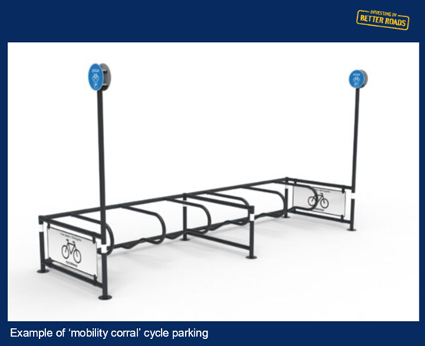
Warningcamp – Community Highways Scheme
We are starting work on a Community Highways Scheme in Warningcamp on the 24 February 2026 through till 17 March 2026. The scheme will introduce a new 20mph speed limit in the village of Warningcamp and a change of speed limit from national speed limit to 40mph on Crossbush Lane.
During the work on Blakehurst Lane there will be temporary traffic signals in operation, the rest of the works will be completed with STOP and GO boards.
Sydney Road, Haywards Heath – Pedestrian Crossing Point
Work to add a designated pedestrian crossing area with tactile paving on Sydney Road, near Church Avenue, will begin on 9 March 2026 and run until 27 March 2026 .
The road will remain open, but there will be temporary lights in operation, so please allow extra time for your journey during this time.
Further Details
You can view more information on all these schemes on One.Network
- Shoreham Town Centre - https://one.network/?GB146441970
- Warningcamp - https://one.network/?GB143253904
- Sydney Road, Haywards Heath - https://one.network/?GB143113510
Utility Projects Update
This section provides updates on projects being carried out by utility companies across the West Sussex Highways Network. |  | 
Southern Gas Network (SGN) Works
Worthing
Planned works for the gas main replacement on Victoria Road and A2031 Teville Road in Worthing are now progressing to phase two:
- Road Closure on Victoria Road from 27 October 2025 until 20 February 2026
- Road closure on Teville Road from Monday 19 January for 14 weeks. Vehicle access to Worthing Train Station (except for buses)
Businesses on Teville Road are open as usual and pedestrian access is always maintained.
Horsham
From Monday 26 January, old gas pipes replacement works will be carried out in the Albion Way area, Horsham. There will be West bound lane closure, and the works will be carried out in phases. Please click here if you need more information.
Chichester
To help minimise traffic disruption, SGN have been carrying out works on side roads and verges. This approach has helped avoid the need for temporary traffic lights on Stockbridge Road.
From Thursday 12 February, work has begun on the Selsey Road/Stockbridge Road roundabout under multi-way traffic lights from 6:30am to 6:30pm. These works will take place for approximately 4 weeks. Traffic flows will be managed to prioritise northbound travel in the morning and southbound travel in the evening.
We understand that ongoing roadworks can be disruptive, and we truly appreciate your patience and understanding. These upgrades are necessary to ensure the long-term safety and reliability of gas supply.
If you need further information about these works, you can contact SGN Customer Service Team by email Customer@sgn.co.uk or alternatively you can call them on 0800 912 1700. For travel and route diversion, please follow Causeway one.network.
Water infrastructure upgrades
Bepton, Midhurst
Road closure - extent from junction of Ingram’s Green Lane to A286. Southern Water will carry out excavation works for upgrades and maintenance to the existing water infrastructure. The works will take place in phases under a road closure from 2 March to 24 June 2026 between 8 am to 8 pm on weekdays and 9 am to 4 pm on weekends.
If you have any concern, please contact Southern Water at - Report A Problem or alternatively call 0330 303 0223
Developer’s Work
Highway Improvement works for access to new Rolls Royce’s extension in Chichester
Highway improvements work at various locations along Stane Street (Roman Road), Chichester are being delivered to support the planned extension of the existing Rolls-Royce manufacturing facility.
The works began on 5 February 2026 and will take approximately 12 weeks to complete under road closure and temporary lights at various locations. All works will be removed around Goodwood events. Please see CausewayOne for further details. Diversion routes are signed on site.
Please note: These are Developer works. For further information, please contact Walker Construction at admin@walker-construction.co.uk or alternatively you can call them on 01303 851111
Updates from VolkerHighways - Reactive Maintenance Contractors
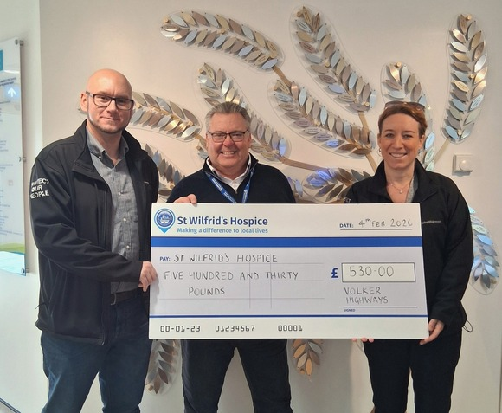
Volker Highways have donated £530 to St Wilfrid’s Hospice, Bosham their Charity of the Year last year.
Volker Highways have been supporting St Wilfrids since the start of our contract in April by donating £1 for every “Close Call” raised by their teams. This is a Health and Safety system we use to record observations when out on sites. This can be to prevent any potential issues before they happen and also to commend specific good practice. The donation will go towards supporting this independent charity who look after over 350 people in West Sussex living with a life limiting or terminal illness.
Volker Highways have donated £1000 to The Bluebell Railway Trust.
The Bluebell Railway approached Volker Highways for support with their project to restore one of their stations, Horsted Keynes. As the station is from the Victorian era it is clearly showing signs of age so a fundraising appeal for £500,000 is in place. The Bluebell Railway Trust is a Registered Charity formed in 1985. The Trust is responsible for generating funds to support the Bluebell Railway. The Trust also owns locomotives and other rolling stock and supports the conservation of skills and heritage on the Bluebell Railway in Sussex. Volker Highways are delighted to be able to support this project which will make a difference to Railway visitors for years to come.
Keep up to date 📱💻
Facebook, X, Bluesky & WhatsApp
Updates on emergency reports are posted every day and project updates are posted frequently on the West Sussex Highways Facebook @West Sussex Highways, X @WSHighways, and Bluesky @wshighways.bsky.social accounts.
Did you know you can get gritter alerts, grass cutting updates and up to date information on road issues on WhatsApp? You can follow silently or opt for alerts to notify you when we share an update. To find us open WhatsApp and select "Updates" from the bottom menu, then simply search for WSHighways or click the link - WSHighways.

Produced by the Customer Communications Officer, Highways Transport and Planning. Please contact active.communities@westsussex.gov.uk with any comments or suggestions for future articles.

