NEWS RELEASE | 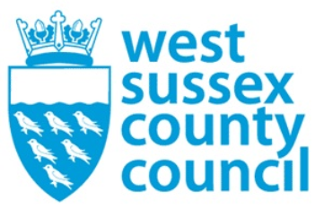

17 February 2026

West Sussex County Council Statement on Election Deferment Decision
A spokesperson for West Sussex County Council said: “We submitted our preferred option for Local Government Reorganisation (LGR) in September and clearly explained to the government the impact that continuing with local elections in 2026 would have on the ability to deliver the government’s policy objectives of devolution and LGR on their requested timetable.
“Based on our submission, minsters decided the threshold for deferring local elections had been met. They have since changed their position. This indecision has heightened the level of difficulty, creating significant uncertainty.
“The risk we face is not whether we have new arrangements in place in 2028, but the extent to which we can be confident those arrangements will be put in place without adversely affecting people that rely on the vital services we deliver. We will now take some time to digest this news and assess the impact on the LGR timetable.”
Future of local government in Sussex

For further information please contact the news desk on 0330 222 8090 or email pressoffice@westsussex.gov.uk.
For urgent out-of-hours enquiries please call 07767 098415.
 

