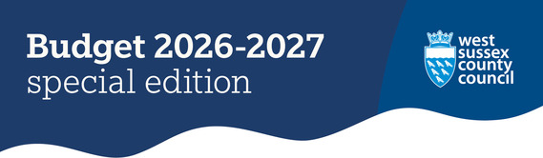
Everything you need to know about council tax and how we spend your money.

Our budget for the coming year
As a county council we deliver over 300 services to more than 915,000 residents and 42,500 businesses across 769 square miles.
Over the next year we will spend £2.3 billion on day-to-day services to deliver essential services, including:
£1,346.7m on schools and education, children’s social care and support
£577.2m caring for adults and keeping people healthy
£90.1m protecting the environment, recycling and waste disposal
£84.6m maintaining roads and providing transport
£72.8m on fire and rescue services and supporting communities
£5.8m supporting the local economy

Your council tax bill
An increase in the county council element of your council tax of 4.99% has now been confirmed. This comprises 2% for Adults’ Social Care and 2.99% for general services.
This means the average Band D cost will increase from £1,800.54 to £1,890.36, an increase of £89.82 per year or £1.73 per week.
How much will your council tax be?


Our Council Plan and priorities
To ensure we provide effective services which offer maximum value for our residents we carefully align our resources with the priorities in Our Council Plan.
Our key priorities are:
- keeping people safe in vulnerable situations
- a sustainable and prosperous economy
- helping people and communities fulfil their potential
- making best use of resources
- maximising the benefits of devolution and local government reorganisation for residents and communities
All of our priorities are underpinned by the cross-cutting theme of ‘protecting the environment’.
Our Council Plan and priorities


Investing in our communities
Alongside our day-to-day revenue budget, we have also agreed a five-year capital programme of £842m, with capital investments of £142.3m for 2026-27, including:
£56.5m to maintain roads and provide transport - focusing on the annual highways works programme including investments in major A roads and highways depots, bus services, and street lighting
£39.3m managing schools and education, children’s social care and support - including adaptations in mainstream schools to increase the number of specialist school places within the county and accommodate a wider variety of needs
£6m for recycling and waste disposal, and to protect the environment - mainly focused on investment into renewable energy, changes needed to waste disposal to accommodate the collection of separate food waste and other nature-based investments to protect the environment
Read more


Support and further information
There is help available if you need support with any aspect of your home finance or budgeting.
For advice and guidance on paying your council tax, contact your local district or borough council to see if you are eligible for a discount or exemption.
Further advice about local and national support can be found on our cost of living pages.
Local elections
The government has confirmed that elections for West Sussex will go ahead this year on Thursday 7 May. Read our statement in response to the government’s decision.
Devolution and local government reorganisation work continues across Sussex. Get the latest: Future of local government in Sussex.
Did you receive this eNewsletter from a friend? Sign up here.


