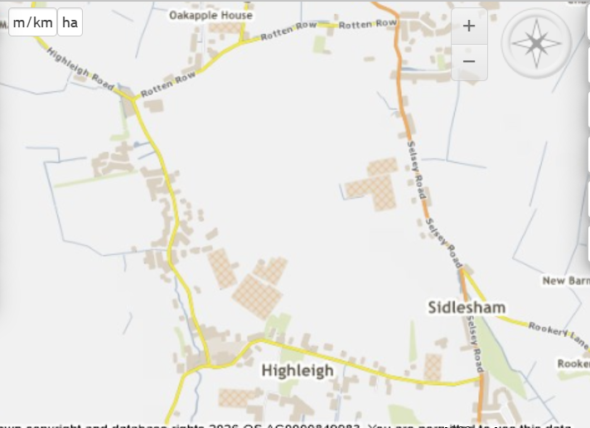
School
Closure out under job 437807
See above…
Please be advised closure was put out for Highfield Road and Keynor Lane due to flooding job 437807 refers. Road closure was implemented with closure points highlighted in red. However, there is a school located within the closure which is experiencing access issues.

After assessing roads in the locality we need to provide a safe access route to the school as such we need additional signage and diversion as set out below…

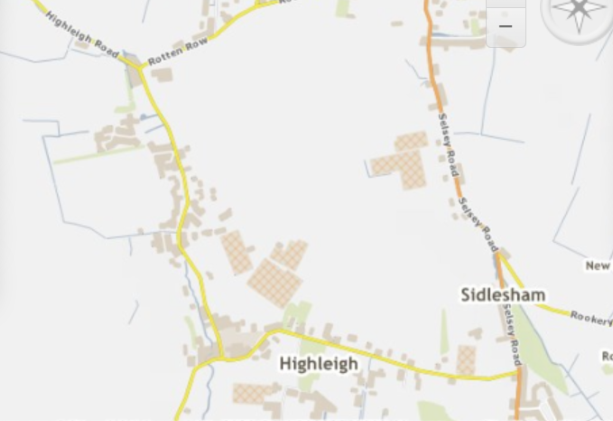
5
4
3
2
1
School
Key existing closure signs to remain highlighted in red shown as 1 and 2 on above plan.
New signs required…

Road closed sign on Highliegh Road just north of junction with Ham Lane (shown as number 3)
Road ahead closed sign Keynor Lane just east of junction with Ham Lane (no 4).
Road closed sign Keynor Lane east of school (No 5)
Summary of signage requirements 2 new closure signs and 1 x road ahead closed sign shown in green

