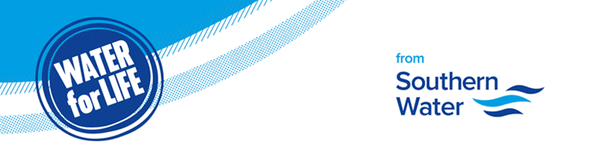

Dear Guy,

Emergency line to report issues

While we are working to minimise the impact of one of the wettest winters on record, groundwater levels are currently very high.
In January, the region experienced significantly above-average rainfall—156% more than the long-term average (158% in Hampshire, 145% on the Isle of Wight, 134% in Sussex, and 121% in Kent).
Our teams are working as hard as they can to help affected customers, and we’ve put in place an extensive tankering operation across the region. We’re posting daily updates on tanker activity on our website, and are sending regular updates to all stakeholders in affected areas. Please let us know if you would like to receive these updates.
We're receiving a lot of emails from MPs about customers experiencing flooding. It’s very important that customers call us first on our emergency line if they are experiencing internal or external flooding - that's the quickest way for us to raise a job and arrange a crew to attend.

Our emergency line is open 24/7, 365 days a year, to help customers with urgent situations including internal and external flooding, bursts or leaks or customers with no water.
The number to call is 0330 303 0368.

If a customer has already contacted us and not heard back, or isn’t happy with our response, we’re very happy to escalate those concerns.
To raise a new case, please email stakeholderteam@southernwater.co.uk, including the work reference numbers that a customer has been given after reporting an issue, the full address, postcode of the problem, and if possible, their Southern Water customer number. This will help us to track down the cases quickly.
Thank you in advance for your help as we manage significant demand across the network. If you would like to discuss the current challenges we’re facing with our team, please let me know, and we can arrange a meeting.

Yours sincerely,
Cris Cloyd
Public Affairs Manager

Southern Water, Southern House, Yeoman Road, Worthing BN13 3NX
southernwater.co.uk

Southern Water Services Ltd, Registered Office: Southern House, Yeoman Road, Worthing BN13 3NX Registered in England No. 2366670

