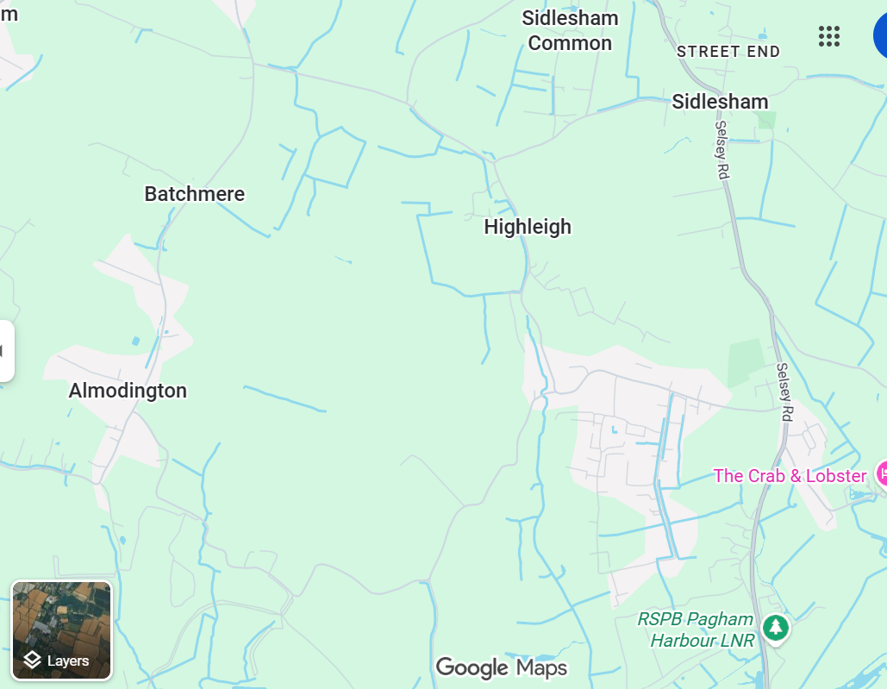
KEY
Hard closure points shown in red
Diversion shown in green

