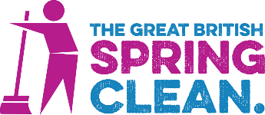

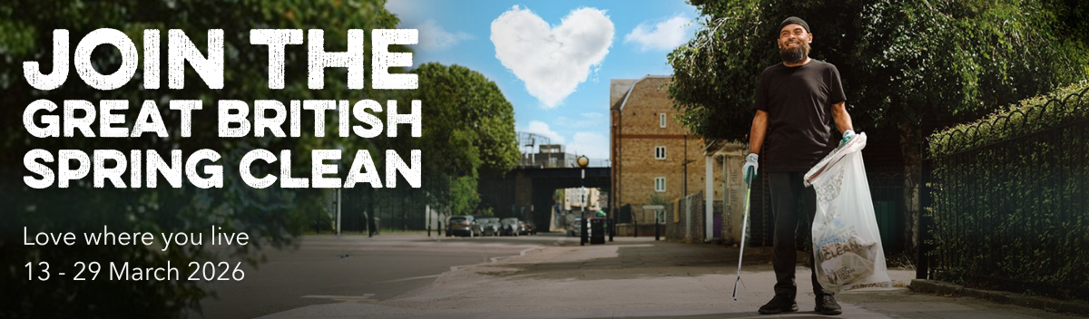

Join us for the 2026 Great British Spring Clean!
We know that you are working hard 365 days a year for the good of your communities – thank you for everything you do.

The Great British Spring Clean will take place from 13 to 29 March 2026. This is a great chance to encourage residents to get involved with our mission to tackle litter.

Will you join us and help residents show they love where they live?

Your town or parish council can sign up below, and once you've filled in your form, you'll receive our free digital #GBSpringClean kick-start kit.

You can also tell us any information you want us to make available to your resident volunteers, such as if you will provide equipment.
Sign up now

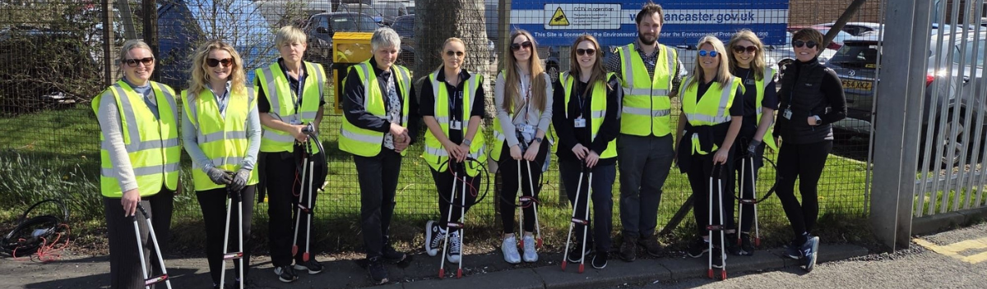
City council staff set the standard
The Great British Spring Clean Awards recognise outstanding efforts to tackle litter and care for communities.

Well done to Lancaster City Council’s Engagement & Development Assistant, Kathryn Taylor, who is shortlisted for our Outstanding Organiser award.

Kathryn organised a staff litter-pick with her team joined by departments including Finance, Executive Support & Wellbeing, Health & Safety, and Environmental Protection collecting 20 large bags around Morecambe in two hours – and some staff went on to pick in their own time.

With Engagement & Development Officer Helen Brister they spread the word to council staff, volunteer litter-pickers and volunteering groups by email, regularly posting on their Parks & Open Spaces Facebook page to showcase good work by volunteers and to advertise the campaign.

She said: “This was the first year I had any involvement with the Great British Spring Clean, and I'm proud of everyone's efforts – I can't wait to see what we can achieve next year!”

This year's award nominations will open in March, so keep your eyes peeled for a deserving Litter Hero and be sure to nominate them here.
Join us

  
  "It’s...an act of national renewal. Working people, coming together, to do their bit for community pride. Black bin-liner, by black bin-liner, helping to build a better Britain."
  PM Keir Starmer speaking about the 2025 campaign (credit: Keir Starmer ©House of Commons)

How to navigate the purdah period
We are aware some councils may be affected by the purdah period ahead of the May 2026 elections and that this may impact how and when our local authority partners choose to communicate about the campaign, and that limited communications for an extended period may pose challenges.

We understand purdah begins around the end of March, which means there is the pre promote period – and the first week of the campaign – in which officials and local authorities observing purdah can participate in the campaign.

We therefore encourage organisations affected by purdah to use the time before the campaign, which starts on 13 March, to promote it.

