
Welcome to the January 2026 edition of our Residents’ eNewsletter, featuring the latest news and updates from your county council.

Our Council Plan and budget
We’re working hard to balance our budget for 2026 to 2027 so we can continue to deliver essential services to communities across West Sussex.
Right now, we’re projecting a budget for the next financial year of over £2.3billion.
The proposals for Our Council Plan and how we intend to spend this money will go to our Performance and Finance Scrutiny Committee on 28 January. The Cabinet will then meet to recommend the plan and budget for approval by Full Council in February.
At the same time, work is ongoing with our partners to prepare West Sussex for devolution and local government reorganisation.
The consultation on reorganisation closed on Sunday and we are waiting now on the government’s response.
Thank you to everyone who took part.
Please also see our statement on our request to defer county council elections due in 2026.
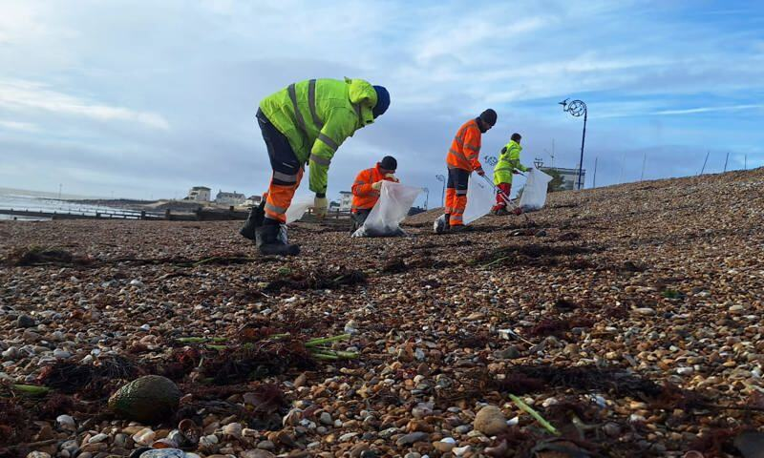
Photo credit: Ambipar
Clean-up continues as more containers come ashore
Teams involved in the major clean-up operation along the West Sussex shoreline are responding as more containers and debris come ashore.
Following stormy weather in the last week, containers have landed at Elmer near Bognor Regis and at Selsey.
Workers are responding right across the West Sussex shoreline as the contents and debris are washed ashore at locations from the Witterings to Shoreham.
We are also working with partners in neighbouring counties as waste comes ashore on beaches beyond West Sussex.
Any containers and their contents on the shoreline may well be unsafe for both people and animals and we strongly advise you not to go near them and help by also keeping children and pets clear.
See our information page for the latest on the operation, further safety guidance, and how to report waste and containers spotted along the shoreline.
More information


New plan for children and young people in West Sussex
A bold new plan that outlines how the county council and its partners will work towards improving outcomes for children and young people across the county has been published.
The Children and Young People’s Plan 2026-2029 outlines five key priorities designed to make West Sussex a place where children feel supported and able to thrive.
Our new animation helps explain the plan in a clear and simple way.
The plan has been released in the same week that government inspectors said that children and young people in West Sussex are receiving the support they need to thrive, stay safe, and reach their full potential.
Feedback from Ofsted has highlighted the quality of services for children in need of help and protection.
More information

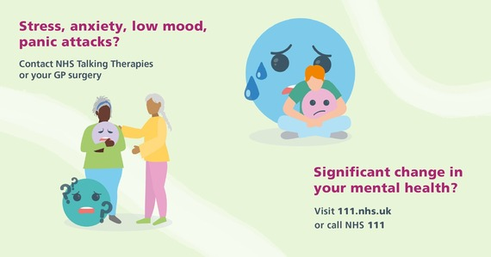
Help with your mental health
We all have times when we feel sad, anxious or low, and that’s completely normal.
If these feelings start to impact your day-to-day life, you don’t have to cope on your own - support is available.
If you’re over 18, the How Are You Really Feeling? website offers supportive online resources and details of people you can talk to.
For children and young people - visit eWellbeing for friendly support, information and practical tips to help manage stress, anxiety and low mood.
How are you really feeling?


Head to our Newsroom to find all the latest news.
- Children under the age of 6 are now being offered a vaccine against chickenpox as part of the routine childhood schedule of immunisations for mumps, measles and rubella. The vaccine will help reduce cases and protect children from serious complications that can cause hospitalisation. Your GP will make contact when the appointment is due. However, if a child has missed any routine vaccines, contact your GP practice to catch up on any missed doses.
- All 36 of our libraries will close to the public for three days on 19, 20 and 21 January for an essential system changeover.
- Our Trading Standards team has secured guilty pleas from two men and a company in Littlehampton. The defendants admitted to conspiracy charges and fraudulent trading involving the sale of illegal tobacco products.
- It’s Clean Air Night on Thursday 22 January when we will be raising awareness about the health harms of air pollution from wood burning in West Sussex. Visit Defra to find a simple guide on which fuels are safe to buy and to check if you live in a Smoke Control Area. You can also sign up for free text or email alerts ‘Extreme weather and air quality alerts’ to know when air pollution levels are high near you.

Discover wonderful ways to enjoy our county in 2026 by visiting the Experience Sussex website.
Whether it’s tucking in to local food and drink, soaking up the seasons with garden visits, getting out and about on the coast and in the countryside, or enjoying cultural events, there’s sure to be something that’s right up your street (and on your doorstep!).
Did you receive this eNewsletter from a friend? Sign up here.
