NEWS RELEASE | 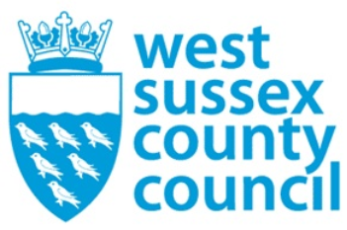

07 January 2026

Three-day closure of West Sussex libraries for essential system changeover
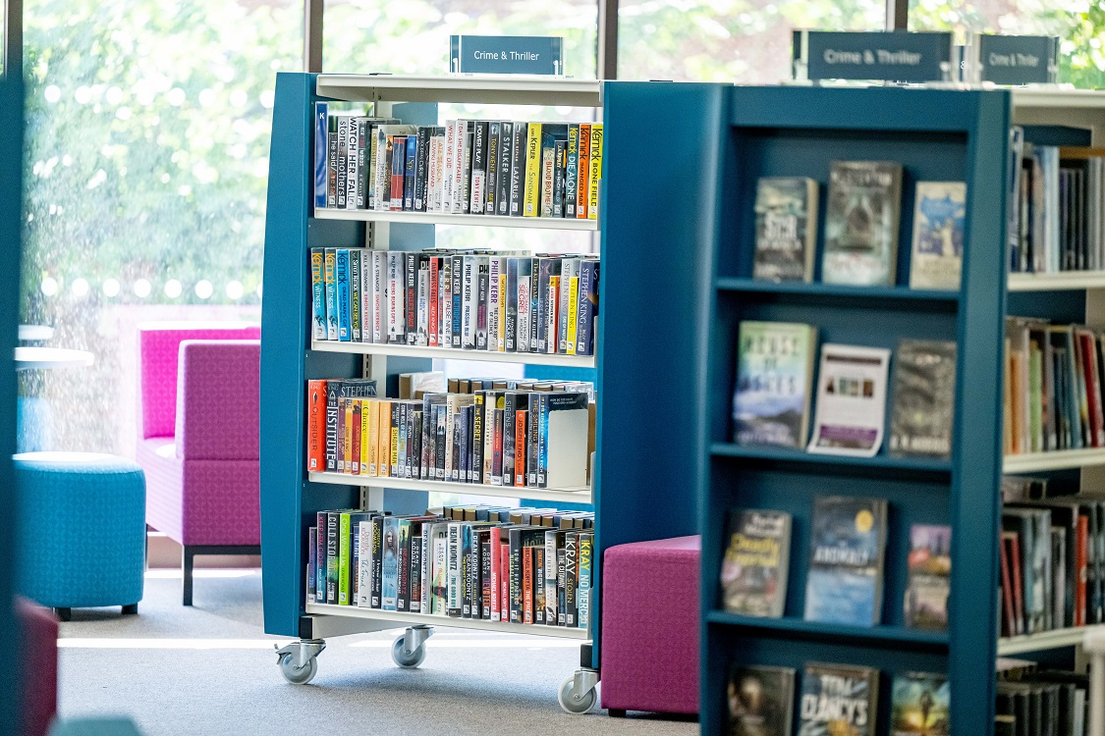
All 36 of our libraries, and the eLibrary, will close to the public for three days on 19, 20 and 21 January 2026.
This is so staff can set up a new online management system which will allow our libraries to continue their excellent services for the thousands of residents who use them every day.
During the closures, data will be transferred to the new system and checks done to ensure everything is functioning correctly, before customers are welcomed back – online and in person - on Thursday 22 January.
Cllr Duncan Crow, West Sussex County Council Cabinet Member for Community Support, Fire and Rescue, said: “It’s essential we make these changes so our systems can continue to offer the many services that so many people rely on. Closing down for a few days will ensure the changeover is delivered efficiently and with minimal disruption so that staff can hit the ground running once we reopen.”
Customers are being advised that no reservations can be placed from Monday 12 January. In addition, the library app and website will be unavailable from the end of the day on Friday 16 January. The new app and website will launch with the system upgrade.
Customers who have wish lists stored online of books they want to read will need to save them in advance of the closure, as the lists won’t transfer to the new system. Previously downloaded eLibrary content can be used during the closure, but new eLibrary loans will not be possible until services resume.
There will be no items due for return during the week of the changeover and no overdue items fines added for this period.

ENDS

For further information please contact the news desk on 0330 222 8090 or email pressoffice@westsussex.gov.uk.
For urgent out-of-hours enquiries please call 07767 098415.
 

Click to Unsubscribe

