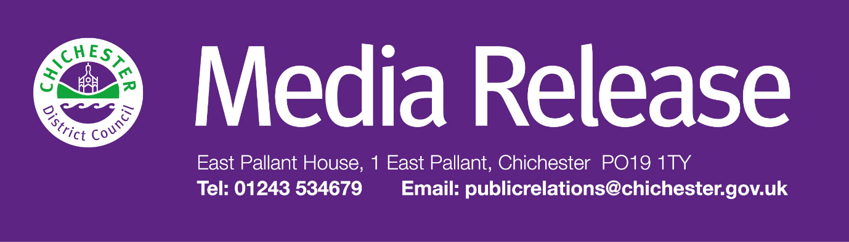
Date of Release: 6 January 2026 Ref: 4553
Call for district residents with captivating stories to tell as part of ‘Living Libraries’ project

People of all ages in Chichester District who have an amazing story to share are being asked to get involved in a community arts project.
Called ‘Living Libraries’, the project is being led by the Culture Spark initiative and will involve asking people to share their stories with volunteers who will then act as storytellers and relay these stories as part of an exciting Living Libraries event in 2026.
“The idea is based on a concept that is hugely popular in Denmark,” says Councillor John Cross, Cabinet Member for Culture, Sport and Place at Chichester District Council. “Looking for storytellers is the first stage of the project, and we’re looking for anyone of any age who has something interesting to share with others, it could be a child’s experience of being in a sport or a competition or a hobby that they really like, it could be an older person with memories of rationing or the swinging sixties, it could be someone who has something interesting to tell about the city or being left handed or a mini memoir! The aim of the programme is for people to learn and understand aspects of people’s lives and to understand more about the people within their local communities.”
The first-ever Living Library was organised in Denmark in 2000 with the aim of breaking down prejudice and promoting better understanding among communities.
Caroline Sharman-Mendoza, of Culture Spark says: “At each event there will be a catalogue of ‘books’ available to be borrowed, each with a title representing the story that has been collected.
“Visitors, or ‘readers’ can choose a ‘book’ from the catalogue and ‘borrow’ it. Instead of reading words on a page, the ‘reader’ has a one-to-one conversation with the ‘book’, listening to the personal story and experiences. After the conversation, the ‘book’ is returned to the ‘library’ and can be ‘borrowed’ by another reader.
“But first we need to collect the stories - So we are asking anyone (all ages welcome) who has a story to tell or who would like to collect one and be the ‘book’ for a day to contact me at culturespark2022@gmail.com to find out more!”
Culture Spark is a creative partnership between Chichester District Council, Chichester Festival Theatre and Pallant House Gallery and is funded by the UK Government.
For further information, please contact Clare Hawkin, Senior Communications Officer, on 01243 534679 or by
emailing chawkin@chichester.gov.uk

