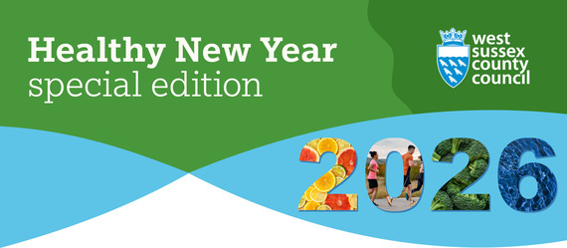
Welcome to our Healthy New Year special edition residents’ eNewsletter!
Read on for helpful information on free local services to support your health and wellbeing.
West Sussex Wellbeing
If you’re looking to make some changes this year to support your health and wellbeing, look no further than West Sussex Wellbeing!

What is West Sussex Wellbeing?
West Sussex Wellbeing is a free service for those aged 18 years and over who live or work in West Sussex. Our friendly team of wellbeing advisors at wellbeing hubs across the county, offer one-to-one and group-based advice and support to help you meet your health and wellbeing goals. These include how to maintain a healthy weight, drinking within recommended limits, stopping smoking, being active and more.
What we offer:
- Up to three one-to-one sessions to discuss your goals and how we can help you achieve them.
- Group programmes to help you maintain a healthy weight and become more active.
- Individual options, including:
  - Health MOT or NHS Health Check (where eligible)
  - Support to stop smoking
  - Help to cut down or stop drinking
  - Support to become more active, including advice on how to stay steady and to prevent falls
- Guidance on how to access high-quality digital programmes that fit around work and family commitments.
Your Wellbeing Advisor will work with you to agree the best type of support, along with a convenient time and date to begin the next steps of your journey.
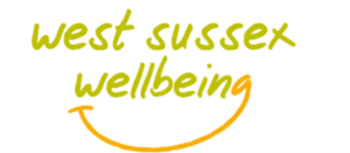
How do I contact my local Wellbeing service?
Find your nearest wellbeing hub close to where you live or work, complete the referral form or alternatively you can email or call to request an appointment. If you have any accessibility needs, just let us know when you get in touch. We will work with you to ensure these are met.
We also have a wealth of self-service support and advice on our West Sussex Wellbeing website, for weight management, alcohol, smoking, being active, falls prevention and more.
Visit our website to find out more about the service, your local wellbeing hub and how to book an appointment with a trained wellbeing advisor:
West Sussex Wellbeing

Gro Health - free expert weight loss support
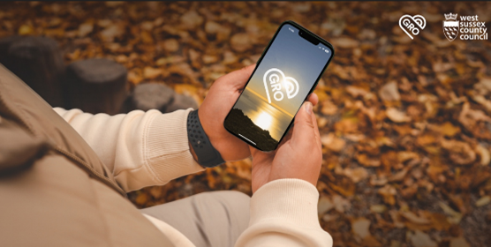
Gro Health is a free digital weight management programme available to people who live or work in West Sussex.
Developed to support people to lose weight, the programme can be accessed as an app or on the web, and provides personalised support for up to 12 months. Visit the Gro Health website to check your eligibility and sign up:
Visit Gro Health

Cutting Back on Alcohol

For both men and women, it is recommended to drink no more than 14 units of alcohol a week, spread across 3 days or more. That's around 6 medium (175ml) glasses of 12% wine, or 6 pints of 4% beer. If you’re pregnant, the safest option is not to drink at all.
Feel in control by taking the online DrinkCoach test. There’s free and confidential alcohol support available in West Sussex, both online and face-to-face.
Find further tailored support through West Sussex Wellbeing
Take the DrinkCoach test

Stopping Smoking
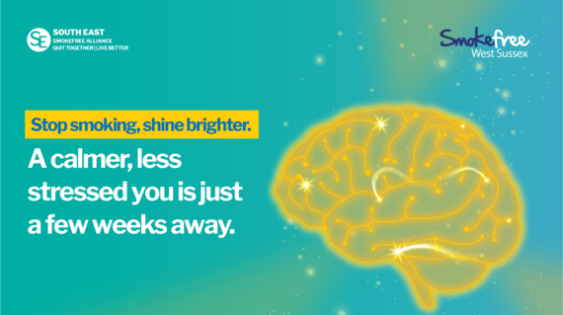
Stop smoking and improve your wellbeing
Did you know quitting smoking can reduce stress and boost your mood? Research shows that, when you quit, your brain starts to rebalance dopamine - the ‘feel-good’ hormone - within just a few weeks. That means quitting isn’t just great for your physical health, it’s a powerful step toward feeling better mentally and emotionally.
Join our 'Stop Smoking, Feel Happier' campaign and take the first step towards a happier, healthier you. Smokefree West Sussex advisors are ready to help you set a quit date, offer free nicotine replacement therapy, including for example, patches, vapes, gum and lozenges and to support you every step of the way.
There’s a wide range of free support available:
- Quit 4 Wellbeing – Specialist face-to-face and telephone support, call 0330 222 7980 for all smoking services.
- Local Wellbeing Teams – Stop-smoking support plus advice on healthy weight, physical activity, and alcohol.
- Smokefree App – A fully digital service for West Sussex residents.
- Stop-smoking support is also available from participating GP surgeries and pharmacies.
Quit today

Looking after your mental health
 |  | We may all have days when we feel sad, anxious or low, but if how you are feeling is having an impact on your day-to-day life, help is available.  If you’re over 18 – visit the 'How Are You Really Feeling?' website for helpful online resources and contact details of people you can speak with.  For children and young people – visit eWellbeing for support, information and tips on managing stress, anxiety and low mood.

Sexual Health
Sexual health is an important part of our overall wellbeing. Our Sex Aware, Feel Empowered (SAFE) webpage is the go-to place for trusted information on testing for sexually transmitted infections (STIs) and contraception options - so you can quickly and easily find advice and local services. |  | 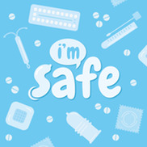

 |  | Winter vaccinations reminder  Flu season is upon us. Getting vaccinated is one of the best ways to protect yourself and those around you, it takes around two weeks for immunity to build up.  It’s now easier than ever to get vaccinated. Visit Winter vaccinations and winter health – NHS to check how to book. If eligible, you can book via the NHS App or by visiting Book free NHS flu vaccination. You can also call 119 or contact your GP practice or pharmacy.  If you’re not eligible for a free NHS vaccine, you can still buy one at most pharmacies.  Alongside vaccination, simple steps help reduce the spread of winter illnesses, including covering your mouth and nose when coughing and sneezing and washing hands regularly with soap and water. Consider staying home if you feel unwell or have a fever.  Take extra care when visiting older or more vulnerable people, and ventilate indoor spaces where possible by opening windows.

Be winter ready  For practical advice and guidance on how to keep warm, healthy and safe during the winter period visit our Keeping Safe this Winter page. |  | 

 |  | Extreme weather and air quality alerts  The extreme weather alert system, run by West Sussex County Council, now includes air quality alerts. Guidance will be provided alongside the alerts so residents can act early to reduce any impact these events may have on their health.  Sign up for the alerts via this link.

Blood pressure monitoring kits in libraries  You can now borrow potentially life-saving blood pressure monitors free of charge from all 36 libraries in West Sussex.  The easy-to-use blood pressure monitoring kits can be borrowed for up to three weeks by local library members and used at home to check blood pressure daily.  Find your nearest library here.  Early detection makes it easier to take steps to protect your health. Find out more information here. |  | 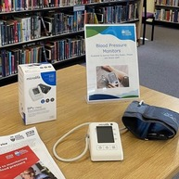

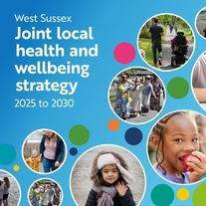 |  | Joint Local Health and Wellbeing Strategy  West Sussex Health and Wellbeing Board is making good progress in delivering their Joint Local Health and Wellbeing Strategy 2025 to 2030. Published in July 2025, the strategy sets out the Board’s plan for improving health and wellbeing for residents and communities and reducing health inequalities across the county.  Delivery groups for the plan’s five priority areas are in place, and will publish their first year action plans, including goals and measures shortly. We’ll keep residents updated on progress throughout 2026. In the meantime, watch our short animation to find out more.


