District Dispatch
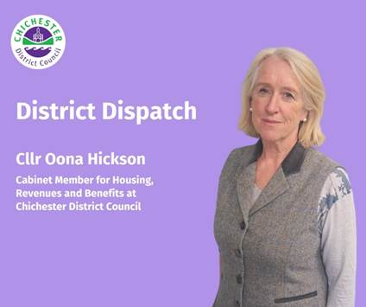
The start of the year can be a challenging time for many people, especially with ongoing cost of living pressures and higher winter energy bills. If you’re worried about the months ahead, now is a great time to reach out for support — our ‘Supporting You’ team are here to help

I often talk about the incredible work of our ‘Supporting You’ team. They work hard throughout the year to make a real difference to people’s lives across our district. By working closely with services across the council, they help residents access a wide range of support to help maximise their income.

The team has dealt with many cases where they have helped people turn their lives around. One case that stands out involved someone facing severe financial hardship, mounting debt, and a lack of access to food. Additionally, they experienced mobility issues and couldn’t get to a supermarket or shop online, and they didn’t have a working cooker or the money to replace it. One of the first things our team did was contact Southern Water to apply for a white goods grant (for essential appliances), which allowed the cooker to be replaced. Southern Water also placed them on a social tariff, which significantly reduced their water bills. Just as importantly, our team arranged a food bank delivery to ensure they had enough to eat. That person is now receiving ongoing support to help manage their debt. And they’re just one of many people we’ve been able to help.

Our team regularly attends the UKHarvest Fed and Nourished Community Food Hubs, which offer affordable food while helping to reduce food waste. All you need to do is bring a bag and, if you’re able, make a suggested donation of £5. UKHarvest visits different locations across the district each month, and you can check their schedule at: www.ukharvest.org.uk/education/community-food-hub. Locations include the Sylvia Beaufoy Centre in Petworth (on the first Thursday of every month); The Grange Centre in Midhurst (every other Monday); and Beacon Church in Selsey (every other Tuesday). These hubs are a great way to access affordable food, learn low-cost cooking, and find support.

Our Supporting You team have also been working with TellJo, a third-party organisation that uses technology in a compassionate way to identify people who may be vulnerable and in need of extra help. We use this as an early intervention tool for residents who’ve missed a council tax payment. Our team then reaches out to explore the underlying issues and offer practical solutions.

We also provide access to a free benefits and budgeting calculator — www.chichester.gov.uk/benefitsandbudgetingcalculator — which helps you estimate your entitlement to various benefits and offers budgeting advice. For example, residents can use it to compare their current income with what they might receive under Universal Credit.

I also want to remind anyone who is of state pension age to check whether they’re eligible for pension credit. From 6 April, the State Pension age will begin increasing from 66 to 67 in incremental stages, depending on a person’s date of birth, so it’s worth checking this at: www.gov.uk/state-pension-age — especially if you’re born between 6 April 1960 and 5 March 1961 as this will be the first group affected.

For those who are eligible, Pension Credit tops up weekly income to a guaranteed minimum of £227.10 a week for single pensioners or £346.60 for couples. People may also receive additional amounts if they care for another adult, are severely disabled, or are responsible for a child or young person. Find out if you’re eligible at: www.gov.uk/pension-credit-calculator

If you’re struggling, please don’t suffer in silence. You can find out more about the support available and contact our team by visiting: www.chichester.gov.uk/supportingyou

Best wishes
Cllr Oona Hickson
Cabinet Member for Housing, and Revenues and Benefits at Chichester District Council

 | Terri Foster  Senior Communications Officer  Communications  Chichester District Council

Ext: 21226 | Tel: 01243521226 | tfoster@chichester.gov.uk | Fax: 01243776766 | https://www.chichester.gov.uk
East Pallant House opening hours: 9am-4pm Monday to Friday


